Sena Success Stories – 2004-06-22

In this issue

1. Network-enabling Arcade Game Display Projectors
2. Industrial Refrigeration plant Data Acquisition system

1. Network-enabling Arcade Game Display Projectors
Customer : F2 Systems, Korea (http://f2.co.kr/eng/index.asp)
Target Serial Device : NEC & Sharp Display Projectors at Arcade game terminals
Sena BP : TCPLink, Korea
Sena Product : HelloDevice LS100
Competitive Edge : Economic Network-enabling solution
Contact Email : sales@sena.com

Customer
F2 Systems is a leading manufacturer of gaming machines and cabinets in the amusement & gaming industry.

Target Serial Device
The Target application scenario is composed with a Display projector, multiple game terminals, and a gateway server with database. Here, target serial device, Display projector creates graphical interface on surfaces, and send the game data to gateway database server. Upon the completion of one game, gateway database server send back the computational and networked data that will be displayed on display projector.

In the past, display projector had been connected to gateway database server using RS232 serial lines. There was a flexibility limitation in this RS232 based system, since it is required to build the cable lines when adding additional servers or moving exiting ones. Therefore, customer has decided to implement a cost-effective solution for networking Display Projectors.

Sena Product HelloDevice LS100

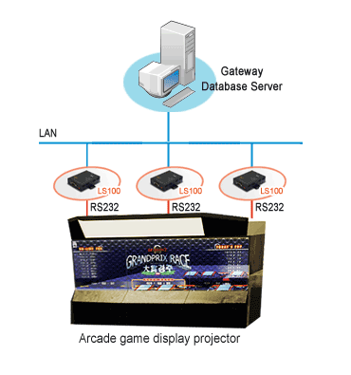
How it works
In the new system, at the end of the network is a HelloDevice LS100, which is connected to Ethernet on one side and connected via a serial communication port to the Display Projector on the other. The HelloDevice LS100 receives game data from display projector, converts to TCP/IP format and sends to a gateway database server. Upon the completion of one game, the LS100 receives the computational data in TCP/IP format, converts to serial data, and sends to the display projector.

Benefits
The HelloDevice LS100 equipped Display Projector has been very successful in providing a standard network interface with following benefits.
* Accurate and reliable data acquisition
* Remote monitoring

===============================================
More Product Information: http://www.sena.com/products/by_name/hd_lite/
===============================================
End.

2. Industrial Refrigeration plant Data Acquisition system

Target Serial Device : Sensors in Grenco's Industrial Refrigeration plant
Sena BP : OptoAfrica, South Africa
Sena Product : IALink100-Modbus
Competitive Edge : Cost-effective Network-enabling solution for Modbus devices
Contact Email : sales@sena.com

Target Serial device
Grenco's Industrial refrigeration plant collects sensor data, display on the SCADA system and makes it available in a central location for subsequent processing. In the past, sensor data from refrigeration plant has taken the form of manual operations and transfer to the local station via RS232 serial lines. This approach limits the capability and efficiency of refrigeration plant data acquisition system, since it is required to build the cable lines and manual operations require the expertise.

Therefore, customer has decided to monitor all SCADA system parameters and communicate Modbus RTU to a GRENCO gateway through network.
Sena Product: IALink100-Modbus
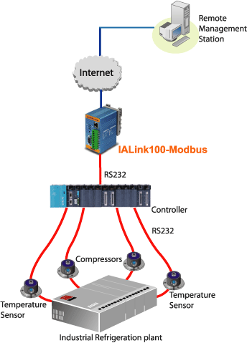

How it works
In the new system, Grenco communicates via a PLC (Modbus TCP) to the IALink100-Modbus, then from the IALink100-Modbus customer communicates Modbus RTU to a GRENCO gateway, which in turn communicates to their sensors in a Refrigeration plant. Now, Grenco reads parameters such as temperatures, pressures, set points of multiple compressors and displays on a SCADA system via the IALink100-Modbus.

Benefits
The IALink100-Modbus enables Modbus-based devices at Industrial Refrigeration plant to be easily connected to Ethernet using industry standard Modbus/TCP protocol. In addition, parameters can be recorded, and uploaded to the Grenco's gateway server through the network.

===============================================
More Product Information: http://www.sena.com/products/by_name/ialink/
===============================================

End.

