Sena Success Stories – 2004-04-12

In this issue

1. Ethernet based Sensor Data acquisition and Monitoring
2. Network-enabling the Online Game Display Projectors
3. Network-enabling the Door Access Control system
4. Terminal Server eliminates the need for multiport modem cards

1. Ethernet based Sensor Data acquisition and Monitoring

As today's computing environment becomes increasingly complex and is subjected to ongoing change, the need to capture and analyze the data is quickly becoming a very real need to closely monitor conditions in the data acquisition industry.

A Data Acquisition system collects data from various sites and makes it available in a central location for subsequent processing. Examples of use include simple electronic gathering of data from oil wells to remote operation of an unmanned oil or gas platform. Other typical applications might be storage tank farm management, water/steam injection, pipeline management, metering stations, steam generator and compressor stations, etc.

In the past, remote management of Sensor data has taken the form of manual operations. This approach limits the capability and efficiency of data acquisition systems. The "manual" methods used for these operations require the expertise of experienced, highly skilled operators.

On the other hand, the worldwide familiarity, and availability of Ethernet, along with its potential performance levels, has prompted increased consideration of Ethernet as a feasible communications technology for process control based data acquisition tasks. A TCP/IP based communications network would allow a wide variety of sensors, actuators, and other devices to be connected. In this network, devices could be easily added to or removed from the system.

Responding to these trends, Sena is providing a TCP/IP-based Data Acquisition solution to collect the data from various process-control based devices and manage over the network.

The HelloDevice SS110 provided cost-effective network connectivity for the controller unit at the oil wells locations using TCP socket services, allowing them to be connected to the local network equipment. Each terminal unit has a variety of oil well measurement sensor and controllers attached to it. Through the ADSL network link, sensors and controllers at the individual oil well locations are now available to the district monitoring stations and the national management center.
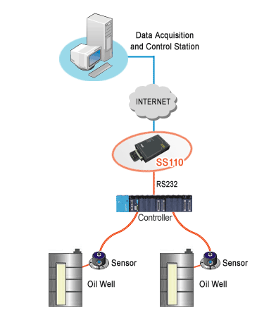
The HelloDevice SS110 is featured with an industry standard RJ45 connector for RS232/422/485 based sensor connections and another RJ-45 socket for Ethernet connectivity. Full support for RS232 and RS422 control lines is available to make the HelloDevice SS110 compatible with sensor applications that require hardware and software handshaking. Also, an automatic turnaround facility for two-wire RS485 multidrop environments is provided to enable the poll response type sensor applications. Parity, data and stop bits can be manipulated and set to the values required to get the accurate sensor data packet structure.

Furthermore, the HelloDevice SS110 allows dynamic IP address allocation as per the DHCP protocol. This provides the advantage over expensive static IP addressing.

Dynamic DNS feature of the SS110 allow controllers to be accessed over DSL-based broadband network or conventional LAN environment through the 10/100 Mbps Ethernet interface. On the other hand customer added a wireless LAN PC card into the PCMCIA slot of the 'HelloDevice SS110'. Powerful security features such as SSL, TLS, 3DES data encryption, and RC4 algorithm encouraging sensors to share the data with remote host securely.

2. Network-enabling the Online Game Display Projectors

A growing segment of the game market has been migrating towards online interactivity games with the evolution of a robust Internet community, exciting games, high-power PCs, mobile game platforms, and reliable game data centers. Since the market is rapidly expanding, many companies intend to use the arcade game product line to move into new markets.

To provide a high level of online interactivity, game hosting requires powerful servers for running the games, enforcing the rules, controlling mechanism, and managing non-player characteristics. Servers link players with authentication, database, and resource management servers. By providing a wide array of benefits and flexibility to the servers, TCP/IP is helping game hosting services and online game hosters to create more easily managed, cost-effective data center infrastructure.

A typical Arcade game architecture is composed with a Display projector, multiple game terminals, and a Gateway server with database. Displays projector is a device that uses a device that uses a rotating mirror to steer the light from an LCD projector onto different surfaces of an environment and to sense interaction with the projected surface.

Display projector is able to create graphical interfaces on surfaces, and send the data to a gateway server through a serial Ethernet data converter. Upon the completion of one game, gateway database server sends the computational and networked data to the serial Ethernet converter that will be displayed on the display projector.
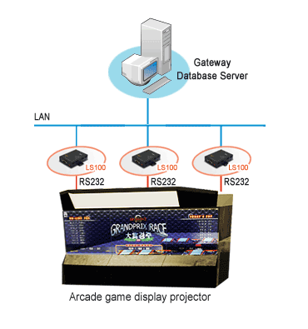
The HelloDevice LS100 enabled Interactive Online Game Industry to add cost-effective network connectivity to the Display projector to seamlessly integrate the data with Gateway database servers through TCP/IP open network standards.

The HelloDevice LS100 equipped Display Projector has been very successful in providing a standard network interface with following benefits.
* Accurate and reliable data acquisition
* Remote monitoring

3. Network-enabling the Door Access Control system

Building automation systems automate the many services required to successfully operate and manage facilities including environmental control, fire and life safety, lighting, energy management, and security access control. These services have traditionally been provided as independent, standalone systems by multiple, proprietary vendors. While improvements in systems integration have been occurred over the past ten years, only recently has it become cost effective and, in some cases, technically possible for a user to deploy an easily portable and fully integrated facility management solution.

Access controller is designed for access control of doors, vehicle boom gate and other building facilities. Typical door access control system is composed of a door access controller and the access management server PC to manage users information. It is capable of controlling a single door usually in a standalone mode. There are 3 different entry access modes that you can set to adjust to your security requirements: Card only, PIN only and Card & PIN only.

Door access controller uses RF-ID Technology to scan the entry access modes. In the past, communication between the door access controller and management PC relies on RS485 communications. There was a flexibility limitation in the RS485-based system, since it is required to re-build the whole cable lines when adding additional controllers or moving exiting ones.

Sena is dedicated to centralizing information by providing open-connectivity of building automation devices onto a reliable and proven TCP/IP protocol standard. Using the HelloDevice PS100 device server, the manufacturer added reliable and proven network connectivity to the door access control system.
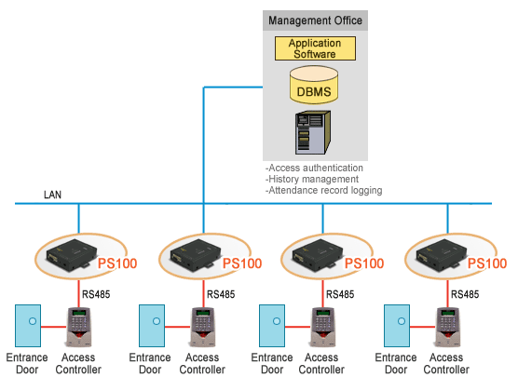

In the new system, access controller is connected back to an Ethernet network through the HelloDevice PS100. This new architecture gives the ability to monitor and control area access on a wide scale allowing the operators visibility of personnel movement around a facility. As a result, it enables the system integrators to build the access control system with minimum cost by using the existing Ethernet network in the building, making the whole system manageable, more efficient, and flexible by connecting them to the Database-based business system.

4. Terminal Server eliminates the need for multiport modem cards

In an increasingly competitive market, the challenge for financial institutions is to provide individual, small merchants and corporate customers with access to multiple products and services anytime, anywhere. As retail and business consumers rely more heavily on services delivered through merchant stores, Internet and mobile devices, financial institutions face a critical challenge: managing the payment processing services and equipment consistently, across multiple channels, while ensuring payment transaction integrity, security, and authentication.

Payment Acquirer is a financial institution or its agent that establish accounts with merchants and process payments on their behalf. The merchant usually accepts several credit cards, but does not want to deal with multiple issuers or bankcard associations. The acquirer is an intermediary between the cardholders and the issuers, and controls the credit limit and the validity of the card account. The acquirer also transfers payments to the merchants account and is compensated by the card issuer.

The merchants connect to the payment gateway, while this gateway is connected to the acquirers’ systems. This is why the payment gateway establishes many relationships between the merchants and the acquirers. Thus, the security of the payment gateway must be very strict.

To be competitive as a Payment Acquirer with multiple delivery channels, a payment-processing infrastructure must provide a flexible foundation for rolling out new services at the pace of merchants, private networks, and device vendors demand.

Typical payment processing equipment at Payment acquirers site is composed of PSTN Lines, modems, and an authentication server PC to process the merchant’s requests. In the past, Payment acquirers used to handle these PSTN modems by connecting them into a multiport modem card that is connected to an authentication server PC through a serial port. A multiport modem card is a number of modems on the same card or many modems in an external chassis. These multiport modem cards can be used by an ISP or Payment Acquirers or by an organization that has a number of phone lines for dialing in and out.

With a wide range of professional experience on numerous POS applications, Sena is providing a TCP/IP-based intelligent device networking solution to connect the multiport modem to the TCP/IP network and manage over the network.

In the new system, the multiport modem card likely would consist of modems connected to a Sena terminal server named as STS1600, which is a specialized unit designed for connecting modems to a network. A dial-in user connects to the STS1600, and then connects (e.g., telnets) from there to an authentication server. The STS1600 also provide security features that can restrict connections to specific systems, or require users to authenticate using SSH connections.

Benefits in the new system with Sena Terminal Server include:
* Simplify installation and maintenance by eliminating expensive multiport serial adapters and messy cabling schemes.
* Scalable architecture increases flexibility in system design and expansion

