Universal Device Servers
HelloDevice Super Series

User Guide

Version 1.2.1

2004-08-16

Copyright Information
Copyright 1998-2004, Sena Technologies, Inc. All rights reserved.
Sena Technologies reserves the right to make any changes and improvements to its product without providing prior notice.

Trademark Information
HelloDevice™ is a trademark of Sena Technologies, Inc.
Windows® is a registered trademark of Microsoft Corporation.
Ethernet® is a registered trademark of XEROX Corporation.

Notice to Users
Proper back-up systems and necessary safety devices should be utilized to protect against injury, death or property damage due to system failure. Such protection is the responsibility of the user.

This device is not approved for use as a life-support or medical system.

Any changes or modifications made to this device without the explicit approval or consent of Sena Technologies will void Sena Technologies of any liability or responsibility of injury or loss caused by any malfunction.

Technical Support
Sena Technologies, Inc.
210 Yangjae-dong, Seocho-gu
Seoul 137-130, Korea
Tel: (+82-2) 573-5422
Fax: (+82-2) 573-7710
E-Mail: support@sena.com
Website: http://www.sena.com

Revision history
Revision | Date | Name | Description
V1.0.0 | 2003-09-19 | I.S. Um | Initial Release
V1.0.1 | 2003-10-08 | O.J. Jung | Figure 5-6, Table A.2 revised
V1.1.0 | 2004-01-09 | I.S. Um | Revision with release version 1.1.0
V1.1.1 | 2004-01-30 | O.J. Jung | Typographical errors are corrected
V1.2.0 | 2004-06-11 | O.J. Jung | Revision with release version 1.2.0(including description for the new SS100 mode)
V1.2.1 | 2004-08-16 | O.J. Jung | Specifications for SS110 are changed

Contents
1. Introduction 8
1.1. Overview 8
1.2. Package Check List 9
1.3. Product Specification 10
1.4. Terminologies and acronyms 11
2. Getting Started 14
2.1. Panel Layout 14
2.1.1. SS100 Panel Layout 14
2.1.2. SS110 Panel Layout 15
2.1.3. SS400 Panel Layout 16
2.1.4. SS800 Panel Layout 16
2.2. Connecting the Hardware 16
2.2.1. Connecting the power 17
2.2.2. Connecting to the network 17
2.2.3. Connecting to the device 18
2.2.4. Accessing the System Console 20
2.2.5. Using the System console 20
2.2.6. Using Remote console 23
2.3. Accessing the Web Browser Management Interface 24
3. Network Configuration 26
3.1. IP Configuration 26
3.1.1. Using a Static IP Address 27
3.1.2. Using DHCP 28
3.1.3. Using PPPoE 29
3.2. SNMP Configurations 29
3.2.1. MIB-II System objects Configuration 30
3.2.2. Access Control Configuration 31
3.2.3. Trap Receiver Configuration 31
3.2.4. Management using SNMP 31
3.3. Dynamic DNS Configuration 32
3.4. SMTP Configuration 33
3.5. IP Filtering 34
3.6. SYSLOG server configuration 36
3.7. NFS server configuration 36
3.8. Ethernet configuration 37
3.9. Web server configuration 38
3.10. TCP service configuration 39
4. Serial Port Configuration 40
4.1. Overview 40
4.2. Individual Port Configuration 42
4.2.1. Port Enable/Disable 43
4.2.2. Port Title 43
4.2.3. Apply All Port Settings 44
4.2.4. Host Mode Configuration 45
4.2.5. Remote host configuration 53
4.2.6. Port IP filtering configuration 54
4.2.7. Cryptography configuration 55
4.2.8. Filter application 60
4.2.9. Serial port parameters 61
4.2.10. Modem configuration 64
4.2.11. Port Logging 65
4.2.12. Port event handling configurations 67
4.3. All Port Configurations 72
5. PC Card Configuration 74
5.1. LAN Card Configuration 75
5.2. Wireless LAN Card Configuration 76
5.3. Serial Modem Card Configuration 78
5.4. ATA/IDE Fixed Disk Card Configuration 78
6. System Administration 80
6.1. System Status 80
6.2. System Logging 80
6.3. User Logged on List 82
6.4. Change Password 83
6.5. Device Name Configuration 83
6.6. Date and Time Settings 83
6.7. Configuration management 84
6.8. Firmware Upgrade 86
6.9. User File Uploading 88
7. System Statistics 91
7.1. Network Interfaces Statistics 91
7.2. Serial Ports Statistics 91
7.3. IP Statistics 92
7.4. ICMP Statistics 94
7.5. TCP Statistics 96
7.6. UDP Statistics 98
8. CLI guide 99
8.1. Introduction 99
8.2. Flash partition 99
8.3. Supported Linux Utilities 100
8.3.1. Shell & shell utilities: 100
8.3.2. File and disk utils: 100
8.3.3. System utilities: 100
8.3.4. Network utilities: 100
8.4. Accessing CLI as root or system administrator 100
8.5. Editing SS Series configuration in CLI 100
8.5.1. Configuration file save/load mechanism: 100
8.5.2. To change configuration in CLI: 101
8.6. Running user defined scripts 101
8.7. File transmission 101
8.8. Examples 102
8.8.1. Disabling the Telnet Port of the Unit 102
9. User customization guide 104
9.1. Introduction 104
9.2. Periodical program execution 104
9.3. User defined web pages 105
9.4. Making and running user’s own code 105
Appendix 1. Connections 106
A 1.1. Ethernet Pin outs 106
A 1.2. Console and Serial port pin-outs for SS100 106
A 1.3. Console and Serial port pin-outs for SS110/400/800 107
A 1.4. Ethernet Wiring Diagram 107
A 1.5. Serial Wiring Diagram 108
A 1.5.1. RS232 Serial Wiring Diagram for SS100 108
A 1.5.2. RS232 Serial Wiring Diagram for SS110/400/800 108
A 1.5.3. RS422/285 Serial Wiring Diagram for SS100 110
A 1.5.4. RS422/285 Serial Wiring Diagram for SS110/400/800 110
Appendix 2. PC card supported by SS Series 112
Appendix 3. SS Series Configuration files 114
A 3.1. System.cnf 114
A 3.2. Redirect.cnf 116
Appendix 4. Well-known port numbers 120
Appendix 5. Guide to the Bootloader menu program 121
A 5.1. Overview 121
A 5.2. Main menu 121
A 5.3. RTC configuration menu 121
A 5.4. Hardware test menu 122
A 5.5. Firmware upgrade menu 126

Introduction

Overview

The HelloDevice SS Series is a Universal terminal server (or device server) that makes your legacy serial devices manageable by industry-standard Ethernet network. Based on open network protocols such as TCP/IP and UDP, it gives you ultimate flexibility to your serial devices. With PPPoE (PPP-over-Ethernet) connection feature of the HelloDevice SS series, the RS232/422/485 serial devices could be managed over DSL-based broadband network.
With the rich broadband network connectivity protocols such as DHCP, PPPoE and Dynamic DNS, you could easily manage the legacy serial devices over broadband Internet by using DSL or cable modem connection. The built-in Dynamic DNS protocol of the HelloDevice SS Series enables you to access the serial devices with their domain names.
The HelloDevice SS Series also provides you with full-featured system management functionality of system status display, firmware upgrade, remote reset and system log display by using various ways such as telnet, serial console port or web.
You could easily configure and administrate the HelloDevice SS Series, with the full-featured management functions of status monitor, remote reset, error log monitor and firmware upgrade by using Telnet and serial console port under the password protection support.
For critical applications of secure data communication, the HelloDevice SS Series supports SSLv2, SSLv3 and TLSv1 for data encryption. In addition, IP address filtering function is provided for protecting unintentional data streams to be transmitted to the HelloDevice SS Series.

Typical application areas of the HelloDevice SS Series are:
- Industrial automation
- Network management
- Retail/Point of sale
- Remote metering
- Remote display
- Building automation
- Security/Access control systems
- General data acquisition application
- Medical application

The HelloDevice SS Series gives you ideal remote management capability of control, monitoring, diagnosis and data gathering over RS232/422/485 serial devices.

Please note that this manual assumes user knowledge of Internetworking protocols and serial communications.

Package Check List

- SS100/110/400/800 external box
- External 110V or 230V power supply
- Serial cable kit
- Quick Start Guide
- CD-ROM, including the HelloDevice VirtualCOM, HelloDevice-IDE, HelloDevice Manager and manuals

Product Specification
 | SS100 |  | SS110 | SS400 | SS800
Serial Interface | 1-port |  |  | 4-port | 8-port
Serial Interface | Serial speeds 75bps to 230Kbps
Serial Interface | Flow Control:  Hardware RTS/CTS, Software Xon/Xoff
Serial Interface | RJ45 connector
Serial Interface | Signals:  RS232 Rx, Tx, RTS, CTS, DTR, DSR, DCD, GND  RS422 Rx+, Rx-, Tx+, Tx-  RS485 Data+, Data-
Serial Interface | Modem controls: DTR/DSR and RTS/CTS
Network Interface | 10/100 Base-Tx Ethernet with RJ45 Ethernet connector
Network Interface | Supports static and dynamic IP address
Protocols | - ARP, IP/ICMP, TCP, UDP, Telnet, SSH v1 & v2,  - SSL v2 & v3, TLS v1  - DNS, Dynamic DNS, HTTP, HTTPS,  - SMTP with/without Authentication, pop-before SMTP,  - DHCP client, NTP, PPPoE, SNMP v1 & v2
PCMCIA | None |  | Supports one of the following PC cards:  ATA flash memory card  802.11b Wireless LAN card  10/100 Base-TX LAN Card  Modem card
Security | User ID & Password
Security | HTTPS
Security | Secure terminal interface: SSH
Security | Data Encryption: SSLv2/v3, TLS v1, 3DES and RC4
Security | IP address filtering
Security | SCP
Modem emulation | Full support for AT commands
Management | Web, Telnet or Serial console port or HelloDevice Manager
Management | O/S support: Windows 98/ME/NT/2000/XP
Management | System log  Automatic email delivery of error log
Management | System statistics  Full-featured system status display
Management | Firmware  Stored in Flash memory and upgradeable via serial console, telnet or web
Diagnostic LED | Power  Ready  10/100 Base Link, Act  Serial InUse(SS400/800 Only)/Rx/ Tx for each port  PC Card(SS110/400/800 Only)
Environmental | Operating temperature: 5’C to 50’C  Storage temperature: –40’C to 66’C
Power | 5VDC, 0.5A @ 5VDC | 7.5VDC, 1A @ 7.5VDC |  | 5VDC, 1.5A @ 5VDC
Dimension  L x W x H (mm) | 100 x 72 x 25 (mm)  3.94 x 2.83 x 0.98 (in.) | 150 x 103 x 26 (mm)  5.9 x 4.0 x 1.0 (in.) |  | 245 x 153 x 30 (mm)  9.6 x 6 x 1.2 (in.)
Dimension  L x W x H (mm) | DIN-rail mount option
Weight (kg) | 0.240 | 0.455 |  | 1.5
Certification | FCC(A), CE(A), MIC
Warranty | 5-year limited warranty

Terminologies and acronyms

This section will define commonly used terms in this manual. These terms are related to Internetworking, and defined in regards to their use with SS Series.

- MAC address
On a local area network or other network, the MAC (Media Access Control) address is the computer's unique hardware number. (On an Ethernet LAN, it is the same as the Ethernet address.)
It is a unique 12-digit hardware number, which is composed of 6-digit OUI (Organization Unique Identifier) number and 6-digit hardware identifier number. The SS Series has the following MAC address template: 00-01-95-xx-xx-xx. The MAC address can be found on the bottom of the original package.

- Host
A user’s computer connected to the network
Internet protocol specifications define "host" as any computer that has full two-way access to other computers on the Internet. A host will have a specific "local” or “host number" that, together with the network number, forms its unique IP address.

- Session
A series of interactions between two communication end points that occur during the span of a single connection
Typically, one end point requests a connection with another specified end point. If that end point replies, agreeing to the connection, the end points take turns exchanging commands and data ("talking to each other"). The session begins when the connection is established at both ends and terminates when the connection is ended.

- Client/Server
Client/server describes the relationship between two computer programs in which one program, the client, makes a service request from another program, the server, which fulfills the request.
A server is a computer program that provides services to other computer programs on one or many computers. The client is the requesting program or user in a client/server relationship. For example, the user of a Web browser is effectively making client requests for pages from servers all over the Web. The browser itself is a client in its relationship with the computer that is getting and returning the requested HTML file. The computer handling the request and sending back the HTML file is a server.
Table 1-1 Acronym Table
ISP | Internet Service Provider
PC | Personal Computer
NIC | Network Interface Card
MAC | Media Access Control
LAN | Local Area Network
UTP | Unshielded Twisted Pair
ADSL | Asymmetric Digital Subscriber Line
ARP | Address Resolution Protocol
IP | Internet Protocol
ICMP | Internet Control Message Protocol
UDP | User Datagram Protocol
TCP | Transmission Control Protocol
DHCP | Dynamic Host Configuration Protocol
SMTP | Simple Mail Transfer Protocol
FTP | File Transfer Protocol
PPP | Point-To-Point Protocol
PPPoE | Point-To-Point Protocol over Ethernet
HTTP | HyperText Transfer Protocol
DNS | Domain Name Service
DDNS | Dynamic Domain Name Service
SNMP | Simple Network Management Protocol
RADIUS | Remote Access for Dial-In User Service
SSH | Secure Shell
NTP | Network Time Protocol
UART | Universal Asynchronous Receiver/Transmitter
Bps | Bits per second (baud rate)
DCE | Data Communications Equipment
DTE | Data Terminal Equipment
CTS | Clear to Send
DSR | Data Set Ready
DTR | Data Terminal Ready
RTS | Request To Send
DCD | Data Carrier Detect

Getting Started

This chapter describes how to set up and configure the SS Series.
- 2.1 Panel Layoutgexplains the layout of the panel and LED indicators.
- 2.2 Connecting the Hardware describesdhow to connect the power, the network, and the equipment to the SS Series.
- 2.3 Accessing the Web Browser Management Interface describes how tosaccess the console port using a serial console or a Telnet or Web menu from remote location.

The following items are required to get started.
- One power cable (included in the package)
- Console and Ethernet cables (included in the package)
- Cable kit (included in the package)
- One PC with Network Interface Card (hereafter, NIC) and/or one RS232 serial port.

Panel Layout

SS100 Panel Layout

The SS100 has six LED indicator lamps for status display. Uppermost lamp indicates the system power-on status. Next lamp indicates the system running status. Third lamp indicates status of receive and transmit of the serial port for data communication. Next three lamps indicate 100 Base-T Ethernet connection, 10/100 Base Ethernet Link and Ethernet Activity, respectively.

Table 2-2 LED indicator lamps of the SS 100

Lamps |  | Function
Status | Power | Turned on to RED if power is supplied
Status | Ready | Turned on to YELLOW if system is ready to run or running.  Blinking when an error is occurred. (Check the log to identify the source of error. The log display is discussed on Section 6.2)
Serial port | Rx/Tx | Blink whenever there is any incoming or outgoing data stream through the serial port of the SS100
Ethernet | 100Base | Turned on to GREEN if connected to 100 Base Ethernet network
Ethernet | Link | Turned on to GREEN if connected to 10 or 100 Base Ethernet network
Ethernet | Act | Blink whenever there is any activities such as incoming or outgoing packets through the SS100 Ethernet port

Figure 2-1 The panel layout of the SS100

SS110 Panel Layout

The SS 110/400/800 has three groups of LED indicator lamps to display the status, as shown in and Figure 2-3 (i.e. System, Ethernet and Serial ports). The first three lamps on the left side indicatonPowery Ready and PC Card interface. The next three lamps ar for Ethernus 100Mbpss Link and Act. Next lamp indicate Receive an tTransmis of the serial port.ws describes the function of each LED indicator lamp.

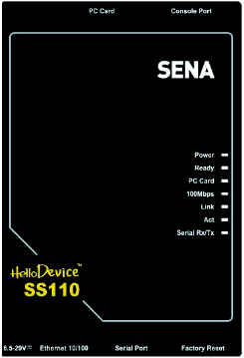
Figure 2-2 The panel layout of the SS110

Table 2-3 LED indicator lamps of the SS 110/400/800

Lamps |  | Function
System | Power | Turned on if power is supplied
System | Ready | Turned on if system is ready to run
System | PC card | Turned on if a PCMCIA device is running
Ethernet | 100Mbps | Turned on if 100Base-TX connection is detected
Ethernet | LINK | Turned on if connected to Ethernet network
Ethernet | Act | Blink whenever there is any activities such as incoming or outgoing packets through the SS Series Ethernet port
Serial port | InUse | Turned on if the serial port is in use (SS400/800 only, Port buffering enabled or port access in use)
Serial port | Rx/Tx | Blink whenever there is any incoming or outgoing data stream through the serial port of the SS Series

SS400 Panel Layout

The SS400 has three groups of LED indicator lamps to display the status, as shown in (i.e. System, Ethernet and Serial ports). The first three lamps on the left side indicatenPower, Ready and PCMCIA interface. The next three lamps are for Ethernes 100Mbps, Link and Act. Next lamps indicateyInUse, Receive andtTransmit of the serial ports. s describes the function of each LED indicator lamp. The rear panel shows the serial ports with RJ45 connector, Ethernet port, the SS400 console port and the power socket.

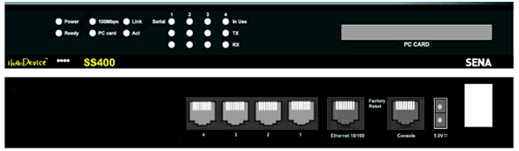
Figure 2-3 The panel layout of the SS400

SS800 Panel Layout

The front panel of the SS800 is nearly identical to the SS400. The SS800 has 8 serial port indicators, while the SS400 has 4. For further information, refer to the chapter, 2.1.3 SS400 Panel Layout.

Connecting the Hardware

This section describes how to connect the SS Series to the equipment for initial testing.
- Connect a power source to the SS Series
- Connect the SS Series to an Ethernet hub or switch
- Connect the device

Connecting the power

Connect the power cable to the SS Series. If the power is properly supplied, the [Power] lamp will light up green(SS 400/800) or red(SS 100/110).
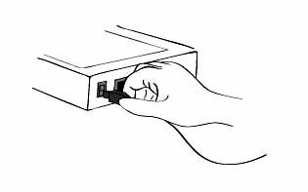
Figure 2-4 Connecting the power to the SS100/110

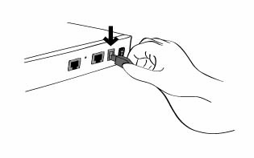
Figure 2-5 Connecting the power to the SS400/800

Connecting to the network

Plug one end of the Ethernet cable to the SS Series Ethernet port. The other end of the Ethernet cable should be connected to a network port. If the cable is properly connected, the SS Series will have a valid connection to the Ethernet network. This will be indicated by:
The [Link] lamp will light up green.
The [Act] lamp will blink to indicate incoming/outgoing Ethernet packets
The [100Mbps] lamp will light up green if the SS Series is connected to 100Base-TX network
The [100Mbps] lamp will not turn on if the current network connection is 10Base-T.
Figure 2-6 Connecting a network cable to the SS100

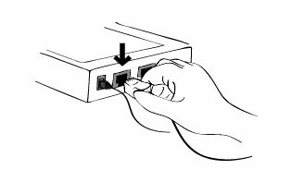
Figure 2-7 Connecting a network cable to the SS110

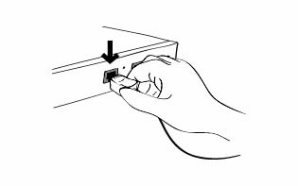
Figure 2-8 Connecting a network cable to the SS400/800

Connecting to the device

Connect the console cable to the SS Series serial port. To connect to the console port of the device, the user needs to consider the type of console port provided by the device itself. In the SS Series cable kit package, plug-in adapters are provided for the easier connectivity to the user’s devices. Please refer to the Appendix 1 Connections for details.

Note:
If the configuration of the SS100 through the serial console is required, connect the serial cable to the serial port of user’s computer first. And push the Data/Console switch to the Console side. Configuration of the SS100 is discussed on Section 2.2.5.

Figure 2-9 Connecting a equipment to the SS100

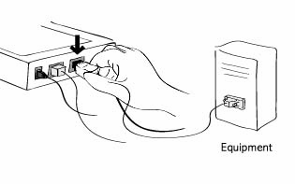
Figure 2-10 Connecting a equipment to the SS110

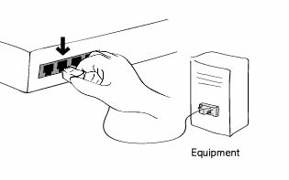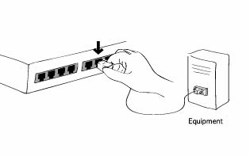
Figure 2-11 Connecting a equipment to the SS400(Left) / SS800(Right)

Accessing the System Console

There are several ways to access the SS Series. These methods are dependent on whether the user is located at a local site or a remote site, or whether s/he requires a menu-driven interface, graphic menu system or CLI (Command Line Interface).

- System console:
Local users can connect directly to the system console port of the SS Series using the console/Ethernet cable with the corresponding adapter.

- Remote console:
Remote users who require a menu-driven interface can utilize Telnet (port 23) connections to the SS Series using terminal emulator.

- Web:
Remote users who want to use a web browser to configure the SS Series can connect to the SS Series using conventional web browsers, such as Internet Explorer or Netscape Navigator.

The above methods require the user authentication by the SS Series system.

Using the System console
- Connect one end of the console/Ethernet cable to the console port on the SS Series.
Figure 2-12 Connecting a system console cable to the SS100

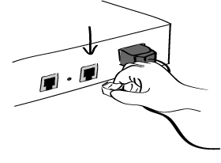
Figure 2-13 Connecting a system console cable to the SS110

Figure 2-14 Connecting a system console cable to the SS400/800

- Connect to the user’s computer with the RJ45-DB9 female adapter.
(For SS100, Push the Data/Console switch to the Console side.)
- Connect the other end of the cable to the serial port of the user’s computer.
- Run a terminal emulator program (i.e. HyperTerminal). Set up the serial configuration parameters of the terminal emulation program as follows:
  - 9600 Baud rate
  - Data bits 8
  - Parity None
  - Stop bits 1
  - No flow control
- Press the [ENTER] key.
- Enter your user name and password to log into the SS Series. The factory default user settings are as follows.
Login: root Password: root
Login: admin Password: admin

192.168.161.5 login: root
Password:****
root@192.168.161.5:~#

- Upon authentication, the CLI are initially provided for configuration. For details on the CLI, refer to the chapter 8 CLI guide.

- “ss.edit” command will allow you to enter the text-menu driven interface and the menu screen in Figure 2-15 is displayed.

root@192.168.161.5:~#ss.edit

------------------------------------------------------------------------------
Welcome to SS-800 configuration page
Current time: 08/22/2003 21:52:36 F/W REV.: v0.4.0
Serial No.: SS800438349-42944 MAC address: 00-01-95-04-19-5a
IP mode: DHCP IP address: 192.168.14.7
------------------------------------------------------------------------------
Select menu:
1. Network configuration
2. Serial port configuration
3. PC Card configuration
4. System administration
5. Save changes
6. Exit without saving
7. Exit and apply changes
8. Exit and reboot
<Enter> Refresh
----->
Figure 2-15 The main menu screen (SS800)

From the main menu screen, the user may select the menu item for the configuration of the SS Series parameters by typing the menu number and pressing the [ENTER] key. In the submenu screen, users can configure the required parameters guided by online comments. All the parameters are stored into the non-volatile memory space of the SS Series, and it will not be stored until users select menu ”5.Save changes”. All the configuration change will be effective after selecting the menu “7. Exit and apply changes” or “8. Exit and reboot”.

Using Remote console

The IP address of the SS Series must be known before users can access the SS Series using the Remote console (see chapter 3 Network Configuration for details). The default IP address of SS Series is 192.168.161.5.
The Remote console access function can be disabled in the remote host access option (3.5 IP Filtering for details).
The following instructions will assist in setting up the Remote Console functionality:

- Run either a Telnet program or a program that supports Telnet functions (i.e. TeraTerm-Pro or HyperTerminal). The target IP address and the port number must match the SS Series. If required, specify the port number as 23. Type the following command in the command line interface of user’s computer.
telnet 192.168.161.5
Or run a Telnet program with the following parameters:

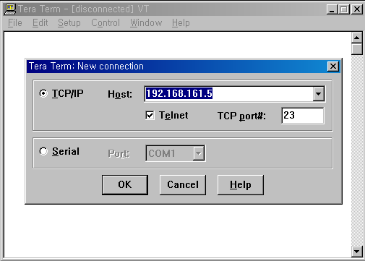
Figure 2-16 Telnet program set up example (TeraTerm Pro)

- The user must log into the SS Series. Type the user name and password. A factory default setting of the user name and password are both root for the system root and admin for the system administrator.
- Upon authentication by the SS Series, the CLI prompts or text menu screens are shown.

Accessing the Web Browser Management Interface

The SS Series supports both HTTP and HTTPS (HTTP over SSL) protocols. The SS Series also provides has its own Web management pages. To access the SS Series Web management page, enter the IP address or resolvable hostname of the SS Series into the web browser’s URL/Location field. This will direct the user to the SS Series login screen. The user must authenticate themselves by logging into they system with a correct user name and password. The factory default settings are:
Login: root Password: root
Login: admin Password: admin

Note: Before accessing the SS Series Web management page, the user must check the IP address (or resolvable Hostname) of the SS Series and Subnet mask settings.
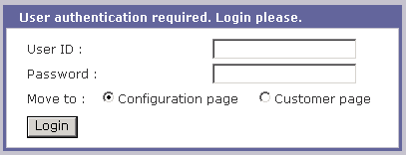
Figure 2-17 Login screen of the SS Series web management

Figure 2-17 shows Login screen of the SS Series web management. On this screen, user can select initial page where he want to move to after login. If user selects Configuration page, he can see the configuration homepage of the SS Series Web management interface shown Figure 2-18. If user select Customer page, he can see the default Customer homepage of the SS Series Web management interface or his own homepage. For more detail information about user customization of Web UI, please refer to 9. User customization guide section.
Figure 2-18 shows the configuration homepage of the SS Series Web management interfacn. A menu bar is provided on the left side of the screen. The menu bar include the uppermost configuration menu groups.sSelectingran item on the menu bar opens a tree view of all the submenus available under each grouping. Selecting a su menu item will allow the usesnto modify parameter settings for that item. Every page will allow the user to [Save to flash], [Save & apply] or [Cancel]stheir actions. After changing the configuration parameter values, the users must select [Save to flash] to save the changed parameter values to the non-volatile memory. To apply all changes made, the user must select [Apply Changes]. This option is available on the bottom of the menu bar. Only when the user selects [Apply changes] will the new parameter values be applied to the SS Series configuration. The user also can select [Save & apply] to save parameters and apply changes in one step.
If the user does not want to save the new parameter values, the user must opt to [Cancel]. All changes made will be lost and the previous values restored.

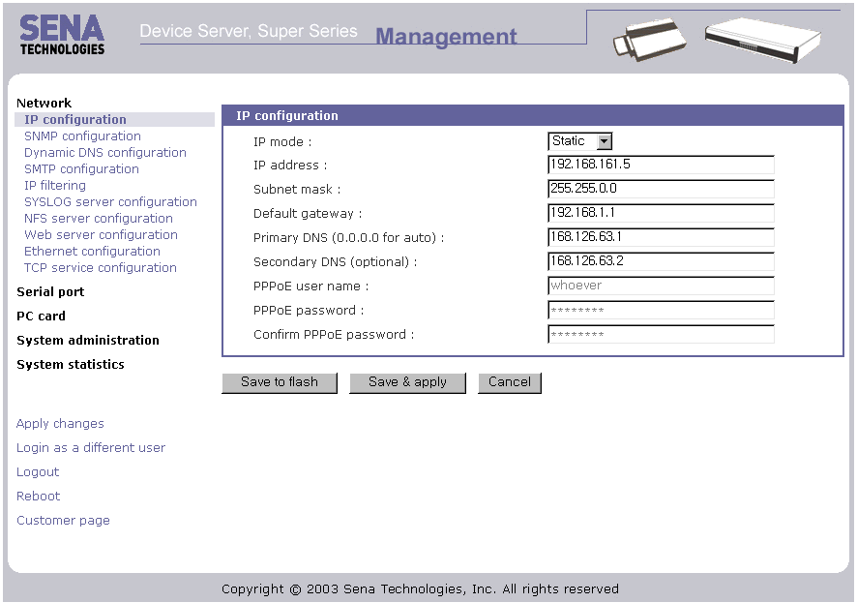
Figure 2-18 The SS Series web management screen

Network Configuration

IP Configuration

The SS Series requires a valid IP address to operate within the user’s network environment. If the IP address is not readily available, contact the system administrator to obtain a valid IP address for the SS Series. Please note that the SS Series requires a unique IP address to connect to the user’s network.
The users may choose one of three Internet protocols in setting up the SS Series IP address: i.e.,
- Static IP
- DHCP (Dynamic Host Configuration Protocol)
- PPPoE (Point-to-Point Protocol over Ethernet)
The SS Series is initially defaulted to STATIC mode, with a static IP address of 192.168.161.5. Table 3-4 shows the configuration parameters for all three IPnconfigurations. Figure 3-19 shows the actual web-based GUI to change the user’s IP configuratice.

Table 3-4 IP configuration Parameters
Static IP | IP address
Static IP | Subnet mask
Static IP | Default gateway
Static IP | Primary DNS/ Secondary DNS
DHCP | Primary DNS/ Secondary DNS (Optional)
PPPoE | PPPoE Username
PPPoE | PPPoE Password
PPPoE | Primary DNS/ Secondary DNS (Optional)

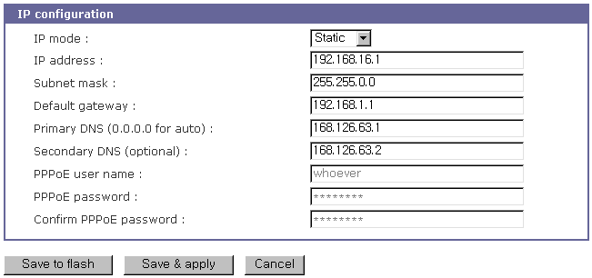
Figure 3-19 IP Configuration

Using a Static IP Address

When using a Static IP address, the user must manually specify all the configuration parameters associated with the IP address of the SS Series. These include the IP address, the network subnet mask, the gateway computer and the domain name server computers. This section will look at each of these in more detail.

Note: The SS Series will attempt to locate all this information every time it is turned on. .

- IP address
A Static IP address acts as a “static” or permanent identification number. This number is assigned to a computer to act as its location address on the network. Computers use these IP addresses to identify and talk to each other on a network. Therefore, it is imperative that the selected IP address be both unique and valid in a network environment.

Note: 192.168.1.x will never be assigned by and ISP (Internet Service Provider). IP addresses using this form are considered private. Actual applications of the SS Series may require access to public network, such as the Internet. If so, a valid public IP address must be assigned to the user’s computer. A public IP address is usually purchased or leased from a local ISP.

- Subnet mask
A subnet represents all the network hosts in one geographic location, such as a building or local area network (LAN). The SS Series will use the subnet mask setting to verify the origin of all packets. If the desired TCP/IP host specified in the packet is in the same geographic location (on the local network segment) as defined by the subnet mask, the SS Series will establish a direct connection. If the desired TCP/IP host specified in the packet is not identified as belonging on the local network segment, a connection is established through the given default gateway.

- Default gateway
A gateway is a network point that acts as a portal to another network. This point is usually the computer or computers that control traffic within a network or a local ISP (Internet service provider). The SS Series uses the IP address of the default gateway computer to communicate with hosts outside the local network environment. Refer to the network administrator for a valid gateway IP address.

- Primary and Secondary DNS
The DNS (Domain Name System) server is used to locate and translate the correct IP address for a requested web site address. A domain name is the web address (i.e. www.yahoo.com) and is usually easier to remember. The DNS server is the host that can translate such text-based domain names into the numeric IP addresses for a TCP/IP connection.
The IP address of the DNS server must be able to access the host site with the provided domain name. The SS Series provides the ability to configure the required IP addresses of both the Primary and Secondary DNS servers addresses. (The secondary DNS server is specified for use when the primary DNS server is unavailable.)

Using DHCP

Dynamic Host Configuration Protocol (DHCP) is a communications protocol that lets network administrators manage and automate the assignment of IP addresses centrally in an organization's network. DHCP allows the network administrator the ability to supervise and distribute IP addresses from a central point and automatically send a new IP address when a computer is plugged into a different network location.
When in static IP mode, the IP address must be entered manually at each computer. If a computer is moved to another network location, a new IP address must be assigned. DHCP allows all the parameters, including the IP address, subnet mask, gateway and DNS servers to be automatically configured when the IP address is assigned. DHCP uses a “lease” concept in assigning IP addresses to a computer. It limits the amount of time a given IP address will be valid for a computer. All the parameters required to assign an IP address are automatically configured on the DHCP server side, and each DHCP client computer receives this information when the IP address is provided at its boot-up.
Each time a computer is reset, the SS Series broadcasts a DHCP request over the network. The reply generated by the DHCP server contains the IP address, as well as the subnet mask, gateway address, DNS servers and the “lease” time. The SS Series immediately places this information in its memory. Once the “lease” expires, the SS Series will request a renewal of the “lease” time from the DHCP server. If the DHCP server approves the request for renewal, the SS Series can continue to work with the current IP address. If the DHCP server denies the request for renewal, the SS Series will start the procedure to request a new IP address from the DHCP server.

Note: While in DHCP mode, all network-related parameters for the SS Series are to be configured automatically, including the DNS servers. If the DNS server is not automatically configured, the user may manually configure the settings by entering the primary and secondary DNS IP addresses. To force an automatic configuration of the DNS address, set the primary and secondary DNS IP addresses to 0.0.0.0 (recommended).

A DHCP sever assigns IP addresses dynamically from an IP address pool, which is managed by the network administrator. This means that the DHCP client, i.e. the SS Series, receives a different IP address each time it boots up. The IP address should be reserved on the DHCP server side to assure that the user always knows the newly assigned SS Series address. In order to reserve the IP address in the DHCP network, the administrator needs the MAC address of the SS Series found on the label sticker at the bottom of the SS Series.

Using PPPoE

PPPoE (Point-to-Point Protocol over Ethernet) is a specification for connecting multiple computer users on an Ethernet LAN (local area network) to a remote site through a modem or similar device. PPPoE can be used to multiple users the ability to share ADSL, cable modem, or wireless connection to the Internet.
To use the SS Series in PPPoE mode, users require a PPPoE account and the necessary equipment for PPPoE access (i.e. an ADSL modem). Since the SS Series provides a PPPoE protocol, it can access the remote host on the Internet over an ADSL connection. The user will have to set up the user name and password of the PPPoE account for the SS Series.
The SS Series negotiates the PPPoE connection with the PPPoE server whenever it boots up. During the negotiation, the SS Series receives the information required for an Internet connection, such as the IP address, gateway, subnet mask and DNS servers. If the connection is established, the SS Series will maintain the connection for as long as possible. If the connection is terminated, the SS Series will attempt to make a new PPPoE connection by requesting a new connection.

Note: While in PPPoE mode, all network-related parameters for the SS Series are to be configured automatically, including the DNS servers. If the DNS server is not automatically configured, the user may manually configure the settings by entering the primary and secondary DNS IP addresses. To force an automatic configuration of the DNS address, set the primary and secondary DNS IP addresses to 0.0.0.0 (recommended).

SNMP Configurations

The SS Series has the SNMP (Simple Network Management Protocol) agent supporting SNMP v1 and v2 protocols. Network managers like NMS or SNMP Browser can exchange information with SS Series, as well as access required functionality.
SNMP protocols include GET, SET, GET–Next, and TRAPs. With these functions, a manager can be notified of significant events (TRAPs), query a device for more information (GET), and make changes to the device state (SET). SNMPv2 adds a GET–Bulk function for retrieving tables of information and security functions.
With the SNMP configuration panel, the user can configure MIB-II System objects, access control settings and TRAP receiver settings. The manager configured in this menu can perform both information exchange and action control. Figure 3-20 shows a SNMP configuration screen via a web interface.

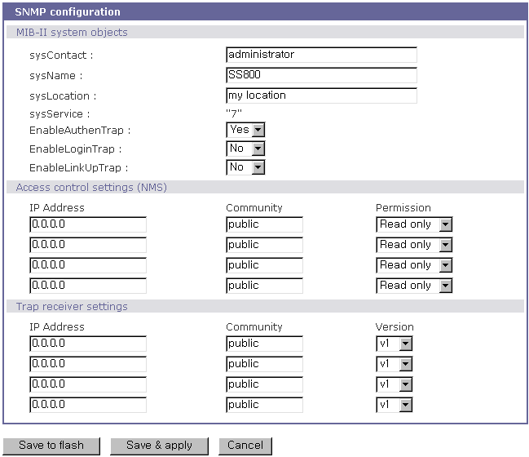
Figure 3-20 SNMP Configuration

MIB-II System objects Configuration

MIB–II System objects configuration sets the System Contact, Name, Location, and Authentication-failure traps used by the SNMP agent of the SS Series. These settings provide the values used for the MIB-II sysName, sysContact, sysLocation, sysService and enableAuthenTrap.

Brief descriptions of each object are as follows,

- sysContact: Identification of the contact person for the managed system (SS Series), and a description of how to contact the person.
- sysName: Name used to identify the system. By convention, this is the fully qualified domain name of the node.
- sysLocation: The physical location of the system (e.g., Room 384, Operations Lab, etc.).
- sysService(Read Only) : A series of values, separated by commas, that indicate the set of services that the system provides. By default, SS Series only supports an Application(7) service level.
- EnableAuthenTrap: Indicates whether the SNMP agent process is permitted to generate authentication-failure traps. The value of this object overrides any configuration information; as such, it provides a means whereby all authentication-failure traps may be disabled..
- EnableLinkUpTraps: Indicates whether the SNMP agent process is permitted to generate Ethernet-link traps
- EnableLoginTrap: Indicates whether the SNMP agent process is permitted to generate system login traps.

If users need support for adding or modifying MIBs, please contact Sena technical support.
For more information about the MIBs and SNMP, see the RFCs 1066, 1067, 1098, 1317, 1318 and 1213.

Access Control Configuration

Access Control defines accessibility of managers to the SS Series SNMP agent. Only the manager set in this menu can access SS Series SNMP agent to exchange information and control actions. If there is no specified IP address (all IP address are defaulted to 0.0.0.0), a manager from any host can access the SS Series SNMP agent.

Trap Receiver Configuration

The Trap receiver defines managers, which can be notified of significant events(TRAP) from the SS Series SNMP agent.

Management using SNMP

The SS Series can be managed through the SNMP protocol using NMS (Network Management System) or SNMP Browser. Before using the NMS or SNMP Browser, the user must set the access control configuration properly so that the SS Series permits host access where the NMS or SNMP Browser is executed. Figure 3-21 shows a screen shot of a typical SNMP browser with MIB-II OIDs of the SS Series SNMP agent.
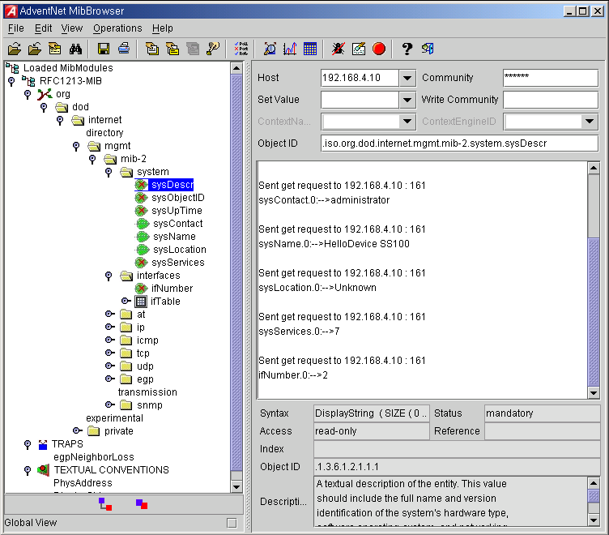
Figure 3-21 Browsing MIB-II OIDs of SS Series SNMP agent using SNMP Browser
(AdventNet MibBrowser)

Dynamic DNS Configuration

When users connect the SS Series to a DSL line or use a DHCP configuration, the IP address might be changed whenever it reconnects to the network. It can therefore be very difficult to post all related contacts for each new IP address. In addition, if the administrator only has access through the remote console, there is no way to know if an IP address has changed, or what the new IP address is.
A Dynamic DNS service is provided by various ISPs or organizations to deal with the above issue. By using the Dynamic DNS service, users can access the SS Series through the hostname registered in the Dynamic DNS Server regardless of any IP address change.
By default, the SS Series only supports Dynamic DNS service offered at Dynamic DNS Network Services, LLC (www.dyndns.org). Contact Sena technical support for issues regarding other Dynamic DNS service providers.
To use the Dynamic DNS service provided by Dynamic DNS Network Services, the user must set up an account in their Members' NIC (Network Information Center - http://members.dyndns. org). The user may then add a new Dynamic DNS Host link after logging in to their Dynamic DNS Network Services Members NIC.
After enabling the Dynamic DNS service in the Dynamic DNS Configuration menu, the user must enter the registered Domain Name, User Name, and Password. After applying the configuration change, users can access the SS Series using only the Domain Name.
Figure 3-22 shows the Dynamic DNS configuration web interface.

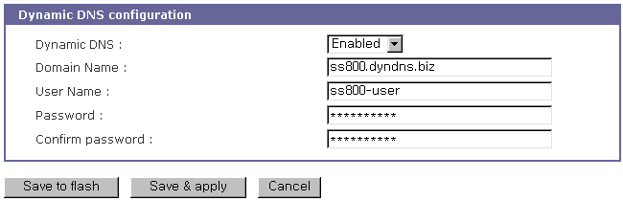
Figure 3-22 Dynamic DNS Configuration

SMTP Configuration

The SS Series can send an email notification when the number of system log messages reaches to certain value and/or when an alarm message is created due to an issue with serial port data. The user must configure a valid SMTP server send these automatically generated emails. The SS Series supports three SMTP server types:
- SMTP without authentication
- SMTP with authentication
- POP-before-SMTP

These examples can be seen in Figure 3-24. Required parameters for each SMTP configuration include:
- SMTP server IP address
- SMTP user name
- SMTP user password
- Device mail address

The device mail address specifies the sender’s email address for all log and alarm delivery emails. SMTP servers often check only the sender’s host domain name of the email address for validity. Consequently, the email address set for the device can use an arbitrary username with a registered hostname (i.e. arbitrary_user@yahoo.com or anybody@sena.com).
The SMTP user name and SMTP user password are required when either SMTP with authentication or POP-before-SMTP mode is selected.

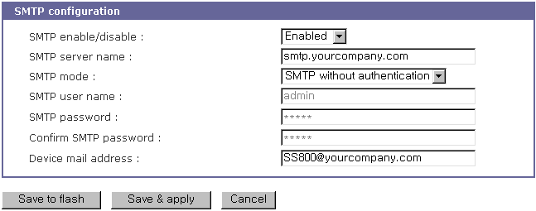
Figure 3-23 SMTP Configurations

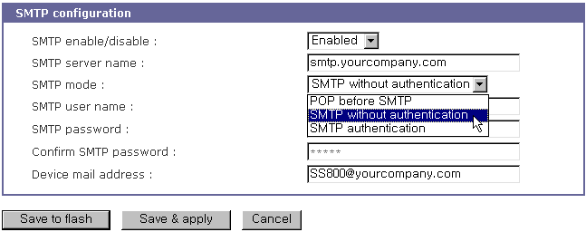
Figure 3-24 SMTP mode selection in SMTP configuration

IP Filtering

The SS Series prevents unauthorized access using either an IP address based filtering method or through the management web page of the SS Series. The users can allow one of the following scenarios by changing the parameter settings:
- Only one host of a specific IP address can access the SS Series
- Hosts on a specific subnet can access the SS Series
- Any host can access the SS Series

The IP filtering feature for access to Telnet console, SSH console or Web server may be enabled or disabled. The factory default of the filtering feature is “Enabled”.
The user may allow a host or a group of hosts to access the SS Series for configuration. The user must then enter the IP address and subnet of access. Any user on a remote host must stay in the specified subnet boundary to have the configuration access.
To allow only a specific host to have configuration access to the SS Series, enter the IP address of the specific host and just give 255.255.255.255 for the subnet
To allow any hosts to have access to the SS Series, give 0.0.0.0 for both of the IP address and subnet. Refer to Table 3-5 for more details. The device’s default settings for allowed remote hosts for configuration is “Any”.

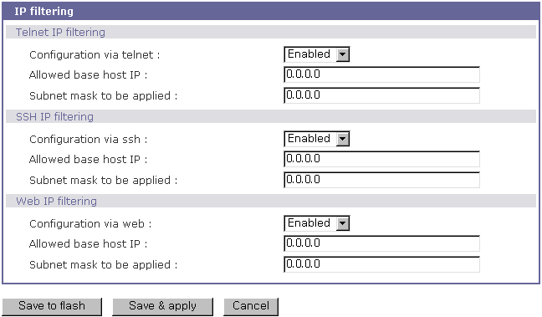
Figure 3-25 IP filtering Configuration

Table 3-5 Input examples of allowed remote hosts
Allowable Hosts | Input format
Allowable Hosts | Base Host IP address | Subnet mask
Any host | 0.0.0.0 | 0.0.0.0
192.168.1.120 | 192.168.1.120 | 255.255.255.255
192.168.1.1 ~ 192.168.1.254 | 192.168.1.0 | 255.255.255.0
192.168.0.1 ~ 192.168.255.254 | 192.168.0.0 | 255.255.0.0
192.168.1.1 ~ 192.168.1.126 | 192.168.1.0 | 255.255.255.128
192.168.1.129 ~ 192.168.1.254 | 192.168.1.128 | 255.255.255.128

Web access also uses the IP filtering function, which can be enabled or disabled. The factory default setting is “Enabled”. When enabled, the user can specify a web host or hosts allowed to access the SS Series for configuration.

SYSLOG server configuration

The SS Series supports a remote message logging service, SYSLOG service for the system and port data logging. To use the remote SYSLOG service, the user must specify the SYSLOG server’s IP address and the facility to be used. Figure 3-26 shows the SYSLOG server configuration page of the supplied Web interface.

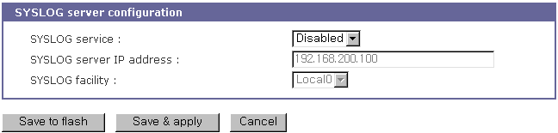
Figure 3-26 SYSLOG server configuration

To receive log messages from the SS Series, the SYSLOG server must be configured as “remote reception allowed”. If there is a firewall between the SS Series and the SYSLOG server, there must be a rule that allows all outgoing and incoming UDP packets to travel across the firewall.
The SS Series supports SYSLOG facilities from local0 to local7. The user can employ these facilities to save messages from the SS Series separately in the SYSLOG server.
If the SYSLOG service is enabled and the SYSLOG server configuration is properly set up, the user may configure the storage location for the system log or port data log of the SS Series as SYSLOG server. For more information about the configuration of port/system log storage location, please refer to section, 4.2.11 Port Logging and 6.2 System Logging.

NFS server configuration

The SS Series supports NFS (Network File System) service for system or port data logging functions. To use this service, the user must specify the IP address of a NFS server and the mounting path on the NFS server. Figure 3-27 shows the web based NFS server configuration page.

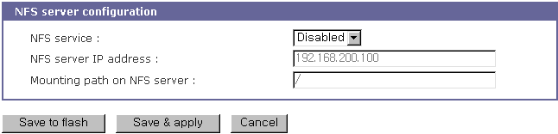
Figure 3-27 NFS server configuration

To store the SS Series log data to the NFS server, the NFS server must be configured as “read and write allowed”. If there is a firewall between the SS Series and the NFS server, there must be a rule that allows all outgoing and incoming packets to travel across the firewall.
If the NFS service is enabled and the NFS server configuration is properly set up, the user may configure the storage location for the system log or port data log of the If there is a firewall between the SS Series and the SYSLOG server, there must be a rule that allows all outgoing and incoming UDP packets to travel across the SS Series as the NFS server. For more information about the configuration of the port/system log storage location, please refer to section, 4.2.11 Port Logging and 6.2 System Logging.

Ethernet configuration

The SS Series supports several types of Ethernet modes:
- Auto Negotiation
- 100 BaseT Half Duplex
- 100 BaseT Full Duplex
- 10 BaseT Half Duplex
- 10 BaseT Full Duplex

After changing the Ethernet mode, the user must reboot the system. The factory default value of the Ethernet mode is Auto Negotiation. With most network environments, Auto Negotiation mode works fine and is recommended. Invalid Ethernet mode configuration may make the SS Series not work in the network environment.

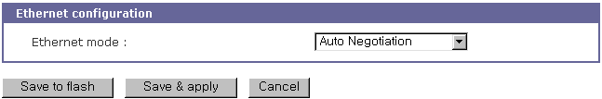
Figure 3-28 Ethernet mode configuration

Web server configuration

The Web server supports both HTTP and HTTPS (HTTP over SSL) services simultaneously. The user can opt to enable or disable each individually. Figure 3-29 shows the Web server configuration page.

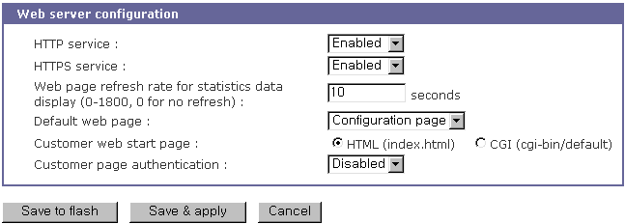
Figure 3-29 Web server configurations

The Web page refresh rate can be also adjusted in this configuration page. The refresh rate is only applicable to the system statistics pages, such as network interfaces, serial ports, IP, ICMP, TCP and UDP. Other pages in the Web interface are not refreshed automatically. For more information about the system statistics, please refer to section 7 System Statistics.

On this configuration menu page, users can select default web page that will pop up after user logs in to the Web UI. Factory default is Configuration page and user can changes this to Customer page. After selecting Default web page as Customer page, user can set Customer web start page as one of HTML(index.html) or CGI(default) which are located under /usr2 directory. User can change or modify these files for his own purpose. For anonymous access to the customer page without user ID and password, disable the customer page authentication feature. For more information about customizing user web page, please refer to 9.3 User defined web pages section.

TCP service configuration

If a TCP session is established between two hosts, it should be closed (normally or abnormally) by either of the hosts to prevent the lock-up of the corresponding TCP port. To prevent this type of lock-up situation, the SS Series provides a TCP “keep-alive” feature. The SS Series will send packets back and forth through the network periodically to confirm that the network is still alive. The corresponding TCP session is closed automatically if there’s no response from the remote host.
To use the TCP “keep-alive” feature with the SS Series, the users should configure three parameters as follows:

- TCP keep-alive time:
This represents the time interval between the last data transmission and keep-alive packet submissions by the SS Series. These “keep-alive” messages are sent to the remote host to confirm that the session is still open. The default time value is 15 sec.
- TCP “keep-alive” probes:
This represents how many “keep-alive” probes will be sent to the remote host, until it decides that the connection is dead. Multiplied with the “TCP ‘keep-alive’ intervals”, this gives the time that a link is forced to close after a “keep-alive” packet has been sent for the first time. The default is 3 times
- TCP keep-alive intervals:
- This represents the waiting period until a “keep-alive” packet is retransmitted due to no acknowledgement by the original Chinatown.
- The default value is 5 seconds.

By default, the SS Series will send the keep-alive packets 3 times with 5 seconds interval after 15 seconds have elapsed since the time when there’s no data transmitted back and forth.

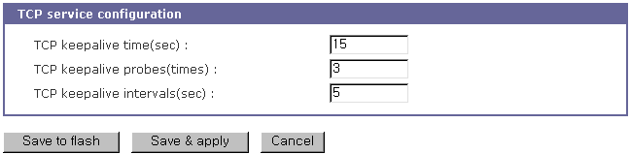
Figure 3-30 TCP keep-alive configuration

Serial Port Configuration

Overview

The serial port configuration capability allows the user to configure the host mode of each port, serial communication parameters, cryptography, port logging parameters and other related parameters.

The serial port’s host mode can be set as any of the following:

- TCP :
The SS Series operates as a TCP server and client. If the connection is not established, it accepts all incoming connections from any registered remote hosts and connects to the registered remote hosts if there is any data from the serial devices. Otherwise, it will send data back and forth. In summary, the SS Series will work as if it is virtually connected to the remote host.
- UDP :
The UDP mode operation is similar to that of TCP mode except that it is based on UDP protocol.
- Modem emulation :
Select this mode when the serial device already supports modem AT commands or users want to perform the session control by using AT commands. Only TCP session is supported.
- Virtual COM :
This feature will be added later.

With the port-logging feature while in console server mode, the data sent through the serial port is transferred to MEMORY, SYSLOG server, NFS server’s storage or an ATA/IDE fixed disk card using a PC Card slot. The user can also define keywords for each serial port that will trigger an email or SNMP trap notification. This will enable the user to monitor the data from the attached device.
Using MEMORY to store data will result in loss of all information when the SS Series is turned off. Use the NFS server or ATA/IDE fixed disk card to preserve the serial port log data.
The serial ports can be configured individually or all at once. Table 4-6 summarizes the configuration parameters related to the serial port configuration.

Table 4-6 Serial port configuration parameters
All serial ports setting  Or  Individual serial port setting  #1~#8(1/4) | Port Enable/Disable
 | Port title
 | Apply all port settings (Individual serial port setting only)
 | Host mode | TCP | TCP listening port
 | Host mode | TCP | Max allowed connection
 | Host mode | TCP | Cyclic connection
 | Host mode | TCP | Inactivity timeout (0 for unlimited)
 | Host mode | UDP | UDP listening port
 | Host mode | UDP | Max allowed connection
 | Host mode | UDP | Accept UDP datagram from unlisted remote host or not
 | Host mode | UDP | Send to recent unlisted remote host or not
 | Host mode | UDP | Inactivity timeout (0 for unlimited)
 | Host mode | Modem emulation
 | Remote host | Add or Edit a remote host  Primary host address  Primary host port  Secondary host address  Secondary host port
 | Remote host | Remove a remote host
 | Port IP filtering | Allowed host IP
 | Port IP filtering | Subnet mask to be applied
 | Cryptography | Encryption method  None/SSLv2/SSLv3/SSLv3 rollback to v2/ TLSv1/3DES/RC4
 | Cryptography | Cipher suite selection
 | Cryptography | Verify client (server mode only)
 | Cryptography | Verify certificate chain depth
 | Cryptography | Check the certificate CN
 | Filter application | Filter application path
 | Filter application | Filter application arguments
 | Serial Port Parameters | Type
 | Serial Port Parameters | Baud rate
 | Serial Port Parameters | Data bits
 | Serial Port Parameters | Parity
 | Serial Port Parameters | Stop bits
 | Serial Port Parameters | Flow control
 | Serial Port Parameters | DTR behavior
 | Serial Port Parameters | DSR behavior
 | Serial Port Parameters | Inter-character timeout (ms)
 | Modem | Enable/Disable modem
 | Modem | Modem init-string
 | Modem | DCD behavior
 | Port logging | Enable/Disable Port logging
 | Port logging | Port log storage location
 | Port logging | Port log buffer size
 | Port logging | Display port log
 | Port event handling | Enable/Disable port event handling
 | Port event handling | Notification interval
 | Port event handling | Email notification | Enable/Disable Email notification
 | Port event handling | Email notification | Title of Email
 | Port event handling | Email notification | Recipient’s Email address
 | Port event handling | SNMP notification | Enable/Disable SNMP notification
 | Port event handling | SNMP notification | Title of SNMP trap
 | Port event handling | SNMP notification | SNMP trap receiver’s IP address
 | Port event handling | SNMP notification | SNMP trap community
 | Port event handling | SNMP notification | SNMP trap version
 | Port event handling | Add/Edit a keyword  Keyword string  Email notification  SNMP trap notification  Port command
 | Port event handling | Remove a keyword

Figure 4-31 shows the web-based serial port configuration screee.
To select and configure a serial port individually, click the port number or title. To configure all of the serial ports at once, click [All] or [Port Title], located below the [All port configuration] label.

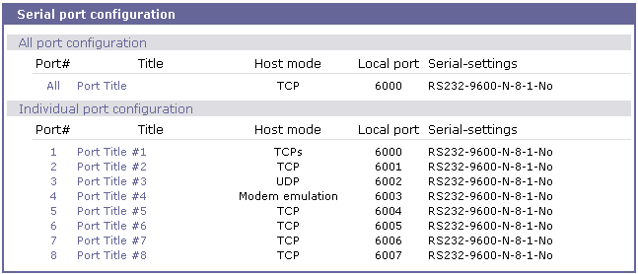
Figure 4-31 Serial port configuration main screen

Individual Port Configuration

The SS Series allows serial ports to be configured either individually or all at once. The parameters for both individual and all port configurations are similar.
Individual Port Configurations are classified into nine (9) groups:
- Port enable/disable
- Port title
- Apply all port settings
- Host mode
- Remote host: Available only when the host mode is set to TCP or UDP mode
- Port IP filtering: Available only when the host mode is set to TCP or UDP mode
- Cryptography: Available only when the host mode is set to TCP mode and Modem Emulation mode
- Filter application
- Serial port parameters
- Modem configuration
- Port logging
- Port event handling: Available only when the port-logging feature of the port is enabled
Users can switch to another serial port configuration screen conveniently using the [--- Move to ---] list box at the right upper side of the individual port configuration screen.

Port Enable/Disable

Each serial port can be enabled or disabled. If a serial port is disabled, users cannot access the serial port. Figure 4-32 shows the serial port enable/disable screen.
By clicking on the [Reset] button, users can reset a stuck or deadlocked serial port. Click on the [Set] button to set the port as factory default.

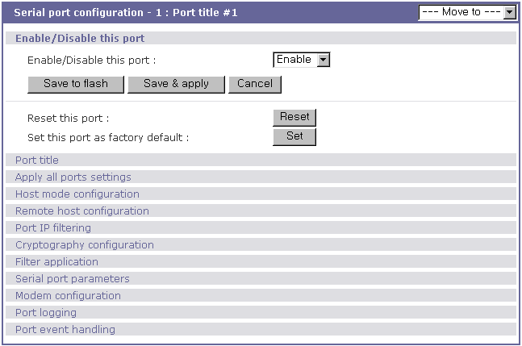
Figure 4-32 Serial port enable/disable

Port Title

Users can enter descriptive information for each port based on the device attached to it. This can include the device type, vendor, and/or location. The port title is helpful in the configuration process,

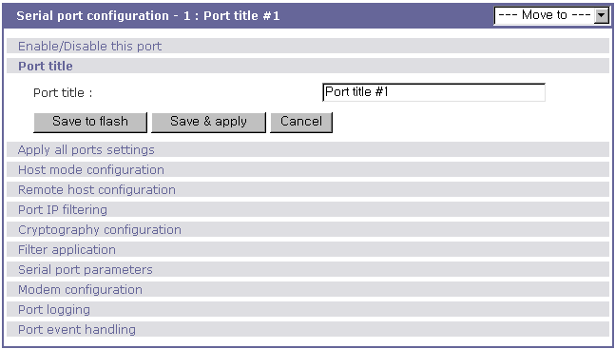
Figure 4-33 Port title configuration

Apply All Port Settings

To prevent the possibility of the user inadvertently selecting to change all port settings at the same time, the SS Series provides the ability to enable or disable this function at an individual serial port level. Changes made when using the “change all port parameters at once” function will not be applied to an individual serial port if the function has been disabled (See Figure 4-34. This shows the [apply all port setting] configuration screen.

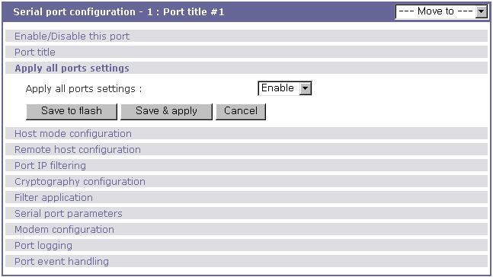
Figure 4-34 Apply all port setting configuration.

Host Mode Configuration

The SS Series operating mode is called the “host mode.” Three host modes are available: TCP mode, UDP mode, Modem emulation mode.

TCP mode
The SS Series works as both TCP server and client. This mode works for most applications, since it will transfer the data either from serial port or from TCP port. If there is no connection established on a TCP port, the TCP port accepts a connection request from any registered remote hosts and relays the transmitted data to the coupled serial port. If there is any data from the serial port, it connects to the registered remote hosts and redirects the data.

UDP mode
The UDP mode operation is similar to that of TCP mode except that it utilizes UDP protocol

Modem emulation mode
Select this mode when the serial device already supports modem AT commands or users want to perform the session control by using AT commands. Only TCP session is supported.

Figure 4-35 shows the main workspace screen for the host mode configuration.
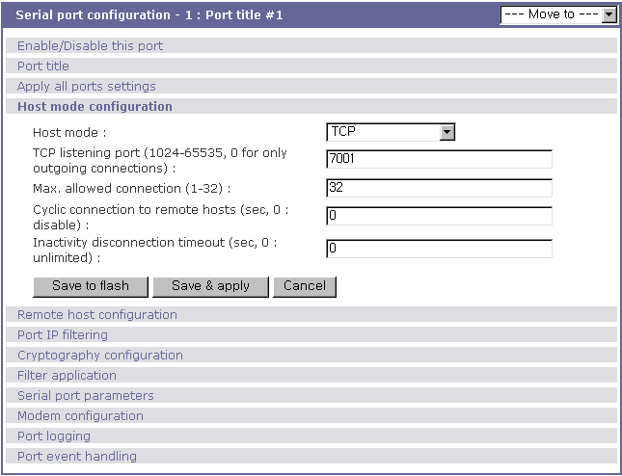
Figure 4-35 Host mode configuration

TCP mode

For easier understanding of TCP modes, a simplified State Transition Diagram is often used. And to help users understand the diagram, the TCP state of the SS Series is briefly described as follows.

- [Listen]
It represents “a waiting for a connection request from any registered remote host”. It is a default start-up mode when it is set as TCP mode.
- [Closed]
It means “no connection state”. If the data transfer between a remote host and the SS Series is completed, the state is changed to this state as a result that either of the remote host or the SS Series sent a disconnection request. After this, the state is automatically changed to [Listen] mode.
- [Sync-Received]
The state is changed from [Listen] to [Sync-Received] if one of the remote hosts has sent a connection request. If the SS Series accepts the request, the state is changed into [Established].
- [Sync-Sent]
If the SS Series has sent a connection request to a remote host, the state is changed from [Closed] to [Sync-Sent]. This state is maintained until the remote host accepts the connection request.
- [Established]
It represents “an open connection”. If one of the hosts, the remote host or the SS Series, accepts a connection request from the other, the connection is opened and state is changed into [Established].
- [Data]
When it is in [Established] state, data from a host will be transferred to the other one. For easier understanding of the TCP session operation, we called the state as [Data] state when actual data transfer is performed. Actually, the [Data] mode is a part of [Established] state as is described in the RFC 793 [Transmission Control Protocol]. This is a normal state for the data transfer phase of the connection.
The SS Series works as either TCP server or client according to the situation. This will be the typical mode for most applications, since it will transfer the data either from serial port or from TCP port. The default TCP state is [Listen] which is the same as that of TCP server mode.

1) Typical State Transition

[Listen] --> [Sync-Received] --> [Established] --> [Data] --> [Closed] --> [Listen]
Or
[Listen] --> [Sync-Sent] --> [Established] --> [Data] --> [Closed] --> [Listen]

The initial state is [Listen]. If there are data coming from the serial port, it will connect to the remote host as a TCP client and then transfer data through the TCP port. If there is incoming connection request from the remote host, it will accept the connection as a TCP server, and then transfer data through the serial port. Thus, users can assume that the SS Series is always connected to the specified remote host.

2) Operations
Serial data transfer
Whenever the serial device sends data through the serial port of the SS Series, data will be accumulated on the serial port buffer of the SS Series. If the buffer is full or the time gap reaches the inter-character timeout (See Options in section 4.4 for details on inter-character timeout), the SS Series connect to the registered remote host(s). If a TCP session has not been established yet. If the SS Series succeeds in connecting to the remote host, the data in the serial port buffer will be transferred to the host. Otherwise, all the data stored in the buffer will be cleared.
Session disconnection
The connected session will be disconnected when the remote host sends disconnection request or when no data transfer activity is found through the serial port for certain amount of time, which is “Inactivity timeout” (See Options in section 4.4 for details on Inactivity timeout). All the data remained in the serial port buffer will be cleared when it is disconnected.
Connection request from remote host
All the incoming TCP connection requests will be rejected in TCP client mode.

3) Parameters
TCP listening port
This is the TCP port number through which remote host can connect a TCP session, and, send and receive data. Incoming connection request to the ports other than TCP Listening Port will be rejected. The SS Series does restrict the port number from 1024 to 65535 and if it is set as 0 only outgoing connection is permitted. (TCP server mode)

Max. allowed connection
The SS Series supports multiple connections from external host(s) to a serial port up to 32. But if there are remote host connections by the remote host list configuration already, possible number of connection is reduced to (Max. allowed connection - remote host(s) connected already). For example, if user set Max. allowed connection as 32 and if there are 3 connections from SS Series to remote hosts, which are configured in the remote host list, then maximum number of connection from external hosts to a serial port will be reduced to 29 (=32 – 3). For more detail information for remote host list configuration, please refer to 4.2.5 remote host list configuration section.

Cyclic Connection
If Cyclic Connection function is enabled, the SS Series will make an attempt to connect to the user-defined remote host(s) at a given interval even if there’s no incoming serial data from the device connected to that serial port. If there is data on the remote host(s) to be sent to serial device, it can be transferred to the serial device via SS Series’s serial port after the connection is established. Eventually, users can monitor the serial device periodically by making the remote host send the serial command to the SS Series whenever it is connected to the remote host. This option is useful when users need to gather the device information periodically even if the serial device does not send its data periodically. Figure 4-6 shows the State Transition Diagram of the session operations in TCP mode.

Figure 4-36 State Transition Diagram of TCP mode

Inactivity Timeout
When Inactivity Timeout function is enabled, connection between remote host(s) and SS Series will be closed automatically if there is no data transmission during the value which is set in Inactivity Timeout configuration.

UDP mode

The UDP mode operation is similar to that of TCP mode except that it is based on UDP protocol and only one pre-defined remote host is able to communicate with the SS Series. Users do not have to configure cyclic connection, since UDP is a connectionless protocol.

1) Operations
If a remote host sends a UDP datagram to the one of UDP Local port of the SS Series, SS Series first checks whether it is from one of the hosts configured on remote host configuration. If the remote host is one of the hosts configured on remote host configuration, then SS Series transfers the data through the serial port. Otherwise, the SS Series discards the incoming UDP datagram. But user can force SS Series accept all incoming UDP datagram regardless remote host configuration by setting Accept UDP datagram from unlisted remote host parameter as ‘Yes’. If there is any incoming data from the serial port, the SS Series transfers the data to the remote host defined on remote host configuration. If the remote port is not opened, the SS Series will not transfer the data.

2) Parameters
UDP receiving port
The concept is the same as TCP listening port. See TCP mode parameters in the section 4.2.4.1 for details.

Max. allowed connection
The concept is the same as that of TCP communication. TCP mode parameters in the section 4.2.4.1 for details.

Accept UDP datagram from unlisted remote host
If Accept UDP datagram from unlisted remote host function is set as ‘No’, SS Series will accept only incoming UDP datagram from the remote host(s) configured on remote host configuration. On the contrary if Accept UDP datagram from unlisted remote host function is set as ‘Yes’, SS Series will accept all incoming UDP datagram regardless remote host configuration.

Send to recent unlisted remote host
If Send to recent unlisted remote host function is set as ‘Yes’, SS Series sends data to the remote host, which has connected SS Series recently. Recent unlisted remote host is a remote host, which has accessed a corresponding serial port of SS Series but is not configured on remote host configuration. Surely, SS Series also send data to the hosts, which are configured on remote host configuration. If Send to recent unlisted remote host function is set as ‘No’, SS Series sends data only to the host(s) which are configured on remote host configuration. SS Series maintains a recent unlisted remote host during the Inactivity Timeout.
Inactivity Timeout
In UDP mode, Inactivity Timeout is used in maintaining recent unlisted remote host. If there is no data transmission between unlisted remote host and serial port of SS Series during Inactivity Timeout, SS Series will not send data from a serial port to the recent unlisted remote host again. Namely, Inactivity Timeout in UDP mode is the time maintained recent unlisted remote host list by SS Series. If user set Inactivity Timeout as 0 in UDP mode, SS Series does not send any data from serial port to unlisted remote host.

Modem emulation mode

In modem emulation mode, the serial port process acts as if it is a modem attached to the serial device. It accepts AT modem commands and answers to them, as modems would do. It also handles the modem signals correctly. Modem emulation mode is useful in the following cases.

- There already exists a modem attached to the users’ serial device.
If users’ serial device already has a modem for phone-line connection, it can be just replaced by the SS Series for Ethernet connection. What users need to do is to use an IP address (or domain name) instead of phone number as a parameter of ATA/ATDT commands.
- It is required to send serial data to the multiple remote hosts.
If the serial device should send data to the multiple hosts, modem emulation mode is required. For example, the first data from the serial device can be sent to the first data acquisition server and the second to the second server. What user device has to do is to change the IP address (or domain name) parameter whenever the device sends ATD(T) XXX command.

By using the modem emulation mode of the SS Series, users can have their serial device connected to the Ethernet network easily, which is cheaper than using phone line modem. Table 4-7 is a summarized AT command table which is supported by0the SS Series. Figure 4-37 shows the typical case of the serial port command florkwhen ATDA command is used to connect to the Ethernet network.

Table 4-7 AT commands supported in the SS Series
Command | Internal Operation | Response  (Verbose Code)
+++ | Return to command input mode | None
ATD(T)  [remote IP or domain name]:[remote port]  [CR][LF] | Set TCP mode as TCP client mode. And then, try to connect to the specified remote host.  e.g. atdt192.168.1.9:1002:  Connect to IP address, 192.168.1.9, port 1002  e.g. atdt  Connect to the remote host using the parameters specified | If successful,  CONNECT [CR][LF]  If failure in connection,  NO CARRIER [CR][LF]  If other errors,  ERROR [CR][LF]
AT or ATZ [CR][LF] | Initialize TCP socket and serial port | If successful,  OK [CR][LF]  If failure,  ERROR [CR][LF]  If successful,  OK [CR][LF]  If failure,  ERROR [CR][LF]
ATA/ [CR][LF] | Repeat last command
ATA  [Local port number]  [CR][LF] | Set TCP mode as TCP server mode. And then, set TCP state as [Listen].  -. If the command parameter, Local port number is not specified, the TCP session parameter, Local Port is used instead.
ATEn [CR][LF] | E, E0: Disable echo  E1: Enable echo
ATHn [CR][LF] | H, H0, H1: Disconnect current TCP connection  All the data will be cleared
ATOn [CR][LF] | O, O0: Turn to data mode
ATQn [CR][LF] | Q, Q0: Response display on (default)  Q1: Response display off
ATVn [CR][LF] | V, V0: Response = <numeric code> [CR][LF]  V1 (default): Response = <verbose code> [CR][LF]
AT&Dn [CR][LF] | D, D0: ignore DTR(PC) signal  D2(default): disconnect TCP session
AT&Fn [CR][LF] | F, F0, F1: Restore default modem settings
AT&Kn [CR][LF] | K, K0: No flow control  K3: RTS/CTS flow control (default)  K4: Xon/Xoff (if supported)
AT&Sn [CR][LF] | S, S0: DSR(PC) always high  S1: DSR(PC) shows TCP connection
ATIn [CR][LF] | I, I0 : display “Sena Technologies, Inc.”  I3 : display model number  Others : display “OK” | <=
AT\Tn [CR][LF] | Set inactivity timer to n minutes  \T, \T0: inactivity timer disabled (default) | OK [CR][LF]
ATBn, ATCn, ATLn, ATMn,  ATNn, ATP, ATT, ATYn, AT%Cn, AT%En, AT&Bn,  AT&Gn, AT&In, AT&Qn,  AT&V, AT}Mn, AT\An,  AT\Bn, AT\Nn | none | OK [CR][LF]
ATS?, ATSn=x, AT&Cn,  AT&Wn, AT&Zn=x | none | ERROR [CR][LF]
ATFn [CR][LF] | None | If n=1  OK [CR][LF]  If others,  ERROR [CR][LF]
ATWn, ATXn | None | If n=0  OK [CR][LF]  If others,  ERROR [CR][LF]

Table 4-8 AT commands Response Code
Verbose Code  (After “ATV1” command executed) | Numeric Code  (After “ATV0” command executed) | Description
OK | 0 | Command executed
CONNECT | 1 | Modem connected to line
RING | 2 | A ring signal has been detected
NO CARRIER | 3 | Modem lost carrier signal
ERROR | 4 | Invalid command

Figure 4-37 Typical case of command/data flow of modem emulation mode

Remote host configuration

Remote host configuration is the list of hosts that will receive data from serial port of SS Series when there is data transmission from a serial port of SS Series.
In TCP mode, user can also configure secondary remote host that will receive data from serial port if SS Series fails to connect to primary remote host. But if connection to primary remote host can be made, SS Series dose not send data to secondary remote host until connection to primary remote host failed. And the maximum possible number of primary remote host is limited up to 16.
In UDP mode, user can configure only primary remote host because there is no way for SS Series to check status of primary remote host, so secondary remote host is meaningless.
Figure 4-38 shows Remote host configuration pages of the Web UI. (TCP mode)

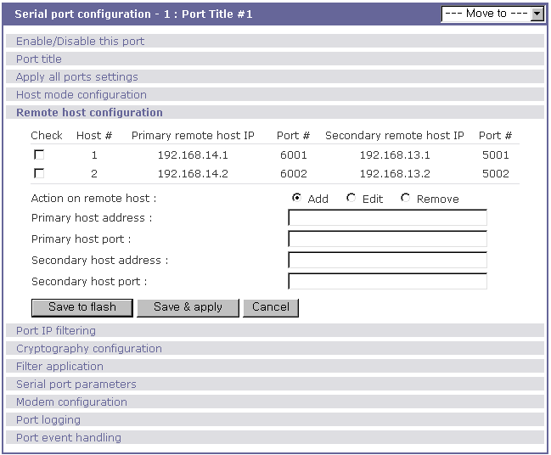
Figure 4-38 Remote host configuration

Port IP filtering configuration

The remote hosts that are allowed to access the SS Series serial ports can be specified based on the IP address filtering rules. The user may allow specific hosts to access the SS Series serial ports by providing a valid IP address or network address and its subnet mask. Please refer to section 3.5 IP Filtering for more details.

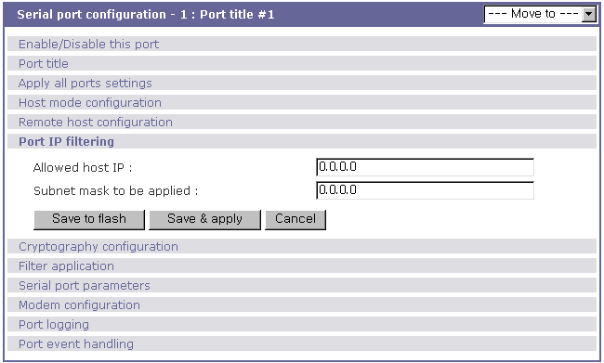
Figure 4-39 Port IP filtering for serial ports

Cryptography configuration

The SS Series supports encrypted sessions for only TCP mode including modem emulation mode (not UDP mode).

Secure Sockets Layer(SSL) and Transport Layer Security(TLS) cryptography method

By setting the cryptography method as one of SSLv2, SSLv3, SSLv3 rollback to v2 or TLSv1, the SS Series can communicate with other device supporting SSL/TLS cryptography method in encrypted sessions.
SSL was developed by Netscape for use between clients and servers. SSL layers on top of any transport protocol and can run under application protocols such as HTTP. SSL aims to be secure, fast, and adaptable to other Web protocols. SSL provides data security for applications that communicate across networks. SSL is a transport-layer security protocol layered between application protocols and TCP/IP.
TLS is an updated version of SSL. The protocol is specified in an Internet RFC, developed under the auspices of the Internet Engineering Task Force (IETF). TLS is an evolution of SSL and it specifies a mechanism for falling back to SSL if either client or server does not support the newer protocol, so a transition to TLS is relatively painless.
To initiate SSL/TLS sessions, exchange of messages called the SSL handshake is required between two devices (Server and Client). The SSL/TLS protocol uses a combination of public-key and symmetric key encryption. Symmetric key encryption is much faster than public-key encryption, but public-key encryption provides better authentication techniques. The handshake allows the server to authenticate itself to the client using public-key techniques, and then allows the client and the server to cooperate in the creation of symmetric keys used for rapid encryption, decryption, and tamper detection during the session that follows. The details of handshake process step involved can be summarized as follows:
- The client sends the server the client's SSL/TLS version number, cipher settings, randomly generated data, and other information the server needs to communicate with the client using SSL/TLS.
- The server sends the client the server's SSL/TLS version number, cipher settings, randomly generated data, and other information the client needs to communicate with the server over SSL/TLS. The server also sends its own certificate and, if the client is requesting a server resource that requires client authentication, requests the client's certificate.
- The client uses some of the information sent by the server to authenticate the server. If the server cannot be authenticated, the user is warned of the problem and informed that an encrypted and authenticated connection cannot be established. If the server can be successfully authenticated, the client goes on to next step.
- Using all data generated in the handshake so far, the client (with the cooperation of the server, depending on the cipher being used) creates the premaster secret for the session, encrypts it with the server's public-key (obtained from the server's certificate, sent in step 2), and sends the encrypted premaster secret to the server. SSL/TLS differ in the way this "shared" master secret is created
- If the server has requested client authentication (an optional step in the handshake), the client also signs another piece of data that is unique to this handshake and known by both the client and server. In this case the client sends both the signed data and the client's own certificate to the server along with the encrypted premaster secret.
- If the server has requested client authentication, the server attempts to authenticate the client. If the client cannot be authenticated, the session is terminated. if the client can be successfully authenticated, the server uses its private key to decrypt the premaster secret, then performs a series of steps (which the client also performs, starting from the same premaster secret) to generate the master secret.
- Both the client and the server use the master secret to generate the session keys, which are symmetric keys used to encrypt and decrypt information exchanged during the SSL/TLS session and to verify its integrity--that is, to detect any changes in the data between the time it was sent and the time it is received over the SSL/TLS connection.
- The client sends a message to the server informing it that future messages from the client will be encrypted with the session key. It then sends a separate (encrypted) message indicating that the client portion of the handshake is finished.
- The server sends a message to the client informing it that future messages from the server will be encrypted with the session key. It then sends a separate (encrypted) message indicating that the server portion of the handshake is finished.
- The SSL/TLS handshake is now complete, and the SSL/TLS session has begun. The client and the server use the session keys to encrypt and decrypt the data they send to each other and to validate its integrity.
Figure 4-40 Typical SSL/TLS Handshake Process

The SS Series can act as a SSL/TLS server or as a SSL/TLS client depending on status of TCP mode. If TCP connection with SSL/TLS is initiated from remote host first, SS Series acts as a SSL/TLS server during the SSL handshake process. On the contrary, if TCP connection with SSL/TLS is initiated from serial port of SS Series first, SS Series acts as a SSL/TLS client during the SSL handshake process.
When user uses SSL/TLS cryptography method, user can configure following parameters.

- Enable/Disable cipher suites
A cipher suite is an object that specifies the asymmetric, symmetric and hash algorithms that are used to secure an SSL/TLS connection. The asymmetric algorithm is used to verify the identity of the server (and optionally, that of the client) and to securely exchange secret key information. The symmetric algorithm is used to encrypt the bulk of data transmitted across the SSL/TLS connection. The hash algorithm is used to protect transmitted data against modification during transmission. The length of the keys used in both the symmetric and asymmetric algorithms must also be specified.
When a client makes an SSL/TLS connection to a server, it sends a list of the cipher suites that it is capable of and willing to use. The server compares this list with its own supported cipher suites and chooses the first cipher suite proposed by the client that it is capable of and willing to use. Both the client and server then use this cipher suite to secure the connection.
Choice of cipher suite(s) depends on environment and security requirements. The RSA-based cipher suites are the most widely used and may also give some advantages in terms of speed.
The SS Series support various cipher suites and user can select each cipher suite by enabling or disabling corresponding cipher suite.

- Verify client (server mode only)
If user selects Verify client option as Yes, SS Series will request the client's certificate while in SSL handshaking process (Step 2). On the contrary, if user selects Verify client option as No, SS Series does not request the client's certificate while in SSL handshaking process (Step 2).

- Verify certificate chain depth
A certificate chain is a sequence of certificates, where each certificate in the chain is signed by the subsequent certificate. The purpose of certificate chain is to establish a chain of trust from a its own(peer) certificate to a trusted CA certificate. The CA vouches for the identity in the peer certificate by signing it. If the CA is one that user trusts (indicated by the presence of a copy of the CA certificate in user’s root certificate directory), this implies user can trust the signed peer certificate as well. In SS Series, user can restrict number of certificate chain depth so that SS Series does not search a trusted CA certificate infinitely in a certificate chain.

- Check the certificate CN
If user selects Check the certificate CN option as Yes, SS Series will check whether the host name is matched with Common Name(CN) in the certificate, and if they do not matched, SS Series will close connection request to the remote host. On the contrary, if user selects Check the certificate CN option as No, SS Series does not check whether the host name is matched with Common Name(CN) in the certificate.
SS Series checks Common Name(CN) only if it acts as SSL/TLS client.

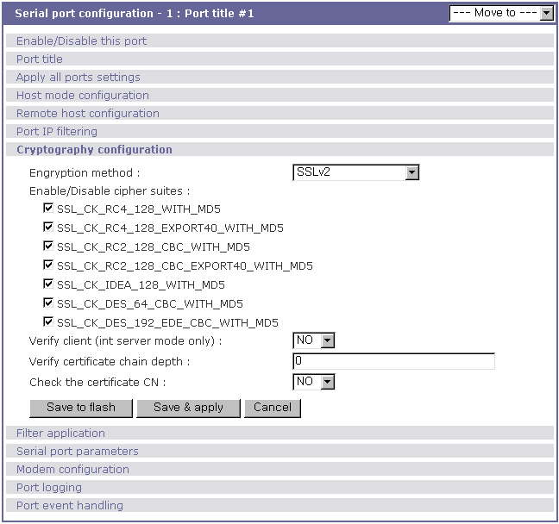
Figure 4-41 Cryptography configuration

3DES cryptography method

By setting the cryptography method as 3DES, the SS Series can communicate with other SS Series device or HelloDevice Pro Series in 3DES(168 bits) encrypted sessions.
Figure 4.12 shows record format of 3DES packet where meanings of each field are as follows,

Length | Data | Padding
Figure 4-42 Record Format of 3DES packet

- Length
The length is 8-bits number. The length is the length of content (data and padding). 3DES is a 64-bit block cipher algorithm, and then the length must be a multiple of 8(64/8).

- Padding
The padding is a standard block cipher. The pad value is the total number of pad bytes in the padding(1~8).

In 3DES algorithm in SS Series, key and initial vector, which are used in generating encrypted data packet, is derived from key block. And key block is generated by using user configured key string. Figure 4-43 shows key derivation process.

Figure 4-43 Key derivation

The key block is defined as:
Key_Block = MD5(KEY_STRING) + MD5(MD5(KEY_STRING)+KEY_STRING)
= (16 bytes) + (16 bytes)
Key = first 24bytes of Key Block
IV(Initial Vector) = last 8 bytes of Key block

RC4 cryptography method

By setting the cryptography method as RC4, the SS Series can communicate with other SS Series device in RC4 encrypted sessions. In RC4 encryption mode, SS Series will encrypt/decrypt all the TCP stream with the user configured key string, and there is no header and no padding. RC4 is faster than 3DES.

Filter application

The SS Series supports user manipulation of raw data between remote host and serial device connected serial port. Filter application configuration can be used for this purpose. If user makes his own filter application program, he can upload it to SS Series and configure name of the program and its arguments through filter application configuration menu. For more detail information about making filter application, please refer to 9.4 Making and running user’s own code section.

Note :
File uploading is supported only in console menu. For more information about file uploading, please refer to 6.9 User File Uploading section.
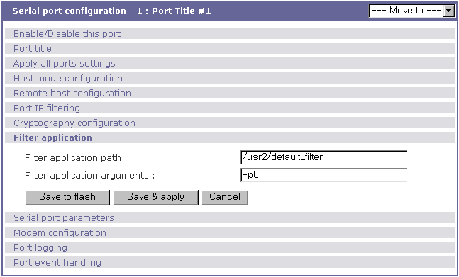
Figure 4-44 Filter application

Serial port parameters

To connect the serial device to the SS Series serial port, the serial port parameters of the SS Series should match exactly to that of the serial device attached. The serial port parameters are required to match this serial communication. The parameters required for the serial communication are: UART type, baud rate, data bits, parity, stop bits, flow control DTR/DSR behavior and inter-character timeout.

- UART type
First of all, the SS Series and the serial device must agree on the serial communication type, which is one of RS232, RS422, RS485 echo mode or RS485 non-echo mode. The SS Series serial port is configured for RS232 communication as a factory default, but it can also be configured for RS422 and RS485 communication. To change the serial communication type, set up the mode in the Type menu. See Appendix B for serial port connections due to the Type setup.
The SS Series supports two types of RS485 communication – echo mode and non-echo mode, which are both two-wire mode. In RS485 echo mode, all data received from the serial port are automatically sent back to the serial port while there is no action of sending-back in non-echo mode. For more information about pin out of serial port and wiring diagram, please refer to Appendix 1 Connections section.

- Baud rate
The valid baud rate for the SS Series is as follows:
75, 150, 200, 300, 600, 1200, 2400, 4800, 9600, 14400, 19200, 38400, 57600, 115200, and 230400
The factory default setting is 9600.

- Data bits
Data bits can be between 7 bits and 8 bits. The factory default setting is 8 bits.

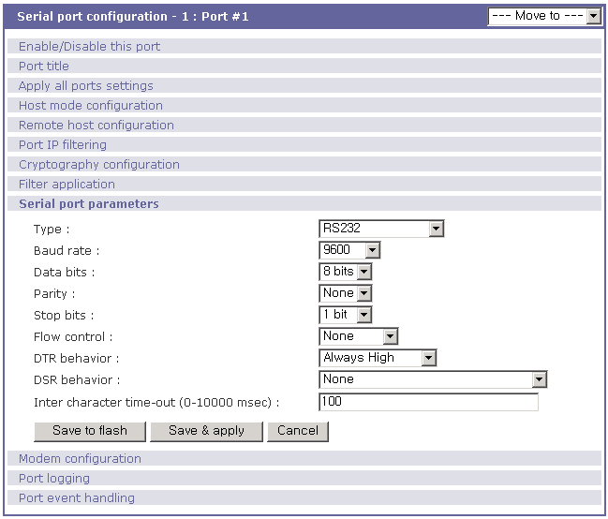
Figure 4-45 UART configuration

- Parity
Parity can be none, even or odd. The factory default setting is none.

- Stop bits
Stop bits can be between 1 bit and 2 bits. The factory default setting is 1 bit.

- Flow control
The factory default setting of the flow control is None. Software Flow Control using XON/XOFF and hardware flow control using RTS/CTS are supported by the SS Series.
Software flow control method controls data communication flow by sending special characters XON/XOFF(0x11/0x13) between two connected devices. And hardware flow control method controls data communication flow by sending signals back and forth between two connected devices.

Note:
Flow control is supported only in RS232 mode. RS422 and RS485 mode do not support any kind of flow control method in hardware or software.

- DTR/DSR behavior
The purpose of the DTR/DSR pin is to emulate modem signal control or to control TCP connection state by using serial port signal. The DTR is a write-only output signal, whereas the DSR is a read-only input signal in the SS Series side.
The DTR output behavior can be set to one of three types: always high, always low or high when open. If the DTR behavior is set to show TCP connection, the state of the DTR pin will be maintained high if the TCP connection is established.
The DSR input behavior can be set to one of three types: none, open/close TCP connection or allow TCP connection only by high. Open/close TCP connection is valid only if the host mode is a TCP client or equivalent. If the DSR behavior is set to open/close TCP connection, the high state of the DSR pin will make the SS Series send a connection request to the specified destination host, whereas the low state close a connection. Allow TCP connection only by HIGH is valid only if host mode is TCP server or equivalent. If this option is set, the incoming TCP connection request will be accepted only when the DSR signal is high state.

Note:
DTR/DSR behavior menu will not be shown when the modem is enabled.

- Inter-character timeout
This parameter defines the interval that the SS Series fetches the overall serial data from its internal buffer. If there is incoming data through the serial port, the SS Series stores data into the internal buffer. The SS Series transfers data stored in the buffer via TCP/IP, only if the internal buffer is full or if the inter-character time interval reaches to the time specified as inter-character timeout. If inter-character timeout is set as 0, then data stored in the internal buffer will be transferred immediately without any delay.
Optimal inter-character timeout would be different according to your application but at least it must be larger than one character interval within specified baud rate. For example, assume that the serial port is set to 1200 bps, 8 Data bits, 1 stop bit, and no parity. In this case, the total number of bits to send a character is 10 bits and the time required to transfer one character is
10 (bits) / 1200 (bits/s) * 1000 (ms/s) = 8.3 ms.
Therefore, you have to set inter-character timeout to be larger than 8.3 ms. The inter-character timeout is specified in milliseconds.
If users want to send the series of characters into a packet, serial device attached to the SS Series should send characters without time delay larger than inter-character timeout between characters and the total length of data must be smaller than or equal to the SS Series internal buffer size. The serial communication buffer size of SS Series is 256 bytes.

Modem configuration

The SS Series supports direct modem connection to the serial port of it. When user wants to connect modem to a serial port, he must configure Modem init-string and DCD behavior on modem configuration page. The SS Series supports modem connection only when host mode is set as TCP mode.

- Enable/Disable modem
By enabling this menu, user can attach a modem directly to the serial port of SS Series. If this parameter is enabled, SS Series considers this port will be used for modem use exclusively.

- Modem init-string
User can specify modem initialization string for his modem in Modem init-string parameter. When a serial port is set as modem mode by setting Enable/Disable modem parameter as Enabled, SS Series sends modem initialization string to the serial port whenever rising edge of DTR pin is detected or parameter related with serial port configuration is changed.

- DCD behavior
If DCD behavior is set as Allow TCP connection only by HIGH, SS Series permits a connection from the remote host only when the DCD status of serial port is high. This feature is useful when user want to use a serial port only for dial-in modem mode. In this case, if there is no connection through modem already, SS Series dose not permit TCP side connection.

- Automatic release modem connection
If Automatic release modem connection is set as Enable, modem connection will be closed by SS Series if all TCP connections are closed once at least one TCP connection is opened. If this option is set as Disable, modem connection will not be closed by SS series even if all TCP connections are closed. Please note that actual phone line connection will be closed if one of modems closes connection, regardless of this option. That is, this option can be used for SS Series to disconnect modem connection by itself when all TCP connections are closed.

If user want to use dial-out function, he should set DCD behavior as None because he must be able to access modem connected to a serial port to send dial out command to the modem first.
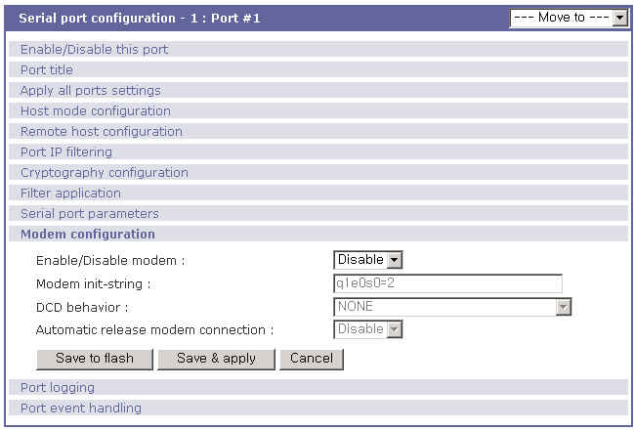
Figure 4-46 Modem configuration

Port Logging

With the port logging feature, the data sent through the serial port is stored to MEMORY, an ATA/IDE fixed disk card, a SYSLOG server or a mounting point on an NFS server.

- Enable/disable port logging
This parameter defines whether to enable or disable the port-logging feature. The factory default setting is [disabled].

- Port log storage location
The port log data can be stored to the SS Series internal memory, an ATA/IDE fixed disk card inserted in PCMCIA slot, the mounting point on an NFS server or the SYSLOG server. If the internal memory is used to store port log data, the port log data will be cleared when the SS Series is turned off. To preserve the serial port log data, set the storage location to be the ATA/IDE fixed disk card, SYSLOG server or NFS server. To do this, the user must configure the corresponding media in advance. Unless the media is properly set up, the user will not be able to select a storage location from the interface.

- Port log buffer size
This parameter defines the maximum amount of port log data to be logged. When using internal memory to store the log data, the total size of the port buffer cannot exceed 3200 Kbytes (i.e. sum of all port buffer size of each serial port should be smaller than or equal to 3200 Kbytes). The factory default setting is 4 Kbytes.
When using an ATA/IDE fixed disk card to store log data, the maximum port buffer size is dependent upon the card capacity.
When using an NFS server to store log data, the maximum port buffer size is unlimited. The user should configure the NFS server to ensure that the port logging system works properly.
When using the SYSLOG server to store log data, the user cannot set the port log buffer size.

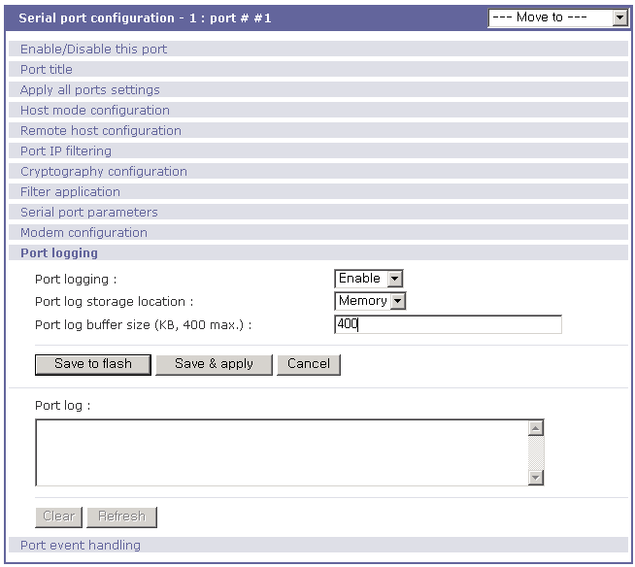
Figure 4-47 Port logging configuration

Port event handling configurations

The SS Series provides a user for a means of monitoring or reacting to data from serial device attached to a serial port of it through Port event handling configuration. Namely, user can define keywords for each serial port that will trigger the email/SNMP notification or command sent to the serial port directly on Port event handling configuration. And this will enable the user to monitor the data from the attached device or to manage/control a device attached serial port directly when pre-defined keywords are detected. At the same time, the status of the connection between the SS Series and the serial device and the status of the TCP connection between the SS Series and remote hosts could be monitored and managed in the same way of the port keywords as well.
Each reaction can be configured individually upon each event. Reaction can be an email delivery, SNMP trap sending, command sending or either combination of all reactions.

- Port event handling
If the user wants to enable port event handling feature, set Port event handling as enable. This is a global parameter so if this feature is disabled, the SS Series does not take any actions on port events.

- Notification interval
To prevent SS Series from being trapped in handling port event, there is a Notification interval parameter. SS Series will send notification email or SNMP trap every Notification interval even it detect predefined keyword within Notification interval. The smaller value of this parameter will result in immediate response for predefined keyword and heavy usage of system resources. The largest value accepted by user is recommended to prevent system resource usage minimization.

- Email notification
This parameter enables or disables Email notification feature of SS Series. When SS Series sends Email notification, it used SMTP server configured in SMTP server configuration. If the SMTP server is not configured correctly or disabled, Email feature gets disabled also. For details of SMTP server configurations and descriptions, please refer to section 3.4 SMTP Configuration.

- Title of Email
This parameter set Title of Email that will be sent by SS Series when pre-defined keyword is detected.

- Recipient's Email address
This parameter set mail recipient who will receive notification mail when pre-defined keyword is detected.

- SNMP notification
This parameter enables or disables SNMP notification feature of SS Series.

- Title of SNMP trap
This parameter set Title of SNMP trap that will be sent by SS Series when pre-defined keyword is detected.

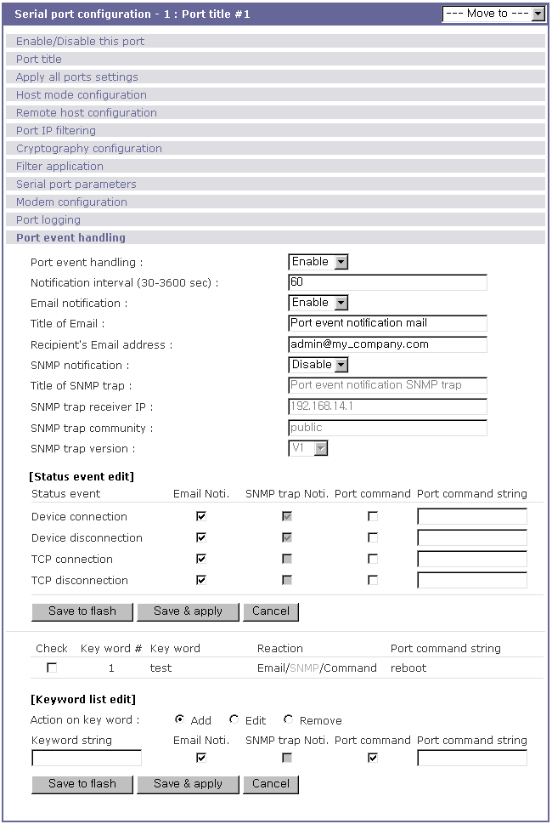
Figure 4-48 Port event-handling configurations

- SNMP trap receiver IP
This parameter set IP address of SNMP trap receiver that will receive SNMP trap notification when pre-defined keyword is detected.

- SNMP trap community
This parameter set a community that will be included in SNMP trap message when pre-defined keyword is detected.

- SNMP trap version
This parameter set a version of SNMP trap, which will be sent when pre-defined keyword is detected.

[Status event edit]
- Device connection/disconnection
Fill in the check boxes of the preferred actions that are to be taken on the event of serial device connection or disconnection.

- TCP connection/disconnection
Fill in the check boxes of the preferred actions that are to be taken on the event of TCP connection or disconnection from remote hosts.

[Keyword list edit]
- Action on key word
User can select “Add” or “Remove” for the action on keyword selected.

- Keyword string
User can specify any word, which he/she wants to set as a keyword.

- Email notification
User can select enable or disable for the Email notification action on keyword selected.

- SNMP trap notification
User can select enable or disable for the SNMP trap notification action on keyword selected.

- Port command
User can select enable or disable for the port command action on keyword selected.

- Port command string
SS Series supports direct reaction to a device attached to serial port when pre-defined keyword is detected. User can specify command or string, which will be sent to a serial port on this menu.

All Port Configurations

If modifications are being made to all serial ports are similar or the same, changes can be made to the serial port configuration for all serial ports simultaneously. With the all port configuration function, the configuration will be applied to all the serial ports; unless an individual ports “apply all port setting” option is disabled. (Please note that SS100/110 does not have all port configuration menu)
“All port configuration” parameters can be grouped into the following groups:
- Port enable/disable
- Port title
- Host mode
- Remote host configuration
- Port IP filtering
- Cryptography configuration (Only valid and visible if host mode set to TCP or Modem Emulation mode)
- Filter application
- Serial port parameters
- Modem configuration (Only valid and visible if host mode set to TCP mode)
- Port logging
- Port event handling

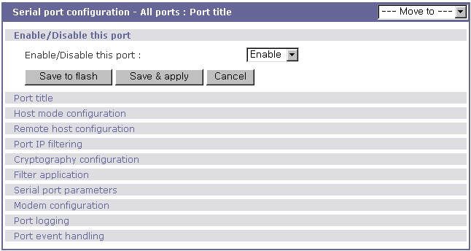
Figure 4-49 All port configuration
- Port enable/disable
This parameter enables or disables port function.
- Port title
If this parameter is set with a certain string, the port title of each serial port will be set with a combination of this string and the port number. For example, if the port title is set with “my server”, the port title of port 1 will be set with “my server #1”, the port title of port#2 will be “my server #2”, and so on.

- Host mode
If the host mode is set to TCP or UDP mode, the listening port number of each serial port will be set with the following equation:
(listening port number + serial port number - 1)
Other parameters of each serial port will be set as the same value set in as “all port configuration”.

- Remote host configuration, Port IP filtering, Cryptography configuration, Filter application, Serial port parameters, Modem configuration, Port logging, Port event handling
For the parameters of the groups above, the values set in an “all port configuration” will be set identically for all of the serial ports.

PC Card Configuration

The SS Series has one extra PC card slot for increased expandability. It supports four types of PC cards:
- Wireless LAN card
- Modem card
- ATA/IDE fixed disk card
But please note that SS100 does not have PC card configuration menu.

The user can allow access via another network connection with either a LAN or wireless LAN card. The ATA/IDE fixed disk card allows the user the ability to store and carry system and serial port log data. Using the card slot for a modem card allows the user out-of-band access to the SS Series without a serial port to connect to an external modem.

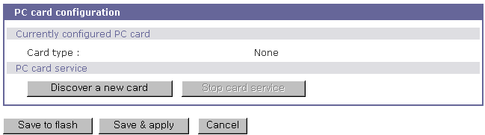
Figure 5-50 Initial PC card configuration menu screen

To use the PC card slot, the users must complete the following steps.
Step 1. Insert the PC card into the PC card slot.
Step 2. Select on the PC card configuration menu.
Step 3. The SS Series will use its plug and play functionality to discover the card type. It will then display the configuration menu screens. The user can now set card’s operation parameters.
Step 4. Save the configuration settings by selecting .
Step 5. Select [Apply changes] from the menu to apply the newly configured settings.

If SS Series fails to discover the PC card, the following error message will be displayed on the menu screen.
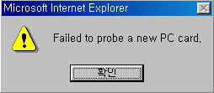
Figure 5-51 Failure to detect error message

Refer to Appendix B.PC Card supported by SS Series to view a list of PC cards support by the SS Series.

To stop or remove the PC card, user must complete the following steps.
Step 1. Select [(Ban- show the actual button) Stop card service].
Step 2. Save the configuration changes by selecting [Save to flash].
Step 3. Apply changes by selecting [Apply changes] from the menu.
Step 4. Remove the PC card from the PC card slot.

Note: Removing the PC card from the slot without following the above instructions may cause a system malfunction.

LAN Card Configuration

A LAN card will create two network interfaces and two IP addresses. The users can assign a valid IP address to each serial port. The IP address must be valid in the SS Series built-in network interface or the environment of SS Series PC card LAN interface environment.

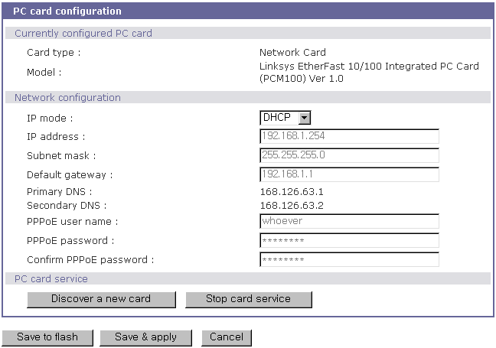
Figure 5-52 PC LAN card configuration

The user must manually select PC LAN card as the card type and set the primary and secondary DNS servers when configuring a PC LAN card. All other configuration steps are the same as detailed in Section 3.1 IP Configurationr
Refer to Appendix B.PC Card supported by SS Series to view a list of LAN PC cards supported by the SS Series.

Wireless LAN Card Configuration

A wireless LAN card will result in two network interfaces and two IP addresses. The user can assign a valid IP address to each serial port. The IP address must valid in the SS Series built-in network interface or in the wireless LAN interface environment.

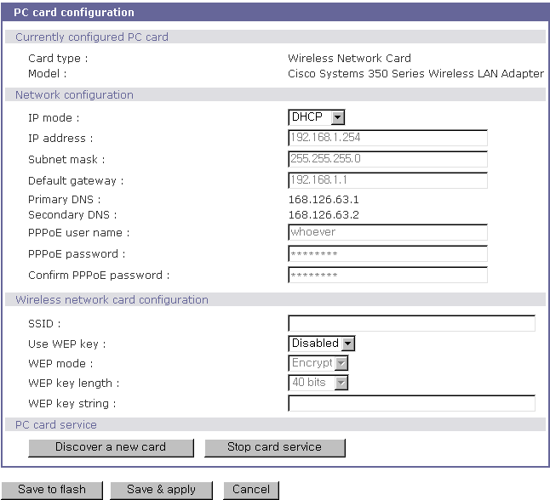
Figure 5-53 PC wireless LAN card configuration

The user must manually select WIRELESS LAN CARD as the card type and set the primary and secondary DNS servers when configuring a PC LAN card. All other configuration steps are the same as detailed in Section 3.1 IP Configuration.
The SS Series supports SSID(Service Set Identifier) and WEP(Wired Equivalent Privacy) key features for the wireless LAN configuration. The user may configure the SSID to specify an AP (Access Point). The user may also configure the WEP mode as either encrypted or shared. The WEP key length must be either 40 or 128 bits. The 40-bit WEP key length requires the user to enter 5 hexadecimal code sets without colons (:). The 128 bits WEP key length requires the user to enter 13 hexadecimal code sets without colons (:).
For example, to use the 128 bits WEP key length option, the user must enter 13 hexadecimal code sets as follows:
000F25E4C2000F25E4C2000F24

Refer to Appendix B.PC Card supported by SS Series to view a list of wireless LAN cards supported by the SS Series.

Serial Modem Card Configuration

Using the extra PC card slot as a modem will allow the user on-line access without tying up a serial port with an external modem. Most 56Kbps PC serial modem cards are compatible with the PC card slot. A complete catalog of modem cards supported by the SS Series is listed in Appendix B.

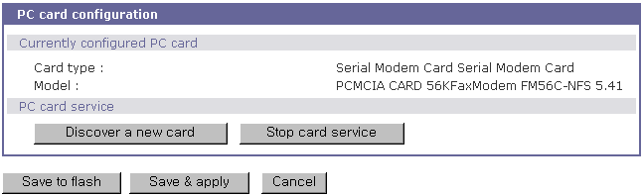
Figure 5-54 PC serial modem card configuration

ATA/IDE Fixed Disk Card Configuration

The user must configure the total data size required to use the PC ATA/IDE fixed disk card to store the system and serial port log. The SS Series will automatically locate the total storage size and the disk space available on the disk.
The user may delete all the files currently on the card by selecting .
The user may select to format the card. The SS Series supports both EXT2 and VFAT file systems for the disk card.
The user may store or retrieve the SS Series configuration files to/from the disk by exporting/importing the SS Series configuration.

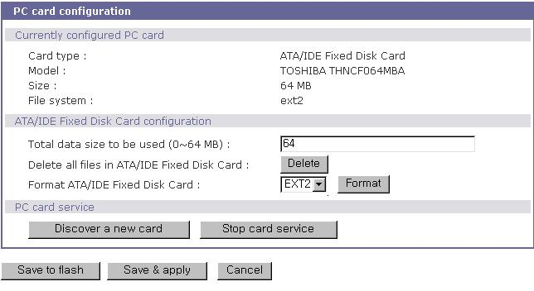
Figure 5-55 PC ATA/IDE fixed disk card configuration

System Administration

The SS Series display the system status and the log data via a Status Display Screen. This screen is to be used for management purposes. System status data includes the model name, serial number, firmware version and the network configuration of the SS Series. The SS Series can also be configured to deliver log data automatically via email to a specified recipient with the system-logging feature.
The users can configure the SS Series’s device name, date and time settings, and reload factory default settings in this menu group. The users can also upgrade the firmware of the SS Series using the web interface, remote consoles or serial console.

System Status

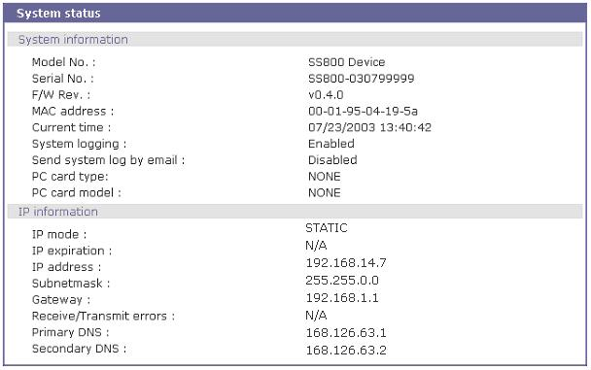
Figure 6-56 System status display

System Logging

The SS Series provides both the system logging feature and the system log status display. The user may configure the SS Series to enable or disable the system logging process, the system log buffer size, as well as select the log storage location.

- System log storage location
The system log can be stored in the SS Series internal memory, the ATA/IDE fixed disk card inserted in PCMCIA slot, the mounting point on an NFS server or the SYSLOG server. If the internal memory is used to store system log data, the log data will be cleared when the SS Series is turned off. To preserve the system log data, set the storage location to be the ATA/IDE fixed disk card, SYSLOG server or NFS server. To do this, the user must configure the corresponding media in advance. Unless the media is properly set up, the user will not be able to select a storage location from the interface.

- System log buffer size
This parameter defines the maximum amount of system log data that can be logged. When using internal memory to store data, the total size of the system log cannot exceed 300 Kbytes.
When using an ATA/IDE fixed disk card to store log data, the maximum buffer size is dependent upon the card capacity.
When using an NFS server to store logs data, the maximum buffer size is unlimited. The user should configure the NFS server to ensure that the port logging system works properly.
When using the SYSLOG server to store log data, the user cannot set the buffer size.
The SS Series can also be configured to send log data automatically if the number of logs unsent reaches a pre-defined number. If enabled, the user must set parameters to initiate the creation of a email. These parameters would include the number of logs required to trigger an email, the recipient email address, etc. Figure 6-57 shows the configuration and system log view screen.

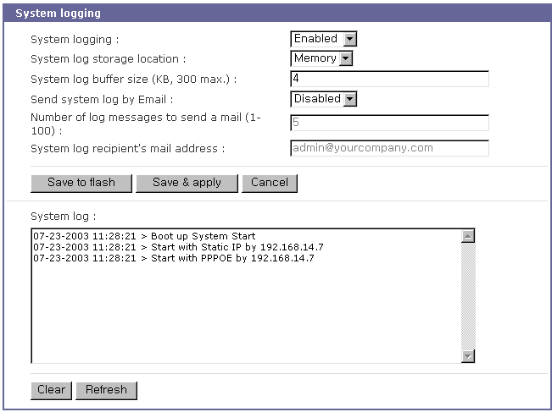
Figure 6-57 System log configuration and view

User Logged on List

This function allows a user to view current and historical user activity on the shell of SS Series.

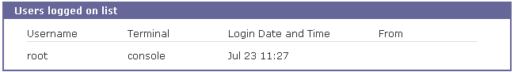
Figure 6-58 User logged on list

The list displays the following information for users who have logged into the system:
User name
Terminal type for the session
Time connected
IP address of the remote host
Note: Users access via the web will not appear on the list. Connections are not always made using HTTP/HTTPS protocol.

Change Password

The password for the administrative users of SS Series can be changed.
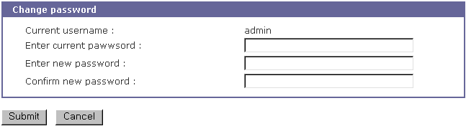
Figure 6-59 Changing the password

Device Name Configuration

The SS Series has its own name for administrative purposes. Figure 6-60 shows the device name configuration screen. When user changes Device name, hostname of SS series shall be changed and then prompt on CLI also shall be changed to the corresponding one as follows,

root@SS800_Device:~#

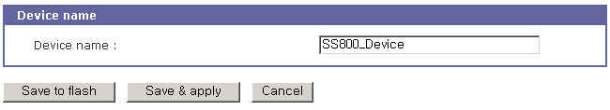
Figure 6-60 Device name configuration

Please note that user cannot set space character as one of device name. And If user sets blank as Device name then hostname is set as IP address of SS series automatically.
And also the device name is utilized for management program, HelloDevice Manager.

Date and Time Settings

The SS Series maintains current date and time information. The SS110/400/800’s clock and calendar settings are backed up by internal battery power.
(Please note that SS100 does not have a battery for internal clock. Current date and time setting will not be retained after system rebooting. So it is recommended to use NTP server to maintain correct date and time in SS100 model)
The user can change the current date and time, as shown in Figure 6-61.
There are two date and time settings.
The first is to use the NTP server to maintain the date and time settings. If the NTP feature is enabled, the SS Series will obtain the date and time information from the NTP server at each reboot. If the NTP server is set to 0.0.0.0, the SS Series will use the default NTP servers. In this case, the SS Series should be connected from the network to the Internet. The user may also need to set the time offset from UTC depending on the users’ location. The second method is to set date and time manually without using the NTP server. This will allow the date and time information to be kept maintained by the internal battery backup.
The users may also need to set the timezone and the time offset from UTC depending on the users’ location to set system date and time exactly. If the user uses daylight saving time, the user may need to set the daylight saving time properties such as the daylight saving timezone, the time offset from UTC, start data and time, end date and time. It allows the SS Series to calculate the exact system time.

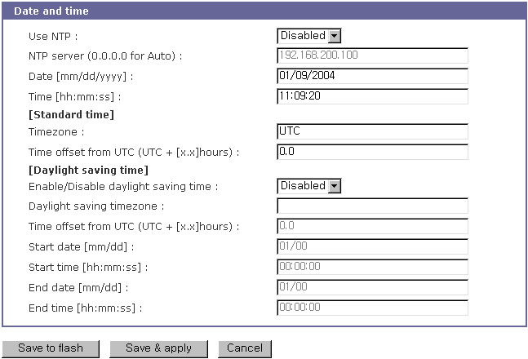
Figure 6-61 Date and time configuration

Configuration management

The user may export the current configurations to a file at such locations as CF card, NFS server, user space or local machine and import the exported configurations as current configurations from CF card, NFS server, user space or local machine.
The user may restore the factory default settings at any time by selecting “Factory default” at location property at the import part or by pushing the factory default reset switch on the back panel of the SS Series. Figure 6-62 shows the configuration management screen. The following parameters should be properly set up to export / import configurations:

Configuration export
Location : Location to export to.
Encrypt : Yes or No.
File name

Configuration import
Location : Location to import from. By selecting Factory default, the user may restore the factory settings.
Configuration selection : Determines what kinds of configurations are imported.
Encrypt : Yes or No. If location is Factory default, it has no effects.
File selection : List all the exported files satisfying the encrypting option at the selected location which is one of CF card, NFS server and user space.
Local : Helps to browse the exported file at local machine if location is local machine.

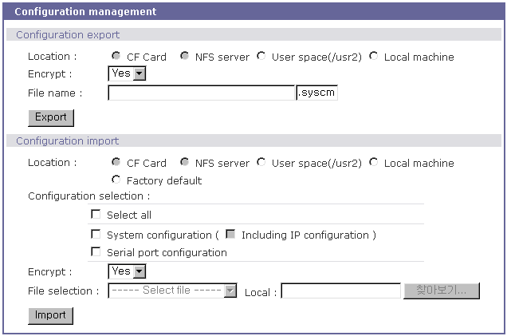
Figure 6-62 Configuration management

To export the current configurations, follow this:
- Select the location to export to.
- Select the encrypting option
- Type the file name.
- Click the [Export] button.

To import the exported configurations, follow this:
- Select the location to import from.
- Select the configurations to import.
- Select the encrypting option.
- Select the file to import from the file selection list box if location is not local machine nor factory default.
- Select the file to import by clicking browse button if location is local machine.
- Click the [Import] button.

Firmware Upgrade

Firmware upgrades are available via serial, remote console or web interface. The latest upgrades are available on the Sena web site at http://www.sena.com/support/downloads/.

Figure 6-63 shows the firmware upgrade web interfac .

To upgrade firmware via the web:
- Select the latest firmware binary by clicking browse button.
- Select and upload the selected version.
- Once the upgrade has been completed, the system will reboot to apply the changes.

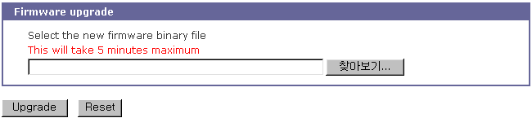
Figure 6-63 Firmware upgrade

To use either a remote or serial console to upgrade your firmware, the TELENT/SSH or terminal emulation program must support Zmodem transfer protocol. After the firmware upgrade, the previous settings will be reset to the factory default settings, except the IP configuration settings.

To upgrade firmware via a remote console:

- Obtain the latest firmware.
- Connect the terminal emulation program using either TELENT/SSH or a serial console port.
(TELNET or SSH is recommended since the process of firmware upgrade by serial console requires extremely long time.)
- Select from the firmware upgrade menu as shown Figure 6-64.
- Follow the online directions and transfer the firmware binary file using the Zmodem protocol as shown in Figure 6-65.
- Once the upgrade has been completed, the system will reboot to apply the changes
- If the firmware upgrade fails, the SS Series will display error messages as shown in . It will also.maintain the current firmware version.

Login : admin
Password : *****

------------------------------------------------------------------------------
Welcome to SS-800 configuration page
Current time: 07/23/2003 15:04:07 F/W REV.: v1.0.0
Serial No.: SS800438349-42944 MAC address: 00-01-95-04-19-5a
IP mode: Static IP IP address: 192.168.14.7
------------------------------------------------------------------------------
Select menu:
1. Network configuration
2. Serial port configuration
3. PC Card configuration
4. System administration
5. Save changes
6. Exit without saving
7. Exit and apply changes
8. Exit and reboot
<Enter> Refresh
---> 4
------------------------------------------------------------------------------
System administration
------------------------------------------------------------------------------
Select menu:
1. System status
2. System logging
3. Device name: SS800 Device
4. Date and time
5. Change password
6. User file upload
7. Reload factory default settings
8. Reload factory default settings except IP settings
9. Firmware upgrade
<ESC> Back, <Enter> Refresh
--->9
Do you want to upgrade firmware? (y/n): y
Transfer firmware by zmodem using your terminal application.
To escape, press Ctrl+X
**B0ff000005b157
Figure 6-64 Firmware upgrade using remote/serial console

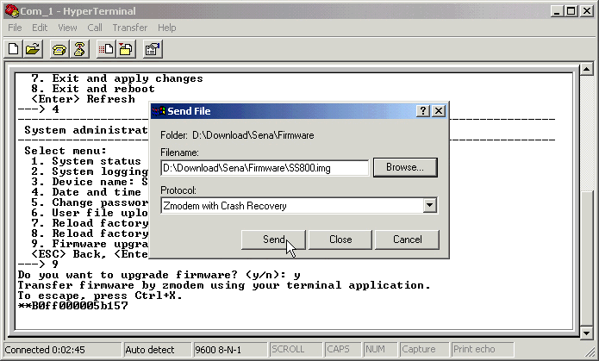
Figure 6-65 Transfer binary file by Zmodem (HyperTerminal)

--->9
Do you want to upgrade firmware? (y/n): y
Transfer firmware by zmodem using your terminal application.
To escape, press Ctrl+X
**B0ff000005b157
**B0ff000005b157
**B0ff000005b157
**B0ff000005b157
Firmware upgrade failed !
Now reboot ...

Figure 6-66 Firmware upgrade failure message

User File Uploading

User can upload his own file to the SS Series. But file uploading feature is only supported in console menu. File uploading menu is located under “4. System administration --> 6. User file upload” of console menu as shown on Figure 6-67.
To upload user file to the SS Series using console menu, user must use a TELNET/SSH or terminal emulation program which supports Zmodem transfer protocol.
Uploading procedure is similar to firmware upgrade using console menu as follows,

- Prepare user file to be uploaded.
- Connect the terminal emulation program using either TELNET/SSH or a serial console port.
(TELNET or SSH is recommended since the process of firmware upgrade by serial console. Using a serial console port may take a long time.)
- Select from the user file upload menu as shown Figure 6-67.
- Follow the online directions and transfer the user file using the Zmodem protocol as shown in Figure 6-65.
- Once the upload has been completed, the system will display success messages as shown in Figure 6-67..
- If the upload fails, the SS Series will display error messages as shown in .

Note :
User file uploading is permitted only under user space (/usr2) directory. For more information about file system inside SS Series, please refer to 8.2 Flash partition section.

------------------------------------------------------------------------------
Welcome to SS-800 configuration page
Current time : 08/14/2003 11:56:13 F/W REV. : v1.0.0
Serial No. : SS800438349-42944 MAC address : 00-01-95-04-d3-03
IP mode : DHCP IP address : 192.168.222.206
------------------------------------------------------------------------------
Select menu:
1. Network configuration
2. Serial port configuration
3. PC Card configuration
4. System administration
5. Save changes
6. Exit without saving
7. Exit and apply changes
8. Exit and reboot
<Enter> Refresh
---> 4
------------------------------------------------------------------------------
System administration
------------------------------------------------------------------------------
Select menu:
1. System status
2. System logging
3. Device name: SS800 Device
4. Date and time
5. Change password
6. User file upload
7. Reload factory default settings
8. Reload factory default settings except IP settings
9. Firmware upgrade
<ESC> Back, <Enter> Refresh
---> 6
Do you want to upload a file to user space? (y/n): y
Enter a filename: test.txt
The file will be saved as /usr2/test.txt.
Transfer a file by zmodem using your terminal application.
To escape, press Ctrl+X.
**B01ff000005b157

Uploading a file is completed.
Figure 6-67 User file upload menu and success messages

Do you want to upload a file to user space? (y/n): y
Enter a filename: test.txt
The file will be saved as /usr2/test.txt.
Transfer a file by zmodem using your terminal application.
To escape, press Ctrl+X.
**B01ff000005b157

Uploading a file failed.
Figure 6-68 User file upload fail messages

System Statistics

The SS Series Web interface provides system statistics menus. The user can use the menus to access statistical data and tables stored in the SS Series memory. Network interfaces statistics and serial ports statistics display statistical usage of the link layer, lo, eth and serial ports. IP, ICMP, TCP and UDP statistics display usages of four primary components in the TCP/IP protocol suite.

Network Interfaces Statistics

Network interfaces statistics display basic network interfaces usage of the SS Series, lo and eth0. lo is a local loop back interface and eth0 is a default network interface of SS Series.

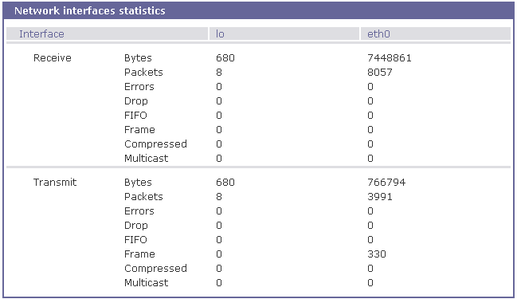
Figure 7-69 Network interfaces statistics

Serial Ports Statistics

Serial ports statistics display the usage history of 32 serial ports, baud rate configurations and each port’s pin status. ( : On : Off )

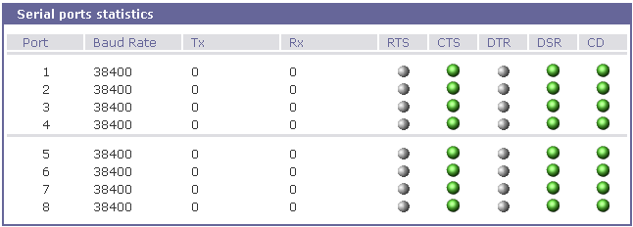
Figure 7-70 Serial ports status

IP Statistics

The IP Statistics screen provides statistical information about packets/connections using an IP protocol. Definitions and descriptions of each parameter are described below:

Forwarding :
Specifies whether IP forwarding is enabled or disabled.
DefaultTTL :
Specifies the default initial time to live (TTL) for datagrams originating on a particular computer.
InReceives :
Shows the number of datagrams received.

InHdrErrors :
Shows the number of datagrams received that have header errors. Datagrams Received Header Errors is the number of input datagrams discarded due to errors in their IP headers, including bad checksums, version number mismatch, other format errors, time-to-live exceeded, errors discovered in processing their IP options, etc.
InAddrErrors :
Specifies the number of datagrams received that have address errors. These datagrams are discarded because the IP address in their IP header's destination field was not a valid address to be received at this entity. This count includes invalid addresses (for example, 0.0.0.0) and addresses of unsupported Classes (for example, Class E).
ForwDatagrams :
Specifies the number of datagrams forwarded.
InUnknownProtos :
Specifies the number of locally addressed datagrams received successfully but discarded because of an unknown or unsupported protocol.
InDiscard :
Specifies the number of input IP datagrams for which no problems were encountered to prevent their continued processing, but which were discarded (for example, for lack of buffer space). This counter does not include any datagrams discarded while awaiting reassembly.
InDelivers :
Specifies the number of received datagrams delivered.
OutRequests :
Specifies the number of outgoing datagrams that an IP is requested to transmit. This number does not include forwarded datagrams.
OutDiscards :
Specifies the number of outgoing datagrams discarded.
OutNoRoutes :
Specifies the number of transmitted datagrams discarded. These are datagrams for which no problems were encountered to prevent their transmission to their destination, but which were discarded (for example, for lack of buffer space.) This counter would include datagrams counted in Datagrams Forwarded if any such packets met this (discretionary) discard criterion.
OutNoRoutes :
Specifies the number of datagrams for which no route could be found to transmit them to the destination IP address. These datagrams were discarded. This counter includes any packets counted in Datagrams Forwarded that meet this "no route" criterion.
ReasmTimeout :
Specifies the amount of time allowed for all pieces of a fragmented datagram to arrive. If all pieces do not arrive within this time, the datagram is discarded.
ReasmReqds :
Specifies the number of datagrams that require reassembly.
ReasmOKs :
Specifies the number of datagrams that were successfully reassembled.
ReasmFails :
Specifies the number of datagrams that cannot be reassembled.
FragOKs :
Specifies the number of datagrams that were fragmented successfully.
FragFails :
Specifies the number of datagrams that need to be fragmented but couldn't be because the IP header specifies no fragmentation. For example, if the datagrams "Don't Fragment" flag was set, the datagram would not be fragmented. These datagrams are discarded.
FragCreates :
Specifies the number of fragments created.

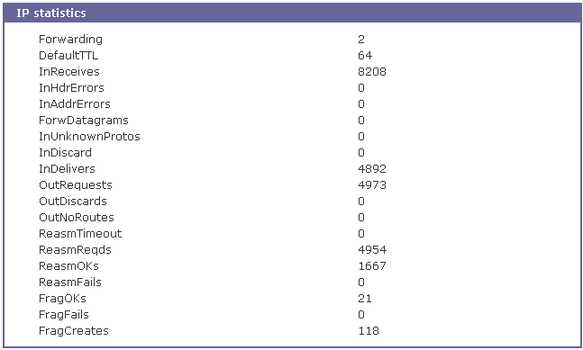
Figure 7-71 IP statistics

ICMP Statistics

The ICMP Statistics screen provides statistical information about packets/connections using an ICMP protocol. Definitions and descriptions of each parameter are described below:

InMsgs, OutMsgs :
Specifies the number of messages received or sent.
InErrors, OutErrors :
Specifies the number of errors received or sent.
InDestUnreachs, OutDestUnreachs :
Specifies the number of destination-unreachable messages received or sent. A destination-unreachable message is sent to the originating computer when a datagram fails to reach its intended destination.
InTimeExcds, OutTimeExcds :
Specifies the number of time-to-live (TTL) exceeded messages received or sent. A time-to-live exceeded message is sent to the originating computer when a datagram is discarded because the number of routers it has passed through exceeds its time-to-live value.
InParmProbs, OutParmProbs :
Specifies the number of parameter-problem messages received or sent. A parameter-problem message is sent to the originating computer when a router or host detects an error in a datagram's IP header.
InSrcQuenchs, OutSrcQuenchs :
Specifies the number of source quench messages received or sent. A source quench request is sent to a computer to request that it reduces its rate of packet transmission.
InRedirects, OutRedirects :
Specifies the number of redirect messages received or sent. A redirect message is sent to the originating computer when a better route is discovered for a datagram sent by that computer.
InEchos, OutEchos :
Specifies the number of echo requests received or sent. An echo request causes the receiving computer to send an echo reply message back to the originating computer.
NEchoReps, OutEchoReps :
Specifies the number of echo replies received or sent. A computer sends an echo reply in response to receiving an echo request message.
InTimestamps, OutTimestamps :
Specifies the number of time-stamp requests received or sent. A time-stamp request causes the receiving computer to send a time-stamp reply back to the originating computer.
InTimestampReps, OutTimestampReps :
Specifies the number of time-stamp replies received or sent. A computer sends a time-stamp reply in response to receiving a time-stamp request. Routers can use time-stamp requests and replies to measure the transmission speed of datagrams on a network.
InAddrMasks, OutAddrMasks :
Specifies the number of address mask requests received or sent. A computer sends an address mask request to determine the number of bits in the subnet mask for its local subnet.
InAddrMaskReps, OutAddrMaskReps :
Specifies the number of address mask responses received or sent. A computer sends an address mask response in response to an address mask request.

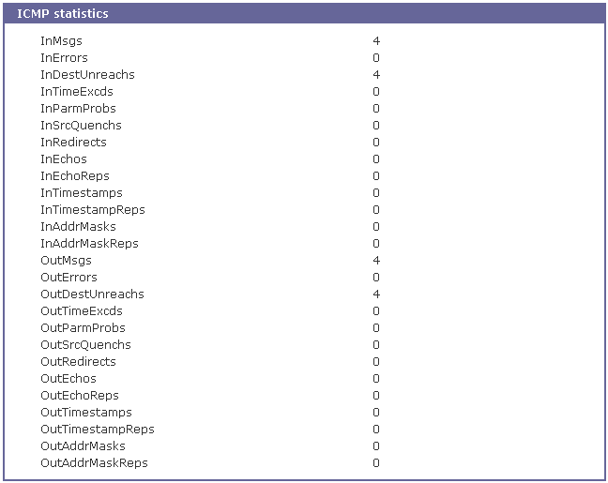
Figure 7-72 ICMP statistics

TCP Statistics

The TCP Statistics screen provides statistical information about packets/connections using a TCP protocol. Definitions and descriptions of each parameter are described below:
RtoAlgorithm :
Specifies the retransmission time-out (RTO) algorithm in use. The Retransmission Algorithm can have one of the following values.
0 : CONSTANT - Constant Time-out
1: RSRE - MIL-STD-1778 Appendix B
2: VANJ - Van Jacobson's Algorithm
3: OTHER - Other
RtoMin :
Specifies the minimum retransmission time-out value in milliseconds.
RtoMax :
Specifies the maximum retransmission time-out value in milliseconds.
MaxConn :
Specifies the maximum number of connections. If is the maximum number is set to -1, the maximum number of connections are dynamic.
ActiveOpens :
Specifies the number of active opens. In an active open, the client is initiating a connection with the server.
PassiveOpens :
Specifies the number of passive opens. In a passive open, the server is listening for a connection request from a client.
AttemptFails :
Specifies the number of failed connection attempts.
EstabResets :
Specifies the number of established connections that have been reset.
CurrEstab :
Specifies the number of currently established connections.
InSegs :
Specifies the number of segments received.
OutSegs :
Specifies the number of segments transmitted. This number does not include retransmitted segments.
RetransSegs :
Specifies the number of segments retransmitted.
RetransSegs :
Specifies the number of errors received.
OutRsts :
Specifies the number of segments transmitted with the reset flag set.

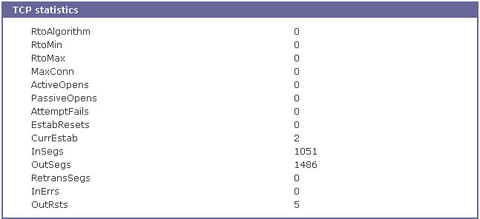
Figure 7-73 TCP statistics

UDP Statistics

The UDP Statistics screen provides statistical information about packets/connections using a UDP protocol. Definitions and descriptions of each parameter are described below:

InDatagrams :
Specifies the number of datagrams received.
NoPorts :
Specifies the number of received datagrams that were discarded because the specified port was invalid.
InErrors :
Specifies the number of erroneous datagrams that were received. Datagrams Received Errors is the number of received UDP datagrams that could not be delivered for reasons other than the lack of an application at the destination port.
OutDatagrams :
Specifies the number of datagrams transmitted.

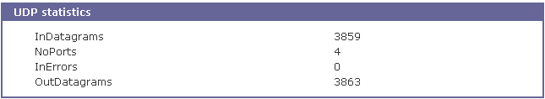
Figure 7-74 UDP statistics

CLI guide

Introduction

The SS Series root or System Administrator (only admin account is added for this group user by factory default) can access the Linux console command line interface (CLI) of the SS Series via the serial console or TELENT/SSH. In the CLI, the authorized user can perform standard Linux commands to view the status of the SS Series, edit the configuration, apply configuration changes, define user scripts and transmit files between the SS Series and remote hosts.
The SS Series provides 1024 KB user space mounted in /usr2 for read/write capabilities in its internal flash memory. Using the user space, the user can create his own scripts or executable binaries to customize the SS Series.
A root user will always have access to the CLI through the serial console on the SS Series back panel or by using a Telnet client from their workstation.
A System Administrator cannot have access to the CLI. He can only access console configuration menu or Web UI.

Flash partition

The SS Series internal flash is partitioned as shown in the table below. The users can freely access the Mtdblock5 which is mounted on /usr2 for their own needs. The user can also access files at /etc, /var, and /temp at their own risk. Simply accessing these files will not affect the SS Series after rebooting. However, if the user invokes the command saveconf, the changes in the configuration file will be committed to the internal flash memory area of the SS Series. This will result in the changes being kept after the reboot sequence. Invalid configuration changes can affect the SS Series behavior. At worst, it may cause the SS Series to be inoperable.

Block | Type | Mount point | Size (KB)
Mtdblock0 | Bootloader | None | 128
Mtdblock1 | Kernel | None | 768
Mtdblock2 | CRAMFS (Read only) | / | 6080
Mtdblock3 | Ram disk image (4MB) | /etc, /var, /tmp | 64
Mtdblock4 | EXT2 (R/W) | /cnf (normally unmounted) | 64
Mtdblock5 | JFFS2 (R/W) | /usr2 | 1024
Mtdblock6 | Reserved | None | 64
Total |  |  | 8192

Supported Linux Utilities

Shell & shell utilities:
sh, ash, bash, echo, env, false, grep, more, sed, which, pwd

File and disk utils:
ls, cp, mv, rm, mkdir, rmdir, ln, mknod, chmod, touch, sync,
gunzip, gzip, zcat, tar, dd, df, du, find, cat, vi, tail,
mkdosfs, mke2fs, e2fsck, fsck, mount, umount, scp

System utilities:
date, free, hostname, sleep, stty, uname, reset,
insmod, rmmod, lsmod, modprobe,
kill, killall, ps, halt, shutdown, poweroff, reboot, telinit, init,
useradd, userdel, usermod, whoami, who, passwd, id, su, who

Network utilities:
ifconfig, iptables, route, telnet, ftp, ssh, ping

Accessing CLI as root or system administrator

Serial console:
- Connect the console port of the SS Series with the PC serial port
- Run the PC terminal emulation program
- Configure the PC serial port to: 9600-8-N-1 No flow control
- Press <enter>
- Login with the SS Series root or admin account
Telnet console:
- telnet SS Series_ip_address

Editing SS Series configuration in CLI

Configuration file save/load mechanism:
- While booting, the SS Series uncompresses /cnf/cnf.tar.gz to /tmp/cnf/* and unmounts /cnf
- When changing the configuration, the SS Series changes the contents of the files in /tmp/cnf
- When the user saves the configuration, the SS Series mounts /cnf and compresses /tmp/cnf/* to /cnf/cnf.tar.gz (Web [Save to flash], or “saveconf” in CLI)

To change configuration in CLI:
To change the SS Series configuration in the CLI, run the menu-driven configuration utility “configmenu”, or configure manually as follows:
- Edit the configuration file manually using vi command
(Please see Appendix C. SS Series Configuration files for detail descriptions of each parameter in the configuration files)
- Save the configuration file to flash using the “saveconf” utility
- Apply all changes using “applyconf” utility

root@192.168.0.117:~# configmenu

or

root@192.168.0.117:~# cd /tmp/cnf
root@192.168.0.117:/tmp/cnf# vi redirect.cnf
root@192.168.0.117:/tmp/cnf# saveconf
root@192.168.0.117:/tmp/cnf# applyconf

Running user defined scripts

Shell script /usr2/rc.user is automatically called when the SS Series is booting. Users can modify the rc.user file to run user defined script or binaries

#!/bin/bash
#
# rc.user : Sample script file for running user programs at boot time
#
#PATH=/bin:/usr/bin:/sbin:/usr/sbin

# Add shell command to execute from here

echo ‘This is the welcome message defined by users’

exit 0

File transmission

The users can use an ftp client for file transmission and use /usr2 directory for data read/write

root@192.168.0.117:~# cd /usr2
root@192.168.0.117:/usr2# ftp 192.168.2.3
Connected to 192.168.2.3.
220 lxtoo.senalab.co.kr FTP server (Version wu-2.6.1-16) ready.
Name (192.168.2.3:root): sena
331 Password required for sena.
Password:
230 User sena logged in.
Remote system type is UNIX.
Using binary mode to transfer files.
ftp> get test.tgz
local: test.tgz remote: test.tgz
200 PORT command successful.
150 Opening BINARY mode data connection for test.tgz (350 bytes).
226 Transfer complete.
350 bytes received in 0.04 secs (9.6 kB/s)
ftp> bye

In addition to a regular FTP client, the user can copy files securely as encrypted using scp client program. If the user wants to copy a file from the SS Series(192.168.0.120) to user’s PC, type a command on the user’s PC as shown below:

[root@localhost work]# scp root@192.168.0.120:/usr2/rc.user /work
The authenticity of host '192.168.0.120 (192.168.0.120)' can't be established.
RSA key fingerprint is c1:70:ab:52:48:ab:e5:dc:47:9c:94:ed:99:6f:94:4f.
Are you sure you want to continue connecting (yes/no)? yes
Warning: Permanently added '192.168.0.120' (RSA) to the list of known hosts.
root@192.168.0.120's password:
rc.user 100% |*****************************| 173 00:00
[root@localhost work]#

Examples

Disabling the Telnet Port of the Unit
The SS Series unit does not support disabling the remote console port individually (port 22 for SSH or port 23 for Telnet to the box)
Currently, the user can only disable or enable all remote consoles together. This must be done using the UI or console configuration menu.

The user may bypass this and disable only one (Telnet or SSH) remote console by modifying the script 'rc.user'. Below are two examples of how this could be done.

Example1. Modify 'inetd.conf'
Step 1 Modify /etc/inetd.conf (comment out or delete telnet service)
Step 2 Copy inetd.conf to /usr2/inetd.conf
Step 3 Edit usr2/rc.user script as follows:

#!/bin/bash
#
# rc.user : Sample script file for running user programs at boot time
#

#PATH=/bin:/usr/bin:/sbin:/usr/sbin

# Add shell command to execute from here
# Add shell command to execute from here

cp -a /usr2/inetd.conf /etc/inetd.conf
ps -ef
while killall inetd 2>/dev/null;
do sleep 1;
ps -ef
done
/usr/sbin/inetd
ps -ef

exit 0

The user may now disable the telnet service every time the system boots up.

Example 2. Run iptables rule

Step 1 Modify 'usr2/rc.user script as follows:

#!/bin/bash
#
# rc.user : Sample script file for running user programs at boot time
#

#PATH=/bin:/usr/bin:/sbin:/usr/sbin

# Add shell command to execute from here

# if user wants to disable telnet service from all host
iptables -A INPUT -p tcp -s --dport 23 -j DROP

# if user wants to enable telnet service only from specific hosts(192.168.0.0 ~ 192.168.0.255)
#iptables -A INPUT -p tcp -s ! 192.168.0.1/255.255.255.0 --dport 23 -j DROP

exit 0

The user may now disable the telnet service every time the system boots up.

If the user resets the SS Series to the factory defaults, /usr2/rc.user script file will be renamed to /usr2/rc.user.old# file, and the default rc.user file will be restored.

User customization guide

Introduction

The SS Series supports various ways of customization so that user can fit SS Series for his own purpose. The SS Series provides following types of user customization methods,

- Periodical program execution
- User defined web pages
- Making and running user’s own code.

Periodical program execution

User can use crontab to execute a specific program periodically. To enable periodical jobs using crontab, please complete following steps,

Step 1 Create a crontab file on /usr2 directory. Following sample crontab file generates current_date file under /tmp directory and revise its contents every 2 minutes.

SHELL=/bin/bash
# Sample crontab job
# Run every two minutes
* * * * * echo `date` > /tmp/current_date

Step 2 Register crontab file using following command.
root@SS800_Device:/usr2# crontab samplecrontab_file

Step 3 To make cron job permanent for every system reboot, please use rc.user script as follows:

#!/bin/bash
#
# rc.user : Sample script file for running user programs at boot time
#

#PATH=/bin:/usr/bin:/sbin:/usr/sbin

# Add shell command to execute from here
crontab /usr/samplecrontab_file

exit 0

Please note that –e option (editing current crontab using editor) is not supported in SS. So user must user vi editor to change contents in crontab file.
For more information about the format of crontab file, please refer to Linux crontab manual(man 5 crontab).

User defined web pages

SS Series supports user defined web pages. User can set user-defined page as a first page which will be popped up after user login to Web UI. For more information about changing default web page, please refer to 3.9 Web server configuration section.
Once default web page is changed to Customer page, Customer page will be popped up after user logs in to Web UI. To change contents of Customer page, user must modify index.html or default CGI program. These two files are located under /usr2 directory of SS Series.
To change contents of index.html file, it is sufficient to change contents of index.html file. But to change contents of CGI program, user should compile source code of CGI program after modifying original source code. To compile source code of CGI program, user need cross development environment or SDK(Software Development Kit) for SS Series. Please contact Sena Technical Support to get SDK for SS Series or more information about cross development environment.

Making and running user’s own code

To make user’s own application code, cross development environment or SDK(Software Development Kit) for SS Series is needed. SS Series SDK is provided in the form of PC CF card. (Please contact Sena Technical Support to get SDK for SS Series or more information about cross development environment).
With SS Series SDK, user can make his own program in the CLI of SS Series.
For more detail information, please refer to SS Series customization guide.
With cross development environment, user can make his own program on his own Linux PC. And then he can upload his own program to SS Series. To run this program in SS Series, user can use user script file and/or crontab program. If the purpose of user program is manipulating of serial data, he can use filter application menu. For more information about configuring filter application, please refer to 4.2.8 Filter application section.

- Connections

  - Ethernet Pin outs

The SS Series uses the standard Ethernet connector that is shielded connector compliant with AT&T258 specifications. Table A- shows the pin assignment and wire color.
Figure A- Pin layout of the RJ45 connector

Table A- Pin assignment of the RJ45 connector for Ethernet
Pin | Description | Color
1 | Tx+ | White with orange
2 | Tx- | Orange
3 | Rx+ | White with green
4 | NC | Blue
5 | NC | White with blue
6 | Rx- | Green
7 | NC | White with brown
8 | NC | Brown

  - Console and Serial port pin-outs for SS100

The pin assignment of the SS100 DB9 connector is summarized in Table A-2. Each pin has a function according to the serial communication type configuration.

Figure A- Pin layout of the DB-9 connector of SS100

Table A- Pin assignment of DB-9 connector for console and serial port of SS100
Pin | RS232 | RS422 | RS485
1 | - | Tx- | Data-
2 | Rx | - | -
3 | Tx | Rx- | -
4 | DTR | Rx+ | -
5 | GND | - | -
6 | DSR | - | -
7 | RTS | - | -
8 | CTS | - | -
9 | - | Tx+ | Data+

  - Console and Serial port pin-outs for SS110/400/800

The SS 110/400/800 uses an RJ45 connector for console and serial ports. The pin assignment of the RJ45 connector for console and serial ports is summarized in Table A-. Each pin has a function according to the serial communication type configuration.

Table A- Pin assignment of RJ45 connector for console and serial ports
Pin | RS232  (console and serial ports) | RS485  (serial ports only) | RS422  (serial ports only)
1 | CTS | Data+ | Tx+
2 | DSR | - | -
3 | RxD | Data- | Tx-
4 | GND | - | -
5 | DCD | - | -
6 | TxD | - | Rx-
7 | DTR | - | -
8 | RTS | - | Rx+

  - Ethernet Wiring Diagram
Figure A- Ethernet direct connection using crossover Ethernet cable

Figure A- Ethernet connection using straight through Ethernet cable

  - Serial Wiring Diagram

    - RS232 Serial Wiring Diagram for SS100

Figure A- RS232 wiring diagram for SS100

    - RS232 Serial Wiring Diagram for SS110/400/800

    - RS422/285 Serial Wiring Diagram for SS100

Figure A- RS485 wiring diagram for SS100

Figure A- RS422 wiring diagram for SS100

    - RS422/285 Serial Wiring Diagram for SS110/400/800

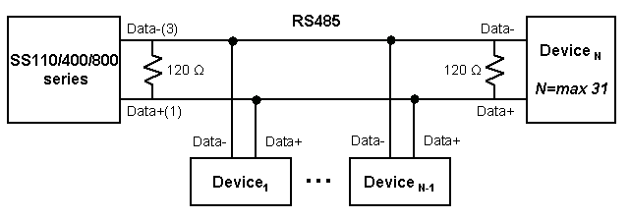
Figure A- RS485 wiring diagram for SS110/400/800

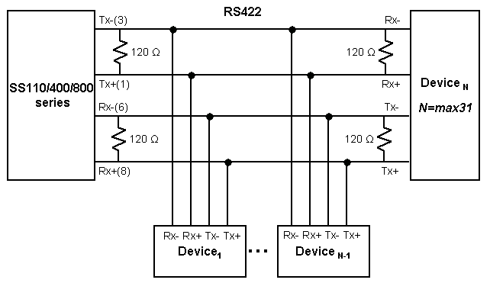
Figure A- RS422 wiring diagram for SS110/400/800

- PC card supported by SS Series

The following PC cards are supported by the SS Series series:

Table A- Network card
Manufacturer | Model/Name | SS probed Model name | Specification
3COM | 3CXE589ET-AP | 3Com Megahertz 589E TP/BNC LAN PC Card | 10 Mbps LAN card
Linksys | Linksys EtherFast 10/100 Integrated PC Card  (PCM100) | Linksys EtherFast 10/100 Integrated PC Card (PCM100) Ver 1.0 | 10/100 Mbps LAN card
Corega | FetherII PCC-TXD | corega K.K. corega FEtherII PCC-TXD | 10/100 Mbps LAN card
Netgear | 16bit PCMCIA Notebook Adapter FA411 | NETGEAR FA411 Fast Ethernet | 10/100 Mbps LAN card

Table A- Wireless Network card
Manufacturer | Model/Name | SS probed Model name | Specification
Cisco Systems | AIR-PCM340/Aironet 340 | Cisco Systems 340 Series Wireless LAN Adapter | 11 Mbps Wireless LAN Adapter
Cisco Systems | AIR-PCM350/Aironet 350 | Cisco Systems 350 Series Wireless LAN Adapter | 11 Mbps Wireless LAN Adapter
Lucent Technologies | PC24E-H-FC/Orinoco Silver | Lucent Technologies WaveLAN/IEEE Version 01.01 | 11 Mbps Wireless LAN Adapter
Lucent Technologies | PC24E-H-FC/Orinoco Gold | Lucent Technologies WaveLAN/IEEE Version 01.01 | 11 Mbps Wireless LAN Adapter
Agere Systems  (Lucent Technologies) | Orinoco Classic Gold  (PC24E-H-FC/Orinoco Gold) | Lucent Technologies WaveLAN/IEEE Version 01.01 | 11 Mbps Wireless LAN Adapter
Buffalo | AirStation  (WLI-PCM-L11GP) | MELCO WLI-PCM-L11 Version 01.01 | 11 Mbps Wireless LAN Adapter

Table A- ATA/IDE Fixed Disk Card
Manufacturer | Model/Name | SS probed Model name | Specification
Advantech | CompactFlash | CF 48M | 48 MB Storage card
SanDisk | SDP series | SunDisk SDP 5/3 0.6 | 64 MB Storage card
SanDisk | SDP series | SanDisk SDP 5/3 0.6 | 256 MB Storage card
Kingston | CompactFlash Storage Card | TOSHIBA THNCF064MAA | 64 MB Storage card
Viking | CompactFlash | TOSHIBA THNCF064MBA | 64 MB Storage card

Table A- Serial Modem Card
Manufacturer | Model/Name | SS probed Model name | Specification
Billionton Systems Inc. | FM56C series | PCMCIA CARD 56KFaxModem FM56C-NFS 5.41 | Ambient (Intel) V.90 FAX/MODEM PC Card
Viking | PC Card Modem 56K | Viking V.90 K56flex 021 A | MODEM PC Card
KINGMAX | KIT PCMCIA 56K  Fax/Modem Card | CIRRUS LOGIC 56K MODEM CL-MD56XX 5.41 | V.90 FAX/MODEM PC Card
TDK | TDK DH6400 | TDK DH6400 1.0 | 64Kbps
NTT DoCoMo | Mobile Card Triplex N | NTT DoCoMo Mobile Card Triplex N | 64Kbps
- SS Series Configuration files
  - System.cnf

#
# system.cnf
#
# system configuration which exist only one place on this file.
#

# kind of IP configuration mode
# 1 - static ip , 2 - dhcp , 3 - pppoe
ipmode = 1

# system ip addres
ipaddr = 192.168.161.5

# system subnet mask
subnet = 255.255.0.0

# system gateway
gateway = 192.168.1.1

# dns configuration
# 'p_dns' is a primary dns ip address and 's_dns' is a secondary dns ip address
# if you want to set dns authmatically in case of dhcp or pppoe,
# you can set 'bmanual_dns' to 0.
p_dns = 168.126.63.1
s_dns = 168.126.63.2

# pppoe configuration
# 'ppp_usr' is pppoe account name and 'ppp_pwd" is a password for that account
ppp_usr = whoever
ppp_pwd = pppoepwd

# Email logging configuration
# if you want to send log via E-mail, set 'emaillog' to 1
# 'emaillog_num' trigger sending email.
# The number of logs are greater than 'emaillog_num", then send it.
emaillog = 0
emaillog_num = 5

# SMTP configuration
# 'smtpsvr' is a SMTP server .
# 'sysmailaddr' is a sender address.
# 'recvmailaddr' is a receiver address.
# 'smtp_mode' means a SMTP server authentication mode.
# 1 - smtp w/o authentication , 2 - pop before smtp , 3 - smtp w/ authentication
# If 'smtp_mode" is 2 or 3, you need SMTP account information.
# 'smtp_user' is a SMTP account name and 'smtp_pwd" is a password.
bsmtp = 0
smtpsvr = smtp.yourcompany.com
sysmailaddr = SS800@yourcompany.com
recvmailaddr = admin@yourcompany.com
smtp_mode = 1
smtp_user = admin
smtp_pwd = admin

# 'device_name' mean a unit name assigned. A unit name will be a identifier among PS products.
device_name = SS800 Device

# IP filtering configuration
# By setting 'btelnet' to 1, you can use remote console.
# Similarly by setting 'bweb' to 1, you can use remote console.
# 0 means that protect any access.
# 'enable_ip', 'enable_netmask' pair is a source rule specification for remote console filtering.
# 'enable_webip', 'enable_webnetmask' pair is for web filtering.
btelnet = 1
bweb = 1
enable_ip = 0.0.0.0
enable_netmask = 0.0.0.0
enable_webip = 0.0.0.0
enable_webnetmask = 0.0.0.0

# dynamic DNS(DDNS) configuration
# dynamic dns can be enabled by setting 'bdyndns' to 1. 0 for disable.
# 'dyn_dn' is a domain name for your DDNS.
# 'dyn_user' is a account name for DDNS and 'dyn_pwd" is a password for it.
bdyndns = 0
dyn_dn = ss800.dyndns.biz
dyn_user = ss800-user
dyn_pwd = ss800-pwd

# NTP configuration
# 'ntp_enable' set to 1 for using NTP or set to 0.
# 'ntp_serverip' is the IP address of NTP server and 'ntp_offset' is a your offset from UTC.
# If you don't know any NTP server IP, then set 'ntp_auto_conf' to 1.
ntp_enable = 0
ntp_auto_conf = 1
ntp_offset = 0.0
ntp_serverip = 192.168.200.100

# Log configuration
# system logging is enabled by 'log_enable' to 1.
# 'logbuf_size' is a variable for representing log buffer size by KB.
# 'log_stoloc' is a location to save log.
# 1 = memory 2 = CF card 3 = NFS 4 = SYSLOGD
# If you choose log location to SYSLOGD, 'logbuf_size' you've set will loose his role - limiting log file size.
log_enable = 1
logbuf_size = 4
log_stoloc = 1

# syslog configuration
# You can run or kill syslogd by setting 'bsyslog_service' to 1 or 0.
# 'syslog_ip' is a IP addresss of a remote syslog server.
# 'syslog_2ndip' is a IP address of a secondary syslogd server which will get the same logs.
# 'syslog_facility' specify what type of program is logging. 0 ~ 7 for LOCAL0 to LOCAL7
bsyslog_service = 0
syslog_ip = 192.168.200.100
syslog_facility = 0

# NFS configuration
# You can mount or unmount NFS by setting 'bnfs_service' to 1 or 0.
# 'nfs_ip' is a NFS server IP addresss and 'nfs_path' is a mount path.
bnfs_service = 0
nfs_ip = 192.168.200.100
nfs_path = /

# WEB configuration
# If you want to support HTTP, then set 'bweb_http' to 1. If not, set tot 0.
# 'bweb_https' is for HTTPS.
# 'web_refresh_rate' is for refresh the changing page when you see the system status page.
bweb_http = 1
bweb_https = 1
web_refresh_rate = 10

# TCP configuration
# 'keepalive_time' is a time before keep alive takes place.
# 'keepalive_probes' is the number of allowed keep alive probes.
# 'keepalive_intvl' is a time interval between keep alive probes.
keepalive_time = 15
keepalive_probes = 3
keepalive_intvl = 5

# Ethernet configuration
# 'ethernet_mode' is a ethernet mode.
# 0 = Auto Negotiation, 1 = 100BaseT Half Duplex, 2 = 100BaseT Full Duplex,
# 3 = 10BaseT Half Duplex, 4 = 10BaseT Full Duplex
ethernet_mode = 0

# PCMCIA configuration
# 'pcmcia_card_type' shows a pcmcia card type.
# 0 for empty , -1 for unsupported card, 1 for CF card, 2 for Network card,
# 3 for Wireless Network card, 4 for Serial Modem card
pcmcia_card_type = 0

# PCMCIA ipconfiguration
# same with system ip configuration
pcmcia_ipmode = 2
pcmcia_ip = 192.168.1.254
pcmcia_subnet = 255.255.255.0
pcmcia_gateway = 192.168.1.1
pcmcia_ppp_usr = whoever
pcmcia_ppp_pwd = pppoepwd
pcmcia_bmanual_dns = 0

# In case of serial modem card, 'pcmcia_modem_initstr' means a modem init string.
pcmcia_modem_initstr = q1e0s0=2

# Wireless network card configuration
# To enable or disable Wired Equivalent Privacy(WEP), set 'pcmcia_wep_enb' to 1 or 0.
# 'pcmcia_web_mode' is a WEP mdoe. 1 for encrypted, 2 for shared
# 'pcmcia_wep_length' is a length for WEP. 1 for 40 bits, 2 for 128 bits
# 'pcmcia_wep_key_str' is a key string for WEP.
pcmcia_wep_enb = 0
pcmcia_wep_mode = 1
pcmcia_wep_length = 1

# 'pcmcia_cf_conf_max' is a maximum size to use in case of CF card.
pcmcia_cf_conf_max = 0

  - Redirect.cnf

#
# redirect.cnf
#
# Port configuration is placed on this file.
# Basically keys followed by 'port' key are data for those port.
# Port number is zero base index and the maximum value for port is used as all port configuration
# Data followed by all port are default values and will NOT be applied.

# 'port' key notify the port data follow.
# If you want to activate the port, set 'benable' to 1. If not, set to 0.
# If you set 'bmanset' to 1, you don't want to change the port data by changing all port configuration.
# If you want to change the port data by changing all port configuration, set to 0.
port = 0
benable = 0
bmanset = 0
port = 1
benable = 0
bmanset = 0
port = 2
benable = 0
bmanset = 0
port = 3
benable = 0
bmanset = 0
port = 4
benable = 0
bmanset = 0
port = 5
benable = 0
bmanset = 0
benable = 0
port = 6
bmanset = 0
benable = 0
port = 7
bmanset = 0
benable = 0

# As refered, maximum port (in case 8 port machine ,8) represents the
# defaults values for all port configuration.
port = 8
benable = 0
bmanset = 0

# Serial parameter configuration
# 'uarttype' is for UART type. But PS only support RS232.
# So set 'uarttype' to 0 and DO NOT CHANGE.
# 'baudrate' is for baudrate. From 1200 to 230400 is available.
# 'stopbits' is for stop bits. 1 for 1 bit, 2 for 2 bits
# 'databits' is for data bits. 7 for 7 bits, 8 for 8 bits.
# 'parity' is for parity. 0 for none, 1 for even , 2 for odd parity.
# 'flowcontrol" is for flow control. 0 for none, 1 for XON/XOFF,
# 2 for hardware flow control
# 'dtropt' is for DTR pin option.
# 1 = Always HIGH, 2 = Always LOW, 3 = High when open
# 'dsropt' is for DSR pin option.
# 0 = None, 1 = Allow TCP connection only by HIGH 2 = open/close TCP connection
# 'interchartimeout' is for inter-character timeout. It works ONLY FOR RAWTCP
# mode.
uarttype = 0
baudrate = 9600
stopbits = 1
databits = 8
parity = 0
flowcontrol = 0
dtropt = 0
dsropt = 0
interchartimeout = 100

# Host mode configuration
# 'hostmode' means a host mode.
# 0 = TCP mode, 1 = UDP mode, 2 = Mode emulation
hostmode = 0
# In TCP mode, 'localport' is a listening port.
localport = 0
# 'max_connection' is a maximum allowed number of remote host
max_connection = 32
# 'remotehost' is a remote host list
# (Primary IP address:port Secondary IP address:port)
remotehost = 192.168.0.135:7000 192.168.0.135:7001
# 'cyclictime ' is a cyclic connection time in seconds
cyclictime = 10
# 'inactivitytimeout' is a inactivity timeout in seconds.
inactivitytimeout = 100

# Cryptography Options
# 'encryptionmode' is encryption mode
# 0 = None, 1 = SSLv2, 2 = SSLv3, 3 = SSLV3 rollback v2, 4 = TLSv1
# 'encryptionkey' is encryption key file name
# 'key_password' is password for encryption key file
# 'cipher_suite' represents a combination of cipher suite.
# 'verify_client' is Verify client(server mode only) option
# 0 = No, 1 = Yes
# 'verify_chain_depth' is a number of chain depth to be searched
# 'verify_cn' is Compare the certificate CN and hostname option
# 0 = No, 1 = Yes
encryptionmode = 2
encryptionkey =
key_password = testing
cipher_suite = 524287
verify_client = 1
verify_chain_depth = 3
verify_cn = 1

# In UDP mode,
# 'accept_unlisted' is Accept UDP datagram from unlisted remote host option
# 0 = No, 1 = Yes
# 'send_to_unlisted' Send to recent unlisted remote host option
# 0 = No, 1 = Yes
accept_unlisted = 1
send_to_unlisted = 1

# IP filtering configuration
# 'allow_ip', 'allow_netmask' pair is a source rule specification for serial port access filtering.
allow_ip = 0.0.0.0
allow_netmask = 0.0.0.0

# 'porttitle' is a port title.
porttitle = Port Title

# Mode configuration option
# 'modem_mode' is modem mode option
# 0 =Disable, 1 =Enable
# 'modem_initstr' is a modem initialization string
# 'modem_dcd_option' is modem DCD pin option
# 0 = None, 1 = Allow TCP connection only by HIGH
modem_mode = 0
modem_initstr =
modem_dcd_option = 0

# Event notification configuration
# Enable of disable Event notification by setting 'event_enable' to 1 or 0.
# 'notification_interval' is interval of event notification.
# 'bmail_handle' is a Enable/Disable E-mail notification option
# 0 = Disable, 1 = Enable
# 'mail_title' is a title of email notification.
# 'mail_address' is a mail recipient’s address
# 'bsnmp_handle' is a Enable/Disable SNMP notification option
# 0 = Disable, 1 = Enable
# 'snmp_title' is a title of SNMP trap notification.
# 'snmp_trap_receiver_ip' is a IP address of SNMP Trap receiver
# 'snmp_trap_receiver_community' is community of SNMP Trap
# 'snmp_trap_receiver_version' is SNMP trap version
# 0 = v1, 1 = v2c
event_enable = 1
notification_interval = 0
bmail_handle = 1
mail_title = jungoj@sena.com
mail_address = jung@sss.com
bsnmp_handle = 1
snmp_title = khfgj
snmp_trap_receiver_ip = 192.168.0.8
snmp_trap_receiver_community = public
snmp_trap_receiver_version = 0

# Event Keyword option
# 'keyword_index' is a index of keyword event
# 'keyword_str' is a event keyword
# 'snmp_enable' is a SNMP notification option for keyword
# 0 = Disable, 1 = Enable
# 'mail_enable' is a email notification option for keyword
# 0 = Disable, 1 = Enable
# 'command_enable' is a port command option for keyword
# 0 = Disable, 1 = Enable
# 'port_command' is a port command string for keyword
keyword_index = 0
keyword_str = test
snmp_enable = 1
mail_enable = 1
command_enable = 1
port_command = fghfgh

# Port buffering configuration
# Enable of disable port buffering by setting 'pb_enable' to 1 or 0.
# 'pb_size' is a maximum port buffering size. Maximum value are different by location.
# 'pb_loc' is a location to store port buffer data.
# 1 = memory 2 = CF card 3 = NFS 4 = SYSLOGD
pb_enable = 0
pb_size = 4
pb_loc = 1

# filter application option
# 'filter_app' is the name and location of filter application
# 'filter_arg' is a option string for filter application
filter_app = /bin/ss.filter
filter_arg =

- Well-known port numbers

Port numbers are divided into three ranges: Well Known Ports, Registered Ports, and Dynamic and/or Private Ports. Well Known Ports are those from 0 through 1023. Registered Ports are those from 1024 through 49151. Dynamic and/or Private Ports are those from 49152 through 65535.

Well Known Ports are assigned by IANA, and on most systems, can only be used by system processes or by programs executed by privileged users. Table A- shows some of the well-known port numbers. For more details, please visit the IANA website:
http://www.iana.org/assignments/port-numbers

Table A- Well-known port numbers
Port number | Protocol | TCP/UDP
21 | FTP (File Transfer Protocol) | TCP
22 | SSH (Secure SHell) | TCP
23 | Telnet | TCP
25 | SMTP (Simple Mail Transfer Protocol) | TCP
37 | Time | TCP, UDP
39 | RLP (Resource Location Protocol) | UDP
49 | TACACS, TACACS+ | UDP
53 | DNS | UDP
67 | BOOTP server | UDP
68 | BOOTP client | UDP
69 | TFTP | UDP
70 | Gopher | TCP
79 | Finger | TCP
80 | HTTP | TCP
110 | POP3 | TCP
119 | NNTP (Network News Transfer Protocol) | TCP
161/162 | SNMP | UDP
443 | HTTPS | TCP

- Guide to the Bootloader menu program

  - Overview

The bootloader menu provides a way to recover the SS Series unit using BOOTP/TFTP as a disaster recovery option and to diagnose the system hardware. If the user presses the <ESC> key within 3 seconds after the SS Series unit is powered up, he will enter the bootloader menu program. From this menu program, the user can set various system parameters, test system hardware, and perform firmware upgrades.

  - Main menu

After entering the bootloader menu program, the user will see following main menu page:

Bootloader 1.1.0 (May 23 2003 - 22:48:25)

CPU : XPC855xxZPnnD4 (50 MHz)
DRAM : 64 MB
FLASH : 8 MB
PC CARD : No card
EEPROM : A Type exist
Ethernet : AUTO-NEGOTIATION
Autoboot Start: 0
-----------------------------------------------------------------------------
Welcome to Boot Loader Configuration page
-----------------------------------------------------------------------------
Select menu
1. RTC configuration [ Feb 14 2003 - 11:00:26 ]
2. Hardware test
3. Firmware upgrade [S/W Version : v1.0.0]
4. Exit and boot from flash
5. Exit and reboot
<ESC> Back, <ENTER> Refresh
----->

Figure A- Main Menu Page of Bootloader Menu

  - RTC configuration menu

Using the RTC configuration menu, the user can set the system time of the SS Series.

-----------------------------------------------------------------------------
RTC configuration
-----------------------------------------------------------------------------
Select menu
1. Date(mm/dd/yy) : 02/14/03
2. Time(hh:mm:ss) : 13:27:12
<ESC> Back, <ENTER> Refresh
-----> 1
Enter Current Date (mm/dd/yy) : 02/15/03
press the ENTER key to continue

-----------------------------------------------------------------------------
RTC configuration
-----------------------------------------------------------------------------
Select menu
1. Date(mm/dd/yy) : 02/15/03
2. Time(hh:mm:ss) : 13:27:20
<ESC> Back, <ENTER> Refresh
-----> 2
Enter Current Time (hh:mm:ss) : 13:25:00
press the ENTER key to continue

-----------------------------------------------------------------------------
RTC configuration
-----------------------------------------------------------------------------
Select menu
1. Date(mm/dd/yy) : 02/15/03
2. Time(hh:mm:ss) : 13:25:01
<ESC> Back, <ENTER> Refresh
----->

Figure A- RTC configuration within Bootloader Menu Program

  - Hardware test menu

Using the Hardware test menu, the user can test hardware components. There are three hardware test modes:
- One time
- Looping (without External test in Auto test)
- Looping (with External test in Auto test)

If the user selects One time, an auto test or each component test is performed just once. In this mode, the ping test to the remote host (server IP address) and UART test are also performed once.
If the user selects Looping (without External test in Auto test), the auto test is performed repeatedly until the user presses the <ctrl-c> keys. In this mode, the ping test to the remote host (server IP address) and UART test are not performed.
If the user selects Looping (with External test in Auto test)’, auto test is performed repeatedly until the user presses the <ctrl-c> keys. And, the ping test to the remote host (server IP address) and UART test are also performed repeatedly.

Note:
To perform the test on the Ethernet and UART properly, the user must connect an Ethernet cable to the Ethernet port of the SS Series and must plug the loopback connector to all the serial ports of the SS Series. There must exist a remote host with a valid IP address. The default server IP address is 192.168.0.128 and it can be changed using the [Firmware Upgrade] menu. Otherwise, the test may not be performed properly.

-----------------------------------------------------------------------------
Hardware Test
-----------------------------------------------------------------------------
Select menu
0. Test Mode - One time
1. Auto test
2. DRAM test
3. FLASH test
4. LED test
5. EEPROM test
6. UART test
7. PC card test
8. Ethernet test
<ESC> Back, <ENTER> Refresh
-----> 0

-----------------------------------------------------------------------------
Hardware Test
-----------------------------------------------------------------------------
Select menu
0. Test Mode - Looping(without External test in Auto test)
1. Auto test
2. DRAM test
3. FLASH test
4. LED test
5. EEPROM test
6. UART test
7. PC card test
8. Ethernet test
<ESC> Back, <ENTER> Refresh
----->0

-----------------------------------------------------------------------------
Hardware Test
-----------------------------------------------------------------------------
Select menu
0. Test Mode - Looping(with External test in Auto test)
1. Auto test
2. DRAM test
3. FLASH test
4. LED test
5. EEPROM test
6. UART test
7. PC card test
8. Ethernet test
<ESC> Back, <ENTER> Refresh
----->0

-----------------------------------------------------------------------------
Hardware Test
-----------------------------------------------------------------------------
Select menu
0. Test Mode - One time
1. Auto test
2. DRAM test
3. FLASH test
4. LED test
5. EEPROM test
6. UART test
7. PC card test
8. Ethernet test
<ESC> Back, <ENTER> Refresh
----->

Figure A- Hardware test menu within Bootloader Menu Program

When the user selects [Auto test], a test of all the hardware components is performed automatically.

-----------------------------------------------------------------------------
Hardware Test
-----------------------------------------------------------------------------
Select menu
0. Test Mode - One time
1. Auto test
2. DRAM test
3. FLASH test
4. LED test
5. EEPROM test
6. UART test
7. PC card test
8. Ethernet test
<ESC> Back, <ENTER> Refresh
----->1

******* Hardware auto-detect and auto-test *******
[DRAM]
DRAM Test in progress ----------------------------------------[65536KB]
DRAM Test ----------------------------------------------------[SUCCESS]

[FLASH]
Flash Test Status---------------------------------------------[ 100 %]
Flash Test ---------------------------------------------------[SUCCESS]

[FAN]
Fan Status --------------------------------------------------[7020 RPM]

[LED]
SERIAL READY LED ON/OFF---------------------------------------3 time(s)

[EEPROM]
EEPROM : A Type exist
EEPROM Test ------------------------------------------------- [SUCCESS]

[UART]
<--Internal loop test-->
Port # 1 test in progressing(Read/Write)----------[SUCCESS]
Port # 2 test in progressing(Read/Write)----------[SUCCESS]
.
.
.
Port # 7 test in progressing(Read/Write)----------[SUCCESS]
Port # 8 test in progressing(Read/Write)----------[SUCCESS]

<--External loop test-->
Port # 1 test in progressing(Read/Write)----------[SUCCESS]
(RTS/CTS)-------------[SUCCESS]
(DTR/DSR)-------------[SUCCESS]
Port # 2 test in progressing(Read/Write)----------[SUCCESS]
(RTS/CTS)-------------[SUCCESS]
(DTR/DSR)-------------[SUCCESS]
.
.
.
Port # 7 test in progressing(Read/Write)----------[SUCCESS]
(RTS/CTS)-------------[SUCCESS]
(DTR/DSR)-------------[SUCCESS]
Port # 8 test in progressing(Read/Write)----------[SUCCESS]
(RTS/CTS)-------------[SUCCESS]
(DTR/DSR)-------------[SUCCESS]

[PCMCIA]
5V CARD
5.0V card found: Lucent Technologies WaveLAN/IEEE Version 01.01
Network Adapter Card

[Ethernet]
Ethernet chip test--------------------------------------------[SUCCESS]
PING 192.168.0.135 from 192.168.161.5 : 64 bytes of ethernet packet.
64 bytes from 192.168.0.135 : seq=0 ttl=255 timestamp=11172879 (ms)
64 bytes from 192.168.0.135 : seq=1 ttl=255 timestamp=11173874 (ms)
64 bytes from 192.168.0.135 : seq=2 ttl=255 timestamp=11174875 (ms)
64 bytes from 192.168.0.135 : seq=3 ttl=255 timestamp=11175876 (ms)

******* Hardware auto-detect and auto-test SUMMARY *******
1. DRAM Test -----------------------------------------------[SUCCESS]
2. FLASH Test -----------------------------------------------[SUCCESS]
3. FAN Test -----------------------------------------------[SUCCESS]
4. EEPROM Test-----------------------------------------------[SUCCESS]
5. UART Test Summary
Port NO | exist status | exist status | exist status | exist status
-------------------------------------------------------------------------------
Port 01-04| YES SUCCESS | YES SUCCESS | YES SUCCESS | YES SUCCESS
Port 05-08| YES SUCCESS | YES SUCCESS | YES SUCCESS | YES SUCCESS

6.PC CARD Test Summary
5V CARD
5.0V card found: Lucent Technologies WaveLAN/IEEE Version 01.01
Network Adapter Card
7. PING Test -----------------------------------------------[SUCCESS]

PRESS any key to continue!!

Figure A- Hardware test screen within Bootloader Menu Program
For each hardware component test, the user can skip a test by pressing the <ESC> key.
-------------------------------------------------------------------------------
Hardware Test
-------------------------------------------------------------------------------
Select menu
0. Test Mode - One time
1. Auto test
2. DRAM test
3. FLASH test
4. LED test
5. EEPROM test
6. UART test
7. PC card test
8. Ethernet test
<ESC> Back, <ENTER> Refresh
-----> 1

******* Hardware auto-detect and auto-test *******
[DRAM]
DRAM Test in progress ----------------------------------------[ 640KB]
DRAM Test ----------------------------------------------------[SKIPPED]

[FLASH]
Flash Test Status---------------------------------------------[ 2 %]
FLASH Test ---------------------------------------------------[SKIPPED]
Figure A- Skip the specific test using ESC key
If a failure occurs while Auto Test with looping mode is being performed, the test will stop and the serial InUse LEDs blink to indicate the hardware test has failed. In this case, the user must press the <ctrl-c> keys to return to the menu page.

  - Firmware upgrade menu

By using the ‘Firmware upgrade’ menu, the user can upgrade the firmware of the unit. Before firmware upgrade, the user can check the current firmware version by selecting menu item 3 from the Main menu page. The firmware upgrade menu program supports two protocols for remote firmware download: BOOTP and TFTP. The default protocol is BOOTP for DHCP environments. If the user selects TFTP, he must also set the IP address for the unit properly. The default IP address for the unit is 192.168.161.5.
For firmware upgrade, a firmware file configured as [Firmware File Name] on the server configured as [Server’s IP address] must exist.

-----------------------------------------------------------------------------
Firmware upgrade
-----------------------------------------------------------------------------
Select menu
1. Protocol [BOOTP]
2. IP address assigned to Ethernet interface [192.168.161.5]
3. Server's IP address [192.168.0.128]
4. Firmware File Name [ss800.bin]
5. Start firmware upgrade
<ESC> Back, <ENTER> Refresh
-----> 1
Select protocol ( 1 = BOOTP, 2 = TFTP) : 2

-----------------------------------------------------------------------------
Firmware upgrade
-----------------------------------------------------------------------------
Select menu
1. Protocol [TFTP]
2. IP address assigned to Ethernet interface [192.168.161.5]
3. Server's IP address [192.168.0.128]
4. Firmware File Name [s800.bin]
5. Start firmware upgrade
<ESC> Back, <ENTER> Refresh
----->

Figure A- Firmware upgrade menu within Bootloader Menu Program

If the user selects [Start firmware upgrade], a confirm message will be displayed on the screen. If the user enters ‘y’, the firmware upgrade process will start. This process cannot be stopped until it is finished.

-----------------------------------------------------------------------------
Firmware upgrade
-----------------------------------------------------------------------------
Select menu
1. Protocol [BOOTP]
2. IP address assigned to Ethernet interface [192.168.161.5]
3. Server's IP address [192.168.0.128]
4. Firmware File Name [ss800.bin]
5. Start firmware upgrade
-----> 5
Firmware upgrade cannot be stopped until finished.
And all configuration parameters are restored to default values.
Do you really want to start firmware upgrade(y/n)?y
BOOTP broadcast 1
ARP broadcast 1
TFTP from server 192.168.0.128; our IP address is 192.168.161.5
Filename 'ss800.bin'.
Load address: 0x100000
Loading: #################################################################
#################################################################
#################################################################
#################################################################
#################################################################
#################################################################
#################################################################
#################################################################
#################################################################
#################################################################
#################################################################
#################################################################
#################################################################
#################################################################
#################################################################
#################################################################
#################################################################
####################################
done
Bytes transferred = 5838194 (591572 hex)

Erase Flash Sectors 9-20 in Bank # 1
BLOCK 1 : Copy to Flash... done
Erase Flash Sectors 21-115 in Bank # 1
BLOCK 2 : Copy to Flash... done
Erase Flash Sectors 116-116 in Bank # 1
BLOCK 3 : Copy to Flash... done
BLOCK 4 : Erase Flash Sectors 117-117 in Bank # 1
Firmware upgrade is finished successfully.

-----------------------------------------------------------------------------
Firmware upgrade
-----------------------------------------------------------------------------
Select menu
1. Protocol [BOOTP]
2. IP address assigned to Ethernet interface [192.168.161.5]
3. Server's IP address [192.168.0.128]
4. Firmware File Name [ss800.bin]
5. Start firmware upgrade
<ESC> Back, <ENTER> Refresh
----->

Figure A- Firmware upgrade process
After finishing the firmware upgrade process, the program will display the menu again along with a success message.

TCP/UDP mode only.
A secondary remote host is available for connection-fail backup in TCP mode
TCP/UDP mode only.
TCP mode only
If Echo mode is enabled, the command will be sent back first. And then, corresponding response will be sent. If disabled, only response will be sent.

