Versatile Console Management Server
VTS series

User Guide

Version 1.5.1

2004-06-08
User Guide for the VTS Series
Version 1.5.1
Firmware version 1.5.1
Printed in Korea

Copyright Information
Copyright 2003, Sena Technologies, Inc. All rights reserved.
Sena Technologies reserves the right to make any changes and improvements to its product without providing prior notice.

Trademark Information
HelloDevice™ is a trademark of Sena Technologies, Inc.
Windows® is a registered trademark of Microsoft Corporation.
Ethernet® is a registered trademark of XEROX Corporation.

Notice to Users
Proper back-up systems and necessary safety devices should be utilized to protect against injury, death or property damage due to system failure. Such protection is the responsibility of the user.

This device is not approved for use as a life-support or medical system.

Any changes or modifications made to this device without the explicit approval or consent of Sena Technologies will void Sena Technologies of any liability or responsibility of injury or loss caused by any malfunction.

Technical Support
Sena Technologies, Inc.
210 Yangjae-dong, Seocho-gu
Seoul 137-130, Korea
Tel: (+82-2) 573-5422
Fax: (+82-2) 573-7710
E-Mail: support@sena.com
Website: http://www.sena.com

Revision history
Revision | Date | Name | Description
V1.1.0 | 2003-06-11 | J.W. Woo | Firmware v.1.1.0 update reflected
V1.2.0 | 2003-08-28 | O.J. Jung | Firmware v.1.2.0 update reflected
V1.3.2 | 2003-10-07 | H.R. Joe | Firmware v.1.3.2 update reflected
V1.4.1 | 2003-12-16 | H.R. Joe | Firmware v.1.4.1 update reflected
V1.5.1 | 2004-06-03 | H.R. Joe | Firmware v.1.5.1 update reflected

Contents
1: Introduction 8
1.1 Overview 8
1.2 Package Check List 9
1.3 Product Specification 10
3.0(Single Power) 10
1.4 Terminologies and acronyms 11
2: Getting Started 13
2.1 Panel Layout 13
2.1.1 VTS3200 Panel Layout 13
2.1.2 VTS1600 Panel Layout 14
2.1.3 VTS800 Panel Layout 14
2.1.4 VTS400 Panel Layout 14
2.1.5 VTS4800 Panel Layout 14
2.2 Connecting the Hardware 15
2.2.1 Connecting the power 15
2.2.2 Connecting to the network 16
2.2.3 Connecting to the device 16
2.3 Accessing the System Console 17
2.3.1 Using the System console 17
2.3.2 Using Remote console 19
2.4 Accessing the Web Browser Management Interface 20
3: Network Configuration 23
3.1 IP Configuration 23
3.1.1 Using a Static IP Address 24
3.1.2 Using DHCP 25
3.1.3 Using PPPoE 26
3.2 SNMP Configuration 27
3.2.1 MIB-II System objects Configuration 28
3.2.2 Access Control Configuration 28
3.2.3 Trap Receiver Configuration 29
3.2.4 Management using SNMP 29
3.3 Dynamic DNS Configuration 30
3.4 SMTP Configuration 31
3.5 IP Filtering 32
3.6 SYSLOG server configuration 35
3.7 NFS server configuration 35
3.8 Web server configuration 38
3.9 Ethernet configuration 39
3.10 TCP service configuration 39
4: Serial Port Configuration 41
4.1 Overview 41
4.2 Port Access Menu Configuration 44
4.2.1 Overview 44
4.2.2 Authentication for the port access menu 46
4.2.3 Protocol of the port access menu 47
4.2.4 Port access menu options 47
4.2.5 Port access menu in clustering 47
4.3 Individual Port Configuration 48
4.3.1 Port Enable/Disable 49
4.3.2 Port Title 50
4.3.3 Apply All Port Settings 50
4.3.4 Host Mode Configuration 51
4.3.5 Serial port parameters 56
4.3.6 Port Logging 57
4.3.7 Port event handling 60
4.3.8 Port IP filtering configuration 62
4.3.9 Authentication configuration 62
4.3.10 User access control configuration 65
4.3.11 Alert configuration 68
4.3.12 Power control configuration 69
4.4 All Port Configurations 70
4.5 Serial port connection 72
5: Clustering Configuration 78
5.1 Overview 78
5.2 Clustering configuration 79
6: Power Controller 87
6.1 Overview 87
6.2 Power controller configuration 87
6.2.1 Add / remove power controller 87
6.2.2 Edit power controller – Power controller tab 88
6.2.3 Edit power controller – Alarms & thresholds tab 89
6.2.4 Edit power controller – Outlets tab 90
6.2.5 Edit power control configuration of the serial port configuration 92
6.3 Power controller management 93
6.3.1 Power controller management – Power controller list 93
6.3.2 Power controller unit management – Power controller tab 94
6.3.3 Power controller unit management – Outlets tab 94
6.3.4 Power controller unit management - Serial port connection 95
6.3.5 Power controller unit management – Serial port power control 96
7: PC Card Configuration 97
7.1 LAN Card Configuration 98
7.2 Wireless LAN Card Configuration 99
7.3 Serial Modem Card Configuration 100
7.4 ATA/IDE Fixed Disk Card Configuration 101
8: System Status and Log 102
8.1 System Status 102
8.2 System Log Configuration 102
8.3 User logged on list 104
9: System Administration 105
9.1 User Administration 105
9.2 Change Password 109
9.3 Device Name Configuration 110
9.4 Date and Time Settings 110
9.5 Configuration management 111
9.6 Firmware Upgrade 113
10: System Statistics 117
10.1 Network Interfaces Statistics 117
10.2 Serial Ports Statistics 117
10.3 IP Statistics 118
10.4 ICMP Statistics 120
10.5 TCP Statistics 122
10.6 UDP Statistics 124
11: CLI guide 125
11.1. Introduction 125
11.2. Flash partition 125
11.3. Supported Linux Utilities 126
11.3.1 Shell & shell utilities: 126
11.3.2 File and disk utils: 126
11.3.3 System utilities: 126
11.3.4 Network utilities: 126
11.4. Accessing CLI 126
11.4.1 Accessing CLI as root 126
11.4.2 Accessing CLI as a system administrator 127
11.5. Editing VTS configuration in CLI 127
11.5.1 Configuration file save/load mechanism: 127
11.5.2 To change configuration in CLI: 127
11.6. Running user defined scripts 127
11.7. File transmission 128
11.8. Examples 128
11.8.1 Disabling the Telnet Port of the Unit 128
11.8.2 Enabling the RADIUS Authentication for the CLI log-in 130
Appendix A: Connections 134
A.1 Ethernet Pin outs 134
A.2 Console and Serial port pin-outs 134
A.3 Cable diagram 135
Appendix B: PC card supported by VTS 138
Appendix C: VTS Configuration files 140
C.1 System.cnf 140
C.2 Redirect.cnf 143
Appendix D: Well-known port numbers 147
Appendix E: Guide to the Bootloader menu program 148
E.1 Overview 148
E.2 Main menu 148
E.3 RTC configuration menu 149
E.4 Hardware test menu 149
E.5 Firmware upgrade menu 154
Appendix F: Guide to use Encrypted NFS feature 156
F.1 Overview 156
F.2 Installing the NFS server 156
F.3 Installing the OpenSSH Package 157
F.4 Configuring Encrypted NFS feature in VTS 158

1: Introduction

1.1 Overview

The VTS is an embedded Linux-based console management server. It gives the user increased flexibility by supporting simultaneous and multi-system configurations through the use of advanced protocols and a single-slot PC card interface.

The VTS allows IT (Information Technology) professionals, network administrators and utility managers to remotely manage IT/Telco equipment, such as servers, routers, switches and other rack systems that have a serial console port via the network.

The VTS3200 and VTS1600 have 32 and 16 serial ports respectively for console port access. The VTS supports RS232 on each serial port allowing virtually any asynchronous serial device to be accessed over a network.

As for the network connectivity, the VTS supports open network protocols such as TCP/IP, UDP and PPPoE (PPP-over-Ethernet), allowing simultaneous equipment management over either a DSL-based broadband Internet connection, or a conventional LAN (Local Area Network) environment.

In-Band management is provided using a 10/100 Base-TX Ethernet network, whereas the Out-of-Band management is done through either dial-in or broadband access. A separate protocol is provided for floating IP environments (Broadband or Dynamic DNS) to allow access to the VTS via a domain name.

The VTS provides the following management functions:
- Status monitoring
- Remote reset
- Error log monitor
- Firmware upgrades accessible over the Web, Telnet or a system console port with password protection support.
- User-level management functions for port access
- IP address filtering function for transmission protection from unintentional data streams
- SSH (Secure Shell) to assure secure data communication.

Please note that this manual assumes user knowledge of Internetworking protocols and serial communications.

1.2 Package Check List

- VTS external box
- Power cable
- 19 in. rack mounting kit
- Console/Ethernet cable (RJ45-RJ45 Straight, 2m) 2 set
- Cable kit
Includes
Serial RJ45 loop-back connector 1 set
RJ45-DB9 female adapter (Cross-Over) 1 set
RJ45-DB25 female adapter (Cross-Over) 1 set
RJ45-DB25 male adapter (Cross-Over) 1 set
RJ45-DB25 male adapter (Straight) 1 set

- A hardcopy of the Quick Start Guide
- CD-ROM, including the HelloDevice-IDE, HelloDevice Manager and manuals

1.3 Product Specification

 | VTS400 | VTS800 | VTS1600 | VTS3200 | VTS4800
Serial Interface | 4-port | 8-port | 16-port | 32-port | 48-port
Serial Interface | RS232 with RJ45 connector
Serial Interface | Serial speeds 1200bps to 230Kbps
Serial Interface | Flow Control:  None, Hardware RTS/CTS, Software Xon/Xoff
Serial Interface | Signals:  RS232 Rx, Tx, RTS, CTS, DTR, DSR, DCD, GND
Serial Interface | Modem controls: DTR/DSR and RTS/CTS
Network Interface | 10/100 Base Ethernet with RJ45 Ethernet connector
Network Interface | Supports static and dynamic IP address
Protocols | ARP, IP/ICMP, TCP, Telnet, SSH v1 & v2,  DNS, Dynamic DNS, HTTP, HTTPS,  SMTP, SMTP with Authentication, pop-before SMTP,  DHCP client, NTP, PPPoE,  SNMP v1 & v2 (MIB II), RIP, Static routing
PC card interface | Supports one of the following PC cards:  ATA/IDE fixed disk card  LAN card  802.11b Wireless LAN card  PSTN/CDMA Modem card
Port function | Host mode  Console server, Terminal server, Dial-in modem, Dial-in Terminal server
Port function | Port buffering and logging  To RAM disk or ATA memory card or NFS server or syslog server
Port function | Email notification according to the equipment alarm messages
Security | User ID & Password
Security | Secure terminal interface: SSH with public key
Security | User-level management & user-access management for ports
Security | RADIUS, TACACS+, LDAP authentication
Security | IP address filtering
Clustering | Supports NAT-based efficient and secure clustering
Clustering | Access up to 16 slave units
Management | Serial console port, Telnet, Web, HelloDevice Manager
Management | System logging  Automatic email delivery of system log  To RAM disk or ATA memory card or NFS server or syslog server
Management | System statistics  Full-featured system status display
Management | Firmware  Downloadable via Telnet, serial console or Web interface
Power | 5VDC |  | 110 ~ 240VAC |  | 110 ~ 240VAC  Dual Power (option)
Dimension  L x W x H (mm) | 245 x 153 x 30 |  | 432 x 193 x 44.5 |  | 443 x 253 x 44
Dimension  L x W x H (mm) |  |  | 19 in. rack mountable
Weight (kg) | 1.5 |  | 2.8 |  | 3.0(Single Power)  3.1(Dual Power)
Certification | FCC, CE, MIC
Warranty | 5-year limited warranty

1.4 Terminologies and acronyms

This section will define commonly used terms in this manual. These terms are related to Internetworking, and defined in regards to their use with VTS.

MAC address
On a local area network or other network, the MAC (Media Access Control) address is the computer's unique hardware number. (On an Ethernet LAN, it is the same as the Ethernet address.)
It is a unique 12-digit hardware number, which is composed of 6-digit OUI (Organization Unique Identifier) number and 6-digit hardware identifier number. The VTS has the following MAC address template: 00-01-95-xx-xx-xx. The MAC address can be found on the bottom of the original package.

Host
A user’s computer connected to the network
Internet protocol specifications define "host" as any computer that has full two-way access to other computers on the Internet. A host will have a specific "local” or “host number" that, together with the network number, forms its unique IP address.

Session
A series of interactions between two communication end points that occur during the span of a single connection
Typically, one end point requests a connection with another specified end point. If that end point replies, agreeing to the connection, the end points take turns exchanging commands and data ("talking to each other"). The session begins when the connection is established at both ends and terminates when the connection is ended.

Client/Server
Client/server describes the relationship between two computer programs in which one program, the client, makes a service request from another program, the server, which fulfills the request.
A server is a computer program that provides services to other computer programs on one or many computers. The client is the requesting program or user in a client/server relationship. For example, the user of a Web browser is effectively making client requests for pages from servers all over the Web. The browser itself is a client in its relationship with the computer that is getting and returning the requested HTML file. The computer handling the request and sending back the HTML file is a server.
Table 1-1 Acronym Table
ISP | Internet Service Provider
PC | Personal Computer
NIC | Network Interface Card
MAC | Media Access Control
LAN | Local Area Network
UTP | Unshielded Twisted Pair
ADSL | Asymmetric Digital Subscriber Line
ARP | Address Resolution Protocol
IP | Internet Protocol
ICMP | Internet Control Message Protocol
UDP | User Datagram Protocol
TCP | Transmission Control Protocol
DHCP | Dynamic Host Configuration Protocol
SMTP | Simple Mail Transfer Protocol
FTP | File Transfer Protocol
PPP | Point-To-Point Protocol
PPPoE | Point-To-Point Protocol over Ethernet
HTTP | HyperText Transfer Protocol
DNS | Domain Name Service
DDNS | Dynamic Domain Name Service
SNMP | Simple Network Management Protocol
RADIUS | Remote Access for Dial-In User Service
SSH | Secure Shell
NTP | Network Time Protocol
UART | Universal Asynchronous Receiver/Transmitter
Bps | Bits per second (baud rate)
DCE | Data Communications Equipment
DTE | Data Terminal Equipment
CTS | Clear to Send
DSR | Data Set Ready
DTR | Data Terminal Ready
RTS | Request To Send
DCD | Data Carrier Detect

2: Getting Started

This chapter describes how to set up and configure the VTS.
- 2.1 Panel Layout explains the layout of the panel and LED indicators.
- 2.2 Connecting the Hardware describes how to connect the power, the network, and the equipment to the VTS.
- 2.3 Accessing System Console describes how to access the console port using a serial console or a Telnet or Web menu from remote location.

The following items are required to get started.
- One power cable (included in the package)
- One console/Ethernet cables (included in the package)
- Cable kit (included in the package)
- One PC with Network Interface Card (hereafter, NIC) and/or one RS232 serial port.

2.1 Panel Layout

2.1.1 VTS3200 Panel Layout

The VTS3200 has three groups of LED indicator lamps to display the status, as shown in Figure 2-1 (i.e. System, Ethernet and Serial ports). The first three lamps on the left side indicate Power, Ready and PCMCIA interface. The next three lamps are for Ethernet 100Mbps, Link and Act. Next lamps indicate InUse, Receive and Transmit of the serial ports. Table 2-1 describes the function of each LED indicator lamp. The rear panel shows the serial ports with RJ45 connector, Ethernet port, the VTS3200 console port and the power socket.

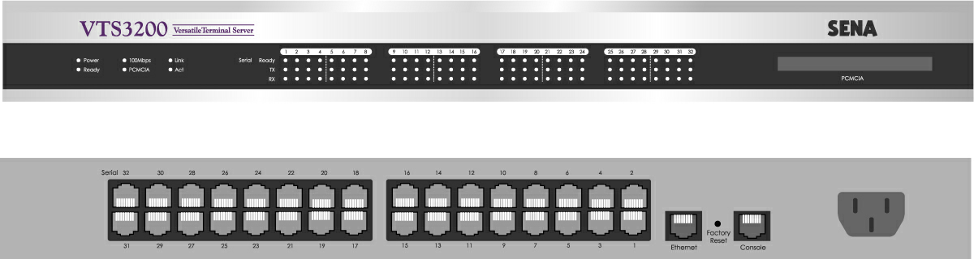
Figure 2-1. The panel layout of the VTS3200

Table 2-1. LED indicator lamps of the VTS3200

Lamps |  | Function
System | Power | Turned on if power is supplied
System | Ready | Turned on if system is ready to run
System | PCMCIA | Turned on if a PCMCIA device is running
Ethernet | 100Mbps | Turned on if 100Base-TX connection is detected
Ethernet | LINK | Turned on if connected to Ethernet network
Ethernet | Act | Blink whenever there is any activities such as incoming or outgoing packets through the VTS Ethernet port
Serial port | InUse | Turned on if the serial port is in use  (Port buffering enabled or port access in use)
Serial port | Rx/Tx | Blink whenever there is any incoming or outgoing data stream through the serial port of the VTS

2.1.2 VTS1600 Panel Layout

The front panel of the VTS1600 is nearly identical to the VTS3200. The VTS1600 has 16 serial port indicators, while the VTS3200 has 32. For further information, refer to the chapter, 2.1.1. VTS3200 Panel Layout.

2.1.3 VTS800 Panel Layout

The front panel of the VTS800 is nearly identical to the VTS3200. The VTS800 has 8 serial port indicators, while the VTS3200 has 32. For further information, refer to the chapter, 2.1.1. VTS3200 Panel Layout.

2.1.4 VTS400 Panel Layout

The front panel of the VTS400 is nearly identical to the VTS3200. The VTS800 has 4 serial port indicators, while the VTS3200 has 32. For further information, refer to the chapter, 2.1.1. VTS3200 Panel Layout.

2.1.5 VTS4800 Panel Layout

The VTS4800 has two groups of LED indicator lamps to display the status, as shown in Figure 2-2 (i.e. System and Ethernet). The first four(five) lamps on the left side indicate Power 1(/2), Ready, PCMCIA interface and Find-Me Function. The next three lamps are for Ethernet 100Mbps, Link and Act. There is no lamp for serial ports in VTS4800 model. Table 2-2 describes the function of each LED indicator lamp. The rear panel shows the serial ports with RJ45 connector, Ethernet port, the VTS4800 console port and the power socket.

(Front panel of Dual Power Model)

(Front panel of Single Power Model)

(Rear Panel)
Figure 2-2. The panel layout of the VTS4800

Table 2-2. LED indicator lamps of the VTS4800

Lamps |  | Function
System | Power 1/2 | Turned on if power is supplied
System | Ready | Turned on if system is ready to run
System | PCMCIA | Turned on if a PCMCIA device is running
System | Find Me | Blinking if user select probing function through HD manager
Ethernet | 100Mbps | Turned on if 100Base-TX connection is detected
Ethernet | LINK | Turned on if connected to Ethernet network
Ethernet | Act | Blink whenever there is any activities such as incoming or outgoing packets through the VTS Ethernet port

2.2 Connecting the Hardware

This section describes how to connect the VTS to the equipment for initial testing.
- Connect a power source to the VTS
- Connect the VTS to an Ethernet hub or switch
- Connect the device

2.2.1 Connecting the power

Connect the power cable to the VTS. If the power is properly supplied, the [Power] lamp will light up green.
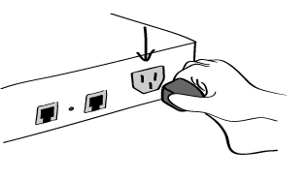
Figure 2-3. Connecting the power to the VTS

2.2.2 Connecting to the network

Plug one end of the Ethernet cable to the VTS Ethernet port. The other end of the Ethernet cable should be connected to a network port. If the cable is properly connected, the VTS will have a valid connection to the Ethernet network. This will be indicated by:
The [Link] lamp will light up green.
The [Act] lamp will blink to indicate incoming/outgoing Ethernet packets
The [100Mbps] lamp will light up green if the VTS is connected to 100Base-TX network
The [100Mbps] lamp will not turn on if the current network connection is 10Base-T.
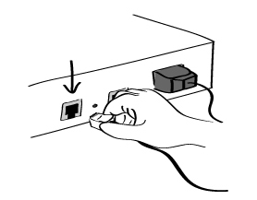
Figure 2-4. Connecting a network cable to the VTS

2.2.3 Connecting to the device

Connect the console cable to the VTS serial port. To connect to the console port of the device, the user needs to consider the type of console port provided by the device itself. In the VTS cable kit package, plug-in adapters are provided for the easier connectivity to the user’s devices. Please refer to the Appendix, A.3 Cabling diagram for details.

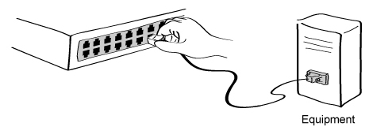
Figure 2-5. Connecting a equipment to the VTS

2.3 Accessing the System Console

There are several ways to access the VTS. These methods are dependent on whether the user is located at a local site or a remote site, or whether s/he requires a menu-driven interface, graphic menu system or CLI (Command Line Interface).

- System console:
Local users can connect directly to the system console port of the VTS using the console/Ethernet cable with the corresponding adapter.
- Remote console:
Remote users who require a menu-driven interface can utilize Telnet (port 23) or SSH (port 22) connections to the VTS using terminal emulator.
- Web:
Remote users who want to use a web browser to configure the VTS can connect to the VTS using conventional web browsers, such as Internet Explorer or Netscape Navigator.

The above methods require the user authentication by the VTS system.

2.3.1 Using the System console

- Connect one end of the console/Ethernet cable to the console port on the VTS.
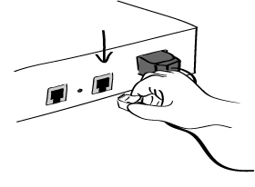
Figure 2-6. Connecting a system console cable to the VTS
- Connect to the user’s computer with the RJ45-DB9 female adapter.
- Connect the other end of the cable to the serial port of the user’s computer.
- Run a terminal emulator program (i.e. HyperTerminal). Set up the serial configuration parameters of the terminal emulation program as follows:
  - 9600 Baud rate
  - Data bits 8
  - Parity None
  - Stop bits 1
  - No flow control
- Press the [ENTER] key.
- Enter your user name and password to log into the VTS. The factory default user settings are as follows.
Login: root Password: root
Login: admin Password: admin

192.168.161.5 login: root
Password:****
root@192.168.161.5:~#

192.168.161.5 login: admin
Password:

Welcome to VTS-3200 Configuration
Press Enter

- Upon authentication, the corresponding user interface is displayed. Either the text-menu driven interface or the CLI are initially provided for configuration. Please refer to the chapter 9.1. User Administration for details on the default user interfaces available for each user role. For details on the CLI, refer to the chapter 11. CLI guide.

If the default interface is set up as text menu, the menu screen in Figure 2-7 is displayed.

192.168.161.5 login: admin
Password:

-------------------------------------------------------------------------------
Welcome to VTS-1600 configuration page
Current time : 02/25/2003 16:46:34 F/W REV. : v1.0.0
Serial No. : vts32000302-00001 MAC Address : 00-01-95-a1-89-b7
IP mode : Static IP IP Address : 192.168.161.5
-------------------------------------------------------------------------------
Select menu
1. Network Configuration
2. Serial Port Configuration
3. Clustering Configuration
4. Power Controller
5. PC Card Configuration
6. System Status & Log
7. System Administration
8. Save Changes
9. Exit without Saving
a. Exit and Apply Changes
b. Exit and Reboot
<ENTER> Refresh
----->

Figure 2-7. The main menu screen (VTS 3200)

From the main menu screen, the user may select the menu item for the configuration of the VTS parameters by typing the menu number and pressing the [ENTER] key. In the submenu screen, users can configure the required parameters guided by online comments. All the parameters are stored into the non-volatile memory space of the VTS, and it will not be stored until users select menu 8.Save Changes. All the configuration change will be effective after selecting the menu a. Exit and Apply Changes or b. Exit and Reboot.

2.3.2 Using Remote console

The IP address of the VTS must be known before users can access the VTS using the Remote console (see chapter 3. Network Configuration for details). The default VTS IP address is 192.168.161.5.
The Remote console access function can be disabled in the remote host access option (See IP filtering in section 3.5 for details). The VTS supports both Telnet and SSH protocol for remote consoles.

The following instructions will assist in setting up the Remote Console functionality:

- Run either a Telnet (or SSH) program or a program that supports Telnet (or SSH) functions (i.e. TeraTerm-Pro or HyperTerminal). The target IP address and the port number must match the VTS. If required, specify the port number as 23 (or 22). Type the following command in the command line interface of user’s computer.
telnet 192.168.161.5 (or ssh admin@192.168.161.5 )
Or run a Telnet program with the following parameters:
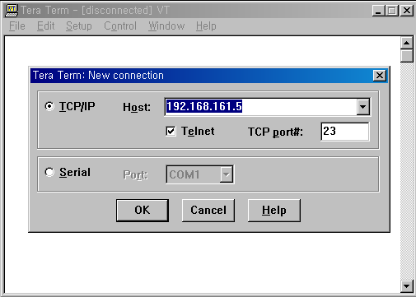
Figure 2-8. Telnet program set up example (TeraTerm Pro)

- The user must log into the VTS. Type the user name and password. A factory default setting of the user name and password are both root for the system root and admin for the system administrator (See the section, 9.1. User Administration).
- Upon authentication by the VTS, one of the CLI prompts or text menu screens are shown to the user according to the default shell configuration of the user’s account. (Refer to Chapter 11. CLI guide for details if the user is logged into the CLI prompt.) The menu-driven interface allows the user to select a menu item by typing the menu number and then pressing [ENTER]. The corresponding screen allows user configuration of the required parameters.

2.4 Accessing the Web Browser Management Interface

The VTS supports both HTTP and HTTPS (HTTP over SSL) protocols. The VTS also provides has its own Web management pages. To access the VTS Web management page, enter the VTS’s IP address or resolvable hostname into the web browser’s URL/Location field. This will direct the user to the VTS login screen. The user must authenticate themselves by logging into they system with a correct user name and password. The factory default settings are:
Login: root Password: root
Login: admin Password: admin

Note: Before accessing the VTS Web management page, the user must check the VTS’s IP address (or resolvable Hostname) and Subnet mask settings.

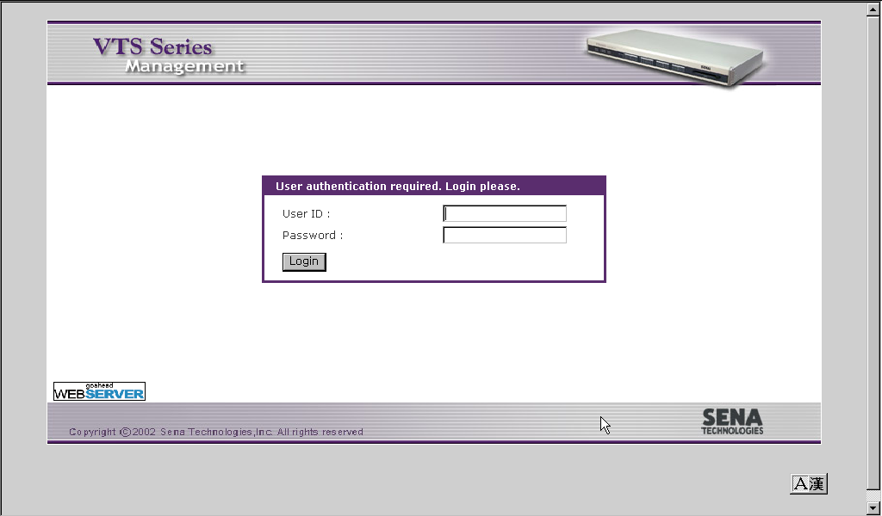
Figure 2-9. Login screen of the VTS Web Management

Figure 2-10 shows the user homepage of the VTS Web management interface. A menu bar is provided on the left side of the screen. The menu bar includes the uppermost configuration menu groups. Selecting an item on the menu bar opens a tree view of all the submenus available under each grouping. Selecting a submenu item will allow the user to modify parameter settings for that item. Every page will allow the user to [Save to flash], [Save & apply] or [Cancel] their actions. After changing the configuration parameter values, the users must select [Save to flash] to save the changed parameter values to the non-volatile memory. To apply all changes made, the user must select [Apply Changes]. This option is available on the bottom of the menu bar. Only when the user selects [Apply changes] will the new parameter values be applied to the VTS configuration. The user also can select [Save & apply] to save parameters and apply changes in one step.
If the user does not want to save the new parameter values, the user must opt to [Cancel]. All changes made will be lost and the previous values restored.

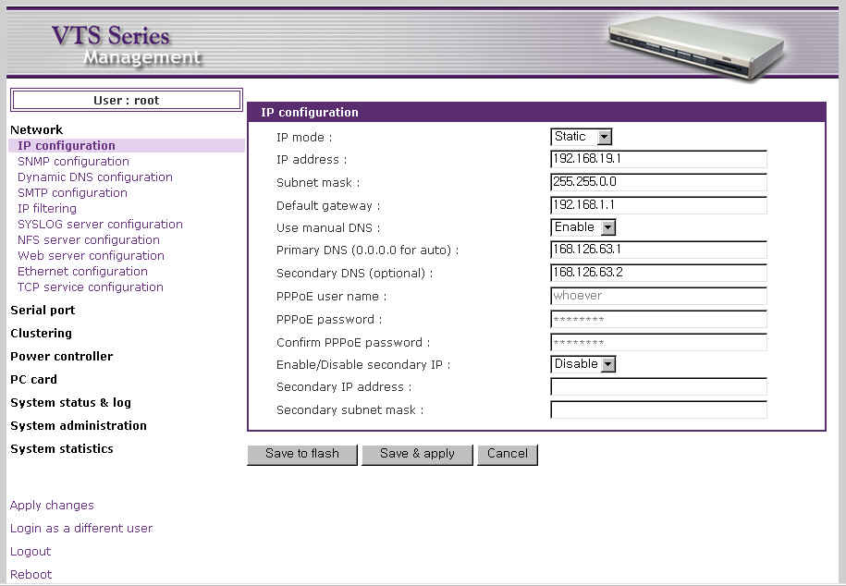
Figure 2-10. The VTS Web Management screen

3: Network Configuration

3.1 IP Configuration

The VTS requires a valid IP address to operate within the user’s network environment. If the IP address is not readily available, contact the system administrator to obtain a valid IP address for the VTS. Please note that the VTS requires a unique IP address to connect to the user’s network.
The users may choose one of three Internet protocols in setting up the VTS IP address: i.e.,
- Static IP
- DHCP (Dynamic Host Configuration Protocol)
- PPPoE (Point-to-Point Protocol over Ethernet)

The VTS is initially defaulted to Static IP mode, with a static IP address of 192.168.161.5. Table 3-1 shows the configuration parameters for all three IP configurations. Figure 3-1 shows the actual web-based GUI to change the user’s IP configuration.

Table 3-1. IP Configuration Parameters

Static IP | IP address
Static IP | Subnet mask
Static IP | Default gateway
Static IP | Use manual DNS/Primary DNS/Secondary DNS
Static IP | Enable/Disable secondary IP / Secondary IP address / Secondary subnet mask
DHCP | Use manual DNS/Primary DNS/Secondary DNS (Optional)
DHCP | Enable/Disable secondary IP / Secondary IP address / Secondary subnet mask
PPPoE | PPPoE Username
PPPoE | PPPoE Password
PPPoE | Use manual DNS/Primary DNS/ Secondary DNS (Optional)
PPPoE | Enable/Disable secondary IP / Secondary IP address / Secondary subnet mask

Users can also access to the VTS through the secondary IP address as long as Enable/Disable secondary IP address is enabled and secondary IP address and subnet mask is set available in static IP protocol. Refer to 3.1.1 Using a Static IP Address to enable and configure the secondary IP address.
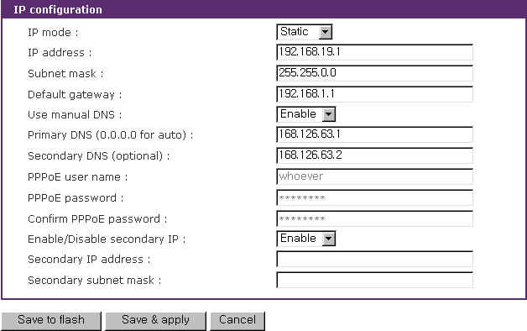
Figure 3-1 IP Configuration

3.1.1 Using a Static IP Address

When using a Static IP address, the user must manually specify all the configuration parameters associated with the VTS’s IP address. These include the IP address, the network subnet mask, the gateway computer and the domain name server computers. This section will look at each of these in more detail.

Note: The VTS will attempt to locate all this information every time it is turned on. .

IP address
A Static IP address acts as a “static” or permanent identification number. This number is assigned to a computer to act as its location address on the network. Computers use these IP addresses to identify and talk to each other on a network. Therefore, it is imperative that the selected IP address be both unique and valid in a network environment.

Note: 192.168.1.x will never be assigned by and ISP (Internet Service Provider). IP addresses using this form are considered private. Actual application of the VTS Series may require access to public network, such as the Internet. If so, a valid public IP address must be assigned to the user’s computer. A public IP address is usually purchased or leased from a local ISP.

Subnet mask
A subnet represents all the network hosts in one geographic location, such as a building or local area network (LAN). The VTS will use the subnet mask setting to verify the origin of all packets. If the desired TCP/IP host specified in the packet is in the same geographic location (on the local network segment) as defined by the subnet mask, the VTS will establish a direct connection. If the desired TCP/IP host specified in the packet is not identified as belonging on the local network segment, a connection is established through the given default gateway.

Default gateway
A gateway is a network point that acts as a portal to another network. This point is usually the computer or computers that control traffic within a network or a local ISP (Internet service provider). The VTS uses the IP address of the default gateway computer to communicate with hosts outside the local network environment. Refer to the network administrator for a valid gateway IP address.

Primary and Secondary DNS
The DNS (Domain Name System) server is used to locate and translate the correct IP address for a requested web site address. A domain name is the web address (i.e. www.yahoo.com) and is usually easier to remember. The DNS server is the host that can translate such text-based domain names into the numeric IP addresses for a TCP/IP connection.
The IP address of the DNS server must be able to access the host site with the provided domain name. The VTS provides the ability to configure the required IP addresses of both the Primary and Secondary DNS servers addresses. (The secondary DNS server is specified for use when the primary DNS server is unavailable.)

3.1.2 Using DHCP

Dynamic Host Configuration Protocol (DHCP) is a communications protocol that lets network administrators manage and automate the assignment of IP addresses centrally in an organization's network. DHCP allows the network administrator the ability to supervise and distribute IP addresses from a central point and automatically send a new IP address when a computer is plugged into a different network location.
When in static IP mode, the IP address must be entered manually at each computer. If a computer is moved to another network location, a new IP address must be assigned. DHCP allows all the parameters, including the IP address, subnet mask, gateway and DNS servers to be automatically configured when the IP address is assigned. DHCP uses a “lease” concept in assigning IP addresses to a computer. It limits the amount of time a given IP address will be valid for a computer. All the parameters required to assign an IP address are automatically configured on the DHCP server side, and each DHCP client computer receives this information when the IP address is provided at its boot-up.
Each time a computer is reset, the VTS broadcasts a DHCP request over the network. The reply generated by the DHCP server contains the IP address, as well as the subnet mask, gateway address, DNS servers and the “lease” time. The VTS immediately places this information in its memory. Once the “lease” expires, the VTS will request a renewal of the “lease” time from the DHCP server. If the DHCP server approves the request for renewal, the VTS can continue to work with the current IP address. If the DHCP server denies the request for renewal, the VTS will start the procedure to request a new IP address from the DHCP server.

Note: While in DHCP mode, all network-related parameters for the VTS are to be configured automatically, including the DNS servers. If the DNS server is not automatically configured, the user may manually configure the settings by entering the primary and secondary DNS IP addresses. To force an automatic configuration of the DNS address, set the primary and secondary DNS IP addresses to 0.0.0.0 (recommended).

A DHCP sever assigns IP addresses dynamically from an IP address pool, which is managed by the network administrator. This means that the DHCP client, i.e. the VTS, receives a different IP address each time it boots up. The IP address should be reserved on the DHCP server side to assure that the user always knows the newly assigned VTS address. In order to reserve the IP address in the DHCP network, the administrator needs the MAC address of the VTS found on the label sticker at the bottom of the VTS.

3.1.3 Using PPPoE

PPPoE (Point-to-Point Protocol over Ethernet) is a specification for connecting multiple computer users on an Ethernet LAN (local area network) to a remote site through a modem or similar device. PPPoE can be used to multiple users the ability to share ADSL, cable modem, or wireless connection to the Internet.
To use the VTS in PPPoE mode, users require a PPPoE account and the necessary equipment for PPPoE access (i.e. an ADSL modem). Since the VTS provides a PPPoE protocol, it can access the remote host on the Internet over an ADSL connection. The user will have to set up the user name and password of the PPPoE account for the VTS.
The VTS negotiates the PPPoE connection with the PPPoE server whenever it boots up. During the negotiation, the VTS receives the information required for an Internet connection, such as the IP address, gateway, subnet mask and DNS servers. If the connection is established, the VTS will maintain the connection for as long as possible. If the connection is terminated, the VTS will attempt to make a new PPPoE connection by requesting a new connection.

Note: While in PPPoE mode, all network-related parameters for the VTS are to be configured automatically, including the DNS servers. If the DNS server is not automatically configured, the user may manually configure the settings by entering the primary and secondary DNS IP addresses. To force an automatic configuration of the DNS address, set the primary and secondary DNS IP addresses to 0.0.0.0 (recommended).

3.2 SNMP Configuration

The VTS has the SNMP (Simple Network Management Protocol) agent supporting SNMP v1 and v2 protocols. Network managers like NMS or SNMP Browser can exchange information with VTS, as well as access required functionality.

SNMP protocols include GET, SET, GET–Next, and TRAPs. With these functions, a manager can be notified of significant events (TRAPs), query a device for more information (GET), and make changes to the device state (SET). SNMPv2 adds a GET–Bulk function for retrieving tables of information and security functions.

With the SNMP configuration panel, the user can configure MIB-II System objects, access control settings and TRAP receiver settings. The manager configured in this menu can perform both information exchange and action control. Figure 3-2 shows a SNMP configuration screen via a web interface.
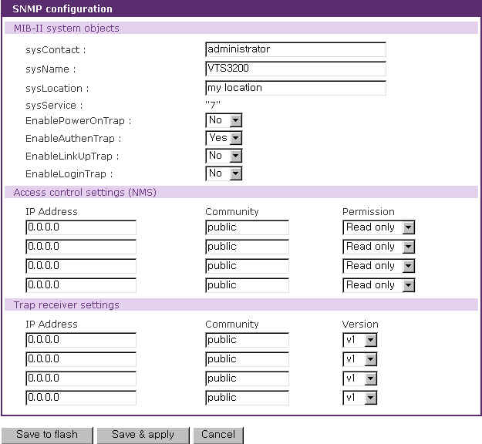
Figure 3-2 SNMP configuration

3.2.1 MIB-II System objects Configuration

MIB–II System objects configuration sets the System Contact, Name, Location, and Authentication-failure traps used by the SNMP agent of the VTS. These settings provide the values used for the MIB-II sysName, sysContact, sysLocation, snmpEnableAuthenTraps, snmpEnable- PowerOnTrap, snmpEnableAuthenTrap, snmpEnableLinkUpTrap and snmpEnableLoginTrap Object Identifications (OIDs).

Brief descriptions of each OIDs are as follows,

- sysContact: Identification of the contact person for the managed system (VTS), and a description of how to contact the person.
- sysName: Name used to identify the system. By convention, this is the fully qualified domain name of the node.
- sysLocation: The physical location of the system (e.g., Room 384, Operations Lab, etc.).
- sysService(Read Only) : A series of values, separated by commas, that indicate the set of services that the system provides. By default, VTS only supports an Application(7) service level.
- EnablePowerOnTrap: Indicates whether the SNMP agent process is permitted to generate power-on traps.
- EnableAuthenTrap: Indicates whether the SNMP agent process is permitted to generate authentication-failure traps. The value of this object overrides any configuration information; as such, it provides a means whereby all authentication-failure traps may be disabled..
- EnableLinkUpTraps: Indicates whether the SNMP agent process is permitted to generate Ethernet-link traps
- EnableLoginTrap: Indicates whether the SNMP agent process is permitted to generate system login traps.

If users need support for adding or modifying MIBs, please contact Sena technical support.
For more information about the MIBs and SNMP, see the RFCs 1066, 1067, 1098, 1317, 1318 and 1213.

3.2.2 Access Control Configuration

Access Control defines accessibility of managers to the VTS SNMP agent. Only the manager set in this menu can access VTS SNMP agent to exchange information and control actions. If there is no specified IP address (all IP address are defaulted to 0.0.0.0), a manager from any host can access the VTS SNMP agent.

3.2.3 Trap Receiver Configuration

The Trap receiver defines managers, which can be notified of significant events(TRAP) from the VTS SNMP agent.

3.2.4 Management using SNMP

The VTS can be managed through the SNMP protocol using NMS (Network Management System) or SNMP Browser. Before using the NMS or SNMP Browser, the user must set the access control configuration properly so that the VTS permits host access where the NMS or SNMP Browser is executed. Figure 3-3 shows a screen shot of a typical SNMP browser with MIB-II OIDs of the VTS SNMP agent.

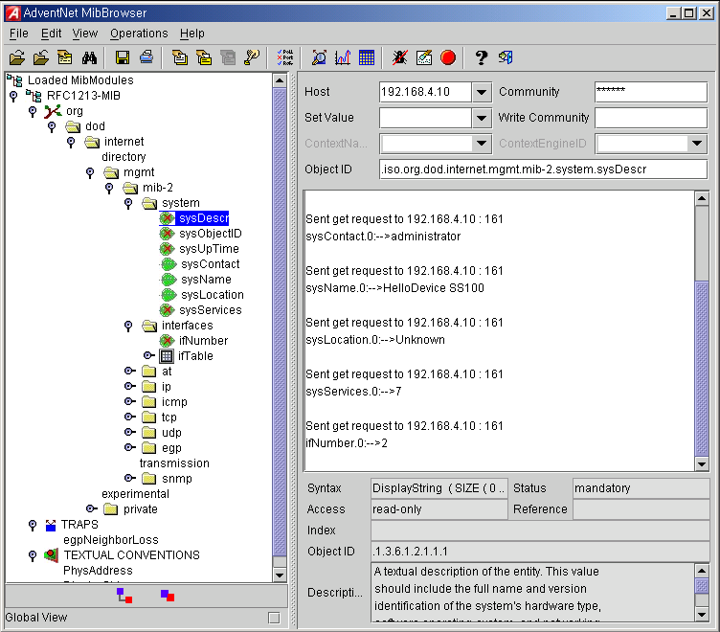

Figure 3-3 Browsing MIB-II OIDs of VTS SNMP agent using SNMP Browser
(AdventNet MibBrowser)

3.3 Dynamic DNS Configuration

When users connect the VTS to a DSL line or use a DHCP configuration, the IP address might be changed whenever it reconnects to the network. It can therefore be very difficult to post all related contacts for each new IP address. In addition, if the administrator only has access through the remote console, there is no way to know if an IP address has changed, or what the new IP address is.

A Dynamic DNS service is provided by various ISPs or organizations to deal with the above issue. By using the Dynamic DNS service, users can access the VTS through the hostname registered in the Dynamic DNS Server regardless of any IP address change.

By default, the VTS only supports Dynamic DNS service offered at Dynamic DNS Network Services, LLC (www.dyndns.org). Contact Sena technical support for issues regarding other Dynamic DNS service providers.

To use the Dynamic DNS service provided by Dynamic DNS Network Services, the user must set up an account in their Members' NIC (Network Information Center - http://members.dyndns. org). The user may then add a new Dynamic DNS Host link after logging in to their Dynamic DNS Network Services Members NIC.

After enabling the Dynamic DNS service in the Dynamic DNS Configuration menu, the user must enter the registered Domain Name, User Name, and Password. After applying the configuration change, users can access the VTS using only the Domain Name.

Figure 3-4 shows the Dynamic DNS configuration web interface.

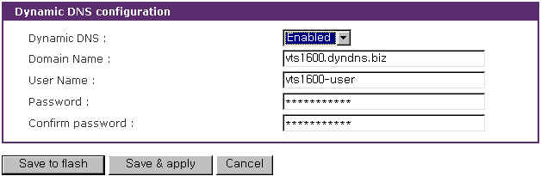

Figure 3-4 Dynamic DNS configuration

3.4 SMTP Configuration

The VTS can send an email notification when the number of system log messages reaches to certain value and/or when an alarm message is created due to an issue with serial port data. The user must configure a valid SMTP server to send these automatically generated emails. The VTS supports three SMTP server types:
- SMTP without authentication
- SMTP with authentication
- POP-before-SMTP

Figure 3.6 shows these examples. Required parameters for each SMTP configuration include:
- Primary / Secondary SMTP server name
- Primary / Secondary SMTP mode
- Primary / Secondary SMTP user name
- Primary / Secondary SMTP user password
- Device mail address

The device mail address specifies the sender’s email address for all log and alarm delivery emails. SMTP servers often check only the sender’s host domain name of the email address for validity. . Consequently, the email address set for the device can use an arbitrary username with a registered hostname (i.e. arbitrary_user@yahoo.com or anybody@sena.com).

The SMTP user name and SMTP user password are required when either SMTP with authentication or POP-before-SMTP mode is selected.

Secondary SMTP configuration is also provided so that mail can be delivered even when the primary SMTP server fails. Only when the primary SMTP server fails, the secondary SMTP server will be tried for mail delivery.

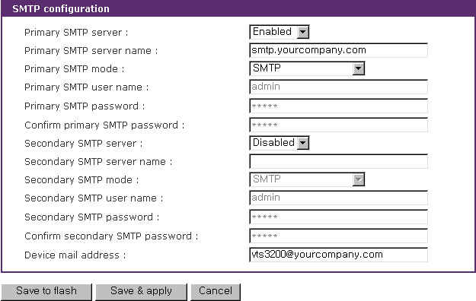
Figure 3-5 SMTP configuration

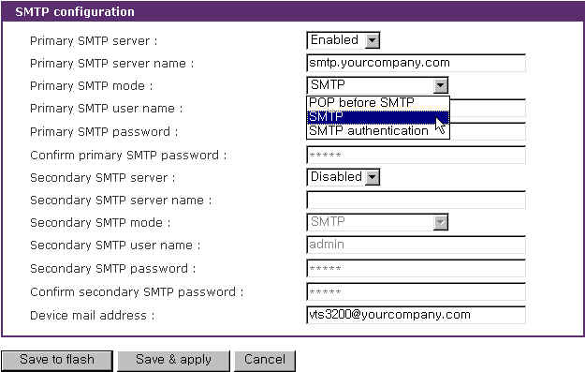
Figure 3-6 SMTP mode selection in SMTP configuration

3.5 IP Filtering

The VTS keeps unauthorized hosts from accessing to the VTS by specifying IP filtering rules. A IP filtering rule consists of Interface, Option, IP address/Mask, Port and Chain rule.

Interface
The Interface is the optional name of the network interface via which a packet is received. It can be one of these three values:
- eth0 : the VTS default interface
- eth1 : the interface added by network PC card or wireless network PC card
- all : both of eth0 and eth1

Option
The Option determines that this rule will be applied to the hosts included or excluded in hosts range specified by the IP address/Mask. It can be one of these two values:
- Normal : applied to the hosts included
- Invert : applied to the hosts excluded

IP address/Mask
The IP address/Mask specifies the host range by entering base host IP address followed by “/” and subnet mask. The host range can be one of the following scenarios by changing the value:
- Only one host of a specific IP address
- Hosts on a specific subnet
- Any host
Table 3-2 Input examples of IP address/Mask
Specified host range | Input format
Specified host range | Base Host IP address | Subnet mask
Any host | 0.0.0.0 | 0.0.0.0
192.168.1.120 | 192.168.1.120 | 255.255.255.255
192.168.1.1 ~ 192.168.1.254 | 192.168.1.0 | 255.255.255.0
192.168.0.1 ~ 192.168.255.254 | 192.168.0.0 | 255.255.0.0
192.168.1.1 ~ 192.168.1.126 | 192.168.1.0 | 255.255.255.128
192.168.1.129 ~ 192.168.1.254 | 192.168.1.128 | 255.255.255.128

Port
The Port is a port or port range of the VTS which hosts try to access to. The port range can be specified by entering port1:port2 where the port range starts with port1 and ends with port2.

Chain rule
The Chain rule determines whether the access of the hosts is allowed or not. It can be one of the these two values :
- ACCEPT : access allowed
- DROP : access not allowed
Figure 3-7 shows IP filtering configuration.

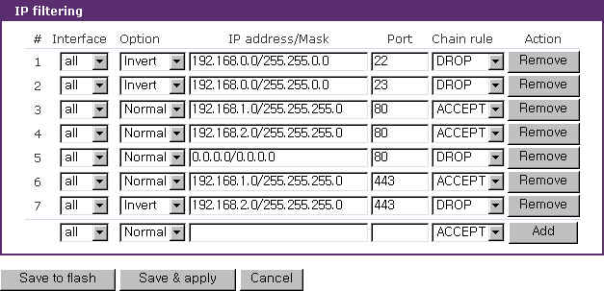
Figure 3-7 IP filtering configuration

The #1 IP filtering rule at Figure 3-7 means the hosts which is not included (Option : invert) in the host range from 192.168.0.1 to 192.168.255.254(IP address/Mask : 192.168.0.0/255.255.0.0) are not allowed (Chain rule : DROP) to connect to SSH (port : 22) of the VTS via both of eth0 and eth1 (Interface : all). The #1 allows only the hosts whose subnet is 192.168.x.x to access to the VTS through SSH. The #2 IP filtering rule allows those which belongs to the subnet 192.168.x.x to connect to the VTS through the telnet via both eth0 and eth1.

No host is allowed to connect to the VTS through http (port 80) by the #5 rule but the hosts whose subnet is 192.168.1.x is allowed by the #3 rule and 192.168.2.x by the rule #4. So, only the hosts which belong to the subnet 192.168.1.x or 192.168.2.x can access to the VTS through http by the #3, #4 and #5 rules.
No host except the hosts whose subnet is 192.168.1.x is allowed to connect to the VTS through https (port 443) by the #7 rule. But, hosts included in the subnet 192.168.1.x are allowed by the #6 rule. So, only the hosts which belong to the subnet 192.168.1.x or 192.168.2.x can access to the VTS through https by the #6 and #7 rules.

Users can add a new IP filtering rule by setting the properties at adding line and then clicking the Add button. User can remove a rule by clicking the Remove button. Users can also edit the rules if they set the rule properties and click the Save to flash or the Save & apply button. The VTS will not filter the access of the hosts according to the IP filtering rules before users apply the changes by clicking the Save & apply button or selecting Apply changes at menu.

3.6 SYSLOG server configuration

The VTS supports a remote message logging service, SYSLOG service for the system and port data logging. To use the remote SYSLOG service, the user must specify the SYSLOG server’s IP address and the facility to be used. Figure 3-8 shows the SYSLOG server configuration page of the supplied Web interface. The VTS provides a maximum of two SYSLOG servers. If the secondary SYSLOG server is configured, the VTS will send the same SYSLOG messages to both servers.

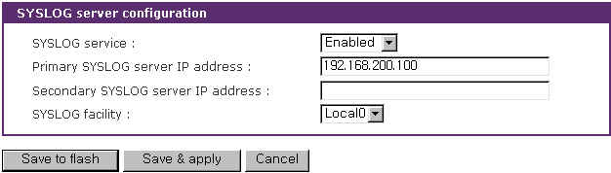
Figure 3-8 SYSLOG server configuration

To receive log messages from the VTS, the SYSLOG server specified in the VTS’s configuration must be configured as “remote reception allowed”. If there is a firewall between the VTS and the SYSLOG server, the user must add a rule that will allow all outgoing and incoming UDP packets the ability to travel across.
The VTS supports SYSLOG facilities from local0 to local7. The user can employ these facilities to save messages from the VTS separately from the SYSLOG server.

If the SYSLOG service is enabled and the SYSLOG server configuration is properly set up, the user can specify the storage location for the VTS’s system log or port data log as SYSLOG server. For more information about the configuration of port/system log storage location, please refer to section, 4.3.6. Port Logging and 8.2 System Log Configuration.

3.7 NFS server configuration

The VTS supports NFS (Network File System) service for system or port data logging functions. The user must specify the NFS server’s IP address and the mounting path on the NFS server to use it. Figure 3-9 shows the web based NFS server configuration page.
To store the VTS log data to the NFS server, the NFS server specified in the VTS’s configuration must be configured as “read and write allowed”. If there is a firewall between the VTS and NFS server, the user must add a rule that will allow all outgoing and incoming packets to travel across.
If the NFS service is enabled and the NFS server configuration is properly set up, the user can specify the storage location for the VTS’s system log or port data log as the NFS server. If secondary NFS server is configured, the same VTS log messages are stored also in the secondary NFS server. For more information about the configuration of the port/system log storage location, please refer to section, 4.3.6. Port Logging and 8.2 System Log Configuration.

Required parameters for each NFS server configuration include:
- Primary / Secondary NFS server IP address
- Mounting path on primary / secondary NFS server
- Primary / Secondary NFS timeout
- Primary / Secondary NFS mount retrying interval
- Enable/Disable encrypted primary / secondary NFS server
- Encrypted primary / secondary NFS server user
- Encrypted primary / secondary NFS server password

NFS timeout specifies time out value for VTS to check how long it will wait the response from the NFS server if NFS server is not responding for some time. If there is no response form NFS server during the NFS timeout interval, VTS releases (unmount) a local directory which is mounted to the directory of NFS server(mounting path on NFS server) and changes data logging location to memory automatically if it is needed.

NFS mount retrying interval specifies time intervals for VTS to check whether connecting to NFS server is possible. VTS check whether connecting to NFS server is possible for every NFS mount retrying interval. And if connection to NFS server is possible, VTS remounts mounting path on NFS server on its local directory again and changes data logging location to NFS server automatically if it is needed.

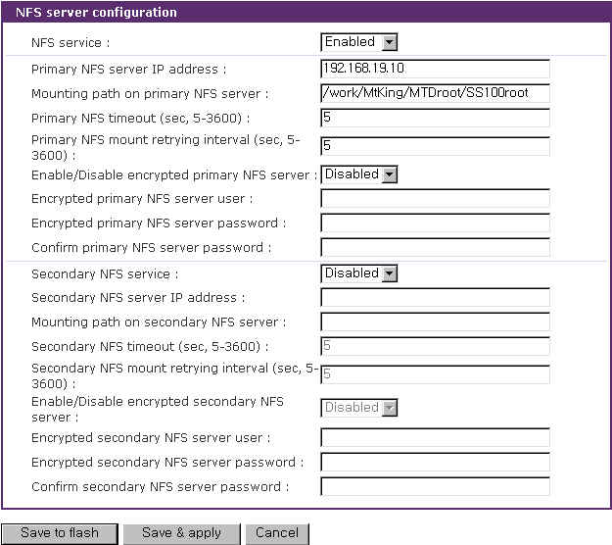
Figure 3-9 NFS server configuration

Whereas NFS is a wide spread protocol for sharing files through network, it has following security problem because it uses UDP protocol in general.
- Data between NFS server and client cannot be encrypted.
- There is no authentication method for the user who tries to connect NFS server.
- It is very difficult to use NFS if there is Firewall between NFS server and client.

But Encrypted NFS feature in VTS solves above problems by using SSH tunneling. To use Encrypted NFS feature, user must use NFS server that support TCP protocol. Most NFS servers for Microsoft Windows support TCP protocol. And also SSH daemon must be installed and run on the same host which be used as an Encrypted NFS server for VTS. And finally a utility program, pause.exe, which is included CR ROM accompanied with VTS products must be copied to the directory where SSH daemon program is located. For more detail procedures about using Encrypted NFS, please see Appendix F. Guide to use Encrypted NFS feature section.

3.8 Web server configuration

The VTS’ Web server supports both HTTP and HTTPS (HTTP over SSL) services simultaneously. The user can opt to enable or disable each individually. Figure 3-10 shows the Web based server configuration page.

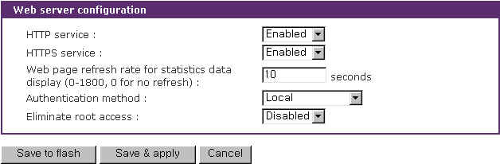
Figure 3-10 Web server configurations

The Web page refresh rate can be also adjusted in this configuration page. The refresh rate is only applicable to the serial port connection page, system statistics pages such as network interfaces, serial ports, IP, ICMP, TCP and UDP and power controller management pages. Other pages in the Web interface are not refreshed automatically. For more information about the serial port connection, please refer to section 4.5 Serial port connection. And for more information about the system statistics, please refer to section 10. System Statistics.

Users can select user authentication method for the VTS web pages login. The VTS currently provides authentication methods of Local, RADIUS, TACACS+, LDAP, and Kerberos Server.

The VTS Root user can be limited to access the VTS web interface by selecting Enabled at Eliminate root access. To keep the VTS Root user from access the remote or serial console of the telnet or SSH protocol, please refer to section 11. CLI Guide 11.1 Introduction.

Notes: Differently with serial ports user authentication, the VTS always refers to the local database for the web server login user authentication. Even when the user authentication method is configured as RDAIUS, TACAS+, LDAP, Kerberos, the authentication will be failed if local database has no record for the corresponding user. However, in this case, the password in the remote authentication server will be utilized instead of the password in the local database. Please refer to the section 4.3.9 Authentication configuration for the serial port authentication details. Also, please refer to the section 9.1 User Administration for the user administration of local database.

3.9 Ethernet configuration

The VTS supports several types of Ethernet modes:
- Auto Negotiation
- 100 BaseT Half Duplex
- 100 BaseT Full Duplex
- 10 BaseT Half Duplex
- 10 BaseT Full Duplex

After changing the Ethernet mode, the user must reboot the system. The factory default value of the Ethernet mode is Auto Negotiation. With most network environments, Auto Negotiation mode should work fine and recommended. Invalid Ethernet mode settings will not make the VTS work in the network environment.

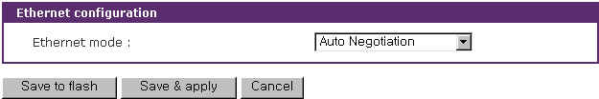
Figure 3-11 Ethernet mode configuration

3.10 TCP service configuration

If a TCP session is established between two hosts, it should be closed (normally or abnormally) by either of the hosts to prevent the lock-up of the corresponding TCP port. To prevent this type of lock-up situation, the VTS provides a TCP “keep-alive” feature. The VTS will send packets back and forth through the network periodically to confirm that the network is still alive. The corresponding TCP session is automatically closed if there’s no response from the remote host.

To use the TCP “keep-alive” feature with the VTS, the users should configure three parameters as follows:

- TCP keep-alive time :
This represents the interval of time between packet submissions by the VTS. These “keep-alive” messages are sent to the remote host after the TCP session is open to confirm that the session is still open. The default time value is 15 sec.
- TCP “keep-alive” probes :
This represents how many “keep-alive” probes the VTS will send to the remote host, until it decides that the connection is dead. Multiplied with the “TCP ‘keep-alive’ intervals”, this gives the time that a link is forced to close after a “keep-alive” packet has been sent for the first time.
The default is 3 times
- TCP keep-alive intervals :
This represents the interval of time before a “keep-alive” packets is retransmitted, due to no acknowledgement by the original Chinatown.
The default value is 5 seconds.

By default, the VTS will send the keep-alive packets 3 times with 5 seconds interval after 15 seconds have elapsed since the time when there’s no data transferred back and forth.

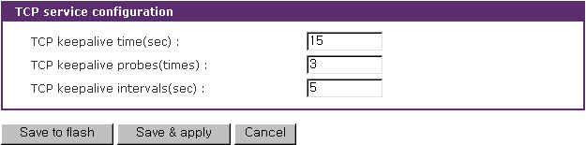
Figure 3-12 TCP keep-alive configuration

4: Serial Port Configuration

4.1 Overview

The serial port configuration capability allows the user to configure the host mode of each port, serial communication parameters, port logging parameters and other related parameters.

The serial port’s host mode can be set as any of the following:
- Console server mode: Connection requests are sent from the remote host. This is to allow access to the serial port from the remote host.
- Terminal server mode: Connection requests are sent from the serial port. This is to allow access to the remote host on the network.
- Dial-in modem mode : Allows access to the serial port from a remote site via an analog modem connection.
- Dial-in terminal server mode: Allows access to the remote host on the network via an analog modem connection.

The VTS also provides a port access menu. This menu displays all the serial ports via the web for easier access to the serial ports. The user is able to access any serial port by simply clicking the hyperlink for the port.

With the port-logging feature while in console server mode, the data sent through the serial port is transferred to MEMORY, SYSLOG server, NFS server’s storage or an ATA/IDE fixed disk card using a PC Card slot. The user can also define keywords for each serial port that will trigger an email or SNMP trap notification. This will enable the user to monitor the data from the attached device.
Using MEMORY to store data will result in loss of all information when the VTS is turned off. Use the NFS server or ATA/IDE fixed disk card to preserve the serial port log data.

One of the useful features provided is the “port sniffing” function. By using “port sniffing” function, users can access a serial port concurrently. But maximum number of sniff user is limited up to 15 users per port. This safeguard prevents unexpected memory shortages due to the increase of TCP sessions.
The serial ports can be configured individually or all at once. Table 4-1 summarizes the configuration parameters related to the serial port configuration.

Table 4-1. Serial port configuration parameters
Port Access Menu | Port access menu Enable/Disable
Port Access Menu | Port access menu port number (listening TCP port)
Port Access Menu | Port access menu protocol (Telnet or SSH)
Port Access Menu | Port access menu inactivity timeout (seconds)
Port Access Menu | Port access menu local IP
Port Access Menu | Port access menu quick connect via (Web applet or Telnet)
Port Access Menu | Port access menu web applet encoding – Web applet only (English (latin1), Korean (KSC5601), Japanese (eucjp), Unicode (UTF8))
Port Access Menu | Port access menu authentication method (Local, RADIUS, TACAS+, LDAP)
Port Access Menu | Enable/Disable email alert for port login
Port Access Menu | Title of email
Port Access Menu | Recipient’s email address
Port Access Menu | Enable/Disable port login trap
Port Access Menu | User global SNMP configuration
Port Access Menu | First / Second Trap receiver settings | IP Address
Port Access Menu | First / Second Trap receiver settings | Community
Port Access Menu | First / Second Trap receiver settings | Version
All serial ports setting  Or  Individual serial port setting  #1~#16(32) | Port Enable/Disable | Enable/Disable port
 | Port Enable/Disable | Reset port (Individual serial port only)
 | Port Enable/Disable | Set port as factory default (Individual serial port only)
 | Port title
 | Apply all port settings (Individual serial port setting only)
 | Host mode configuration | Console  server |  | Enable/Disable assigned IP
 | Host mode configuration |  |  | Assigned IP
 | Host mode configuration |  |  | Listening TCP port
 | Host mode configuration |  |  | Protocol (Telnet/SSH/RawTCP)
 | Host mode configuration |  |  | Port escape sequence
 | Host mode configuration |  |  | Port break sequence
 | Host mode configuration |  |  | Inactivity timeout (0 for unlimited)
 | Host mode configuration |  |  | Use comment
 | Host mode configuration |  |  | Quick connect via
 | Host mode configuration |  |  | Web applet encoding (same as Port access menu web applet encoding)
 | Host mode configuration | Terminal  server |  | Destination IP
 | Host mode configuration |  |  | Destination port
 | Host mode configuration |  |  | Protocol (Telnet/SSH/RawTCP)
 | Host mode configuration |  |  | Inactivity timeout (0 for unlimited)
 | Host mode configuration | Dial-in modem |  | Inactivity timeout (0 for unlimited)
 | Host mode configuration |  |  | Modem init string
 | Host mode configuration | Dial-in  terminal server |  | Destination IP
 | Host mode configuration |  |  | Destination port
 | Host mode configuration |  |  | Protocol (Telnet/SSH/ RawTCP)
 | Host mode configuration |  |  | Inactivity timeout (0 for unlimited)
 | Host mode configuration |  |  | Modem init string
 | Serial Port Parameters | Baud rate
 | Serial Port Parameters | Data bits
 | Serial Port Parameters | Parity
 | Serial Port Parameters | Stop bits
 | Serial Port Parameters | Flow control
 | Serial Port Parameters | DTR behavior
 | Serial Port Parameters | Inter-character timeout (ms) (RawTCP only)
 | Port logging  (only provided in console server mode) | Port logging enable/disable
 | Port logging  (only provided in console server mode) | Logging direction (Server output / User input / Both with arrows / Both without arrows)
 | Port logging  (only provided in console server mode) | Port log storage location (Memory / CF card / NFS server / SYSLOG server)
 | Port logging  (only provided in console server mode) | Port log buffer size
 | Port logging  (only provided in console server mode) | Port log file name (User port title / Specify below + file name)
 | Port logging  (only provided in console server mode) | Time stamp to port log enable/disable
 | Port logging  (only provided in console server mode) | Show last 10 lines of a log upon connect enable /disable
 | Port logging  (only provided in console server mode) | Monitoring interval (sec.)
 | Port event handling (only provided on port logging enabled) | Key word
 | Port event handling (only provided on port logging enabled) | Email notification Enable/Disable
 | Port event handling (only provided on port logging enabled) | Title of email
 | Port event handling (only provided on port logging enabled) | Recipient’s email address
 | Port event handling (only provided on port logging enabled) | SNMP trap notificatin Enable/Disable
 | Port event handling (only provided on port logging enabled) | Title of SNMP trap
 | Port event handling (only provided on port logging enabled) | Use global SNMP configuration
 | Port event handling (only provided on port logging enabled) | First / Second Trap receiver settings | IP Address
 | Port event handling (only provided on port logging enabled) | First / Second Trap receiver settings | Community
 | Port event handling (only provided on port logging enabled) | First / Second Trap receiver settings | Version
 | Port IP filtering (console server mode only) | Allowed base hosts IP
 | Port IP filtering (console server mode only) | Subnet mask to be applied
 | Authentication | None
 | Authentication | Local
 | Authentication | RADIUS server | First RADIUS authentication server
 | Authentication | RADIUS server | Second RADIUS authentication server
 | Authentication | RADIUS server | First RADIUS accounting server
 | Authentication | RADIUS server | Second RADIUS accounting server
 | Authentication | RADIUS server | RADIUS timeout (0-300 sec.)
 | Authentication | RADIUS server | RADIUS secret
 | Authentication | RADIUS server | RADIUS retries (0-50 times)
 | Authentication | TACAS+ server | First TACAS+ authentication server
 | Authentication | TACAS+ server | Second TACAS+ authentication server
 | Authentication | TACAS+ server | First TACAS+ accounting server
 | Authentication | TACAS+ server | Second TACAS+ accounting server
 | Authentication | TACAS+ server | TACAS+ secret
 | Authentication | LDAP server | First LDAP authentication server
 | Authentication | LDAP server | Second LDAP authentication server
 | Authentication | LDAP server | LDAP search base
 | Authentication | Kerberos server | First Kerberos authentication server
 | Authentication | Kerberos server | Second Kerberos authentication server
 | Authentication | Kerberos server | Realm for first Kerberos server
 | Authentication | Kerberos server | Realm for second Kerberos server
 | User access control | <<Everyone>> or individual user’s access | Port
 | User access control | <<Everyone>> or individual user’s access | Monitor
 | User access control | <<Everyone>> or individual user’s access | Power
 | User access control | Sniff session | Enable/Disable sniff mode
 | User access control | Sniff session | Sniff session display mode (Server output / User input / Both)
 | User access control | Sniff session | Display data direction arrows enable/disable
 | Alert configuration (console server mode only) | Email alert for port login Enable/Disable
 | Alert configuration (console server mode only) | Title of email
 | Alert configuration (console server mode only) | Recipient’s email address
 | Alert configuration (console server mode only) | Email alert for device connection Enable/Disable
 | Alert configuration (console server mode only) | Title of email
 | Alert configuration (console server mode only) | Recipient’s email address
 | Alert configuration (console server mode only) | Port login trap Enable/Disable
 | Alert configuration (console server mode only) | Device connection trap Enable/Disable
 | Alert configuration (console server mode only) | Use global SNMP configuration
 | Alert configuration (console server mode only) | First / Second Trap receiver settings | IP Address
 | Alert configuration (console server mode only) | First / Second Trap receiver settings | Community
 | Alert configuration (console server mode only) | First / Second Trap receiver settings | Version
 | Power control configuration | Power controller
 | Power control configuration | Outlet
Figure 4-1 shows the web-based serial port configuration screen.

To select and configure a serial port individually, click the port number or title. To configure all of the serial ports at once, click [All] or [Port Title], located below the [All port configuration] label.

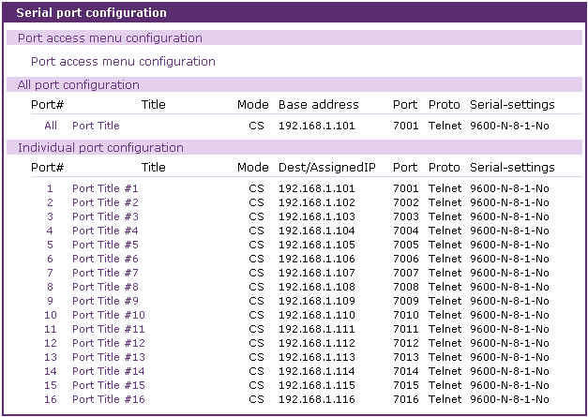
Figure 4-1 Serial port configurations main screen

The user also has the ability to connect to each serial port and port access menu from the configuration Web page using the terminal emulation Java applet. To access each port and port access menu through the Web
- The user must select the serial port → connection link on the left menu bar
- The user must select a terminal icon in the Individual port connection.
- The user may now use the serial port link provided in the port access menu connection.

Notes: For serial port connections details, please refer to the section 4.5 Serial port connection

4.2 Port Access Menu Configuration

4.2.1 Overview

With the port access menu, the VTS will confirm connection to a specified virtual port via a Telnet/SSH client connection. Once connected, the VTS will display the connection route to all serial ports on the port access menu. This will also include the port number, the port title and the serial port mode. The VTS allows users to access a serial port configured as a console server by selecting the corresponding port number at the menu.
The VTS connects to the virtual port by:
- Using the VTS IP address with the user-defined TCP port number as the port access menu
- Using the IP address of the virtual port with a pre-defined TCP port number

For example, if the VTS IP address is 192.168.1.100 and the TCP port number of the virtual port is 6000, the user would enter the following command at the Windows Command Prompt:
telnet 192.168.1.100 6000 <ENTER>
If the IP address of this virtual port is 192.168.1.132, the user can also connect to the port without using the port number by entering the following command at the Windows Command Prompt:
telnet 192.168.132.0 <ENTER>

If Enable/Disable email alert for port login is set as Enable, a email is sent to the specified address with the specified title when users login port access menu. If Enable/Disable port login trap is set as Enable, a SNMP trap is transferred to an administrator depending on trap receiver settings.
Figure 4-2 shows the Port access menu configuration screen.
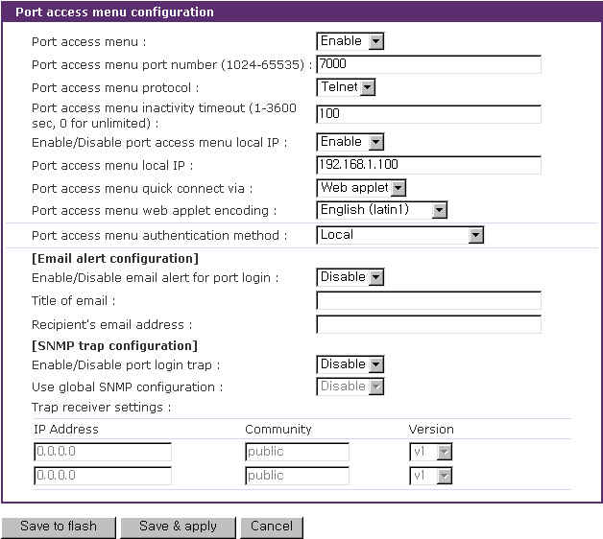
Figure 4-2 Port Access Menu Configuration
Note: When assigning the IP address of the port access menu, the user must be sure not to conflict with other host IP addresses. If there is a conflict, the IP address of the port access menu will be disabled. If the user disables local IP or assigns 0.0.0.0 for the local IP, the VTS does not assign local IP address for port access menu and the user should access the port access menu using the VTS IP address and the VTS port number.

Figure 4-3 shows the port access menu screen using the Windows Telnet program.
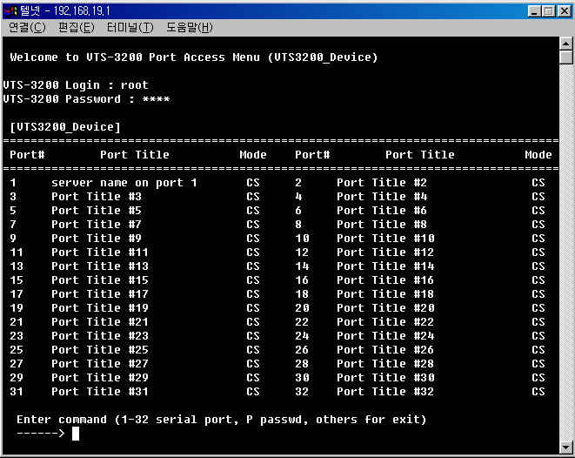
Figure 4-3 Accessing master connection port using Telnet

4.2.2 Authentication for the port access menu

The VTS provides a dual authentication procedure to access the port access menu.
The user must first be authenticated by the “port access menu authentication” method to access the port access menu. The user must then be authenticated by the “serial port authentication” method to access the serial port display.
If the “port access menu authentication” method is configured to [none], all users will have access to the serial ports in the port access menu.
If the “serial port authentication” method is configured to [None], users will have no access into the port.
If the “port access menu authentication” method is set to [Local] or another method (i.e. RADIUS, LDAP, TACACS+ or Kerberos) is identified, the user can access the serial ports in the port access menu when the following conditions are satisfied:
- The user is authenticated and gains access to the port access menu
- The user is authenticated and gains access to the serial port in the port access menu.
- The user is registered in the port’s user access list.

Once authenticated, the user can access only the “console server mode” serial ports. All other serial ports are inaccessible.
Once authenticated, the user accessing the port access menu also has priority over all other connections. If the user requests a connection currently in use, that connection is closed and a new session is opened for the authenticated user.

4.2.3 Protocol of the port access menu

The port access menu protocol can be configured to use either Telnet or SSH. It may not be coincident with that of each port. Because the protocol for the serial port is specifies the way to connect to the VTS from remote hosts, it is meaningless if the users are already login to the VTS using port access menu. Although it may seem to the users that the protocol configured for port access menu overrides that for each serial port, the protocol selected for the port access menu has precedence over that of the serial port.

4.2.4 Port access menu options

Users can assign which client program will be used for connection menu of the web page by configuring Port access menu quick connect via option. If user configures Port access menu quick connect via option as Web applet, the web applet will use Port access menu web applet encoding option to encode the received data to the string to display. If Enable/Disable email alert for port login is set as Enable, the VTS will send an email according to the Email alert configuration on user’s login to the port access menu. If user configures Enable/Disable port login trap as Enable and IP address at trap receiver settings as trap receiver, the VTS will transfer the port login trap according to the Trap receiver settings whenever users log in to the port access menu. If Use global SNMP configuration is set as Enable, trap receiver settings configured at SNMP configuration are used as the destination of the SNMP trap. For details of SNMP trap configurations and descriptions, please refer to section 3.2 SNMP Configuration.

4.2.5 Port access menu in clustering

In clustering mode (chapter 5), slave units can be accessed via port access menu of the master unit. Users can select a slave unit by entering S key for slave unit menu and then selecting A~P key at slave unit menu in the port access menu of the master unit. Once a slave unit is accessed, users can see a port access menu of the slave unit, and access to a desired serial port within the port access menu of the slave unit. The IP address at the top of the screen shows the IP address of the unit currently being accessed.

[VTS3200_Device]
================================================================================
Port# Port Title Mode Port# Port Title Mode
================================================================================
1 Port Title #1 CS 2 Port Title #2 CS
3 Port Title #3 CS 4 Port Title #4 CS
5 Port Title #5 CS 6 Port Title #6 CS
7 Port Title #7 CS 8 Port Title #8 CS
9 Port Title #9 CS 10 Port Title #10 CS
11 Port Title #11 CS 12 Port Title #12 CS
13 Port Title #13 CS 14 Port Title #14 CS
15 Port Title #15 CS 16 Port Title #16 CS
17 Port Title #17 CS 18 Port Title #18 CS
19 Port Title #19 CS 20 Port Title #20 CS
21 Port Title #21 CS 22 Port Title #22 CS
23 Port Title #23 CS 24 Port Title #24 CS
25 Port Title #25 CS 26 Port Title #26 CS
27 Port Title #27 CS 28 Port Title #28 CS
29 Port Title #29 CS 30 Port Title #30 CS
31 Port Title #31 CS 32 Port Title #32 CS

Enter command ( 1-32 serial port, P passwd, S slave unit, others for exit )
------> S

[VTS3200_Device]
================================================================================
Unit # IP Unit # IP
================================================================================
A 192.168.19.3 B ----------
C ---------- D ----------
E ---------- F ----------
G ---------- H ----------
I ---------- J ----------
K ---------- L ----------
M ---------- N ----------
O ---------- P ----------

Enter command ( A-P slave unit, others for main )
------>

4.3 Individual Port Configuration

The VTS allows serial ports to be configured either individually or all at once. The parameters for both individual and all port configurations are similar.
Individual Port Configurations are classified into 12 groups:
- Port enable/disable
- Port title
- Apply all port settings
- Host mode configuration
- Serial port parameters
- Port logging: Only available if the host is set to Console Server Mode.
- Port event handling: Only available if the host is set to Console Server Mode and Port logging is enabled.
- Port IP filtering: Only available if the host is set to Console Server Mode.
- Authentication
- User access control: Only available if the host is set to Console Server Mode.
- Alert configuration: Only available if the host is set to Console Server Mode.
- Power control configuration: Only available if a power controller is added.

Users can switch to another serial port configuration screen conveniently using the [--- Move to ---] list box at the right upper side of the individual port configuration screen.

4.3.1 Port Enable/Disable

Each serial port can be enabled or disabled. If a serial port is disabled, users cannot access the serial port. Figure 4-4 shows the serial port enable/disable screen.
Each stuck serial port can be reset by clicking the [Reset] button at the [Reset this port] part and set as factory default by clicking the [Set] button at the [Set this port as factory default] part.

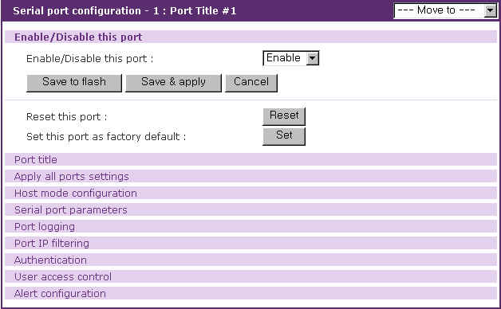
Figure 4-4 Serial port enable/disable

4.3.2 Port Title

Users can enter descriptive information for each port based on the device attached to it. This can include the device type, vendor, and/or location. The port title is not only helpful in the configuration process, but can also be utilized as descriptive information for the port access menu and dial-in modem access.
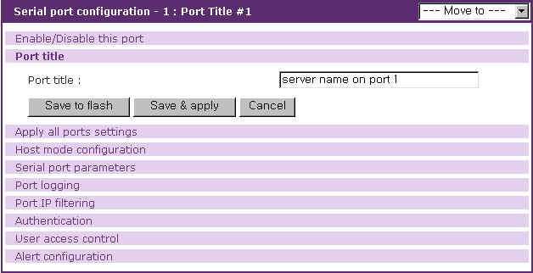
Figure 4-5 Port title configuration

4.3.3 Apply All Port Settings

To prevent the possibility of the user inadvertently selecting to change all port settings at the same time, the VTS provides the ability to enable or disable this function at an individual serial port level. Changes made when using the “change all port parameters at once” function will not be applied to an individual serial port if the function has been disabled (See Figure 4-6. This shows the apply all port setting configuration screen.
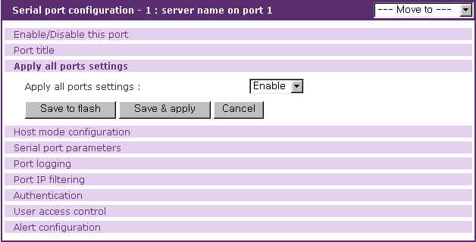
Figure 4-6 Apply all port setting configuration

4.3.4 Host Mode Configuration

The VTS operating mode is called the “host mode.” Four host modes are available: console server mode, terminal server mode, dial-in modem mode and dial-in terminal sever.

Console Server Mode
This mode utilizes a TCP server socket , which listens for a Telnet or SSH client connection. Once a Telnet or SSH client session is opened, the data stream can be sent back and forth to the device connected to the serial port.

Terminal Server Mode
This mode uses the VTS to capture data from the device connected to the serial port. The VTS makes a TCP connection as a Telnet or SSH client to a pre-defined remote host to send incoming data from the serial port.

Dial-in Modem Mode
The VTS also supports out-of-band access with an external modems. When a serial port is configured as dial-in modem mode, the VTS assumes that the serial port is connected with an external modem, and waits for a dial-in connection from a remote site. Using a terminal emulation program to access the VTS will result in the display of all available serial ports. The user can then select a serial port to access.

Dial-in Terminal Server
The Dial-in terminal server mode is a combination of both the terminal server mode and dial-in modem mode. When the users configures a serial port(s) as a Dial-in terminal server, the VTS assumes that the serial port is connected to an external modem, and waits for dial-in connection from a remote site. Once the user dials into the VTS using a terminal emulation program, it accepts the connection and makes a TCP connection as a Telnet or SSH client to a pre-defined remote host. Figure 4.7 shows the main workspace screen for the serial port configuration.

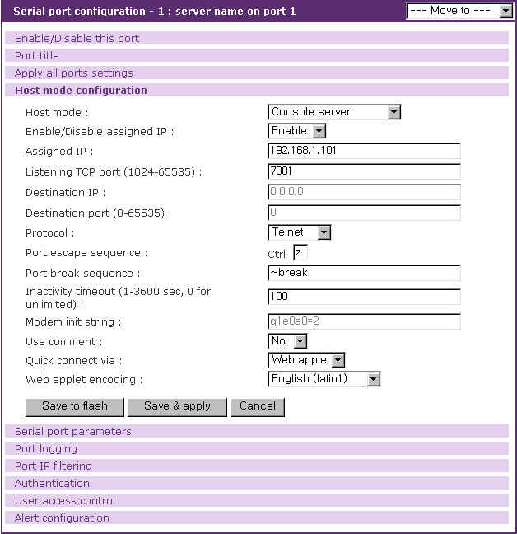
Figure 4-7 Host mode configuration

Console server mode configuration

For console server mode, the user can configure the following parameters:

assigned IP address
listening TCP port number
protocol
port escape sequence
port break sequence
inactivity timeout.
use comment
quick connect via
web applet encoding

Assigned IP address
If the users assign an IP address to a serial port of the console server, the user can access the serial port directly through the IP address of the configured port. The user may set this parameter by using the Telnet or SSH client program with the standard TCP port number of telnet (23) or SSH (22).
If the IP address of the serial port is assigned as 192.168.1.101, the users can connect to the port as follows:

telnet 192.168.1.101
The assigned IP address may not conflict with the existing IP address. If a conflict is detected, the IP address of the serial port will be disabled. If the user wants not to assign an IP address to a serial port, select disable at the Enable/Disable assigned IP menu, or assign 0.0.0.0 to the assigned IP.

Listening TCP port number
The user can also access a serial port through the IP address of the VTS and the listening TCP port number of the serial port. The user must use the TCP port number as well as the VTS IP address to the Telnet/SSH client.
If the IP address of the VTS and the serial port are assigned as 192.168.1.100 and 192.168.1.101, the user can connect to the port as follows:

telnet 192.168.1.100 6001

Protocol
Select Telnet, SSH or Raw TCP as the protocol. If the users are using a Telnet client program, select Telnet. If the users are using an SSH client program, select SSH. When Raw TCP is selected, direct TCP socket communication is available between the VTS and the remote host.

Port escape sequence
When users connects to a port, they will get the port escape menu by entering the port escape sequence. The port escape menu contains [show last 100 lines of log buffer], [send message to port user], [close current connection to port] for all users, [enter as a slave session] for sniff users, [send break] for main session user, [take over main session] for sniff users having both port and monitor access control and [disconnect a sniff session] for users having both port and monitor access control. If the serial port device is powered by a power controller and the user logged on has the power access control, the port escape menu also contains [power device on], [power device off] and [reboot device using power-switch].

Port break sequence
The user can send a break signal to the serial port by entering the break sequence that is configured as the port break sequence in the configuration menu.

Inactivity timeout
The purpose of the inactivity timeout parameter settings is to maintain the TCP connection state as either Closed or Listen. If there is no activity between the VTS and the Telnet/SSH client during the specified inactivity timeout interval, the existing session will automatically be closed. If the user wants to maintain the connection indefinitely, configure the inactivity timeout period to 0. Although the inactivity timeout is disabled, the VTS will continue to check the connection status between the Telnet/SSH client and the VTS by sending “keep alive” packets periodically. If the Telnet/SSH client does not answer the packets, system will assume that the connection is down unintentionally. The VTS will close the existing Telnet/SSH connection, regardless of the inactivity setting.

Use comment
The user can input comments when a port user accesses a serial port if Use comment is configured to Yes. To use this feature, protocol should be configured as Telnet or SSH. Comments input will be displayed in Comments item of individual port connection, which is in the serial port connection page. Please refer to the section 4.5 Serial port connection for details.

Quick connect via
The user can select a client program that is used for the VTS web connection page by configuring Quick connect via if the protocol is configured as Telnet. If the user wants to launch the java applet for a telnet client when the user selects the connection icon in the serial port connection page, select Web applet. If the user wants to use Telnet client provided by an OS, select Telnet. With Windows OS, Hyper Terminal is launched in this case.

Web applet encoding
This option is used to display the data from device through a serial port that are encoded in various way.

Terminal server mode configuration

For terminal server mode, the user can configure the following parameters:

destination IP address
destination TCP port number
protocol
inactivity timeout.

Destination IP address and Destination TCP port number
The destination IP address and destination TCP port numbers identify the Telnet/SSH server information needed for the VTS to capture any incoming data from an attached device.

Protocol
The protocol can be either Telnet, SSH or Raw TCP. If the user wants to connect to either a Telnet or SSH server, the user must select Telnet or SSH.

Inactivity timeout
If there is no data transfer between the VTS and the Telnet/SSH server for the during the inactivity timeout interval, the current Telnet or SSH connection will be closed. If the user wants to maintain the connection indefinitely, configure the inactivity timeout period to 0.

Dial-in modem mode configuration

For dial-in modem mode, the users can configure the following parameters:

Inactivity timeout
Modem init string.
Inactivity timeout
If there is no activity between the VTS and the dial-in client program during the specified inactivity timeout interval, the existing session will automatically be closed. If the user wants to maintain the connection indefinitely, configure the inactivity timeout period to 0.

Modem init string
The modem init string is used to initialize an external modem attached to a serial port. If the user does not specify any init string, the default init command is used. The default modem init command is ‘q1e0s0=2’. For more information about the modem init string, please refer to the modem manual.

Dial-in terminal server mode configuration

For dial-in terminal server mode, the user can configure the following parameters:

destination IP address: (Please refer to the Terminal Server Mode section)
destination TCP port number: (Please refer to the Terminal Server Mode section)
protocol: (Please refer to the Terminal Server Mode section)
inactivity timeout: (Please refer to the Dial-in Modem Mode section)
modem init string: (Please refer to the Dial-in Modem Mode section)

4.3.5 Serial port parameters

To connect the serial device to the VTS serial port, the serial port parameters of the VTS should match exactly to that of the serial device attached. The serial port parameters are required to match this serial communication.

The parameters required for the serial communication are:
baud rate
data bits
parity
stop bits
flow control
DTR behavior
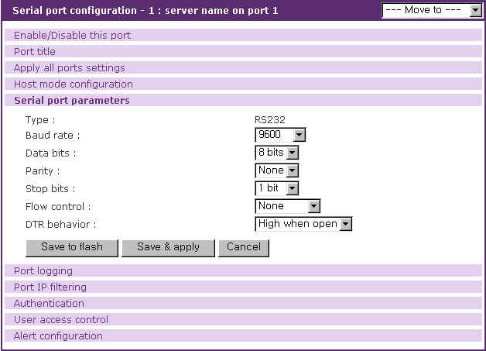
Figure 4-8 Serial port parameter configuration

Baud rate
The valid baud rate for the VTS is as follows:
1200, 2400, 4800, 9600, 14400, 19200, 38400, 57600, 115200, and 230400
The factory default setting is 9600.

Data bits
Data bits can be between 7 bits and 8 bits. The factory default setting is 8 bits.

Parity
Parity can be none, even or odd. The factory default setting is none.

Stop bits
Stop bits can be between 1 bit and 2 bits. The factory default setting is 1 bit.

Flow control
Flow control can be none, software(Xon/Xoff) or hardware(RTS/CTS). The factory default setting is none.

DTR behavior
The DTR output behavior of a serial port can be configured as: always high, always low or High when open. If the DTR behavior is set to High when open, the state of the DTR pin will be maintained high as long as the TCP connection is established. When the host mode is configured as either “dial-in modem mode” or “dial-in terminal server mode”, the user cannot set the DTR behavior.

Users can enable dial-in modem support on console port by using rc.user script. Please add following line to rc.user,
echo 57600 > /var/run/mgetty.console
where 57600 is the baudrate of modem to be connected on console port.
Please, note that dial-in modem support on console port is effective after rebooting the system with above rc.user file.

4.3.6 Port Logging

With the port-logging feature while in console server mode, the data sent through the serial port is stored to MEMORY, an ATA/IDE fixed disk card, a SYSLOG server or a mounting point on an NFS server. The user can also define keywords for each serial port that will trigger an email/SNMP notification at port event handling configuration. This will enable the user to monitor the data from the attached device. For more information about the port event handling, please refer to section 4.3.7. Port event handling.
The port-logging feature is valid and visible only if the host mode of the serial port is configured to console server mode. The port-logging feature will not be accessible if the serial port is configured to terminal server or dial-in modem mode.
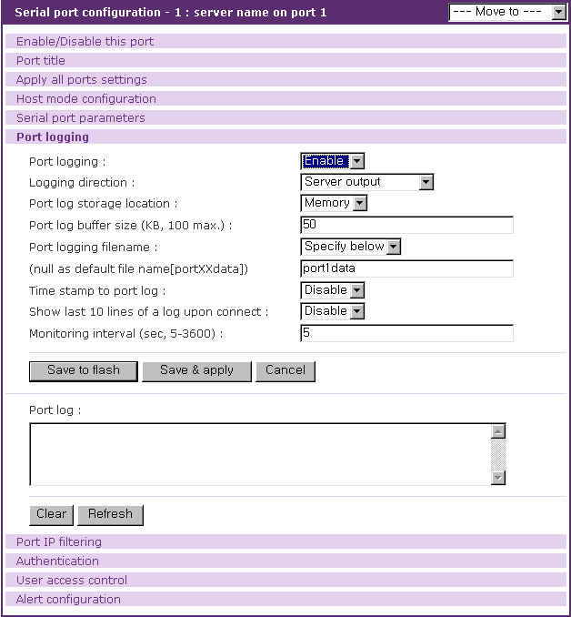
Figure 4-9 Port logging configuration

The configuration parameters for port logging are as follows:
enable/disable port logging
logging direction
port log storage location
port log buffer size
port log file name
time stamp to port log
show last 10 lines of a log upon connect
monitoring interval

Enable/disable port logging
This parameter defines whether to enable or disable the port-logging feature. The factory default setting is [disabled].

Logging direction
This parameter defines whether the incoming and the outgoing data are logged with direction arrows or not. The factory default setting is [Server output].

Port log storage location
The port log data can be stored to the VTS internal memory, an ATA/IDE fixed disk card inserted in PCMCIA slot, the mounting point on an NFS server or the SYSLOG server. If the internal memory is used to store port log data, the port log data will be cleared when the VTS is turned off. To preserve the serial port log data, set the storage location to be the ATA/IDE fixed disk card, SYSLOG server or NFS server. To do this, the user must configure the corresponding media in advance. Unless the media is properly set up, the user will not be able to select a storage location from the interface.

Port log buffer size
This parameter defines the maximum amount of port log data to be logged. When using internal memory to store the log data, the total size of the port buffer cannot exceed 3200 Kbytes (i.e. sum of all port buffer size of each serial port should be smaller than or equal to 3200 Kbytes). The factory default setting is 4 Kbytes.
When using an ATA/IDE fixed disk card to store log data, the maximum port buffer size is dependent upon the card capacity.
When using an NFS server to store log data, the maximum port buffer size is unlimited. The user should configure the NFS server to ensure that the port logging system works properly.
When using the SYSLOG server to store log data, the user cannot set the port log buffer size.

Port log file name

Port log file name defines a port log file name to be logged. If Port logging file name is set as Use port title, the port title is used as logging file name. If Specify below, the file name specified below is used and if this parameter is not configured, port log file name of portXXdata will be used instead where XX denotes corresponding serial port number.

Time stamp to port log
If Time stamp to port log is enabled, every line of log data includes time stamp. Factory default setting of this parameter is disable.

Show last 10 lines of a log upon connect
If Show last 10 lines of a log upon connect is enabled, the last 10 lines of log will be disaplayed when a user connects the port. Factory default setting of this parameter is disable.

Monitoring interval
If port-logging option is enabled and port event handling (see section 4.3.7 Port event handling) is configured, the VTS will search a defined key word presence to make a corresponding reaction. Within this condition, Monitoring interval defines the interval whenever the VTS searches a key word from the buffered port log. The smaller value of this parameter will result in immediate keyword search and heavy usage of system resources. The largest value accepted is recommended to prevent system resource usage minimization.

4.3.7 Port event handling

If port-logging option is enabled, the user can let the VTS to search a defined keyword from the port logging data and send an email or SNMP trap to an administrator by Port event handling configurations. Each reaction can be configured individually upon each keyword. Reaction can be an email delivery, SNMP trap sending or both.

The configuration parameters for port event handling are as follows:
Key word
Email notification
Title of email
Recipient’s email address
SNMP trap notification
Title of SNMP trap
Use global SNMP configuration
First/Second SNMP trap receiver IP address
First/Second SNMP trap community
First/Second SNMP trap version

Email notification configurations
If the user wants an email notification for the reaction, set Email notification parameter to enable, and configure a recipient’s mail address and the email title..

SNMP trap notification configurations
If SNMP trap notification is enabled, A SNMP trap is transferred if a keyword is found from port log data. For details of SNMP trap configurations and descriptions, please refer to section 3.2 SNMP Configuration.

Use global SNMP configuration
This parameter defines whether the trap receiver setting of the SNMP configuration at network configuration is used as trap receiver.

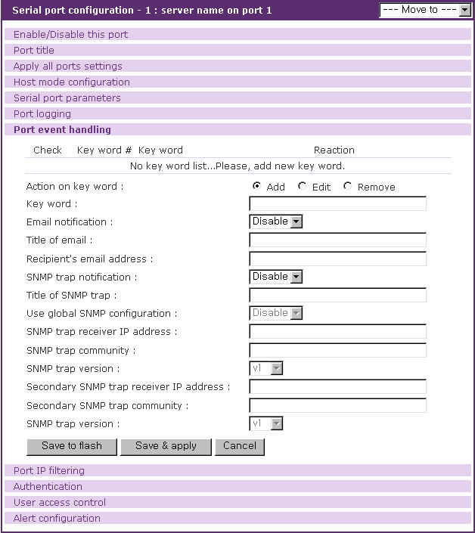

Figure 4-10 Port event handling configuration

After a keyword is added to the port event handling configuration, the VTS monitors it is detected. And if it is detected and no user connects to the port, the alerting icon will be displayed by the port title at serial port connection page till any user connects to the port. Figure 4-11 shows the serial port connection page showing the alerting icon at port 1 named server name on port 1.
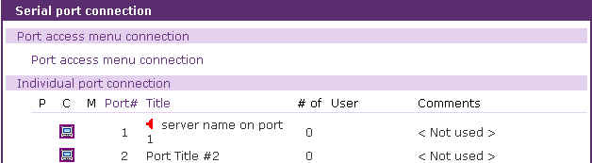
Figure 4-11 Serial port connection page showing the alerting icon

4.3.8 Port IP filtering configuration

The remote hosts that are allowed to access the VTS serial ports can be specified based on the IP address filtering rules. The user may allow specific hosts to access the VTS serial ports by providing a valid IP address or network address and its subnet mask. Please refer to section 3.5 for more details.
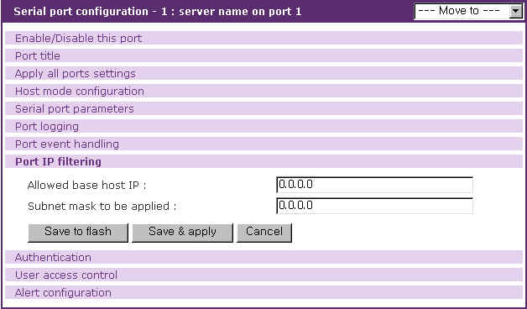
Figure 4-12 Port IP filtering for serial ports

4.3.9 Authentication configuration

Authentication is the process of identifying an individual, usually based on a username and password. The VTS supports various authentication options, such as None, Local, RADIUS, TACACS+, Kerberos and LDAP to authenticate the users who access the serial port. When the authentication is set to Local, the VTS will use its own user list to authenticate a user. If configured otherwise, the VTS will request authentication from the external authentication servers (i.e. RADIUS, Kerberos, TACACS+ and LDAP servers). Figure 4-13 shows conceptually the user authentication process when using an external authentication server.
The user may also select to combine authentication methods. This method will instruct the VTS attempt authentication with the first method. If this fails, the VTS is instructed to attempt authentication with the second selected method. For example, RADIUS authentication can be combined with local authentication. If the user selects the “RADIUS server – local” authentication method, the VTS will try to authenticate using RADIUS first and then try with the VTS local database if the RADIUS authentication process fails.
Figure 4-13 Concept of the user authentication by the external servers

The following is all the authentication options that the VTS provides for each serial port:
None
Local
RADIUS server
RADIUS server - Local
Local - RADIUS server
TACACS+ server
TACACS+ server - Local
Local - TACACS+ server
LDAP server
LDAP server - Local
Local - LDAP server
Kerberos server
Kerberos server - Local
Local - Kerberos server
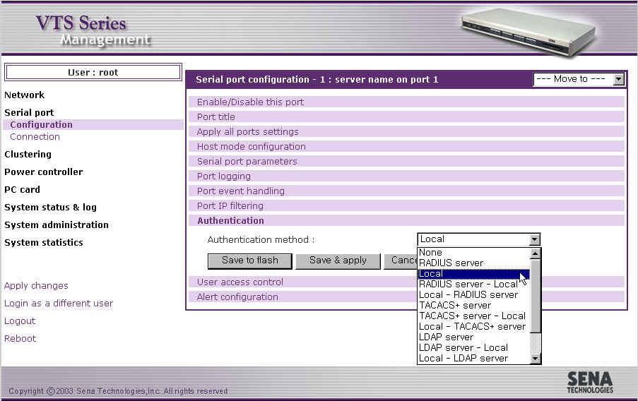
Figure 4-14 The VTS authentication options for the serial port

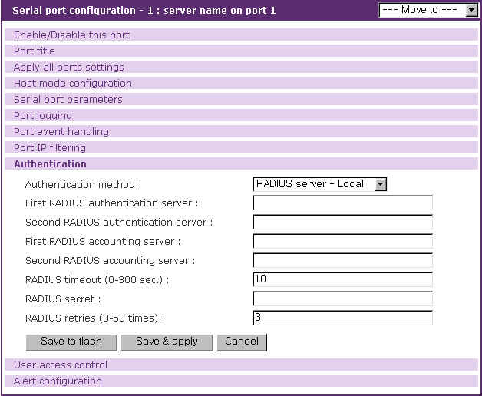
Figure 4-15 Authentication configuration for the RADIUS server – Local

4.3.10 User access control configuration

The user access control configuration can be used for restricting or permitting users who try to connect to or sniff a serial port of the VTS and manage power of a serial port. How to manage sniff session is also configured at sniff session part.

Port access control is used to permit or restrict to connect to a serial port. Monitor access control is used to permit or restrict to sniff a serial port. Power access control is used to permit or restrict to manage the power of a serial port that is connected to a power controller outlet.
The access controls of <<Everyone>> specify the access control of all the users except the users who are added in the user list of user access control. Users whose access controls are different from those of <<Everyone>> should be added in the user list of user access control.
If a serial port is disabled to be sniffed, the monitor access control does not affect. If a serial port is not connected to a power controller outlet, the power access control does not affect.

In the case of sniff mode, users who can connect to a serial port are divided to three groups – users who have both of the port and the monitor access control, users who have only port access control and users who have only monitor access control.
Users having port and monitor access control can open the serial port as main session and access to it as sniff session. They can disconnect sniff sessions at main session and sniff session and take over main session at sniff session.
User having just port access control can open the serial port as main session and connect to it as sniff session but they can neither disconnect sniff session nor take over main session at sniff session.
Users having just monitor access control can connect to it just at sniff session and they can neither disconnect sniff session nor take over main session.

Users should be not only identified by VTS or authentication server according to authentication configuration but also permitted by VTS according user access control in order that they may connect to a serial port. For further details about authentication configuration, please refer to section 4.3.9. Authentication configuration.

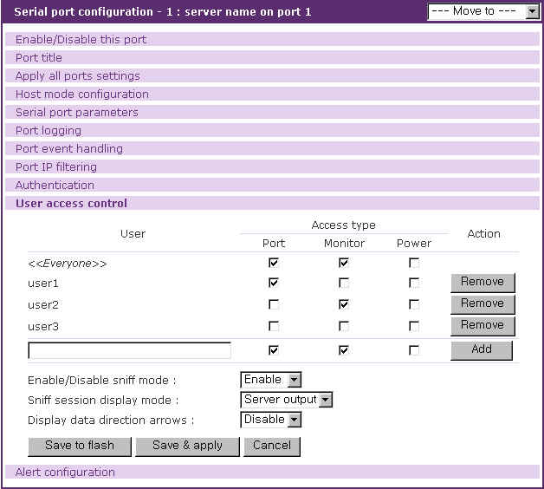
Figure 4-16 User Access Control configuration for serial ports

User access control
Access type consists of port , monitor and power access control. The port access control specify if user may connect to the serial port as main session. The monitor access control specify if user may connect to it as sniff session. The power access control specify if user may manage the power of the serial port.
The access controls of <<Everyone>> are applied to all the users who are not added to user list of user access control. The users should be added to user list if their access controls do not match <<Everyone>> access controls.
If the administrator wants to specify users who must be restricted from accessing a specific serial port, the administrator may check <<Everyone>> access control and add them to user list with option unchecked. If the administrator wants to specify the users who are allowed to access a specific serial port, he may uncheck <<Everyone>> access control and add them to user list with option checked.

Sniff session
The sniff session enables multiple users to access a single serial port. Users having the port access control or the monitor access control can access the serial port even if another user is using it at the time. Number of simultaneous Sniff users allowed to access is limited to 15 and also limited by system resource.
Enable/Disable sniff mode should be set as [Enable] to allow users to sniff.
The sniff session display mode has three settings: User input, Server output and both. If set to User input mode, the sniff user can see only the incoming user data for a serial port from a remote host. If set to Server output mode, the sniff user can only see the outgoing data from the serial port to the remote host. If set to Both mode, the sniff user can see all the data sent back and forth through the serial port.
Display data direction arrows determines whether the incoming and the outgoing data are shown with direction arrows or not.

If a sniff user access to a serial port that is in use by a user already, the sniff user has a screen as in Figure 4-17. Then the sniff user get the port menu by typing the port escape sequence. A sniff user having both the port and the monitor access control has a higher level of authority than a regular user having either the port or the monitor access control and is able to take over main session that is in connection currently and disconnect another sniff session. By selecting a menu shown in Figure 4-17, a sniff user can enter as the main session by killing a current main session, or take over a main session and switch a current main session to a sniff session, or keep current main session and initiate a new sniff session. Besides these functions, a sniff user can terminate the other sniff session by selecting disconnect a sniff session or send messages to other users by selecting send message to port user or display logs by selecting show last 100 lines of log buffer or close current connection by selecting close current connection to port.

Welcome to VTS-1600 Console Server

VTS-1600 Login : admin
VTS-1600 Password : *****
Entering server port, ..... type ^z for port menu.

New sniff session started ...

After typing the port escape sequence

Port menu:

(server name on port 1) (Port 1) is being used by (sena)
The (admin) is connected in monitoring mode.

m take over main session
s enter as a slave session

l show last 100 lines of log buffer
d disconnect a sniff session
a send message to port user

x close current connection to port

Figure 4-17. Sniff user interface screen

4.3.11 Alert configuration

Email agent process sends email depending on email alert configurations and SNMP agent process transfers a SNMP trap to an administrator depending on SNMP trap configurations when the events related to the serial port such as port login and serial port connection occur.

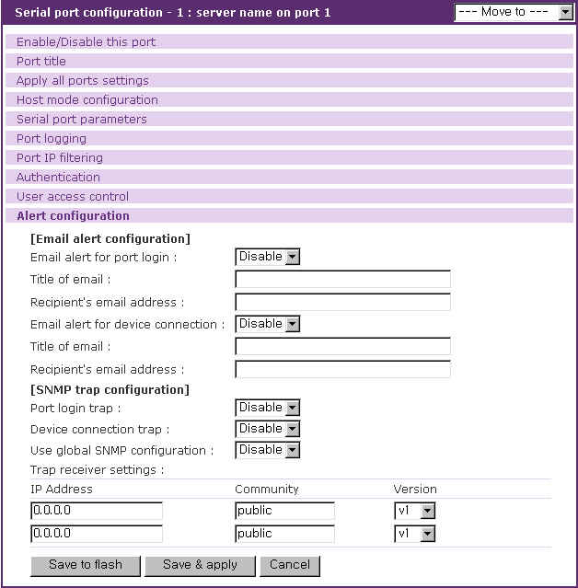
Figure 4-18 Alert configuration

The configuration parameters for alert configuration are as follows:
Enable/Disable email alert for port login
Enable/Disable email alert for device connection
Title of email
Recipient’s email address
Enable/Disable port login trap
Enable/Disable device connection trap
Use global SNMP configuration
Trap receiver settings

Enable/Disable email alert for port login
This parameter defines whether the email is sent when a user logs in and out the serial port.

Enable/Disable email alert for device connection
This parameter defines whether the email is sent when the serial port is connected or disconnected to a device.

Title of email
This parameter defines the title of email.

Recipient’s email address
This parameter defines to whom the email is sent

Enable/Disable port login trap
This parameter defines whether the SNMP trap is transferred when a user logs in and out the serial port.

Enable/Disable device connection trap
This parameter defines whether the SNMP trap is transferred when the serial port is connected or disconnected to a device.

Use global SNMP configuration
This parameter defines whether the trap receiver setting of the SNMP configuration at network configuration is used as trap receiver.

Trap receiver settings
For details of SNMP trap configurations and descriptions, please refer to section 3.2 SNMP Configuration.

4.3.12 Power control configuration
If a power controller is connected to VTS, user can configure which power controller outlets a serial port is connected to at this page. The power of the serial port is managed using this configuration.

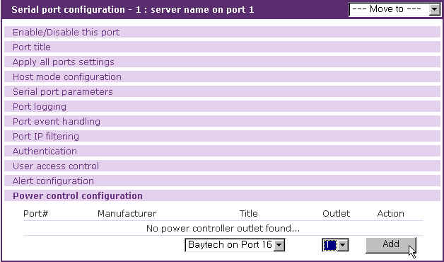
Figure 4-19 Power control configuration

4.4 All Port Configurations

If modifications are being made to all serial ports are similar or the same, changes can be made to the serial port configuration for all serial ports simultaneously. With the all port configuration function, the configuration will be applied to all the serial ports; unless an individual ports “apply all port setting” option is disabled.
“All port configuration” parameters can be grouped into the following groups:
- Port enable/disable
- Port title
- Host mode configuration
- Serial port parameters
- Port logging: Only valid and visible if host mode set to Console Server Mode.
- Port event handling: Only available if the host is set to Console Server Mode and Port logging is enabled.
- Port IP filtering: Only available if the host is set to Console Server Mode.
- Authentication
- User access control: Only available if the host is set to Console Server Mode.
- Alert configuration: Only available if the host is set to Console Server Mode.
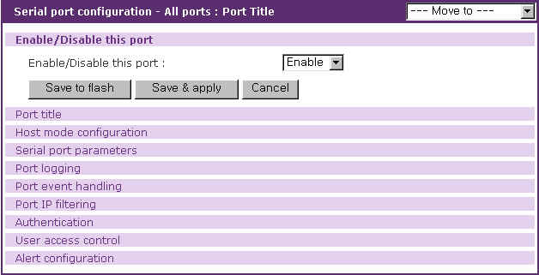
Figure 4-20 All port configuration

Port enable/disable
This parameter enables or disables port function.

Port title
If this parameter is set with a certain string, the port title of each serial port will be set with a combination of this string and the port number. For example, if the port title is set with “my server”, the port title of port 1 will be set with “my server #1”, the port title of port#2 will be “my server #2”, and so on.

Host mode
If the host mode is set to console server mode, the assigned IP address of each serial port allowed will be the following equation:
(IP address assigned + serial port number - 1)
For example, if the IP address assigned is 192.168.1.1 in all port configuration, the IP address of port 1 will be 192.168.1.1, that of port 2 is 192.168.1.2, and so on. Similarly, the listening TCP port number will be also set with the following equation:
(listening TCP port number + serial port number - 1)
If the host mode is set to terminal server mode, the destination IP address of each serial port will be assigned incrementally to the case of the console server mode. However, the destination TCP port number will be the same regardless of the serial port number. For example, if the destination IP address and the TCP port number are set as 192.168.1.1:8001, the destination IP address and TCP port number of port 1 is 192.168.1.1:8001 and 192.168.1.2:8002 for port 2.

Serial port parameters, Port logging, Port event handling, Port IP filtering, Authentication, User access control, Alert configuration
For the parameters of the groups above, the values set in an “all port configuration” will be set identically for all of the serial ports.

4.5 Serial port connection

The VTS Web configuration interface provides a web-based serial port connection which enables the user to access the serial ports without using the telnet or SSH client program. If the users select the Serial port - connection menu item in the menu bar, the screen in figure 4-21 is displayed. This provides the port access menu and the serial port connection. The user may access the serial port by clicking the terminal icon at C column. The terminal emulation pop-up window will be opened to grant user access to the serial port.

It also provides the serial port power control. The user may be able to move to the serial port power control page and control the power of a serial port by clicking the on / off state icon at P column if a power controller is added to the VTS and the serial port device is linked to the power controller outlet. It also provides the short cut to the power controller management page to control the power controller added to VTS. Clicking the management icon in M column, the user can move to the power controller management page and deal with the power controller. (refer to 6.3.4 Power controller unit management - Serial port connection)

Note: If the protocol of the serial port is configured as Telnet, pop-up terminal emulation program will be either a java telnet client or a telnet client provided by the OS used depending on the Quick connect via parameter configuration. Please refer to the section 4.3.4 Host Mode Configuration for details.
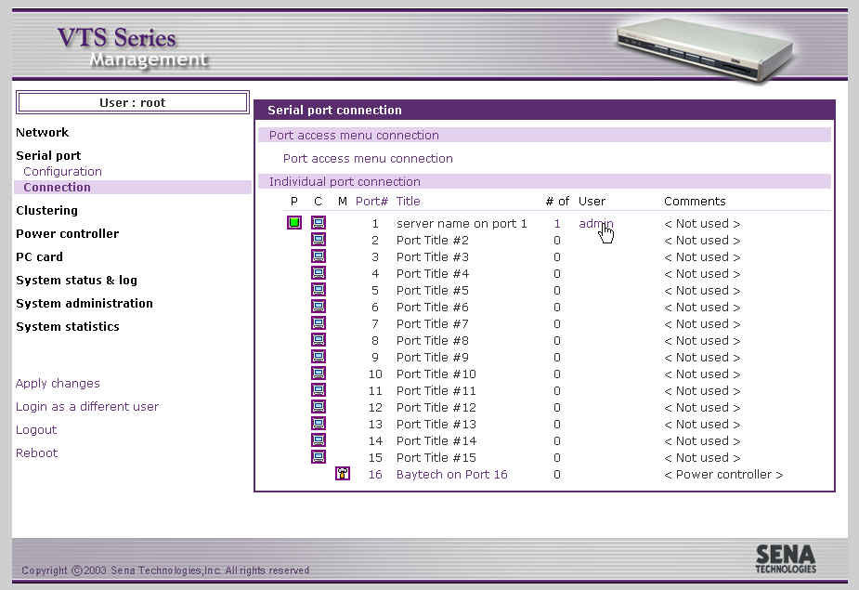
Figure 4-21 Serial port connection page

A Java applet is used to provide the text-based user interface to access the serial port. This Java applet supports only Telnet or SSH connection. The user cannot access the serial port via the web when the host mode of the port is set to Raw TCP connection. The user is asked to enter his/her user ID and password to access the port. Once authenticated, the user now has access to the serial port. The title bar of the pop-up window and the Java applet shows the information regarding the connection, i.e. Telnet or SSH, connection status, the serial port number and the port title. On the bottom of the screen, there are hot key buttons accessible to connect, disconnect or send break.

Note: The users registered with their SSH public key cannot access the port through the web because the Java applet does not provide an SSH public key authentication.

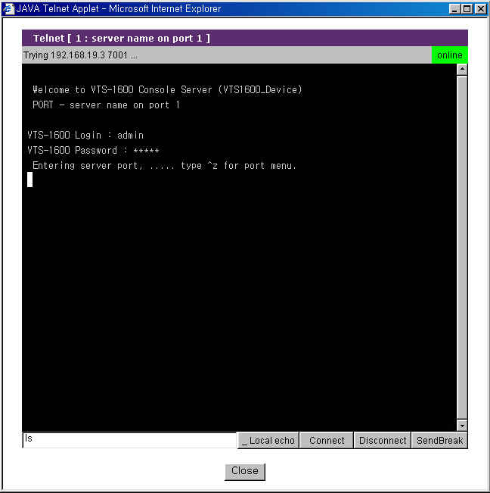
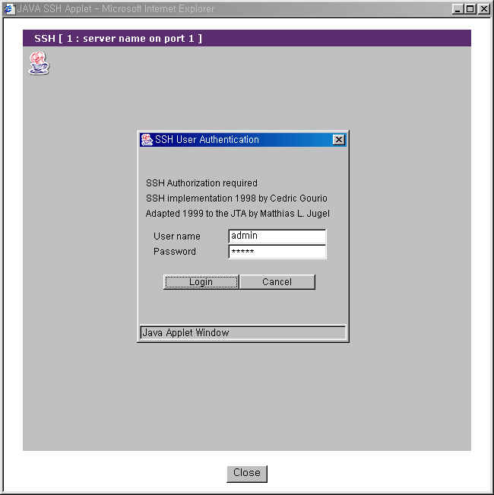
Figure 4-22 JTA window for Telnet and SSH
In addition, serial port connections page displays current port connection status including the number of connected users, port user IDs and comments input by a port user for each port.

The VTS allows users to monitor the users connecting to the VTS serial port besides the main session user and disconnect the current connections to the VTS serial port. Users can open Serial port users logged on list (refer to Figure 4-23) by clicking the # or user link of the VTS serial port to commit.
Users can disconnect the connection to the VTS serial port of the some users by checking and clicking the Kill button at the serial port users logged on list window. (refer to Figure 4-23)

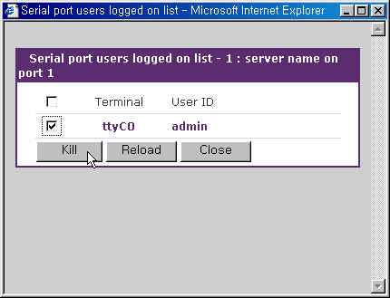
Figure 4-23 Serial port users logged on list

The VTS also provides users with the direct access to the serial port without login to the Web management interface. Users can connect to the serial port by entering URL at address text field of the Web browser such as
http://<IP>/connect.asp?p=<port number>
or
http://<IP>/connect.asp?t=<port title>
where <IP> is the IP address or domain name of the VTS, <port number> is the number of the serial port and <port title> is the title of the serial port. Users can access to the serial port whose port number is same as <port number> or whose title contains <port title>. Figure 4-24 and Figure 4-25 shows the JTA applet directly connected to the serial port matching <port number> or <port title>.

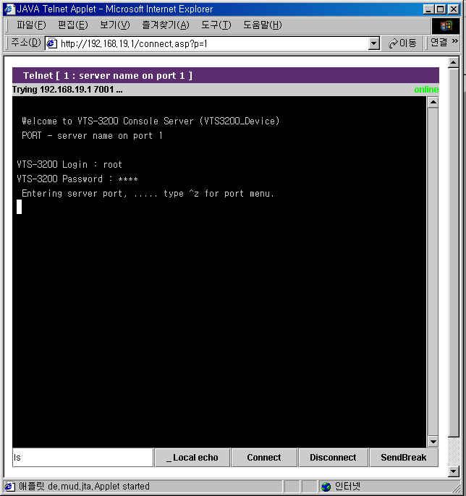
Figure 4-24 Direct access to serial port through port number
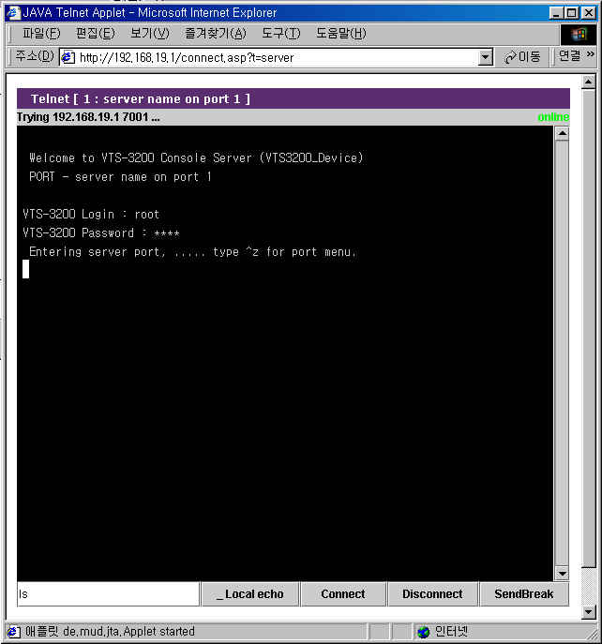
Figure 4-25 Direct access to serial port through port title
The VTS allows users to access to the serial port through the remote SSH serial console specifying the user as
<user>:p=<port number>
or
<user>:t=<port title>
where <user> is user ID, <port number> is the number of the serial port and <port title> is the title of the serial port. Users can access to the serial port whose port number is same as <port number> or whose title is same as <port title>. Figure 4-26 and Figure 4-27 shows the SSH client directly connected to the serial port matching <port number> or <port title> on linux.

[root@loclahost ~] ssh root:p=1@192.168.19.1
root:p=1@192.168.19.1’s password:
Entering server port, ..... type ^z for port menu.

Figure 4-26 Direct access to serial port using the remote SSH serial console through port number

[root@loclahost ~] ssh ‘root:t=server name on port 1@192.168.19.1’
root:t=server name on port 1@192.168.19.1’s password:
Entering server port, ..... type ^z for port menu.

Figure 4-27 Direct access to serial port using the remote SSH serial console through port title

5: Clustering Configuration

5.1 Overview

The VTS provides centralized management of other VTS serial ports with its clustering feature. The user may access up to 544 serial ports (=32 ports * 16 slave units + 32 ports for master unit) through one master unit.
The VTS uses NAT (Network Address Translation) based methodology to access the slave unit serial ports. Using a kernel-based simple IP forwarding mechanism, the VTS provides an efficient, flexible, fast and secure method of access. It can also manage other terminal servers if the users manually set up the IP forwarding rule to reflect the current environment.
The incoming data stream to the master unit’s TCP port is forwarded to the (IP address: TCP port) of the slave units. Therefore, the only thing that the user has to set up for the master unit’s configuration is the IP forwarding rule for the slave units. No additional sets up for the slave units are required for the application.
Let’s assume that the user is trying to connect to the slave unit’s serial port by way of the master unit. The environment for the clustering is as follows.
- User’s computer has the IP address: 192.168.0.100
- The IP address of the master: 192.168.0.2
- The IP address of the slave: 192.168.0.3.
- The TCP port, 6033 of the master is reserved for the serial port 1 (TCP port, 6001) of the slave unit.

Figure 5-1 shows the operation concept of the VTS clustering feature under this condition.

Figure 5-1 VTS clustering operation concept
Figure 5-2 illustrates an application diagram how the user may connect to the VTS slave units through the broadband Internet.

Figure 5-2 VTS clustering example

5.2 Clustering configuration

Only the master unit configuration is required to apply the clustering features except Authentication mode. Authentication mode defines whether user will be authenticated at clustering slave unit or clustering master unit when a port of clustering slave unit is connected and its authentication mode is set as Local. Authentication mode is disabled when Clustering mode is set as Master.

If a user wants to configure the VTS as the master, they should do it in the Clustering configuration workspace. Figure 5-3 shows the Clustering configuration workspace. If user selects Master at Clustering mode and save it, the clustering configuration screen for the master unit will be displayed. Figure 5-4 shows the clustering configuration screen for the master unit.
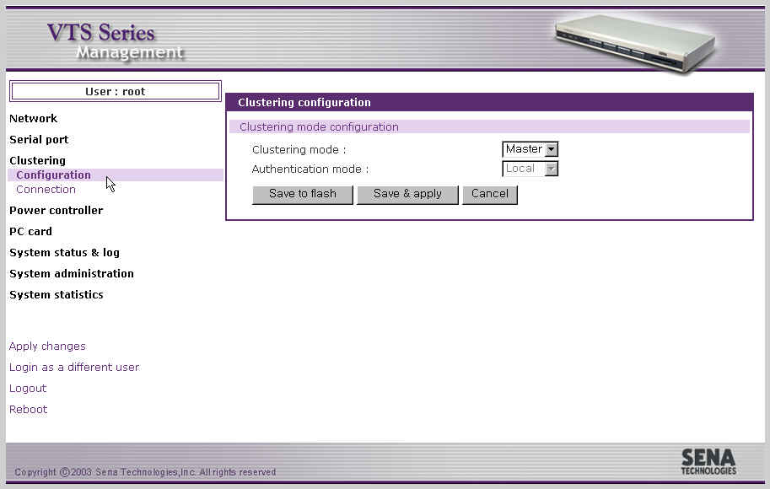
Figure 5-3 VTS clustering configuration as a mater

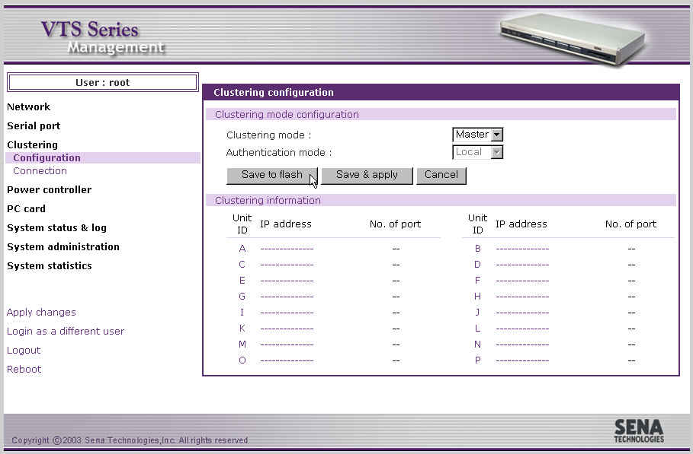
Figure 5-4 VTS clustering configuration for the master unit

In order to add the slave in this workspace, the user selects the slave number displayed. Then, the screen for the configuration of the slave unit will be shown up. Figure 5-5 shows the screen for the configuration of the slave unit. The user then enables the slave configuration. The screen will then guide them to the IP forwarding table screen for access of the specified slave unit. Figure 5-6 shows IP forwarding table for the clustering configuration of the salve unit.

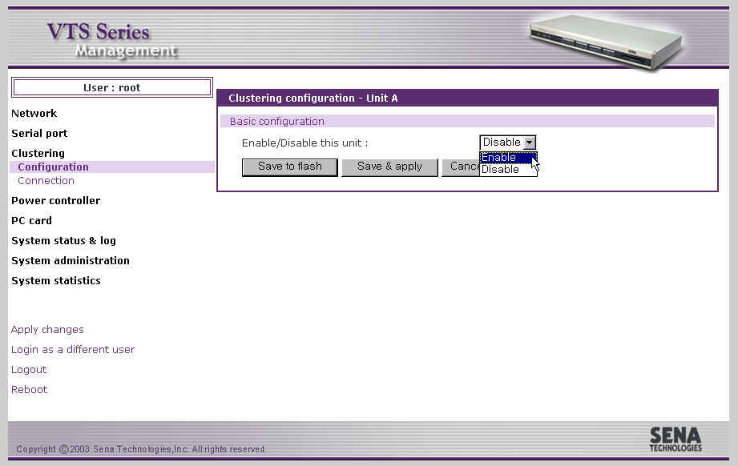
Figure 5-5 Enabling the configuration of the salve unit

The users may either manually set up the IP forwarding table or automatically import the serial port configurations of the slave units. Access to the Port access menu and to the individual serial port is provided. The Source port is the TCP port number of the master unit that will be forwarded to the Destination port of the slave port.
To automatically configure the port-forwarding table, enter the IP address of the slave unit, and then click the [Auto Config] button. The master unit automatically imports the port information of the slave unit and reserves the source port for them. Figure 5-7 shows the result after running the auto configuration. The automatic configuration imports the configuration only if the unit is configured as a slave and only for the slave ports set to console server mode. The user may change the source port number or the destination port number by setting up the base port number for either one. Web management interface provides users with link to web interface for clustering slave unit configuration. The user can determine which protocol of HTTP and HTTPS is used to connect to it by selecting Protocol at Connect to slave unit to change configuration part.

Note: The source port number may not conflict with the existing configuration of the master’s serial ports. If there is conflict detected, the clustering feature is disabled.

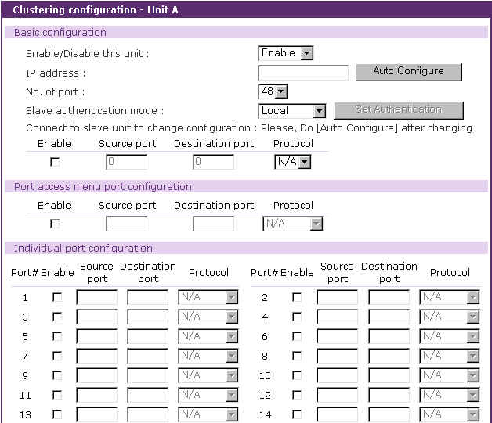
…
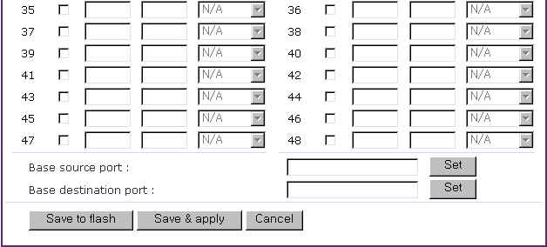

Figure 5-6 IP forwarding table for the clustering configuration of the salve unit

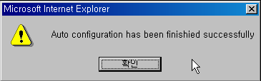
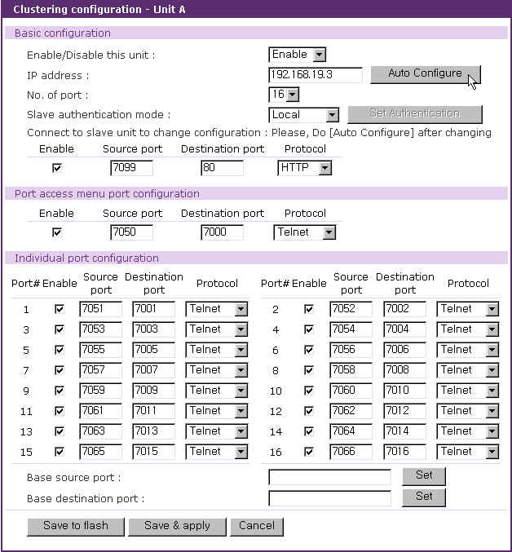
Figure 5-7 VTS automatic clustering configuration result

If the automatic configuration process fails, an error message will appear. The most common error is entry of an incorrect IP address or network problem (i.e. network down).

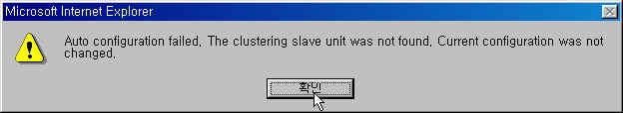
Figure 5-8 VTS clustering configuration error message

Please check whether the port information of the slave unit is correctly set up. Then select the [Save to flash] and [Apply changes] buttons in order to complete the clustering configuration for the slave units. Figure 5-9 shows the result after saving and applying the clustering configuration.

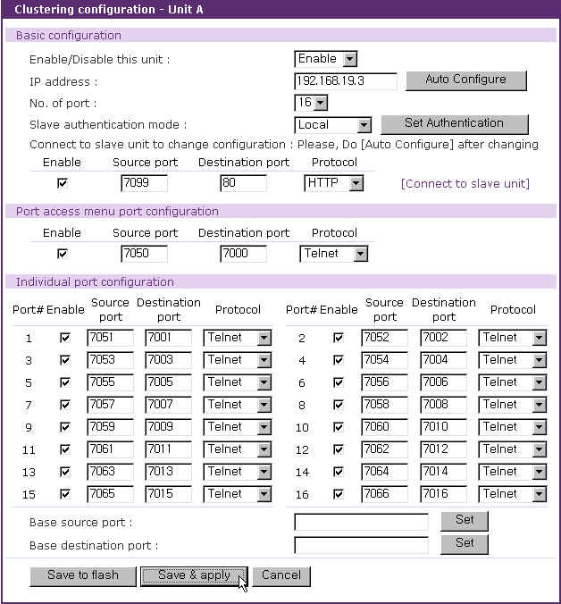
Figure 5-9 VTS clustering configuration after saving and applying

User can change the clustering authentication mode of the clustering slave unit by selecting Slave authentication mode and clicking Set Authentication button. User can also access to the web interface of the clustering slave unit where user can configure the clustering slave unit by clicking the link named [Connect to slave unit]. After user changes the configuration of the clustering slave unit, user needs to click Auto Configure button to reflect the changes of the clustering slave unit to the clustering configurations of the clustering master unit.

Upon completing the clustering configuration, the user may try to connect to the ports of the slave unit by selecting [Clustering – Connection] menu item on the menu bar. Figure 5-10 shows the screen for clustering connection. The user may connect the slave ports by selecting the unit number or the IP address of the slave in the clustering connection workspace. Then the workspace displaying all the serial ports available in the slave’s serial port will be shown up.

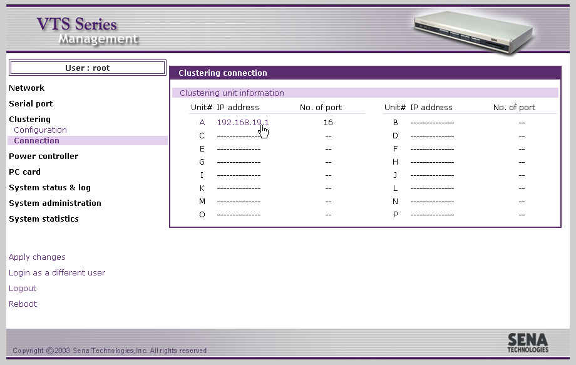
Figure 5-10 VTS clustering connection page – slave information

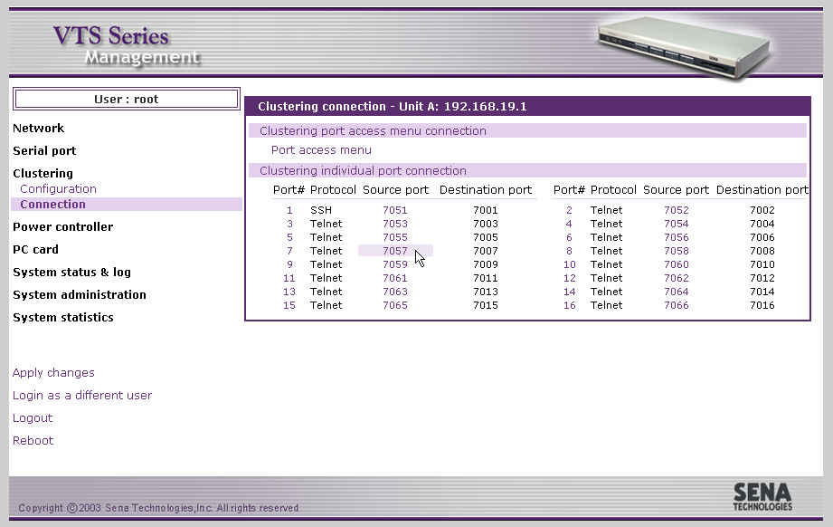
Figure 5-11 VTS clustering connection page – slave unit
Figure 5-11 shows the workspace displaying all the serial ports available in the slave’s serial port. This is similar to the serial port connection. The user may now select the port number to access the serial port of the slave unit by using the Java applet window. The user may use their own terminal emulation program, such as telnet or an SSH client program to access the source port of the master unit to connect to the destination port of the slave.

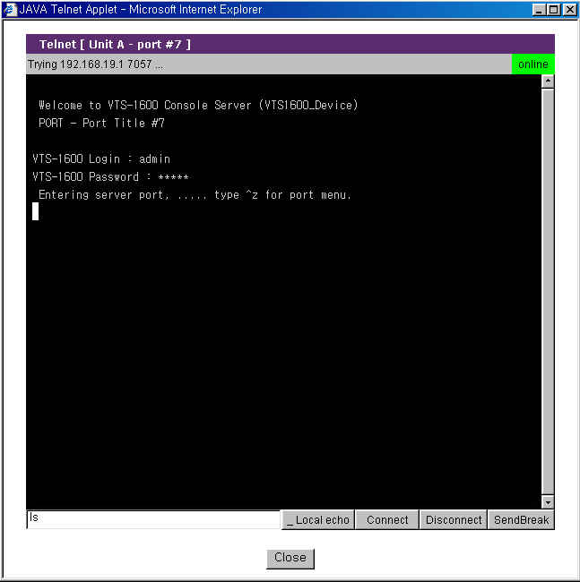
Figure 5-12 connection to the serial port of slave unit

6: Power Controller

6.1 Overview

The VTS allows users to add, configure and manage remote power controller such as Baytech RPC series. When users add a power controller to the VTS and plug a device which is connected to the VTS serial port into the outlet of the power controller, users can configure it at the power controller configuration page or the power control configuration page of the Serial port configuration. For further details about power control configuration, please refer to section 4.3.12. Power control configuration. Users can also manage it at the power controller management page or the serial port power control page from serial port connection.
The power controller features of the VTS help users manage the power of the device connected to the VTS serial port. Users can not only turn on / off and reboot the device but also monitor the state of the power controller. The properties to set or to monitor depends on the power controller.

Available power controllers
- Baytech RPC series

6.2 Power controller configuration

Users add / remove a power controller, configure the count of the outlet, the title and the alarms and thresholds of the power controller and link an outlet to a certain device or a serial port of the VTS. Users can also link a serial port of the VTS to an outlet of the power controller at the power control configuration page of the serial port configuration.

6.2.1 Add / remove power controller

If the users select the Power controller - Configuration menu item in the menu bar, the power controller configuration page (refer to Figure 6-1 Power controller configuration) is displayed. Clicking Add controller button after selecting the port where a power controller is connected and manufacturer at Add power controller part, user can add the power controller. After the power controller is add, the power controller unit configuration page is displayed. And then users can configure the power controller added.
Users can remove the power controller by clicking the Remove button of the power controller at Power controllers part.

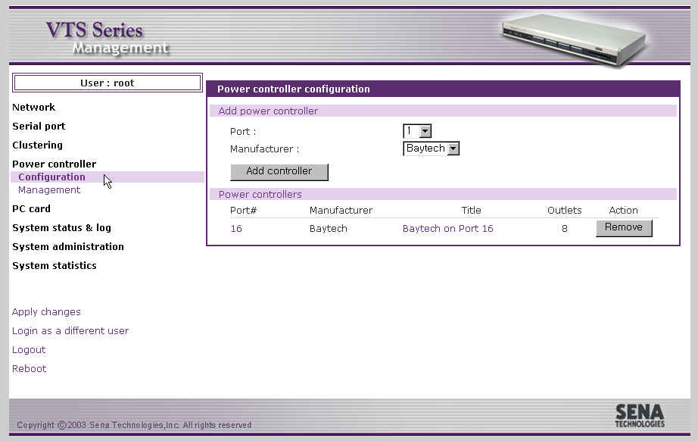
Figure 6-1 Power controller configuration

6.2.2 Edit power controller – Power controller tab

When a power controller is added or a power controller in power controller list of power controllers part at the power controller configuration page(refer to Figure 6-1 Power controller configuration) is selected, the power controller tab of power controller configuration (refer to Figure 6-2 Power controller configuration – power controller tab) is displayed.
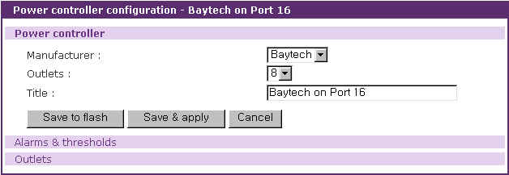
Figure 6-2 Power controller configuration – power controller tab

User may configure the manufacturer, the count of outlets and the title of the power controller. If more than a power controllers are added, users may be able to identify each power controllers by the title of the power controllers, so they will easily access to the power controller that they want to configure or manage.

6.2.3 Edit power controller – Alarms & thresholds tab

When users select a power controller in power controller list of power controllers part at the power controller configuration page (refer to Figure 6-1 Power controller configuration) and then the Alarms & thresholds tab link at power controller unit configuration page, users can access to the alarms & thresholds tab of power controller configuration (refer to Figure 6-3 Power controller configuration – alarms & thresholds tab). These properties may not be supported depending on the power controllers.

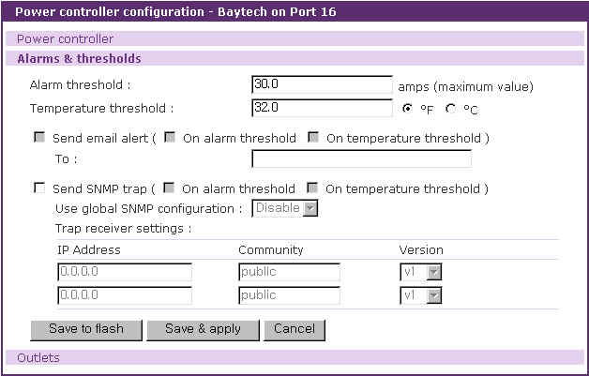
Figure 6-3 Power controller configuration – alarms & thresholds tab

The configuration parameters for power controller alarms & thresholds are as follows:
Alarm threshold
Temperature threshold
Send email alert
Send SNMP trap

Alarm threshold
This parameter defines the threshold to be set on the current that sets off an audible alarm when exceeded. When this threshold is reached, email alerts or SNMP traps can also be sent according to Send email alert and Send SNMP trap parameters.

Temperature threshold
This parameter defines the threshold to be set on the internal temperature of the power controller. When this threshold is reached, email alerts or SNMP traps can also be sent according to Send email alert and Send SNMP trap parameters.

Send email alert
Send email alert : determines whether email is sent.
On alarm threshold : determines whether email is sent when alarm threshold is reached.
On temperature threshold : determines whether email is sent when temperature threshold is reached.
To : determines to whom email is sent

Send SNMP trap
Send SNMP trap : determines whether SNMP trap is sent.
On alarm threshold : determines whether email is sent when alarm threshold is reached.
On temperature threshold : determines whether email is sent when temperature threshold is reached.
Use global SNMP configuration : determines whether the trap receiver setting of the SNMP configuration at network configuration is used as trap receiver.
Trap receiver settings : For details of SNMP trap configurations and descriptions, please refer to section 3.2 SNMP Configuration.

6.2.4 Edit power controller – Outlets tab

When users select a power controller in power controller list of power controllers part at the power controller configuration page(refer to Figure 6-1 Power controller configuration) and then the Outlets tab link at power controller unit configuration page, users can access to the outlets tab of power controller configuration (refer to Figure 6-4 Power controller configuration – outlets tab).

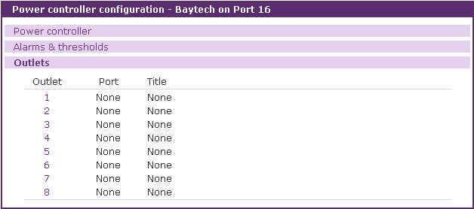
Figure 6-4 Power controller configuration – outlets tab
Users can unfold outlet configuration part by clicking the outlet number link and fold it by clicking the number of the unfolded outlet. Figure 6-5 shows the folded outlet configuration part.

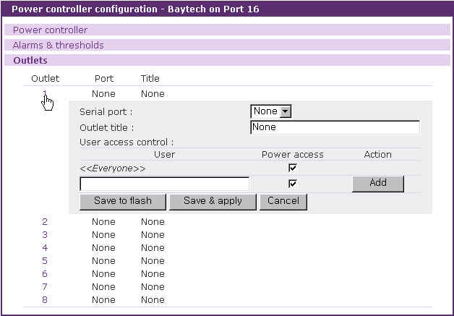
Figure 6-5 Power controller configuration – outlet configuration

The configuration parameters for outlet configuration are as follows:
Serial port
Outlet title
User access control

Serial port
This parameter defines this outlet supplies the device of this serial port of the VTS with the power. None means this outlet serves a device that is not connected to any serial port of the VTS. If it is set to a serial port number of the VTS, the outlet title is set to the title of the serial port configuration, the user access control of power is set to the power access of the user access control of the serial port configuration and they are not editable. (refer to Figure 6-6 Power controller configuration – outlet configuration with serial port)

Outlet title
This parameter is descriptive to the outlet. When users configure or manage a outlet, it helps them to identify it from others. If the serial port is set to a serial port, this column is not editable, set as the serial port title and just link to the port title page of the serial port configuration is provided. (refer to Figure 6-6 Power controller configuration – outlet configuration with serial port)
User access control
This parameter defines whether user can access to the outlet or not. If a user has the power access control, he can monitor the power state at the serial port connection page (refer to 6.3.4 Power controller unit management - Serial port connection) and manage the power controller outlet at the power controller unit management page (refer to 6.3.3 Power controller unit management – Outlets tab) or the serial port power control page linked from the P column of the serial port connection page (refer to 6.3.5 Power controller unit management – Serial port power control).
If <<Everyone>> is checked, all the user except the users who is in the user list of the user access control part can access to it. Unless, they are not allowed to access to it. The users in the user list depend on their own access control.
If the serial port is set to a serial port, this column is not editable, set as the power access control of the user access control of the serial port configuration and just link to the user access control page of the serial port configuration is provided. (refer to Figure 6-6 Power controller configuration – outlet configuration with serial port)

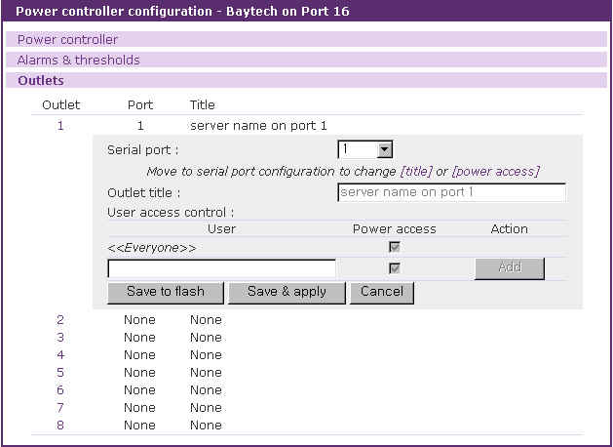
Figure 6-6 Power controller configuration – outlet configuration with serial port

6.2.5 Edit power control configuration of the serial port configuration

The power control configuration page is one of the serial port configuration. If a power controller is added to the VTS, the serial port configuration of each port has this tab. (refer to 4.3.12 Power control configuration).
This page is designed to link the device of a serial port of the VTS to outlets of the power controllers in contrast to the outlet configuration page which is used to link a outlet to a device that is connected to a serial port of the VTS or not. (refer to 6.2.4 Edit power controller – Outlets tab).

6.3 Power controller management

Users monitor / manage a power controller and its outlets at the power controller management pages, the serial port connection page and serial port power control page linked from the serial port connection page.

6.3.1 Power controller management – Power controller list

If the users select the Power controller - Management menu item in the menu bar, the power controller mangement page (refer to Figure 6-7 Power controller management – power controller list) is displayed. It shows the list of power controllers added to the VTS. It contains the information of the power controller such as the connected serial port of the VTS, the manufacturer, the title, the count of outlets and the status of the power controller. If the status of power controller is [Connected], the link to power controller management of the power controller unit on the port number and title column is provided.

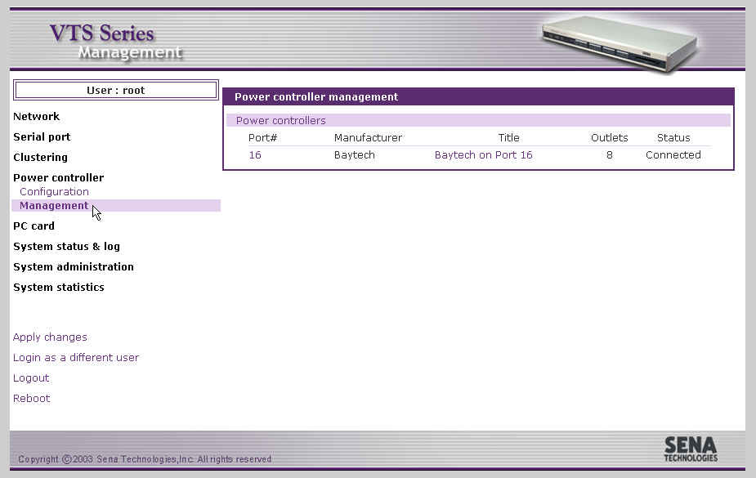
Figure 6-7 Power controller management – power controller list

6.3.2 Power controller unit management – Power controller tab

When a power controller in power controller list of the power controller management page(refer to Figure 6-7 Power controller management – power controller list) is selected, the power controller tab of power controller management (refer to Figure 6-8 Power controller unit management – power controller tab) is displayed. This page can be accessed by clicking the icon on M column at the serial port connection page, too.
It shows the information and the status of the power controllers. Users can reset such value as [Max current detected] by clicking clear button. It is varied as to the power controller model.

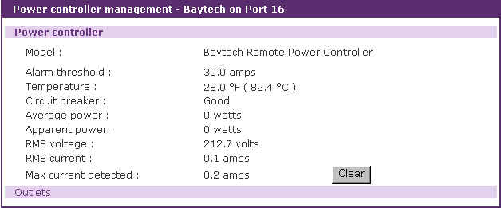
Figure 6-8 Power controller unit management – power controller tab

6.3.3 Power controller unit management – Outlets tab

When users select a power controller in power controller list at the power controller management page(refer to Figure 6-7 Power controller management – power controller list) and then the Outlets tab link at power controller unit management page, users can access to the outlets tab of power controller unit management (refer to Figure 6-9 Power controller unit management – outlets tab).

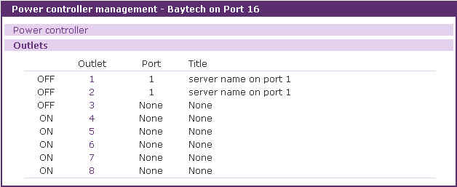
Figure 6-9 Power controller unit management – outlets tab
It shows such information as the number of the serial port where the outlet linked, the title and the status of the outlet. It provides the outlet management part to manage the power of the device linked to the outlet. Users can turn on / off and reboot the outlet.
Users can unfold outlet management part by clicking the outlet number link and fold it by clicking the number of the unfolded outlet. Figure 6-10 shows the folded outlet management part.

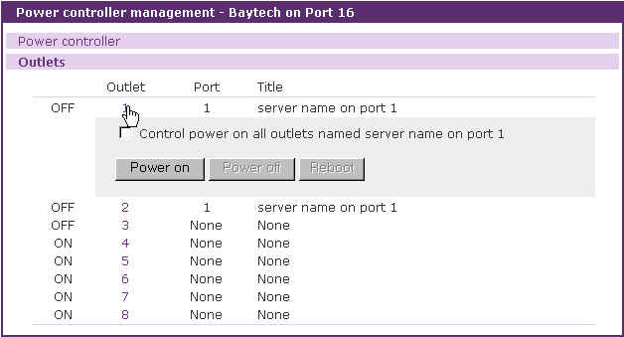
Figure 6-10 Power controller unit management – outlet management

Users can also turn on all the outlets which is linked to the same serial port by checking the [Control power on all outlets named …] check box and pressing the [Power on] button if the serial port is linked to more than one outlet. If users turn off or reboot this outlet in this case, all the outlets are turned off or rebooted.

6.3.4 Power controller unit management - Serial port connection

The serial port connection page linked from the Serial port - Connection menu item also shows the status of the power controller. (refer to Figure 6-11 Power controller unit management – serial port connection). In the contrast that the power controller unit management shows it in the view of outlets, the serial port connection page focuses on the power of the device connected to the VTS serial port.
It not only shows the status of the power but also contains the link to the serial port power control page where users can monitor and control the power of the serial port. Only if the status is on (green) or off (red), users can move to the serial port power control page by clicking the status icon at P column. On trasition (yellow) status, the icon has no link.
The serial port where the power controller is attached has the icon at M column. It is linked to the power controller unit management page. So are the port number and the title of the serial port.

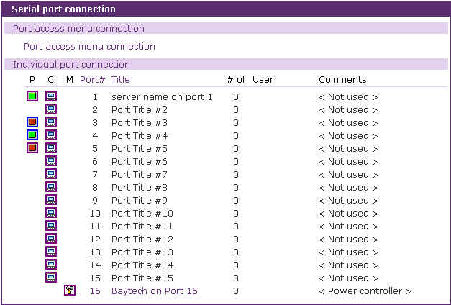
Figure 6-11 Power controller unit management – serial port connection

6.3.5 Power controller unit management – Serial port power control

Users can access to the serial port power control page by clicking the on / off status icon at P column of the serial port connection page. (refer to Figure 6-12 Power controller unit management – serial port power control). If the outlet management page controls a outlet of the power controller, this page manages the power of the device connected to the serial port.

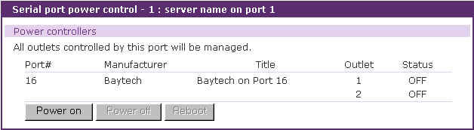
Figure 6-12 Power controller unit management – serial port power control

It shows the information of the outlets where the device of the VTS serial port is linked and the power status of the device. It helps to turn on / off and reboot the device. All the outlets are affected at the same time.

7: PC Card Configuration
The VTS has one extra PC card slot for increased expandability. It supports four types of PC cards:
- LAN card
- Wireless LAN card
- Modem card
- ATA/IDE fixed disk card

The user can allow access via another network connection with either a LAN or wireless LAN card. The ATA/IDE fixed disk card allows the user the ability to store and carry system and serial port log data. Using the card slot for a modem card allows the user out-of-band access to the VTS without a serial port to connect to an external modem.
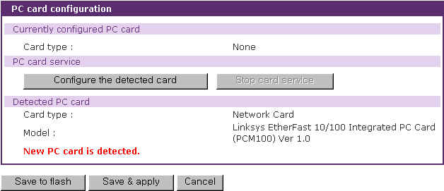
Figure 7-1 Initial PC card configuration menu screen on detecting a new PC card
To use the PC card slot, the users must complete the following steps.
Step 1. Insert the PC card into the PC card slot.
Step 2. Select the Configure the detected card button on the PC card configuration page.
Step 3. The VTS will use its plug and play functionality to discover the card type. It will then display the configuration menu screens. The user can now set card’s operation parameters.
Step 4. Save the configuration settings by selecting the Save to flash button.
Step 5. Select [Apply changes] from the menu to apply the newly configured settings.
If VTS fail to discover the PC card, the following error message will be displayed on the menu screen.
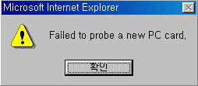
Figure 7-2 Failure to detect error message
Refer to Appendix B.PC Card supported by VTS to view a list of PC cards support by the VTS.

To stop or remove the PC card, user must complete the following steps.
Step 1. Select [(Ban- show the actual button) Stop card service].
Step 2. Save the configuration changes by selecting [Save to flash].
Step 3. Apply changes by selecting [Apply changes] from the menu.
Step 4. Remove the PC card from the PC card slot.

Note: Removing the PC card from the slot without following the above instructions may cause a system malfunction.

7.1 LAN Card Configuration

A LAN card will create two network interfaces and two IP addresses. The users can assign a valid IP address to each serial port . The IP address must be valid in the VTS built-in network interface or the environment of VTS PC card LAN interface environment.

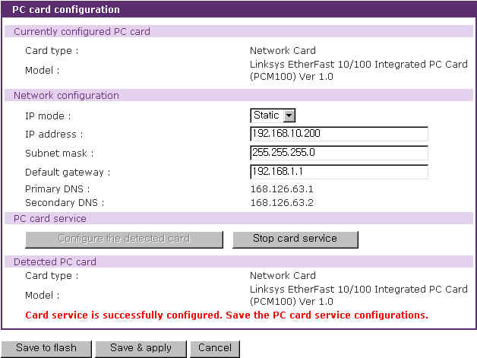
Figure 7-3 PC LAN card configuration

The user must manually select PC LAN card as the card type and set the primary and secondary DNS servers when configuring a PC LAN card. All other configuration steps are the same as detailed in Section 3.1. IP Configuration.
Refer to Appendix B.PC Card supported by VTS to view a list of LAN PC cards supported by the VTS.

7.2 Wireless LAN Card Configuration

A wireless LAN card will result in two network interfaces and two IP addresses. The user can assign a valid IP address to each serial port. The IP address must valid in the VTS built-in network interface or in the wireless LAN interface environment.

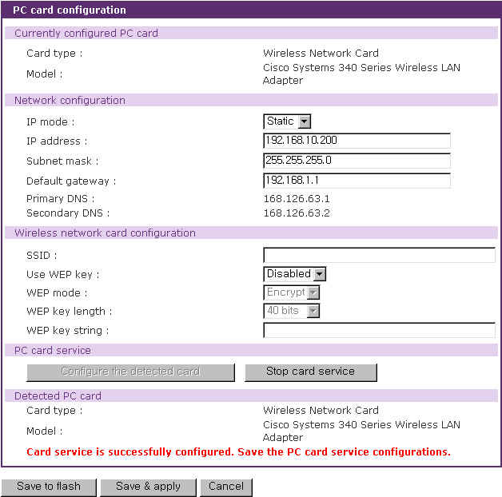
Figure 7-4 PC wireless LAN card configuration

The user must manually select WIRELESS LAN CARD as the card type and set the primary and secondary DNS servers when configuring a PC LAN card. All other configuration steps are the same as detailed in Section 3.1. IP Configuration.

The VTS supports SSID(Service Set Identifier) and WEP(Wired Equivalent Privacy) key features for the wireless LAN configuration. The user may configure the SSID to specify an AP (Access Point). The user may also configure the WEP mode as either encrypted or shared. The WEP key length must be either 40 or 128 bits. The 40-bit WEP key length requires the user to enter 5 hexadecimal code sets without the separator of colon (:). The 128 bits WEP key length requires the user to enter 13 hexadecimal code sets without the separator of colon (:).
For example, to use the 128 bits WEP key length option, the user must enter 13 hexadecimal code sets as follows:
000F25E4C2000F25E4C2000F24

Refer to Appendix B.PC Card supported by VTS to view a list of wireless LAN cards supported by the VTS.

7.3 Serial Modem Card Configuration

Using the extra PC card slot as a modem will allow the user on-line access without tying up a serial port with an external modem. Most 56Kbps PC serial modem cards are compatible with the PC card slot. A complete catalog of modem cards supported by the VTS is listed in Appendix B.PC Card supported by VTS
The default modem init string is “q1e0s0=2”. This allows the modem to operate in quiet mode (‘q1’), echo off mode (‘e0’) and the number of rings on which to answer in Auto Answer mode equaling two (“s0=2”). For more detailed information on the command sets, please refer to the modem manual.
After inactivity timeout period has passed, the connection will be closed.

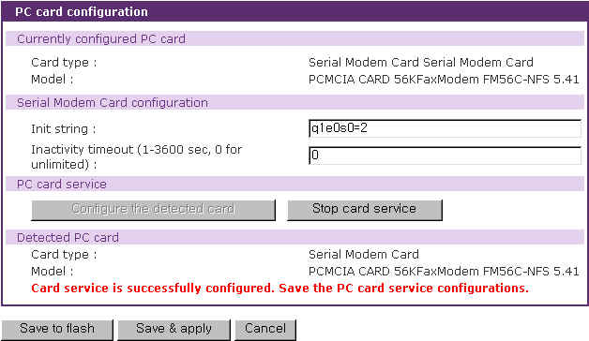
Figure 7-5 PC serial modem card configuration

7.4 ATA/IDE Fixed Disk Card Configuration

The user must configure the total data size required to use the PC ATA/IDE fixed disk card to store the system and serial port log. The VTS will automatically locate the total storage size and the disk space available on the disk.
The user may delete all the files currently on the card by selecting .
The user may select to format the card. The VTS supports both EXT2 and VFAT file systems for the disk card.
The user may store or retrieve the VTS configuration files to/from the disk by exporting/importing the VTS configuration.

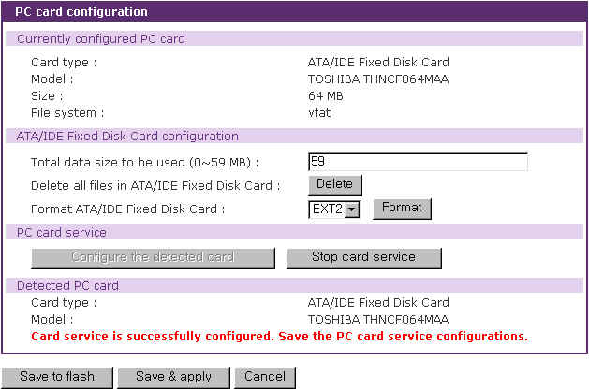
Figure 7-6 PC ATA/IDE fixed disk card configuration

8: System Status and Log

The VTS display the system status and the log data via a Status Display Screen. This screen is to be used for management purposes. System status data includes the model name, serial number, firmware version, bootloader version and the network configuration of the VTS. The VTS can also be configured to deliver log data automatically via email to a specified recipient with the system-logging feature.

8.1 System Status

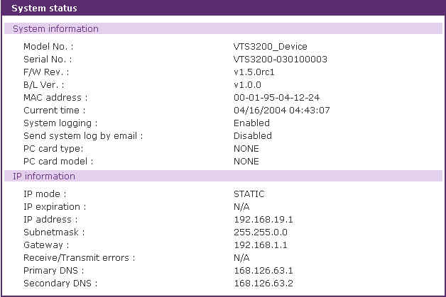
Figure 8-1 System status display

8.2 System Log Configuration

The VTS provides both the system logging feature and the system log status display. The user may configure the VTS to enable or disable the system logging process and select the system log buffer size as well as the log storage location.

System log storage location
The system log can be stored in the VTS internal memory, the ATA/IDE fixed disk card inserted in PCMCIA slot, the mounting point on an NFS server or the SYSLOG server. If the internal memory is used to store system log data, the log data will be cleared when the VTS is turned off. To preserve the system log data, set the storage location to be the ATA/IDE fixed disk card, SYSLOG server or NFS server. To do this, the user must configure the corresponding media in advance. Unless the media is properly set up, the user will not be able to select a storage location from the interface.

System log buffer size
This parameter defines the maximum amount of system log data that can be logged. When using internal memory to store data, the total size of the system log cannot exceed 300 Kbytes.
When using an ATA/IDE fixed disk card to store log data, the maximum buffer size is dependent upon the card capacity.
When using an NFS server to store logs data, the maximum buffer size is unlimited. The user should configure the NFS server to ensure that the port logging system works properly.
When using the SYSLOG server to store log data, the user cannot set the buffer size.
The VTS can also be configured to send log data automatically if the number of logs unsent reaches a pre-defined number. If enabled, the user must set parameters to initiate the creation of a email. These parameters would include the number of logs required to trigger an email, the recipient email address, etc. Figure 8-2 shows the configuration and system log view screen.

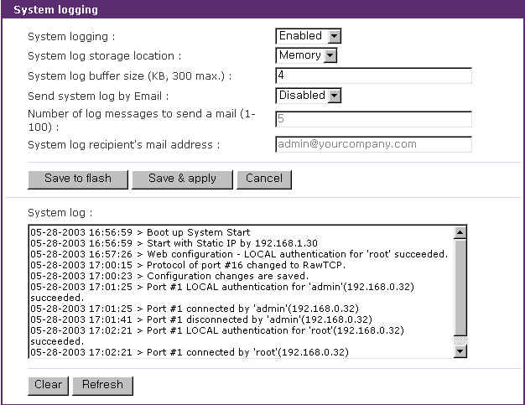
Figure 8-2 System log configuration and view

8.3 User logged on list

This function allows a user to view current and historical user activity on the system.

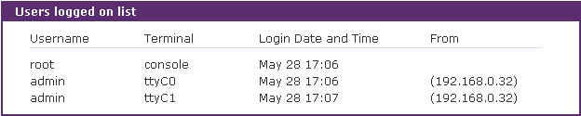
Figure 8-3 User logged on list

The list displays the following information for users who have logged into the system:
User name
Terminal type for the session
Time connected
IP address of the remote host

Note: Users access via the web will not appear on the list. Connections are not always made using HTTP/HTTPS protocol.

9: System Administration

The VTS utilizes three user profile types to manage accessibility to different functions. These three levels of user types include: system admin, port admin and user.

The system admin group has full read/write access of the VTS configuration. The system admin can view or edit all VTS configurations, as well as use the VTS without any limitations.
The port admin group has full read/write access to the serial port configuration parameters and power controller outlet configuration parameters. The port admin group are only provided read access to the other VTS configuration settings. The port admin group also has access to the port access menu.
The user group has no right to modify any of the VTS configurations. The user may access the serial port connection screen and the power controller management screen on the web interface to connect to the VTS serial ports or access the port access menu and to manage the power controller if allowed.

In addition to the local authentication method, the VTS also supports an authentication server based method for user authentication. If a remote authentication method (i.e. RADIUS, TACAS+, LDAP) is enabled, the VTS will confirm the username and password with the remote authentication server and check the response from the server. The users can also use the cascaded authentication method such as remote authentication first and then local authentication if the remote authentication fails, or vice versa.

The users can configure the VTS’s device name, date and time settings, the current user’s password, and import / export configurations in this menu group. The users can also upgrade the firmware of the VTS using the web interface, remote consoles or serial console.

9.1 User Administration

The VTS manages four user-level groups. Access of the configuration interfaces and of the serial ports is based on the user’s group level.

- User: General Port User Group
- Users who belong to this group can access each serial port of which the port access control they have, if the serial port is disabled to sniff.
- Users who belong to this group can access each serial port of which the port or monitor access control they have, if the serial port is enabled to sniff.
- Users who belong to this group can manage the power of the outlet of which the power access control they have.
Note:
The user access control is introduced to support user grouping of serial ports and power controller.
- Users in this group can also access the port access menu.
- Users in this group can use the serial port connection menu and power controller management menu on Web interface.
- Users in this group cannot access any configuration menu or CLI.

- Port Administrator: Serial Port Administrator Group
- The Serial Port Administrator group has the all privileges that the User group has when connected to the serial port and to the power controller.
- The Serial Port Administrator group can access the configuration menu through the Web interface or console. The group can only change the configuration parameters provided for the serial port, the clustering and power controller outlet. However, this group cannot change the configuration parameters of system itself (i.e. network configuration, PC card and system administration).
- The users who belong to this group cannot access CLI.

- System Administrator: System Administrator group
- The System Administrator group has all the privileges that users in the Port Administrator group have when connected to the serial port.
- The System Administrator group can access the configuration menu through the Web interface or console. They can change all the configuration parameters of the system itself.
- The System Administrator group can access the CLI, as well as execute the program. The CLI allows the group access to the configuration and port access menu.

- root : System Super User
- A System Super User has all the privileges that users in the System Administrator group have when connected to the serial port.
- A System Super User can access the Linux CLI. A System Super User has full access to modify the CLI system.
- Only one user can be identified as the A System Super User. The user name cannot be changed.

The factory default user names and the passwords are:
System Super User
Login: root Password: root
System Administrator
Login: admin Password: admin.

The user groups and their VTS access privileges are summarized in the Table 9-1.

Table 9-1. User groups and their privileges
Group | Super user | System Administrator | Port Administrator | Users
Default User name | Root | Admin | - | -
Default config  User interface | CLI | Text menu | - | -
Interface Program | CLI  Text menu  Port access menu | CLI  Text menu  Port access menu | Text menu  Port access menu | Port access menu
SSH public key  upload | O | O | X | X
CLI access | O | O | X | X
Configuration  text menu access | O | O | ᇫ** | X
Port Access Menu  Access | O | O | O | O
Web UI Access | O | O | ᇫ** | ᇫ***
System parameter Change | O | O | ᇫ** | X
User parameter  Change | O | O | X | X
User Edit/Removal | O | O | X | X
Note:
- ** Only the serial port/clustering and power controller outlet related configuration settings are accessible. Read-only privilege is provided for all other fields.
- *** The user may access only the connection workspace for the serial port / the clustering and the power controller management.

Figure 9-1 shows the initial user administration web interface.
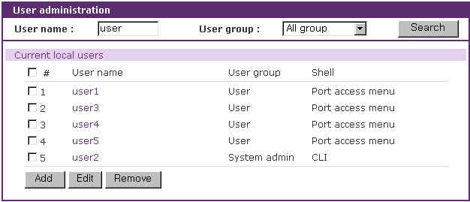
Figure 9-1 User administration
User list can be restricted to searching condition by specifying user name, user group or both of them. If user name is empty, all users are listed. If user name specified, users whose name starts with specified user name are listed. If user group is selected, users who belong to it are listed. The default condition is empty in user name and [All group] in user group.

To add a user, Open add user screen by clicking the [Add] button, type the username, group and password at the add user screen, and then click the [Add] button. Figure 9-2 shows the Add User screen.

The following parameters should be properly set up to create a user’s account:
User Name
User Group: One of User, Port admin, System admin
User Password
Shell program: One of CLI, Configuration menu, Port access menu
SSH public key authentication: One of Enabled or Disabled
SSH version: One of v1 or v2
SSH public key file

If the SSH public key is uploaded into the VTS, the users who connect to the VTS using the SSH client program will be automatically authenticated using this key file. Otherwise, a password-based authentication will be done.

Notes:
User ID and password should be at least 3 characters or more for user add and change. There will be an error message if they are shorter than or equal to 2 characters.

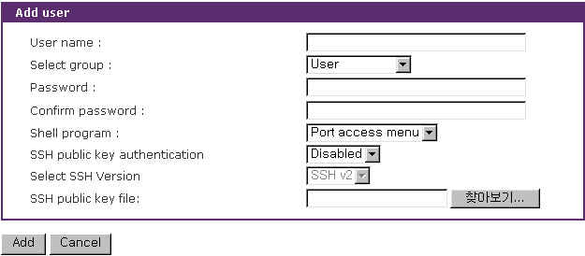
Figure 9-2 Adding a user

To remove a user,
- Check the users at the User administration screen
- Click the [Remove] button
To change the parameters of the user account, open the edit user screen by selecting the user name at the User administration screen and then edit the parameters of user account like adding user.

9.2 Change Password

Figure 9-3 shows the change password screen. To change the current user’s password, type the current password and a new password and then confirm the new password.
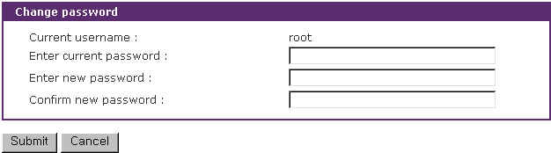
Figure 9-3 Change password

A user who can access only the port access menu can change the password at the port access menu page. When connecting to the port access menu, the page below will be displayed. Please, enter P at command input column and new password and confirm the new password and the password will be changed.
[192.168.100.3]
================================================================================
Port# Port Title Mode Port# Port Title Mode
================================================================================
1 Port Title #1 CS 2 Port Title #2 CS
3 Port Title #3 CS 4 Port Title #4 CS
5 Port Title #5 CS 6 Port Title #6 CS
7 Port Title #7 CS 8 Port Title #8 CS
9 Port Title #9 CS 10 Port Title #10 CS
11 Port Title #11 CS 12 Port Title #12 CS
13 Port Title #13 CS 14 Port Title #14 CS
15 Port Title #15 CS 16 Port Title #16 CS
17 Port Title #17 CS 18 Port Title #18 CS
19 Port Title #19 CS 20 Port Title #20 CS
21 Port Title #21 CS 22 Port Title #22 CS
23 Port Title #23 CS 24 Port Title #24 CS
25 Port Title #25 CS 26 Port Title #26 CS
27 Port Title #27 CS 28 Port Title #28 CS
29 Port Title #29 CS 30 Port Title #30 CS
31 Port Title #31 CS 32 Port Title #32 CS

Enter command ( 1-32 serial port, A-P slave unit, P passwd, others for exit )
------> P
Enter new password : *****
Retype new password : *****
Password was changed.

9.3 Device Name Configuration

The VTS has its own name for administrative purposes. Figure 9-4 shows the device name configuration screen. When user changes Device name, hostname of VTS shall be changed and then prompt on CLI also shall be changed to the corresponding one as follows,

root@VTS3200_Device:~#
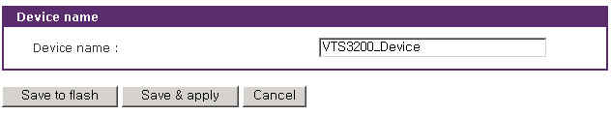
Figure 9-4 Device name configuration
Please note that user cannot set space character as one of device name. And If user sets blank as Device name then hostname is set as IP address of VTS automatically.
And also the device name is mainly utilized for management program, HelloDevice Manager.

9.4 Date and Time Settings

The VTS maintains current date and time information. The VTS clock and calendar settings are backed up by internal battery power. The user can change the current date and time, as shown in Figure 9-5.
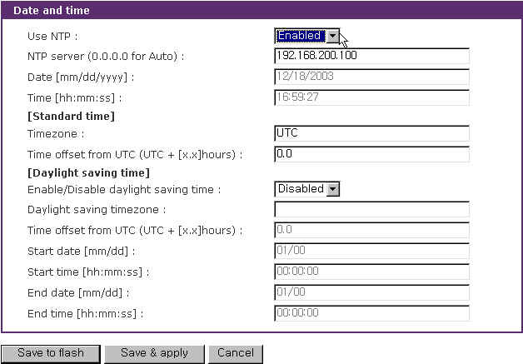
Figure 9-5 Date and time configuration
There are two date and time settings.
The first is to use the NTP server to maintain the date and time settings. If the NTP feature is enabled, the VTS will obtain the date and time information from the NTP server at each reboot. If the NTP server is set to 0.0.0.0, the VTS will use the default NTP servers. In this case, the VTS should be connected from the network to the Internet. The second method is to set date and time manually without using the NTP server. This will allow the date and time information to be kept maintained by the internal battery backup.
The user may also need to set the timezone and the time offset from UTC depending on the users’ location to set system date and time exactly. If the user uses daylight saving time, the user may need to set the daylight saving time properties such as the daylight saving timezone, the time offset from UTC, start data and time, end date and time. It allows the VTS to calculate the exact system time.

9.5 Configuration management

The user may export the current configurations to a file at such locations as CF card, NFS server, user space or local machine and import the exported configurations as current configurations from CF card, NFS server, user space or local machine.
The user may restore the factory default settings at any time by selecting “Factory default” at location property at the import part or by pushing the factory default reset switch on the back panel of the VTS. Figure 9-6 shows the configuration management screen. The following parameters should be properly set up to export / import configurations:

Configuration export
Location : Location to export to.
Encrypt : One of Yes or No.
File name

Configuration import
Location : Location to import from. By selecting Factory default, the user may restore the factory settings.
Configuration selection : Determines what kinds of configurations are imported.
Encrypt : One of Yes or No. If location is Factory default, it does not affect.
File selection : List all the exported files satisfying the encrypting option at the selected location which is one of CF card, NFS server and user space.
Local : Helps to browse the exported file at local machine if location is local machine.

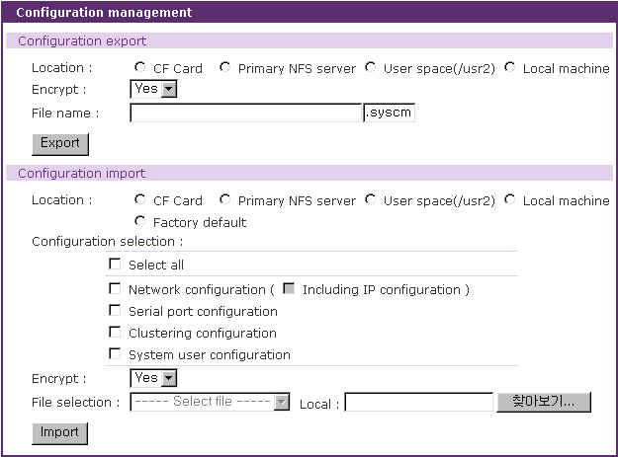
Figure 9-6 Configuration management

To export the current configurations:
- Select the location to export to.
- Select the encrypting option
- Type the file name.
- Click the [Export] button.

To import the exported configurations:
- Select the location to import from.
- Select the configurations to import.
- Select the encrypting option.
- Select the file to import from the file selection list box if location is not local machine nor factory default.
- Select the file to import by clicking browse button if location is local machine.
- Click the [Import] button.

9.6 Firmware Upgrade

Firmware upgrades are available via serial, remote console or web interface. The latest upgrades are available on the Sena web site at http://www.sena.com/support/downloads/. The VTS supports the automatic firmware and configuration upgrade at booting. If users set the properties related to the automatic firmware and configuration, the VTS will check whether the firmware and configuration are newly updated and upgrade the new firmware and configuration if needed.
Figure 9-7 shows the firmware upgrade web interface.

To upgrade firmware via the web:
- Select the latest firmware binary by clicking browse button.
- Select and upload the selected version.
- Once the upgrade has been completed, the system will reboot to apply the changes.

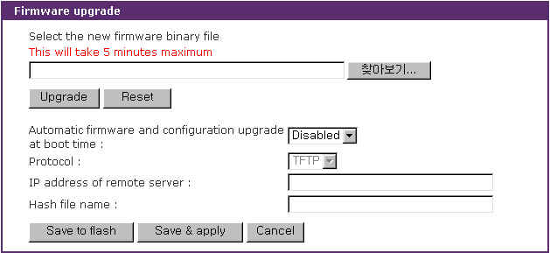
Figure 9-7 Firmware upgrade

To use either a remote or serial console to upgrade your firmware, the TELNET/SSH or terminal emulation program must support Zmodem transfer protocol. After the firmware upgrade, the previous settings will be reset to the factory default settings, except the IP configuration settings.

To upgrade firmware via a remote console:
- Obtain the latest firmware.
- Connect either TELNET/SSH or a serial console port using the terminal emulation program.
(TELNET or SSH is recommended since the process of firmware upgrade by serial console requires extremely long time.)
- Select from the firmware upgrade menu as shown in Figure 9-8.
- Follow the online directions and transfer the firmware binary file using the Zmodem protocol as shown in Figure 9-9.
- Once the upgrade has been completed, the system will reboot to apply the changes
- If the firmware upgrade fails, the VTS will display error messages as shown in Figure 9-10. It will also maintain the current firmware version.

Login : admin
Password : *****

-------------------------------------------------------------------------------
Welcome to VTS-3200 configuration page
Current time : 0000/00/00 00:00:00 F/W REV. :
Serial No. : MAC Address : 00-01-95-04-1b-2e
IP mode : DHCP IP Address : 192.168.0.129
-------------------------------------------------------------------------------
Select menu
1. Network Configuration
2. Serial Port Configuration
3. Clustering Configuration
4. Power Controller
5. PC Card Configuration
6. System Status & Log
7. System Administration
8. Save Changes
9. Exit without Saving
a. Exit and Apply Changes
b. Exit and Reboot
<ENTER> Refresh
-----> 7
-------------------------------------------------------------------------------
System Administration
-------------------------------------------------------------------------------
Select menu
1. User administration
2. Device name : VTS3200 Device
3. Date and time
4. Configuration management
5. Firmware upgrade
<ESC> Back, <ENTER> Refresh
-----> 5
-------------------------------------------------------------------------------
System Administration --> Firmware Upgrade
-------------------------------------------------------------------------------
Select menu
1. Firmware Upgrade
2. Automatic firmware and configuration upgrade at boot time : Disable
<ESC> Back, <ENTER> Refresh
-----> 1

*** Firmware upgrade will RESTART your device. ***
Do you want to start firmware upgrade ? (y/n) : y
Preparing for firmware upgrade. Wait a moment...
Transfer firmware by zmodem using your terminal application.
**B0ff000005b157

Figure 9-8 Firmware upgrade using remote/serial console
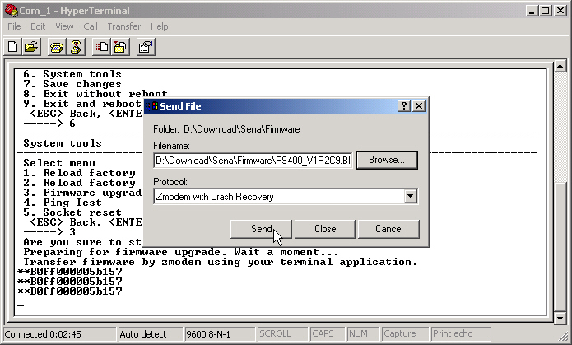
Figure 9-9 Transfer binary file by Zmodem (HyperTerminal)

-----> 5

*** Firmware upgrade will RESTART your device. ***
Do you want to start firmware upgrade ? (y/n) : y
Preparing for firmware upgrade. Wait a moment...
Transfer firmware by zmodem using your terminal application.
**B0ff000005b157
**B0ff000005b157
**B0ff000005b157
**B0ff000005b157
Firmware upgrade failed !
Now reboot ...

Figure 9-10 Firmware upgrade failure message

To use the function to upgrade the firmware and configuration at boot time, users have to set the following properties :

Automatic firmware and configuration upgrade at boot time
It determines whether the VTS upgrade at boot time or not.

Protocol
It determines which protocol the VTS uses to communicate with the remote host on upgrading.

IP address of remote server
It determines to which host the VTS connects to get the hash file, firmware image and configuration file.
Hash file name
It determines the name of hash file that is used to specify the firmware image file and configuration file to upgrade. The VTS checks if the VTS needs to upgrade or not by comparing the model name and version at hash file with the VTS model name and firmware version. Hash file format is below :

<TYPE>,<NAME>,<MODEL>,<VERSION>

Where <TYPE> - 1:firmware image 2:configuration (1 byte)
<NAME> - the name of firmware image file or configuration file
<MODEL> - the model name of VTS such as VTS800, VTS1600 and VTS3200
<VERSION> - version of firmware or configuration
In case of firmware update, this field should be the same version number that the firmware has. In case of configuration update, this field is a user assigned version number with the similar format of firmware version

Hash file example is below:

1,vts48.img,VTS3200,v1.5.0
2,vts48.syscm,VTS3200,v1.0.0

10: System Statistics

The VTS Web interface provides system statistics menus. The user can use the menus to access statistical data and tables stored in the VTS memory. Network interfaces statistics and serial ports statistics display statistical usage of the link layer, lo, eth and serial ports. IP, ICMP, TCP and UDP statistics display usages of four primary components in the TCP/IP protocol suite.

10.1 Network Interfaces Statistics

Network interfaces statistics display basic network interfaces usage of the VTS, lo and eth0. lo is a local loop back interface and eth0 is a default network interface of VTS.

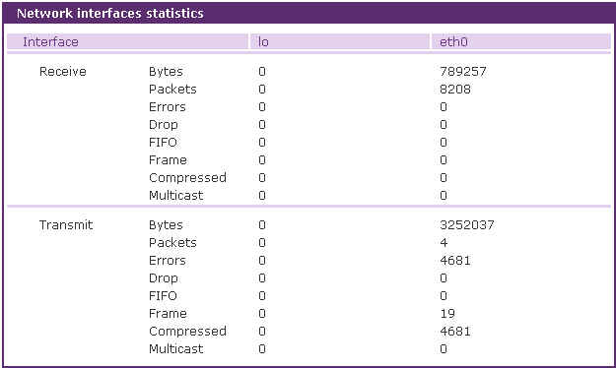
Figure 10-1 Network interfaces statistics

10.2 Serial Ports Statistics

Serial ports statistics display the usage history of 32 serial ports, baud rate configurations and each port’s pin status. ( : On : Off )

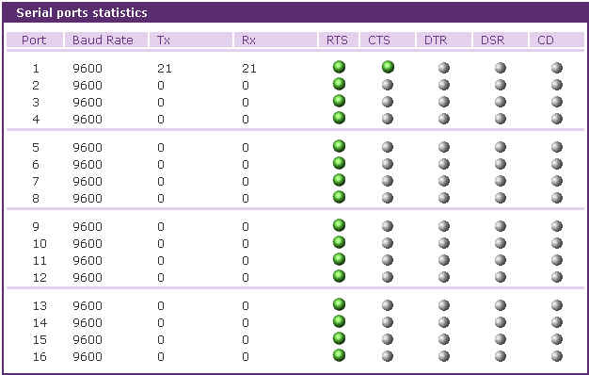

Figure 10-2 Serial ports status

10.3 IP Statistics

The IP Statistics screen provides statistical information about packets/connections using an IP protocol. Definitions and descriptions of each parameter are described below:

Forwarding :
Specifies whether IP forwarding is enabled or disabled.
DefaultTTL :
Specifies the default initial time to live (TTL) for datagrams originating on a particular computer.
InReceives :
Shows the number of datagrams received.
InHdrErrors :
Shows the number of datagrams received that have header errors. Datagrams Received Header Errors is the number of input datagrams discarded due to errors in their IP headers, including bad checksums, version number mismatch, other format errors, time-to-live exceeded, errors discovered in processing their IP options, etc.
InAddrErrors :
Specifies the number of datagrams received that have address errors. These datagrams are discarded because the IP address in their IP header's destination field was not a valid address to be received at this entity. This count includes invalid addresses (for example, 0.0.0.0) and addresses of unsupported Classes (for example, Class E).
ForwDatagrams :
Specifies the number of datagrams forwarded.
InUnknownProtos :
Specifies the number of locally addressed datagrams received successfully but discarded because of an unknown or unsupported protocol.
InDiscard :
Specifies the number of input IP datagrams for which no problems were encountered to prevent their continued processing, but which were discarded (for example, for lack of buffer space). This counter does not include any datagrams discarded while awaiting reassembly.
InDelivers :
Specifies the number of received datagrams delivered.
OutRequests :
Specifies the number of outgoing datagrams that an IP is requested to transmit. This number does not include forwarded datagrams.
OutDiscards :
Specifies the number of outgoing datagrams discarded.
OutNoRoutes :
Specifies the number of transmitted datagrams discarded. These are datagrams for which no problems were encountered to prevent their transmission to their destination, but which were discarded (for example, for lack of buffer space.) This counter would include datagrams counted in Datagrams Forwarded if any such packets met this (discretionary) discard criterion.
OutNoRoutes :
Specifies the number of datagrams for which no route could be found to transmit them to the destination IP address. These datagrams were discarded. This counter includes any packets counted in Datagrams Forwarded that meet this "no route" criterion.
ReasmTimeout :
Specifies the amount of time allowed for all pieces of a fragmented datagram to arrive. If all pieces do not arrive within this time, the datagram is discarded.
ReasmReqds :
Specifies the number of datagrams that require reassembly.
ReasmOKs :
Specifies the number of datagrams that were successfully reassembled.
ReasmFails :
Specifies the number of datagrams that cannot be reassembled.
FragOKs :
Specifies the number of datagrams that were fragmented successfully.
FragFails :
Specifies the number of datagrams that need to be fragmented but couldn't be because the IP header specifies no fragmentation. For example, if the datagrams "Don't Fragment" flag was set, the datagram would not be fragmented. These datagrams are discarded.
FragCreates :
Specifies the number of fragments created.

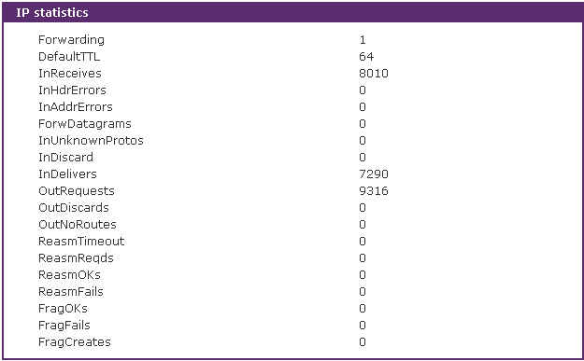

Figure 10-3 IP statistics

10.4 ICMP Statistics

The ICMP Statistics screen provides statistical information about packets/connections using an ICMP protocol. Definitions and descriptions of each parameter are described below:

InMsgs, OutMsgs :
Specifies the number of messages received or sent.
InErrors, OutErrors :
Specifies the number of errors received or sent.
InDestUnreachs, OutDestUnreachs :
Specifies the number of destination-unreachable messages received or sent. A destination-unreachable message is sent to the originating computer when a datagram fails to reach its intended destination.
InTimeExcds, OutTimeExcds :
Specifies the number of time-to-live (TTL) exceeded messages received or sent. A time-to-live exceeded message is sent to the originating computer when a datagram is discarded because the number of routers it has passed through exceeds its time-to-live value.
InParmProbs, OutParmProbs :
Specifies the number of parameter-problem messages received or sent. A parameter-problem message is sent to the originating computer when a router or host detects an error in a datagram's IP header.
InSrcQuenchs, OutSrcQuenchs :
Specifies the number of source quench messages received or sent. A source quench request is sent to a computer to request that it reduces its rate of packet transmission.
InRedirects, OutRedirects :
Specifies the number of redirect messages received or sent. A redirect message is sent to the originating computer when a better route is discovered for a datagram sent by that computer.
InEchos, OutEchos :
Specifies the number of echo requests received or sent. An echo request causes the receiving computer to send an echo reply message back to the originating computer.
NEchoReps, OutEchoReps :
Specifies the number of echo replies received or sent. A computer sends an echo reply in response to receiving an echo request message.
InTimestamps, OutTimestamps :
Specifies the number of time-stamp requests received or sent. A time-stamp request causes the receiving computer to send a time-stamp reply back to the originating computer.
InTimestampReps, OutTimestampReps :
Specifies the number of time-stamp replies received or sent. A computer sends a time-stamp reply in response to receiving a time-stamp request. Routers can use time-stamp requests and replies to measure the transmission speed of datagrams on a network.
InAddrMasks, OutAddrMasks :
Specifies the number of address mask requests received or sent. A computer sends an address mask request to determine the number of bits in the subnet mask for its local subnet.
InAddrMaskReps, OutAddrMaskReps :
Specifies the number of address mask responses received or sent. A computer sends an address mask response in response to an address mask request.

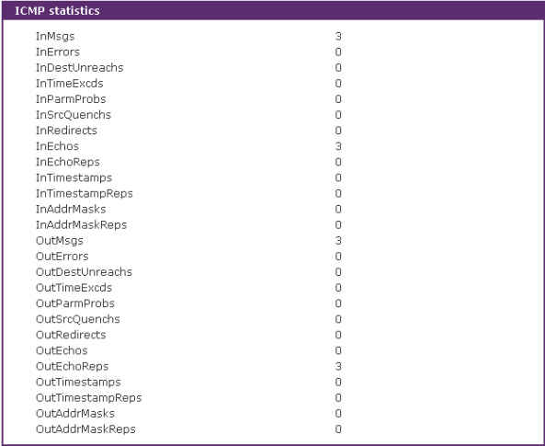

Figure 10-4 ICMP statistics

10.5 TCP Statistics

The TCP Statistics screen provides statistical information about packets/connections using a TCP protocol. Definitions and descriptions of each parameter are described below:

RtoAlgorithm :
Specifies the retransmission time-out (RTO) algorithm in use. The Retransmission Algorithm can have one of the following values.
0 : CONSTANT - Constant Time-out
1: RSRE - MIL-STD-1778 Appendix B
2: VANJ - Van Jacobson's Algorithm
3: OTHER - Other
RtoMin :
Specifies the minimum retransmission time-out value in milliseconds.
RtoMax :
Specifies the maximum retransmission time-out value in milliseconds.
MaxConn :
Specifies the maximum number of connections. If is the maximum number is set to -1, the maximum number of connections are dynamic.
ActiveOpens :
Specifies the number of active opens. In an active open, the client is initiating a connection with the server.
PassiveOpens :
Specifies the number of passive opens. In a passive open, the server is listening for a connection request from a client.
AttemptFails :
Specifies the number of failed connection attempts.
EstabResets :
Specifies the number of established connections that have been reset.
CurrEstab :
Specifies the number of currently established connections.
InSegs :
Specifies the number of segments received.
OutSegs :
Specifies the number of segments transmitted. This number does not include retransmitted segments.
RetransSegs :
Specifies the number of segments retransmitted.
RetransSegs :
Specifies the number of errors received.
OutRsts :
Specifies the number of segments transmitted with the reset flag set.

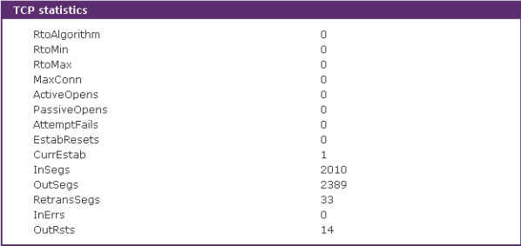

Figure 10-5 TCP statistics

10.6 UDP Statistics

The UDP Statistics screen provides statistical information about packets/connections using a UDP protocol. Definitions and descriptions of each parameter are described below:

InDatagrams :
Specifies the number of datagrams received.
NoPorts :
Specifies the number of received datagrams that were discarded because the specified port was invalid.
InErrors :
Specifies the number of erroneous datagrams that were received. Datagrams Received Errors is the number of received UDP datagrams that could not be delivered for reasons other than the lack of an application at the destination port.
OutDatagrams :
Specifies the number of datagrams transmitted.

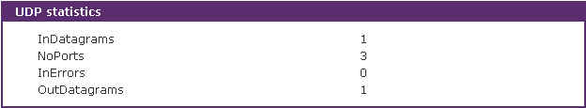

Figure 10-6 UDP statistics

11: CLI guide

11.1. Introduction

The VTS Root or System Administrator can access the Linux console command line interface (CLI) of the VTS via the serial console or Telnet/SSH. In the CLI, the authorized user can perform standard Linux commands to view the status of the VTS, edit the configuration, apply configuration changes, define user scripts and transmit files between the VTS and remote hosts.
The VTS provides 1024 KB user space mounted in /usr2 for read/write capabilities in its internal flash memory. Using the user space, the user can create their own scripts or executable binaries to customize the VTS.
A Root user will always have access to the CLI through the serial console on the VTS back panel or by using a Telnet/SSH client from their workstation. A System Administrator user can also access to the CLI but with limited rights.
The Root user will not be able to access the telnet remote / serial console by removing remark character of following line in /etc/pam.d/login file.
auth requisite pam_securetty.so
The Root user will not be able to access the SSH remote / serial console by changing configuration in /etc/ssh/sshd_config file
#PermitRootLogin yes => PermitRootLogin no.

11.2. Flash partition

The VTS internal flash is partitioned as shown in the table below. The users can freely access the Mtdblock5 which is mounted on /usr2 for their own needs. The user can also access files at /etc, /var, and /temp at their own risk. Simply accessing these files will not affect the VTS after rebooting. However, if the user invokes the command saveconf, the changes in the configuration file will be committed to the internal flash memory area of the VTS. This will result in the changes being kept after the reboot sequence. Invalid configuration changes can effect the VTS behavior. At worst, it may cause the VTS to be inoperable.

Block | Type | Mount point | Size (KB)
Mtdblock0 | Bootloader | None | 128
Mtdblock1 | Kernel | None | 768
Mtdblock2 | CRAMFS (Read only) | / | 6080
Mtdblock3 | Ram disk image (4MB) | /etc, /var, /tmp | 64
Mtdblock4 | EXT2 (R/W) | /cnf (normally unmounted) | 64
Mtdblock5 | JFFS2 (R/W) | /usr2 | 1024
Mtdblock6 | Reserved | None | 64
Total |  |  | 8192
Note : Do not access each mtdblock using mount or dd command in the CLI.
This may make the VTS inoperable.

11.3. Supported Linux Utilities

11.3.1 Shell & shell utilities:
sh, ash, bash, echo, env, false, grep, more, sed, which, pwd

11.3.2 File and disk utils:
ls, cp, mv, rm, mkdir, rmdir, ln, mknod, chmod, touch, sync,
gunzip, gzip, zcat, tar, dd, df, du, find, cat, vi, tail,
mkdosfs, mke2fs, e2fsck, fsck, mount, umount, scp

11.3.3 System utilities:
date, free, hostname, sleep, stty, uname, reset,
insmod, rmmod, lsmod, modprobe,
kill, killall, ps, halt, shutdown, poweroff, reboot, telinit, init,
useradd, userdel, usermod, whoami, who, passwd, id, su, who

11.3.4 Network utilities:
ifconfig, iptables, route, telnet, ftp, ssh, ping

11.4. Accessing CLI

11.4.1 Accessing CLI as root
Serial console:
- Connect the console port of the VTS with the PC serial port
- Run the PC terminal emulation program
- Configure the PC serial port to: 9600-8-N-1 No flow control
- Press <enter>
- Login with the VTS root account
Telnet/SSH console:
- telnet VTS_ip_address or
- ssh root@VTS_ip_address

11.4.2 Accessing CLI as a system administrator
System administrator configuration
- Access web: System administration -> Users administration
- [Add user] or [Edit user]
- Select group = System admin
- Shell program = CLI
- [Add] or [Submit]
- Access serial console or telnet console as with System admin login

11.5. Editing VTS configuration in CLI

11.5.1 Configuration file save/load mechanism:
- While booting, the VTS uncompresses /cnf/cnf.tar.gz to /tmp/cnf/* and unmounts /cnf
- When changing the configuration, the VTS changes the contents of the files in /tmp/cnf
- When the user saves the configuration, the VTS mounts /cnf and compresses /tmp/cnf/* to /cnf/cnf.tar.gz (Web [Save to flash], or “saveconf” in CLI)

11.5.2 To change configuration in CLI:
To change the VTS configuration in the CLI, run the menu-driven configuration utility “configmenu”, or configure manually as follows:
- Edit the configuration file manually using vi command
(Please see Appendix C. VTS Configuration files for detail descriptions of each parameter in the configuration files)
- Save the configuration file to flash using the “saveconf” utility
- Apply all changes using “applyconf” utility

root@192.168.0.117:~# configmenu

or

root@192.168.0.117:~# cd /tmp/cnf
root@192.168.0.117:/tmp/cnf# vi redirect.cnf
root@192.168.0.117:/tmp/cnf# saveconf
root@192.168.0.117:/tmp/cnf# applyconf

11.6. Running user defined scripts

Shell script /usr2/rc.user is automatically called when the VTS is booting. Users can modify the rc.user file to run user defined script or binaries
#!/bin/bash
#
# rc.user : Sample script file for running user programs at boot time
#
#PATH=/bin:/usr/bin:/sbin:/usr/sbin

# Add shell command to execute from here

echo ‘This is the welcome message defined by users’

exit 0

11.7. File transmission

The users can use an ftp client for file transmission and use /usr2 directory for data read/write

root@192.168.0.117:~# cd /usr2
root@192.168.0.117:/usr2# ftp 192.168.2.3
Connected to 192.168.2.3.
220 lxtoo.senalab.co.kr FTP server (Version wu-2.6.1-16) ready.
Name (192.168.2.3:root): sena
331 Password required for sena.
Password:
230 User sena logged in.
Remote system type is UNIX.
Using binary mode to transfer files.
ftp> get test.tgz
local: test.tgz remote: test.tgz
200 PORT command successful.
150 Opening BINARY mode data connection for test.tgz (350 bytes).
226 Transfer complete.
350 bytes received in 0.04 secs (9.6 kB/s)
ftp> bye

In addition to a regular FTP client, the user can copy files securely as encrypted using scp client program. If the user wants to copy a file from the VTS(192.168.0.120) to user’s PC, type a command on the user’s PC as shown below:

[root@localhost work]# scp root@192.168.0.120:/usr2/rc.user /work
The authenticity of host '192.168.0.120 (192.168.0.120)' can't be established.
RSA key fingerprint is c1:70:ab:52:48:ab:e5:dc:47:9c:94:ed:99:6f:94:4f.
Are you sure you want to continue connecting (yes/no)? yes
Warning: Permanently added '192.168.0.120' (RSA) to the list of known hosts.
root@192.168.0.120's password:
rc.user 100% |*****************************| 173 00:00
[root@localhost work]#

11.8. Examples

11.8.1 Disabling the Telnet Port of the Unit
The VTS unit does not support disabling the remote console port individually (port 22 for SSH or port 23 for Telnet to the box)
Currently, the user can only disable or enable all remote consoles together. This must be done using the UI or console configuration menu.

The user may bypass this and disable only one (Telnet or SSH) remote console by modifying the script 'rc.user'. Below are two examples of how this could be done.

Example1. Modify 'inetd.conf'
Step 1 Modify /etc/inetd.conf (comment out or delete telnet service)
Step 2 Copy inetd.conf to /usr2/inetd.conf
Step 3 Edit usr2/rc.user script as follows:

#!/bin/bash
#
# rc.user : Sample script file for running user programs at boot time
#

#PATH=/bin:/usr/bin:/sbin:/usr/sbin

# Add shell command to execute from here
# Add shell command to execute from here

cp -a /usr2/inetd.conf /etc/inetd.conf
ps -ef
while killall inetd 2>/dev/null;
do sleep 1;
ps -ef
done
/usr/sbin/inetd
ps -ef

exit 0

The user may now disable the telnet service every time the system boots up.

Example 2. Run iptables rule

Step 1 Modify 'usr2/rc.user script as follows:

#!/bin/bash
#
# rc.user : Sample script file for running user programs at boot time
#

#!/bin/bash
#
# rc.user : Sample script file for running user programs at boot time
#

#PATH=/bin:/usr/bin:/sbin:/usr/sbin

# Add shell command to execute from here

# if user wants to disable telnet service from all host
iptables -A INPUT -p tcp -s --dport 23 -j DROP

# if user wants to enable telnet service only from specific hosts(192.168.0.0 ~ 192.168.0.255)
#iptables -A INPUT -p tcp -s ! 192.168.0.1/255.255.255.0 --dport 23 -j DROP

exit 0

The user may now disable the telnet service every time the system boots up.

If the user resets the VTS to the factory defaults, /usr2/rc.user script file will be renamed to /usr2/rc.user.old# file, and the default rc.user file will be restored.

11.8.2 Enabling the RADIUS Authentication for the CLI log-in

The CLI of the VTS unit supports Linux-PAM (Pluggable Authentication Modules for Linux). With this feature, the user can add RADIUS authentication for the CLI login. Please note that there should be local users on VTS with the same name as in radius server so that login process can assign the user proper shell program after remote authentication.

Example1. Serial/Telnet console
Step 1 Add the user account to the RADIUS server (192.168.0.135)
Step 2 Add the user account to the VTS unit
Step 3 Create the server file, which contains the RADIUS server IP address, secret and time-out values, under /usr2/ directory.
# vi /usr2/server
192.168.0.135 testing123 10

Step 4 Create the login file, which is a PAM configuration file for checking whether the user is allowed to login to a machine, under /usr2/ directory.
# vi /usr2/login
For Radius only authentication,
auth required pam_securetty.so
auth required pam_radius_auth.so
account required pam_unix.so
password required pam_unix.so
session required pam_unix.so

For Radius and Local authentication,
(First Radius and then local authentication if Radius authentication is succeeded.
User should enter his passwords twice.)
auth required pam_securetty.so
auth required pam_radius_auth.so
auth required pam_unix_auth.so
account required pam_unix.so
password required pam_unix.so
session required pam_unix.so

For Radius or Local authentication,
(First Radius and then local authentication if Radius authentication is failed.)
auth required pam_securetty.so
auth sufficient pam_radius_auth.so
auth required pam_unix_auth.so
account required pam_unix.so
password required pam_unix.so
session required pam_unix.so

Step 5 Create securetty which permits root login as follows,
# vi /usr2/securetty
console
ttyS0
pts/0

Step 6 Copy server, login and securetty files to the corresponding directory as follows,
# cp /usr2/server /etc/raddb
# cp /usr2/login /etc/pam.d
# cp /usr2/securetty /etc/securetty

Step 7 Reflect above changes to /usr2/rc.user script so that it can be effected on every system reboot as follows,
#!/bin/bash
#
# rc.user : Sample script file for running user programs at boot time
#

#PATH=/bin:/usr/bin:/sbin:/usr/sbin

# Add shell command to execute from here

# Add shell command to execute from here
cp –f /usr2/server /etc/raddb/
cp –f /usr2/login /etc/pam.d/
cp –f /usr2/securetty /etc/

exit 0

The user now use the RADIUS authentication method for CLI login through telnet client.

Please note that the user must successfully complete the steps described above to enable the RADIUS authentication for CLI login. If an error occurs, the user will need to reset the system back to the factory defaults to be able to access the system.

To permit multiple root access, user should add pts logins to securetty file as follows,
console
ttyS0
pts/0
pts/1
...
pts/9

If the user resets the VTS to factory defaults, /usr2/rc.user script file will be renamed to /usr2/rc.user.old# file, and default rc.user file will be restored.

Example2. SSH console
Step 1 Add the user account to the RADIUS server (192.168.0.135)
Step 2 Add the user account to the VTS unit
Step 3 Create the server file, which contains the RADIUS server IP address, secret and time-out values, under /usr2/ directory.
# vi /usr2/server
192.168.0.135 testing123 10

Step 4 Create the sshd file, which is a PAM ssh configuration file for checking whether the user is allowed to login to a machine, under /usr2/ directory.
# vi /usr2/ssh
For Radius only authentication,
auth required pam_radius_auth.so
auth required pam_nologin.so
session required pam_unix.so

For Radius and Local authentication,
(First Radius and then local authentication if Radius authentication is succeeded.
User should enter his passwords twice.)
auth required pam_radius_auth.so
auth required pam_unix_auth.so
session required pam_unix.so

For Radius or Local authentication,
(First Radius and then local authentication if Radius authentication is failed.)
auth sufficient pam_radius_auth.so
auth required pam_unix_auth.so
session required pam_unix.so

Step 5 Change UsePAM equals yes and PasswordAuthentication equals no in sshd_config file
# cp /etc/ssh/sshd_config /usr2/
# vi /usr2/sshd_config
...
PasswordAuthentication no
...
UsePAM yes

Step 6 Modify inetd.conf to run SSHD with modified configuration file as follows,
# cp /etc/inetd.conf /usr2/
# vi /usr2/inetd.conf
...
ssh stream tcp nowait root /usr/sbin/tcpd sshd –i -f /usr2/sshd_config
...

Step 7 Copy server, sshd and inetd.conf files to the corresponding directory as follows,
# cp /usr2/server /etc/raddb/
# cp /usr2/ssh /etc/pam.d/
# cp /usr2/inetd.conf /etc/

Step 8 Restart inetd process to apply changed configuration,
# killall inetd
# /usr/sbin/inetd

The user now use the RADIUS authentication for CLI login through SSH client.

Step 9 Reflect above changes to /usr2/rc.user script so that it can be applied to every system reboot as follows,

#!/bin/bash
#
# rc.user : Sample script file for running user programs at boot time
#

#PATH=/bin:/usr/bin:/sbin:/usr/sbin

# Add shell command to execute from here

# Add shell command to execute from here
cp –f /usr2/server /etc/raddb/
cp –f /usr2/sshd /etc/pam.d/
cp –f /usr2/inetd.conf /etc/

while killall inetd 2>/dev/null;
do sleep 1;
done
/usr/sbin/inetd

exit 0

Appendix A: Connections

A.1 Ethernet Pin outs

The VTS uses the standard Ethernet connector that is shielded connector compliant with AT&T258 specifications. Table A-1 shows the pin assignment and wire color.
Figure A-1 Pin layout of the RJ45 connector

Table A-1. Pin assignment of the RJ45 connector for Ethernet

Pin | Description | Color
1 | Tx+ | White with orange
2 | Tx- | Orange
3 | Rx+ | White with green
4 | NC | Blue
5 | NC | White with blue
6 | Rx- | Green
7 | NC | White with brown
8 | NC | Brown

A.2 Console and Serial port pin-outs

The VTS uses an RJ45 connector for console and serial ports. The pin assignment of the RJ45 connector for console and serial ports is summarized in Table A-2. Each pin has a function according to the serial communication type configuration.

Table A-2. Pin assignment of RJ45 connector for console and serial ports

Pin | Description
1 | CTS
2 | DSR
3 | RxD
4 | GND
5 | DCD
6 | TxD
7 | DTR
8 | RTS

A.3 Cable diagram

Devices | Serial port type | Use
Cisco equipments  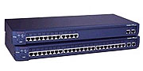  Sun Netra servers  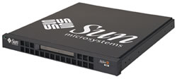 | RJ45 | Console/Ethernet cable
Nortel equipments  Other DB9 DTE devices | DB9 male | Console/Ethernet cable  + RJ45-DB9F cross-over adapter
Sun Sparc servers  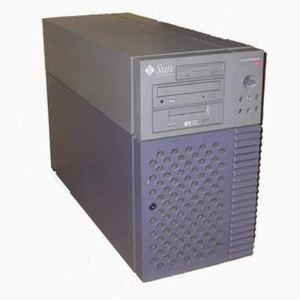  Other DB25 DTE devices | DB25 female | Console/Ethernet cable  + RJ45-DB25M cross-over adapter
Serial printers  DB25 DTE devices | DB25 male | Console/Ethernet cable  + RJ45-DB25F cross-over adapter
Modem  ISDN terminal adapters | DB25 male | Console/Ethernet cable  + RJ45-DB25M straight adapter

 Console cable + RJ45-DB9F adapter

 Console cable + RJ45-DB25F/M adapter

Appendix B: PC card supported by VTS

The following PC cards are supported by VTS series:

Table B-1 Network card
Manufacturer | Model/Name | VTS probed Model name | Specification
3COM | 3CXE589ET-AP | 3Com Megahertz 589E TP/BNC LAN PC Card | 10 Mbps LAN card
Linksys | Linksys EtherFast 10/100 Integrated PC Card  (PCM100) | Linksys EtherFast 10/100 Integrated PC Card (PCM100) Ver 1.0 | 10/100 Mbps LAN card
Corega | FetherII PCC-TXD | corega K.K. corega FEtherII PCC-TXD | 10/100 Mbps LAN card
Netgear | 16bit PCMCIA Notebook Adapter FA411 | NETGEAR FA411 Fast Ethernet | 10/100 Mbps LAN card

Table B-2 Wireless Network card
Manufacturer | Model/Name | VTS probed Model name | Specification
Cisco Systems | AIR-PCM340/Aironet 340 | Cisco Systems 340 Series Wireless LAN Adapter | 11 Mbps Wireless LAN Adapter
Cisco Systems | AIR-PCM350/Aironet 350 | Cisco Systems 350 Series Wireless LAN Adapter | 11 Mbps Wireless LAN Adapter
Lucent Technologies | PC24E-H-FC/Orinoco Silver | Lucent Technologies WaveLAN/IEEE Version 01.01 | 11 Mbps Wireless LAN Adapter
Agere Systems  (Lucent Technologies) | Orinoco Classic Gold  (PC24E-H-FC/Orinoco Gold) | Lucent Technologies WaveLAN/IEEE Version 01.01 | 11 Mbps Wireless LAN Adapter
Buffalo | AirStation  (WLI-PCM-L11GP) | MELCO WLI-PCM-L11 Version 01.01 | 11 Mbps Wireless LAN Adapter

Table B-3 ATA/IDE Fixed Disk Card
Manufacturer | Model/Name | VTS probed Model name | Specification
Advantech | CompactFlash | CF 48M | 48 MB Storage card
SanDisk | SDP series | SunDisk SDP 5/3 0.6 | 64 MB Storage card
SanDisk | SDP series | SanDisk SDP 5/3 0.6 | 256 MB Storage card
Kingston | CompactFlash Storage Card | TOSHIBA THNCF064MAA | 64 MB Storage card
Viking | CompactFlash | TOSHIBA THNCF064MBA | 64 MB Storage card

Table B-4 Serial Modem Card
Manufacturer | Model/Name | VTS probed Model name | Specification
Billionton Systems Inc. | FM56C series | PCMCIA CARD 56KFaxModem FM56C-NFS 5.41 | Ambient (Intel) V.90 FAX/MODEM PC Card
Viking | PC Card Modem 56K | Viking V.90 K56flex 021 A | MODEM PC Card
KINGMAX | KIT PCMCIA 56K  Fax/Modem Card | CIRRUS LOGIC 56K MODEM CL-MD56XX 5.41 | V.90 FAX/MODEM PC Card
TDK | TDK DH6400 | TDK DH6400 1.0 | 64Kbps
NTT DoCoMo | Mobile Card Triplex N | NTT DoCoMo Mobile Card Triplex N | 64Kbps

Appendix C: VTS Configuration files

C.1 System.cnf

#
# system.cnf
#
# system configuration which exist only one place on this file.
#

# kind of IP configuration mode
# 1 - static ip , 2 - dhcp , 3 - pppoe
ipmode = 1

# system ip addres
ipaddr = 192.168.161.5

# system subnet mask
subnet = 255.255.0.0

# system gateway
gateway = 192.168.1.1

# dns configuration
# 'p_dns' is a primary dns ip address and 's_dns' is a secondary dns ip address
# if you want to set dns authmatically in case of dhcp or pppoe,
# you can set 'bmanual_dns' to 0.
p_dns = 168.126.63.1
s_dns = 168.126.63.2
bmanual_dns = 1

# pppoe configuration
# 'ppp_usr' is pppoe account name and 'ppp_pwd" is a password for that account
ppp_usr = whoever
ppp_pwd = pppoepwd

# Email logging configuration
# if you want to send log via E-mail, set 'emaillog' to 1
# 'emaillog_num' trigger sending email.
# The number of logs are greater than 'emaillog_num", then send it.
emaillog = 0
emaillog_num = 5

# SMTP configuration
# 'smtpsvr' is a SMTP server .
# 'sysmailaddr' is a sender address.
# 'recvmailaddr' is a receiver address.
# 'smtp_mode' means a SMTP server authentication mode.
# 1 - smtp w/o authentication , 2 - pop before smtp , 3 - smtp w/ authentication
# If 'smtp_mode" is 2 or 3, you need SMTP account information.
# 'smtp_user' is a SMTP account name and 'smtp_pwd" is a password.
smtpsvr = smtp.yourcompany.com
sysmailaddr = vts1600@yourcompany.com
recvmailaddr = admin@yourcompany.com
smtp_mode = 1
smtp_user = admin
smtp_pwd = admin

# 'device_name' mean a unit name assigned. A unit name will be a identifier among PS products.
device_name = VTS Device

# IP filtering configuration
# By setting 'btelnet' to 1, you can use remote console.
# Similarly by setting 'bweb' to 1, you can use remote console.
# 0 means that protect any access.
# 'enable_ip', 'enable_netmask' pair is a source rule specification for remote console filtering.
# 'enable_webip', 'enable_webnetmask' pair is for web filtering.
btelnet = 1
bweb = 1
enable_ip = 0.0.0.0
enable_netmask = 0.0.0.0
enable_webip = 0.0.0.0
enable_webnetmask = 0.0.0.0

# dynamic DNS(DDNS) configuration
# dynamic dns can be enabled by setting 'bdyndns' to 1. 0 for disable.
# 'dyn_dn' is a domain name for your DDNS.
# 'dyn_user' is a account name for DDNS and 'dyn_pwd" is a password for it.
bdyndns = 0
dyn_dn = vts1600.dyndns.biz
dyn_user = vts1600-user
dyn_pwd = vts1600-pwd

# NTP configuration
# 'ntp_enable' set to 1 for using NTP or set to 0.
# 'ntp_serverip' is the IP address of NTP server and 'ntp_offset' is a your offset from UTC.
# If you don't know any NTP server IP, then set 'ntp_auto_conf' to 1.
ntp_enable = 0
ntp_auto_conf = 1
ntp_offset = 0.0
ntp_serverip = 192.168.200.100

# Log configuration
# system logging is enabled by 'log_enable' to 1.
# 'logbuf_size' is a variable for representing log buffer size by KB.
# 'log_stoloc' is a location to save log.
# 1 = memory 2 = CF card 3 = NFS 4 = SYSLOGD
# If you choose log location to SYSLOGD, 'logbuf_size' you've set will loose his role - limiting log file size.
log_enable = 1
logbuf_size = 4
log_stoloc = 1

# Port access menu(PAM) configuration
# Enable or disable port access menu by setting 'master_enb' 1 or 0.
# 'master_port' is a listening port for PAM.
# 'master_proto' means a protocol .
# 1 = Telnet , 2 = SSH , 3 = RawTCP
# To set inactivity time-out, set 'master_inactivity'. A unit is second.
# 'master_localip' means a assigned ip for PAM.
# 'master_authmethod' means a authentication method for PAM.
# 0 = None
# 1 = radius 2 = local 3 = radius/local 4 = local/radius
# 5 = TACACS+ 6 = TACACS+/local 7 = local/TACACS+
# 8 = LDAP 9 = LDAP/local 10 = local/LDAP
# If your authenticatio method is not None or Local, then you have to specify other parameters
# 'master_p_radius_auth' and 'master_s_radius_auth' is a authentication server ip address.
# One is a primary server and the other is secondary one.
# 'master_p_radius_acct' and 'master_s_radius_acct' is for accounting server.
# Accounting server parameters isn't needed in case of LDAP.
# 'master_radius_secret' is a shared secret only for RADIUS and TACACS+.
# In RADIUS case, you have two more parameters, 'master_radius_timeout' and 'master_radius_retries'.
# One is for the timeout and the other is for the count of retries.
# 'master_ldap_search_base' parameter - ldap base string - is ONLY FOR LDAP.
master_enb = 1
master_port = 7000
master_proto = 1
master_inactivity = 100
master_localip = 192.168.1.100
master_authmethod = 2
master_radius_timeout = 10
master_radius_retries = 3
master_ldap_search_base = "dn=yourcomapy,dn=com"

# syslog configuration
# You can run or kill syslogd by setting 'bsyslog_service' to 1 or 0.
# 'syslog_ip' is a IP addresss of a remote syslog server.
# 'syslog_2ndip' is a IP address of a secondary syslogd server which will get the same logs.
# 'syslog_facility' specify what type of program is logging. 0 ~ 7 for LOCAL0 to LOCAL7
bsyslog_service = 0
syslog_ip = 192.168.200.100
syslog_facility = 0

# NFS configuration
# You can mount or unmount NFS by setting 'bnfs_service' to 1 or 0.
# 'nfs_ip' is a NFS server IP addresss and 'nfs_path' is a mount path.
bnfs_service = 0
nfs_ip = 192.168.200.100
nfs_path = /

# WEB configuration
# If you want to support HTTP, then set 'bweb_http' to 1. If not, set tot 0.
# 'bweb_https' is for HTTPS.
# 'web_refresh_rate' is for refresh the changing page when you see the system status page.
bweb_http = 1
bweb_https = 1
web_refresh_rate = 10

# TCP configuration
# 'keepalive_time' is a time before keep alive takes place.
# 'keepalive_probes' is the number of allowed keep alive probes.
# 'keepalive_intvl' is a time interval between keep alive probes.
keepalive_time = 15
keepalive_probes = 3
keepalive_intvl = 5

# Ethernet configuration
# 'ethernet_mode' is a ethernet mode.
# 0 = Auto Negotiation, 1 = 100BaseT Half Duplex, 2 = 100BaseT Full Duplex,
# 3 = 10BaseT Half Duplex, 4 = 10BaseT Full Duplex
ethernet_mode = 0

# PCMCIA configuration
# 'pcmcia_card_type' shows a pcmcia card type.
# 0 for empty , -1 for unsupported card, 1 for CF card, 2 for Network card,
# 3 for Wireless Network card, 4 for Serial Modem card
pcmcia_card_type = 0

# PCMCIA ipconfiguration
# same with system ip configuration
pcmcia_ipmode = 2
pcmcia_ip = 192.168.1.254
pcmcia_subnet = 255.255.255.0
pcmcia_gateway = 192.168.1.1
pcmcia_ppp_usr = whoever
pcmcia_ppp_pwd = pppoepwd
pcmcia_bmanual_dns = 0

# In case of serial modem card, 'pcmcia_modem_initstr' means a modem init string.
pcmcia_modem_initstr = q1e0s0=2

# Wireless network card configuration
# To enable or disable Wired Equivalent Privacy(WEP), set 'pcmcia_wep_enb' to 1 or 0.
# 'pcmcia_web_mode' is a WEP mdoe. 1 for encrypted, 2 for shared
# 'pcmcia_wep_length' is a length for WEP. 1 for 40 bits, 2 for 128 bits
# 'pcmcia_wep_key_str' is a key string for WEP.
pcmcia_wep_enb = 0
pcmcia_wep_mode = 1
pcmcia_wep_length = 1

# 'pcmcia_cf_conf_max' is a maximum size to use in case of CF card.
pcmcia_cf_conf_max = 0

C.2 Redirect.cnf

#
# redirect.cnf
#
# Port configuration except port access menu place on this file.
# Basically keys followed by 'port' key are data for those port.
# Port number is zero-by-index and the maximum value for port is used as all port configuration
# Data followed by all port are default values and will NOT be applied.

# 'port' key notify the port data follow.
# If you want to activate the port, set 'benable' to 1. If not, set to 0.
# If you set 'bmanset' to 1, you don't want to change the port data by changing all port configuration.
# If you want to change the port data by changing all port configuration, set to 0.
port = 0
benable = 0
bmanset = 0
port = 1
benable = 0
bmanset = 0
port = 2
benable = 0
bmanset = 0
port = 3
benable = 0
bmanset = 0
port = 4
benable = 0
bmanset = 0
port = 5
benable = 0
bmanset = 0
benable = 0
port = 6
bmanset = 0
benable = 0
port = 7
bmanset = 0
benable = 0
port = 8
benable = 0
bmanset = 0
port = 9
benable = 0
bmanset = 0
port = 10
benable = 0
bmanset = 0
port = 11
benable = 0
bmanset = 0
port = 12
benable = 0
bmanset = 0
port = 13
benable = 0
bmanset = 0
port = 14
benable = 0
bmanset = 0
port = 15
benable = 0
bmanset = 0

# As refered, maximum port (in case 16 port machine ,16) represents the defaults values for
# all port configuration.
port = 16
benable = 0
bmanset = 0

# Serial parameter configuration
# 'uarttype' is for UART type. But PS only support RS232.
# So set 'uarttype' to 0 and DO NOT CHANGE.
# 'baudrate' is for baudrate. From 1200 to 230400 is available.
# 'stopbits' is for stop bits. 1 for 1 bit, 2 for 2 bits
# 'databits' is for data bits. 7 for 7 bits, 8 for 8 bits.
# 'parity' is for parity. 0 for none, 1 for even , 2 for odd parity.
# 'flowcontrol" is for flow contorl. 0 for none, 1 for XON/XOFF, 2 for hardware flow control
# 'dtropt' is for dtr option.
# 1 = Always HIGH, 2 = Always LOW, 3 = High when open
# 'interchartimeout' is for inter-character timeout. It works ONLY FOR RAWTCP mode.
uarttype = 0
baudrate = 9600
stopbits = 1
databits = 8
parity = 0
flowcontrol = 0
dtropt = 0
interchartimeout = 100

# Host mode configuration
# 'protocol' means a host mode.
# 0 = Terminal Server, 1 = Console Server, 2 = Dial-in modem, 3 = Dial-In Termimal Server
protocol = 1
# In Terminal Server mode, 'destip' and 'destport' is destination IP and port to connect.
destip = 0.0.0.0
destport = 0
# In Console Server mode, 'localip' is a assigned IP to the port and 'localport' is a listenning port.
local_ip = 0.0.0.0
localport = 0
# 'inactivitytimeout' is a inactivity timeout in seconds.
inactivitytimeout = 100
# 'run_proto' is a ethernet protocol for this port. This key is useless for Dial-In modem mode.
# 1 = Telnet , 2 = SSH , 3 = RawTCP
run_proto = 1
# 'ssh_break_string' is a string for send a break in case of Console server mode and 'run_proto' is SSH.
ssh_break_string = ~break

# IP filtering configuration
# 'allow_ip', 'allow_netmask' pair is a source rule specification for serial port access filtering.
allow_ip = 0.0.0.0
allow_netmask = 0.0.0.0

# 'porttitle' is a port title.
porttitle = Port Title

# Email notification configuration
# Enable of disable e-mail notification by setting 'en_enable' to 1 or 0.
# 'en_minsnddelay' is a minimum delay of sending email notification.
# A unit is second and minimum value is 5.
# 'en_msgtitle' is a message title of email.
# 'en_mailto' is reciever addresss.
# 'en_keywords' is a keyword to monitor. 'en_keyword' key can occur serveral times.
# But the maximum number of keywords is 30.
en_enable = 0
en_minsnddelay = 5
en_msgtitle = Email Alarm Notification
en_mailto = admin@yourcompany.com

# Port buffering configuration
# Enable of disable port buffering by setting 'pb_enable' to 1 or 0.
# 'pb_size' is a maximum port buffering size. Maximum value are different by location.
# 'pb_loc' is a location to store port buffer data.
# 1 = memory 2 = CF card 3 = NFS 4 = SYSLOGD
pb_enable = 0
pb_size = 4
pb_loc = 1

# In Dial-In Modem or Dial-in Terminal Server mode, you can set modem initstring by setting 'modem_initstr'.
modem_initstr = q1e0s0=2

# Authentication configuration
# 'authmethod' means a authentication method for port log-in.
# 0 = None
# 1 = radius 2 = local 3 = radius/local 4 = local/radius
# 5 = TACACS+ 6 = TACACS+/local 7 = local/TACACS+
# 8 = LDAP 9 = LDAP/local 10 = local/LDAP
# If your authenticatio method is not None nor Local, then you have to specify other parameters
# 'p_radius_auth' and 's_radius_auth' is a authentication server ip address.
# One is a primary server and the other is secondary one.
# 'p_radius_acct' and 's_radius_acct' is for accounting server.
# Accounting server parameters isn't needed in case of LDAP.
# 'radius_secret' is a shared secret only for RADIUS and TACACS+.
# In RADIUS case, you have two more parameters, 'radius_timeout' and 'radius_retries'.
# One is for the timeout and the other is for the count of retries.
# 'ldap_search_base' parameter - ldap base string - is ONLY FOR LDAP.
authmethod = 2
radius_timeout = 10
radius_retries = 3
ldap_search_base = "dn=yourcomapy,dn=com"

# 'user_ctrl_mode' is user access control mode.
# 0 = disable, 1 = restriction , 2 = permission
# 'restricted_user_list' is a string shows a restricted user list
# 'permitted_user_list' is a string shows a permitted user list
# in user list string, user IDs must be seperated by comma(,).
user_ctrl_mode = 0

# 'sniff_mode' is a sniffing mode option.
# 0 = disable, 1 = input , 2 = output , 3 = Both
# 'sniff_user_list' is a sniff user list. Like above user list, user name should be seperated by comma.
sniff_mode = 0

Appendix D: Well-known port numbers

Port numbers are divided into three ranges: Well Known Ports, Registered Ports, and Dynamic and/or Private Ports. Well Known Ports are those from 0 through 1023. Registered Ports are those from 1024 through 49151. Dynamic and/or Private Ports are those from 49152 through 65535.

Well Known Ports are assigned by IANA, and on most systems, can only be used by system processes or by programs executed by privileged users. Table D-1 shows some of the well-known port numbers. For more details, please visit the IANA website:
http://www.iana.org/assignments/port-numbers

Table D-1 Well-known port numbers
Port number | Protocol | TCP/UDP
21 | FTP (File Transfer Protocol) | TCP
22 | SSH (Secure SHell) | TCP
23 | Telnet | TCP
25 | SMTP (Simple Mail Transfer Protocol) | TCP
37 | Time | TCP, UDP
39 | RLP (Resource Location Protocol) | UDP
49 | TACACS, TACACS+ | UDP
53 | DNS | UDP
67 | BOOTP server | UDP
68 | BOOTP client | UDP
69 | TFTP | UDP
70 | Gopher | TCP
79 | Finger | TCP
80 | HTTP | TCP
110 | POP3 | TCP
119 | NNTP (Network News Transfer Protocol) | TCP
161/162 | SNMP | UDP
443 | HTTPS | TCP

Appendix E: Guide to the Bootloader menu program

E.1 Overview

The bootloader menu provides a way to recover the VTS unit using BOOTP/TFTP as a disaster recovery option and to diagnose the system hardware. If the user presses the <ESC> key within 3 seconds after the VTS unit is powered up, he will enter the bootloader menu program. From this menu program, the user can set various system parameters, test system hardware, and perform firmware upgrades.

E.2 Main menu

After entering the bootloader menu program, the user will see following main menu page:

Bootloader 0.3.0 (Feb 14 2003 - 10:49:27)

CPU : XPC855xxZPnnD4 (50 MHz)
DRAM : 64 MB
FLASH : 8 MB
PC CARD : No card
EEPROM : A Type exist
Ethernet : AUTO-NEGOTIATION
Autoboot Start: 0
-----------------------------------------------------------------------------
Welcome to Boot Loader Configuration page
-----------------------------------------------------------------------------
Select menu
1. RTC configuration [ Feb 14 2003 - 11:00:26 ]
2. Hardware test
3. Firmware upgrade [S/W Version : v0.6.11]
4. Exit and boot from flash
5. Exit and reboot
<ESC> Back, <ENTER> Refresh
----->

Figure. E.1 Main Menu Page of Bootloader Menu Program

E.3 RTC configuration menu

Using the RTC configuration menu, the user can set the system time of the VTS.

-----------------------------------------------------------------------------
RTC configuration
-----------------------------------------------------------------------------
Select menu
1. Date(mm/dd/yy) : 02/14/03
2. Time(hh:mm:ss) : 13:27:12
<ESC> Back, <ENTER> Refresh
-----> 1
Enter Current Date (mm/dd/yy) : 02/15/03
press the ENTER key to continue

-----------------------------------------------------------------------------
RTC configuration
-----------------------------------------------------------------------------
Select menu
1. Date(mm/dd/yy) : 02/15/03
2. Time(hh:mm:ss) : 13:27:20
<ESC> Back, <ENTER> Refresh
-----> 2
Enter Current Time (hh:mm:ss) : 13:25:00
press the ENTER key to continue

-----------------------------------------------------------------------------
RTC configuration
-----------------------------------------------------------------------------
Select menu
1. Date(mm/dd/yy) : 02/15/03
2. Time(hh:mm:ss) : 13:25:01
<ESC> Back, <ENTER> Refresh
----->

Figure. E.2 RTC configuration within Bootloader Menu Program

E.4 Hardware test menu

Using the Hardware test menu, the user can test hardware components. There are three hardware test modes:
- One time
- Looping (without External test in Auto test)
- Looping (with External test in Auto test)

If the user selects One time, an auto test or each component test is performed just once. In this mode, the ping test to the remote host (server IP address) and UART test are also performed once.
If the user selects Looping (without External test in Auto test), the auto test is performed repeatedly until the user presses the <ctrl-c> keys. In this mode, the ping test to the remote host (server IP address) and UART test are not performed.
If the user selects Looping (with External test in Auto test)’, auto test is performed repeatedly until the user presses the <ctrl-c> keys. And, the ping test to the remote host (server IP address) and UART test are also performed repeatedly.

Note:
To perform the test on the Ethernet and UART properly, the user must connect an Ethernet cable to the Ethernet port of the VTS and must plug the loopback connector to all the serial ports of the VTS. There must exist a remote host with a valid IP address. The default server IP address is 192.168.0.128 and it can be changed using the [Firmware Upgrade] menu. Otherwise, the test may not be performed properly.

-----------------------------------------------------------------------------
Hardware Test
-----------------------------------------------------------------------------
Select menu
0. Test Mode - One time
1. Auto test
2. DRAM test
3. FLASH test
4. FAN test
5. LED test
6. EEPROM test
7. UART test
8. PC card test
9. Ethernet test
<ESC> Back, <ENTER> Refresh
-----> 0

-----------------------------------------------------------------------------
Hardware Test
-----------------------------------------------------------------------------
Select menu
0. Test Mode - Looping(without External test in Auto test)
1. Auto test
2. DRAM test
3. FLASH test
4. FAN test
5. LED test
6. EEPROM test
7. UART test
8. PC card test
9. Ethernet test
<ESC> Back, <ENTER> Refresh
----->0

-----------------------------------------------------------------------------
Hardware Test
-----------------------------------------------------------------------------
Select menu
0. Test Mode - Looping(with External test in Auto test)
1. Auto test
2. DRAM test
3. FLASH test
4. FAN test
5. LED test
6. EEPROM test
7. UART test
8. PC card test
9. Ethernet test
<ESC> Back, <ENTER> Refresh
----->0

-----------------------------------------------------------------------------
Hardware Test
-----------------------------------------------------------------------------
Select menu
0. Test Mode - One time
1. Auto test
2. DRAM test
3. FLASH test
4. FAN test
5. LED test
6. EEPROM test
7. UART test
8. PC card test
9. Ethernet test
<ESC> Back, <ENTER> Refresh
----->

Figure. E.3 Hardware test menu within Bootloader Menu Program

When the user selects [Auto test], a test of all the hardware components is performed automatically.

-----------------------------------------------------------------------------
Hardware Test
-----------------------------------------------------------------------------
Select menu
0. Test Mode - One time
1. Auto test
2. DRAM test
3. FLASH test
4. FAN test
5. LED test
6. EEPROM test
7. UART test
8. PC card test
9. Ethernet test
<ESC> Back, <ENTER> Refresh
----->1

******* Hardware auto-detect and auto-test *******
[DRAM]
DRAM Test in progress ----------------------------------------[65536KB]
DRAM Test ----------------------------------------------------[SUCCESS]

[FLASH]
Flash Test Status---------------------------------------------[ 100 %]
Flash Test ---------------------------------------------------[SUCCESS]

[FAN]
Fan Status --------------------------------------------------[7020 RPM]

[LED]
SERIAL READY LED ON/OFF---------------------------------------3 time(s)

[EEPROM]
EEPROM : A Type exist
EEPROM Test ------------------------------------------------- [SUCCESS]

[UART]
<--Internal loop test-->
Port # 1 test in progressing(Read/Write)----------[SUCCESS]
Port # 2 test in progressing(Read/Write)----------[SUCCESS]
Port # 3 test in progressing(Read/Write)----------[SUCCESS]
Port # 4 test in progressing(Read/Write)----------[SUCCESS]
.
.
.
Port #30 test in progressing(Read/Write)----------[SUCCESS]
Port #31 test in progressing(Read/Write)----------[SUCCESS]
Port #32 test in progressing(Read/Write)----------[SUCCESS]
<--External loop test-->
Port # 1 test in progressing(Read/Write)----------[SUCCESS]
(RTS/CTS)-------------[SUCCESS]
(DTR/DSR)-------------[SUCCESS]
Port # 2 test in progressing(Read/Write)----------[SUCCESS]
(RTS/CTS)-------------[SUCCESS]
(DTR/DSR)-------------[SUCCESS]
Port # 3 test in progressing(Read/Write)----------[SUCCESS]
(RTS/CTS)-------------[SUCCESS]
(DTR/DSR)-------------[SUCCESS]
Port # 4 test in progressing(Read/Write)----------[SUCCESS]
(RTS/CTS)-------------[SUCCESS]
(DTR/DSR)-------------[SUCCESS]
.
.
.
Port #31 test in progressing(Read/Write)----------[SUCCESS]
(RTS/CTS)-------------[SUCCESS]
(DTR/DSR)-------------[SUCCESS]
Port #32 test in progressing(Read/Write)----------[SUCCESS]
(RTS/CTS)-------------[SUCCESS]
(DTR/DSR)-------------[SUCCESS]

[PCMCIA]
5V CARD
5.0V card found: Lucent Technologies WaveLAN/IEEE Version 01.01
Network Adapter Card

[Ethernet]
Ethernet chip test--------------------------------------------[SUCCESS]
PING 192.168.0.135 from 192.168.161.5 : 64 bytes of ethernet packet.
64 bytes from 192.168.0.135 : seq=0 ttl=255 timestamp=11172879 (ms)
64 bytes from 192.168.0.135 : seq=1 ttl=255 timestamp=11173874 (ms)
64 bytes from 192.168.0.135 : seq=2 ttl=255 timestamp=11174875 (ms)
64 bytes from 192.168.0.135 : seq=3 ttl=255 timestamp=11175876 (ms)

******* Hardware auto-detect and auto-test SUMMARY *******
1. DRAM Test -----------------------------------------------[SUCCESS]
2. FLASH Test -----------------------------------------------[SUCCESS]
3. FAN Test -----------------------------------------------[SUCCESS]
4. EEPROM Test-----------------------------------------------[SUCCESS]
5. UART Test Summary
Port NO | exist status | exist status | exist status | exist status
-------------------------------------------------------------------------------
Port 01-04| YES SUCCESS | YES SUCCESS | YES SUCCESS | YES SUCCESS
Port 05-08| YES SUCCESS | YES SUCCESS | YES SUCCESS | YES SUCCESS
Port 09-12| YES SUCCESS | YES SUCCESS | YES SUCCESS | YES SUCCESS
Port 13-16| YES SUCCESS | YES SUCCESS | YES SUCCESS | YES SUCCESS
Port 17-20| YES SUCCESS | YES SUCCESS | YES SUCCESS | YES SUCCESS
Port 21-24| YES SUCCESS | YES SUCCESS | YES SUCCESS | YES SUCCESS
Port 25-28| YES SUCCESS | YES SUCCESS | YES SUCCESS | YES SUCCESS
Port 29-32| YES SUCCESS | YES SUCCESS | YES SUCCESS | YES SUCCESS

6.PC CARD Test Summary
5V CARD
5.0V card found: Lucent Technologies WaveLAN/IEEE Version 01.01
Network Adapter Card
7. PING Test -----------------------------------------------[SUCCESS]

PRESS any key to continue!!

Figure. E.4 Hardware test screen within Bootloader Menu Program

For each hardware component test, the user can skip a test by pressing the <ESC> key.

-------------------------------------------------------------------------------
Hardware Test
-------------------------------------------------------------------------------
Select menu
0. Test Mode - One time
1. Auto test
2. DRAM test
3. FLASH test
4. FAN test
5. LED test
6. EEPROM test
7. UART test
8. PC card test
9. Ethernet test
<ESC> Back, <ENTER> Refresh
-----> 1

******* Hardware auto-detect and auto-test *******
[DRAM]
DRAM Test in progress ----------------------------------------[ 640KB]
DRAM Test ----------------------------------------------------[SKIPPED]

[FLASH]
Flash Test Status---------------------------------------------[ 2 %]
FLASH Test ---------------------------------------------------[SKIPPED]

Figure. E.5 Skip the specific test using ESC key

If a failure occurs while Auto Test with looping mode is being performed, the test will stop and the serial InUse LEDs blink to indicate the hardware test has failed. In this case, the user must press the <ctrl-c> keys to return to the menu page.

E.5 Firmware upgrade menu

By using the ‘Firmware upgrade’ menu, the user can upgrade the firmware of the unit. Before firmware upgrade, the user can check the current firmware version by selecting menu item 3 from the Main menu page. The firmware upgrade menu program supports two protocols for remote firmware download: BOOTP and TFTP. The default protocol is BOOTP for DHCP environments. If the user selects TFTP, he must also set the IP address for the unit properly. The default IP address for the unit is 192.168.161.5.

For firmware upgrade, a firmware file configured as [Firmware File Name] on the server configured as [Server’s IP address] must exist.

-----------------------------------------------------------------------------
Firmware upgrade
-----------------------------------------------------------------------------
Select menu
1. Protocol [BOOTP]
2. IP address assigned to Ethernet interface [192.168.161.5]
3. Server's IP address [192.168.0.128]
4. Firmware File Name [vts3200.bin]
5. Start firmware upgrade
<ESC> Back, <ENTER> Refresh
-----> 1
Select protocol ( 1 = BOOTP, 2 = TFTP) : 2

-----------------------------------------------------------------------------
Firmware upgrade
-----------------------------------------------------------------------------
Select menu
1. Protocol [TFTP]
2. IP address assigned to Ethernet interface [192.168.161.5]
3. Server's IP address [192.168.0.128]
4. Firmware File Name [vts3200.bin]
5. Start firmware upgrade
<ESC> Back, <ENTER> Refresh
----->

Figure. E.6 Firmware upgrade menu within Bootloader Menu Program

If the user selects [Start firmware upgrade], a confirm message will be displayed on the screen. If the user enters ‘y’, the firmware upgrade process will start. This process cannot be stopped until it is finished.

-----------------------------------------------------------------------------
Firmware upgrade
-----------------------------------------------------------------------------
Select menu
1. Protocol [BOOTP]
2. IP address assigned to Ethernet interface [192.168.161.5]
3. Server's IP address [192.168.0.128]
4. Firmware File Name [vts3200.bin]
5. Start firmware upgrade
-----> 5
Firmware upgrade cannot be stopped until finished.
And all configuration parameters are restored to default values.
Do you really want to start firmware upgrade(y/n)?y
BOOTP broadcast 1
ARP broadcast 1
TFTP from server 192.168.0.128; our IP address is 192.168.161.5
Filename 'vts3200.bin'.
Load address: 0x100000
Loading: #################################################################
#################################################################
#################################################################
#################################################################
#################################################################
#################################################################
#################################################################
#################################################################
#################################################################
#################################################################
#################################################################
#################################################################
#################################################################
#################################################################
#################################################################
#################################################################
#################################################################
####################################
done
Bytes transferred = 5838194 (591572 hex)

Erase Flash Sectors 9-20 in Bank # 1
BLOCK 1 : Copy to Flash... done
Erase Flash Sectors 21-115 in Bank # 1
BLOCK 2 : Copy to Flash... done
Erase Flash Sectors 116-116 in Bank # 1
BLOCK 3 : Copy to Flash... done
BLOCK 4 : Erase Flash Sectors 117-117 in Bank # 1
Firmware upgrade is finished successfully.

-----------------------------------------------------------------------------
Firmware upgrade
-----------------------------------------------------------------------------
Select menu
1. Protocol [BOOTP]
2. IP address assigned to Ethernet interface [192.168.161.5]
3. Server's IP address [192.168.0.128]
4. Firmware File Name [vts3200.bin]
5. Start firmware upgrade
<ESC> Back, <ENTER> Refresh
----->

Figure. E.7 Firmware upgrade process
After finishing the firmware upgrade process, the program will display the menu again along with a success message.

Appendix F: Guide to use Encrypted NFS feature

F.1 Overview

NFS is a wide spread protocol for sharing files through network, but it has following security problem because it uses UDP protocol in general.
- Data between NFS server and client cannot be encrypted.
- There is no authentication method for the user who tries to connect NFS server.
- It is very difficult to use NFS if there is Firewall between NFS server and client.

To complement these security problems in native NFS protocol, Encrypted NFS (or Secure NFS) is used for secure file sharing. Encrypted NFS feature in VTS is implemented by using SSH tunneling. This section describes how to make Encrypted NFS server in user’s own host where Microsoft Windows is installed.

F.2 Installing the NFS server

To use Encrypted NFS feature, user must use NFS server that support TCP protocol. Most NFS servers for Microsoft Windows support TCP protocol. In this section, Omni-NFS server v4.2 from Xlink Technology Inc. is used for illustration. User can download evaluation version of Omni-NFS server from their web site. (http://www.xlink.com/eval.htm)

To install Omni-NFS server on user’s Windows host, please complete following steps.
Step 1. Get the Omni-NFS server v4.2
Step 2. Run "nfserver.exe" and follow the instructions
Step 3. After finishing installation of Onmi-NFS server, select NFS server under "Start -> Program -> Omni-NFS Server V4.2"
Step 4. On the XLink NFS Server windows, select New Entry under Action menu
Step 5. Click Browse button on the NFS Server Export window and select folder to be mounted.

NOTE : 1. User should remember "Exported Alias" of exported folder,
this will be used as a Mounting Path on VTS configuration.
2. In general Linux does not support NTFS file system(and VTS also),
so user should select folder on FAT or FAT32 file system.

Step 6. On the Directory Access Rights section of NFS Server Export window, check "Read/Write" to permit data logging from VTS

F.3 Installing the OpenSSH Package

Encrypted NFS feature in VTS is implemented by using SSH tunneling. So user should also install SSH daemon on the same host where NFS server is installed. In this section, OpenSSH for Windows v3.6.1 is used for illustration. OpenSSH for Windows is a free package and user can download it from following URL,

http://lexa.mckenna.edu/sshwindows/download/releases/

To install OpenSSH for Windows on user’s Windows host, please complete following steps.

Step 1. Get the OpenSSH for Windows package.
Step 2. Run "setupssh361-20030512.exe" and follow the instructions
Step 3. Open a command prompt and change to the installation directory (Program Files\OpenSSH is the default)
Step 4. Change directory into the bin directory.
Step 5. Use mkgroup to create a group permissions file.

C:\Program Files\OpenSSH\bin> mkgroup -l >> ..\etc\group

Step 6. Use mkpasswd to add authorized users into the passwd file. To add ALL users on the Windows, do not type '-u username' options.

C:\Program Files\OpenSSH\bin> mkpasswd -l >> ..\etc\passwd

Step 7. Start the OpenSSH server.

C:\Program Files\OpenSSH\bin> net start opensshd

Step 8. Copy “pause.exe” to "Program Files\OpenSSH\bin" directory.
NOTE : 1. “pause.exe” is a proprietary utility program of SENA for VTS.
2. This utility is used to maintain Encrypted TCP connection between
server(Windows NFS server host) and clients(VTS).
3. This utility is included in CR ROM accompanied with VTS products.
Please contact SENA Technical support if there is no this utility.

F.4 Configuring Encrypted NFS feature in VTS

After installing NFS server and OpenSSH successfully, user can use Encrypted NFS feature in VTS. To configure Encrypted NFS feature in VTS, please complete following steps.

Step 1. Login to Web UI
Step 2. Go to NFS server configuration page.
Step 3. Set each parameters as follows,
NFS service : Enabled
Primary NFS server IP address : write IP address of Encrypted NFS server here
Mounting path on primary NFS server : write "Exported Alias" here
Primary NFS timeout (sec, 5-3600) : write any value you want (default is 5)
Enable/Disable encrypted primary NFS server : Enabled
Encrypted primary NFS server user : write account name of Encrypted NFS server here
Encrypted primary NFS server password : write password of account here
Confirm primary NFS server password : write password of account here again
Step 4. Save & apply.
Step 5. Set the log location of system log or port log as NFS server.
Step 6. Test

To test encrypted NFS, user can use ethernet packet capture program like LanExplorer or EtherReal. In normal NFS(not encrypted NFS) case, user can capture all data tramsmission between VTS and NFS server in the form of clean text. But for encrypted NFS case, user can also capture all data tramsmission between CM and NFS server, user cannot decode it because it is encrypted.

